**REPORT**

Fingerprint Locker

and

Attendance System

**Objective:**

The main objective of this project is to design a fingerprint sensor locker such that system can be accessed using a reliable fingerprint sensor to ensure that only authorized individuals can access the locker. Creating a system that accurately records attendance data for users, including timestamps and user identifiers and integrating this to a reliable locking mechanism controlled by the system to secure the contents present in the locker.

**Introduction:**

In this project, we are going to design a Fingerprint Sensor Based Biometric Attendance System and Locker using Arduino. We will be interfacing fingerprint sensor with Arduino, LCD Display, Servo Motor and Keypad to design the desired project. In this project, we used the fingerprint Module and Arduino to take and keep attendance data and records.

**Required Components:**

1. Arduino Mega 2560 -1
2. Finger print module -1
3. 16x2 LCD- 1
4. Servo Motor -1
5. NodeMCU-1
6. 4x4 keypad -1
7. Potentiometer -1
8. Buzzer -1
9. Power

10.Connecting wires

11.Box

**Arduino Mega 2560**:

The Arduino Mega 2560 is a microcontroller board based on the ATmega2560. It is an upgraded version of the Arduino Mega and is designed for more complex projects that require a larger number of digital and analog inputs/outputs and more program memory.

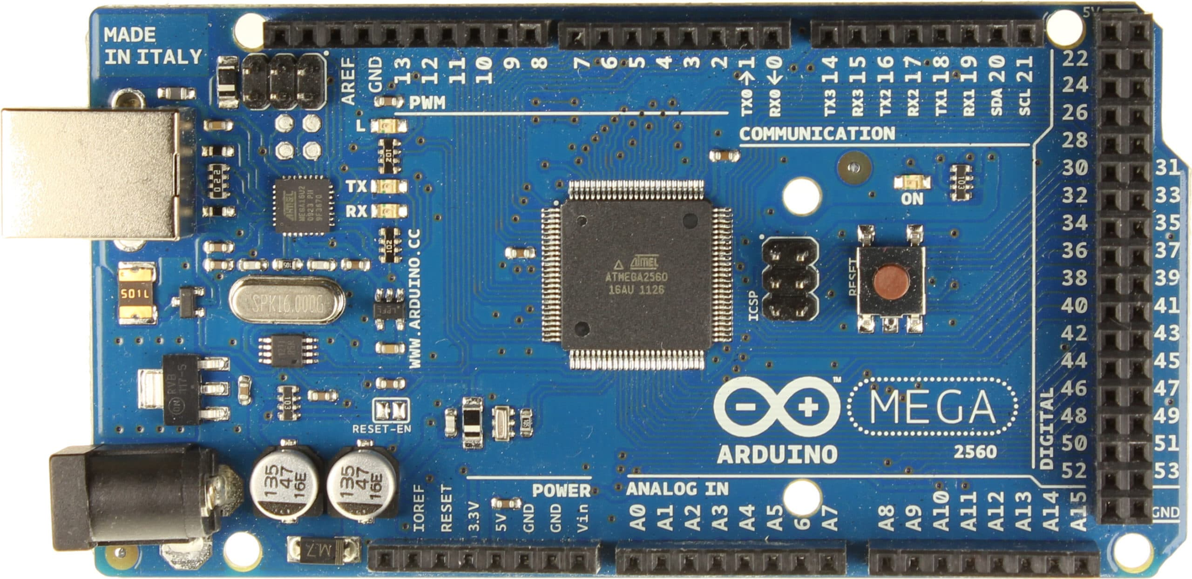

**Microcontroller:**

The heart of the Arduino Mega 2560 is the ATmega2560 microcontroller. It's an 8-bit AVR (Advanced Virtual RISC) microcontroller with 256 KB of flash memory for storing the program code, 8 KB of SRAM for data storage, and 4 KB of EEPROM for non-volatile storage.

**Clock Speed:**

The ATmega2560 operates at a clock speed of 16 MHz, providing the board with the ability to execute instructions at a high speed.

**Digital I/O Pins:**

The Mega 2560 has a total of 54 digital input/output pins. Among these, 15 can be used as PWM (Pulse Width Modulation) outputs. These pins can be configured as digital inputs or outputs, allowing you to interface with a variety of sensors, actuators, and other digital devices.

**Analog Inputs:**

There are 16 analog inputs on the Mega 2560, labeled A0 through A15. These pins can be used to read analog signals from sensors, such as potentiometers or temperature sensors.

**Communication Interfaces:**

The Mega 2560 supports various communication interfaces, including:

* UART (Universal Asynchronous Receiver/Transmitter)
* SPI (Serial Peripheral Interface)
* I2C (Inter-Integrated Circuit)
* USB (Universal Serial Bus)

These interfaces enable the Arduino to communicate with other devices, such as sensors, displays, and other microcontrollers.

**Memory:**

The Mega 2560 has 256 KB of flash memory for storing the program code, which is significantly larger than the memory available on other Arduino boards. This makes it suitable for more complex programs.

**Operating Voltage:**

The operating voltage of the Mega 2560 is 5V. It can be powered through the USB connection or an external power supply.

**Reset Button:**

The board is equipped with a reset button, allowing you to restart your program or manually trigger a reset.

**Power Supply:**

The Mega 2560 can be powered through the USB connection, an external DC power jack, or the Vin pin. The recommended voltage range is 7-12V.

**Compatibility:**

The Mega 2560 is compatible with the Arduino Software (IDE), making it easy to program and upload code to the board. It is also compatible with most shields designed for the Arduino Mega.

**Shields:**

Arduino shields are expansion boards that can be plugged into the Mega 2560 to add additional functionality. The large number of pins and compatibility with various shields make the Mega 2560 versatile for a wide range of projects.

**Fingerprint Scanner Sensor Module:**

This is a fingerprint sensor module with TTL UART interface for direct connections to microcontroller UART or to PC through MAX232 / USB-Serial adapter. The user can store the fingerprint data in the module and can configure it in 1:1 or 1: N mode for identifying the person.

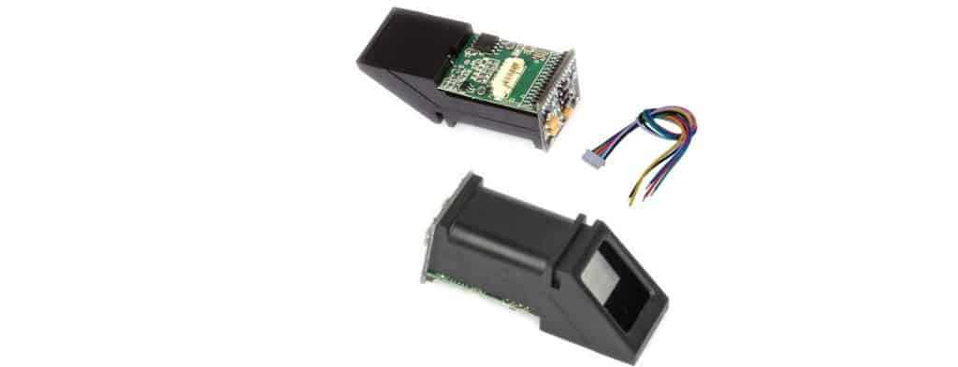

The Fingerprint module can be directly interfaced with any microcontroller as well as Arduino Board. This optical biometric fingerprint reader with great features and can be embedded into a variety of end products like access control system, attendance system, safety deposit box, car door locking system.

**Features**

1. Integrated image collecting and algorithm chip together, ALL-in-One
2. Fingerprint can conduct secondary development & embedded into a variety of end products
3. Low power consumption, low cost, small size, excellent performance
4. Professional optical technology, precise module manufacturing techniques
5. Good image processing capabilities can successfully capture image up to resolution 500 dpi

**Specifications**

1. Fingerprint sensor type: Optical
2. Sensor Life: 100 million times
3. Static indicators: 15KVBacklight: bright green
4. Interface: USB1.1/UART(TTL logical level)
5. RS232 communication baud rate: 4800BPS~115200BPS changeable
6. Dimension: 55*32*21.5mm
7. Image Capture Surface 15—18(mm)
8. Verification Speed: 0.3 sec
9. Scanning Speed: 0.5 sec
10. Character file size: 256 bytes
11. Template size: 512 bytes
12. Storage capacity: 250
13. Security level: 5 (1,2,3,4,5(highest))
14. False Acceptance Rate (FAR) :0.0001%
15. False Rejection Rate (FRR): 0.1%
16. Resolution 500 DPI
17. Voltage :3.6-6.0 VDC
18. Working current: Typical 90 mA, Peak 150mA
19. Matching Method: 1: N

**Servo Motor:**

A servo motor is a type of rotary actuator that allows for precise control of angular position, velocity, and acceleration. It is a closed-loop system, meaning it uses feedback from a sensor to adjust its position and maintain a desired output. Here are some key features and components of a typical servo motor:

Components of a Servo Motor:

DC Motor**:** The core of a servo motor is a DC (direct current) motor. The motor provides the mechanical power necessary for the motor shaft to rotate.

Gear Train**:** Servo motors often include a gear train, which reduces the high-speed, low-torque output of the motor to a lower-speed, higher-torque output at the output shaft. This gearing mechanism is crucial for precision and control.

Control Circuitry: The control circuitry is responsible for interpreting the control signals, typically in the form of pulses, received by the servo motor. This circuitry determines the direction and speed of the motor shaft rotation.

Feedback Device (Potentiometer or Encoder): Servo motors incorporate a feedback device, usually a potentiometer or an encoder, to provide information about the current position of the motor shaft. This feedback is crucial for the closed-loop control system.

Positioning Control System: The servo motor's control system uses the feedback information to compare the actual position of the motor shaft with the desired position (set by the control signal). It then adjusts the motor's operation to minimize any difference between the actual and desired positions.

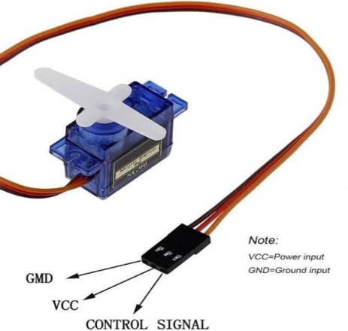

**NodeMCU:**

The NodeMCU is an open-source firmware and development kit that helps you prototype your IoT (Internet of Things) projects. It is based on the ESP8266 Wi-Fi module and combines the capabilities of a microcontroller with Wi-Fi connectivity. The NodeMCU development board is popular for its ease of use and is well-suited for projects involving IoT, home automation, and other applications that require wireless communication.

ESP8266 Module:

The core of the NodeMCU is the ESP8266 Wi-Fi module, which includesMicrocontroller, Wi-Fi Connectivity

Development Board:

The NodeMCU development board incorporates the ESP8266 module and provides additional features:

1. USB-to-Serial Converter
2. Power Supply
3. GPIO Pins
4. Reset and Flash Buttons
5. LED Indicators

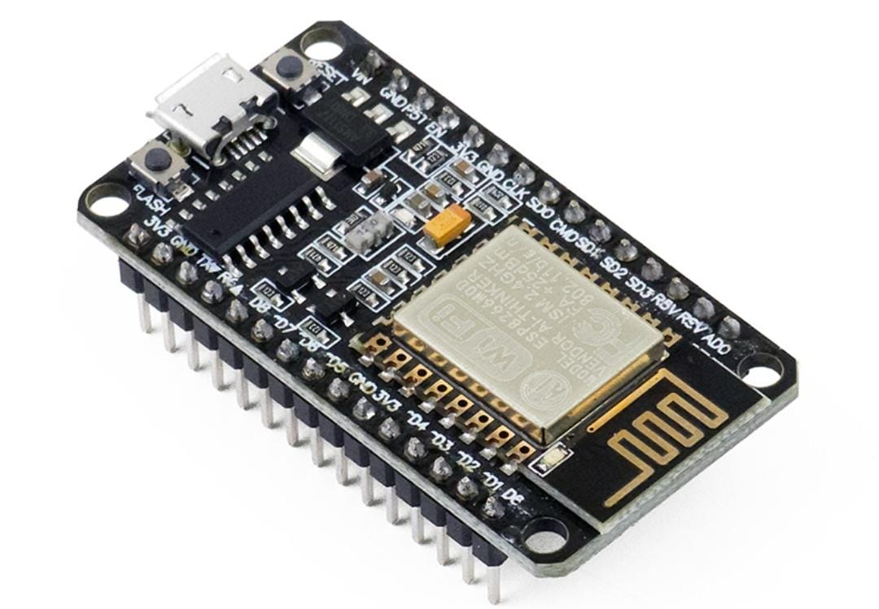

**Box:**

As per our requirements the following model is the desired one with a mechanical lock mechanism for emergency situation.

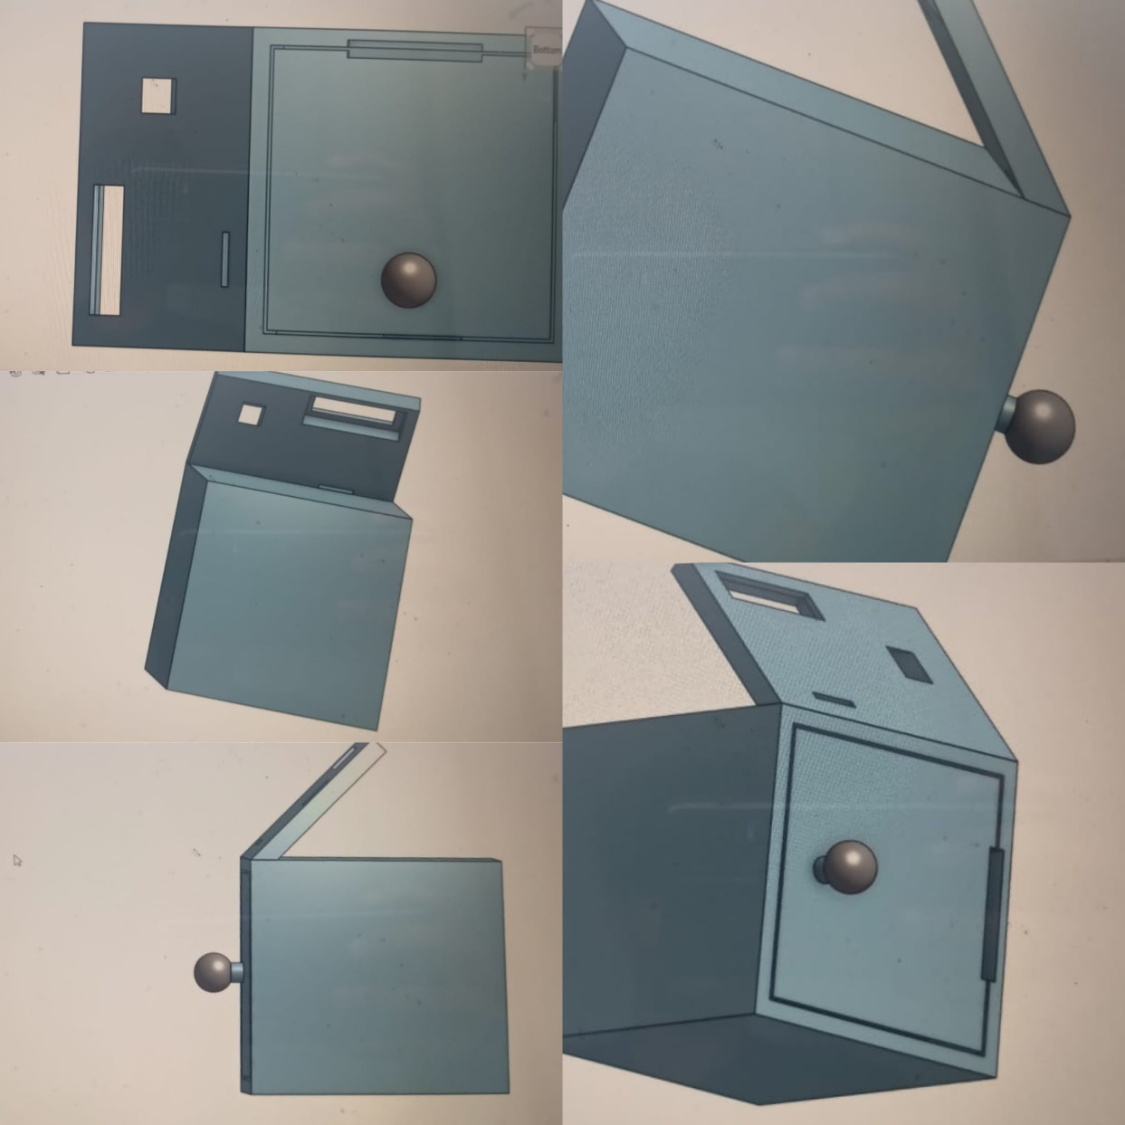

* + **Integrate all the above components using a bread board with the respective connections to adruino,fingerprint,servo,nodemcu,keypad using wires**

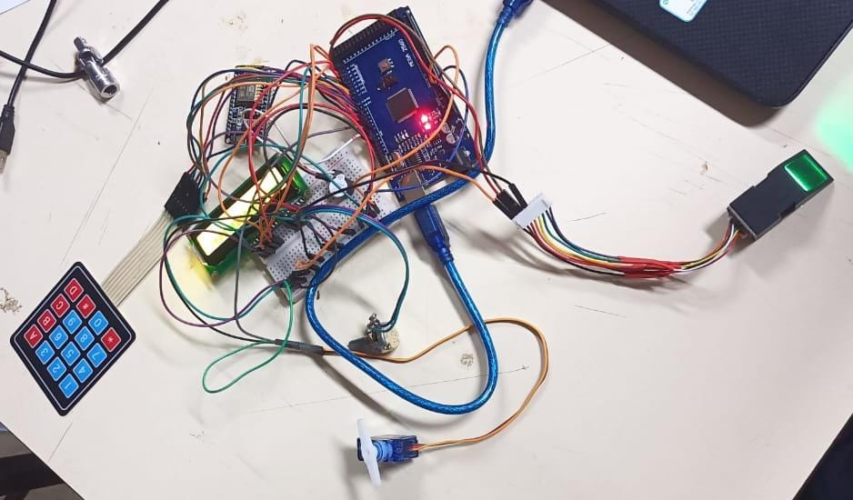

The above mechanism includes controlling servo motor with the keypad using correct password and by using verifed and accessible fingerprint both.

Using servo we can open or close the door to take the contents of the box.

The fingerprint sensor also records attendance of the user with time stamp and user ID if the user is enrolled in the module already.

Once the door is opened we can close it by using the ‘#’ key in the keypad directly according to our code and buzzer sounds occurs after every step of accessing the locker or attendance.

And if the the system fails due to some power issue or loose connections, then we can open the the locker using a physical key lock mechanism.

We have to place the lock such that the rim coming out after opening with the key should push the servo motor to 90 degrees and with this we should be able to open the door.