DAY-2

Installation of python: By two ways

1)www.anaconda.com:

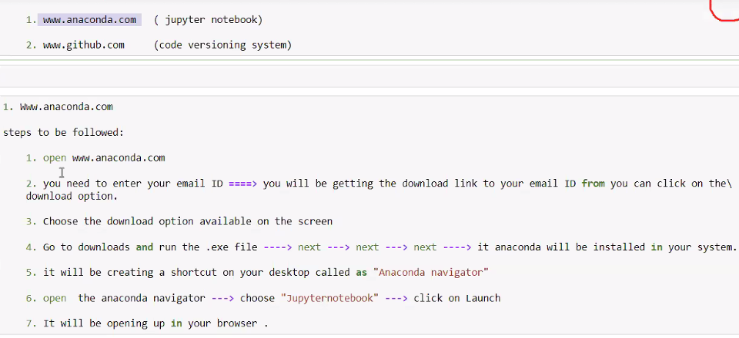  
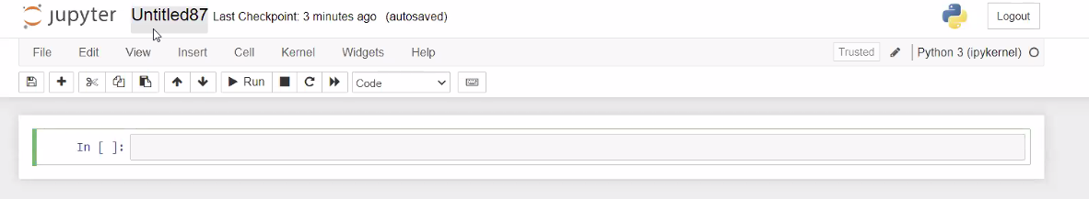

* There is a menu bar in the top(file,edit….)and the rectangular pink box is input cell.
* Every program starts with print(“hello world”)
* Shift+enter gives output.
* click + for more input lines.
* File---downloads----

2)[www.github.com](http://www.github.com): used for transferring the file from one to another:

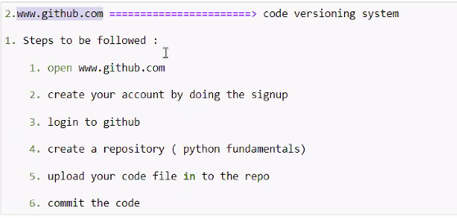

DAY-3

**Intro:**

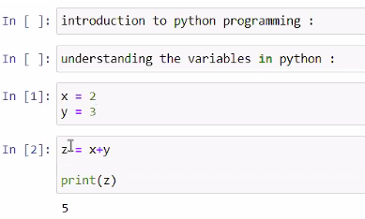

**Rules for giving a variable:**

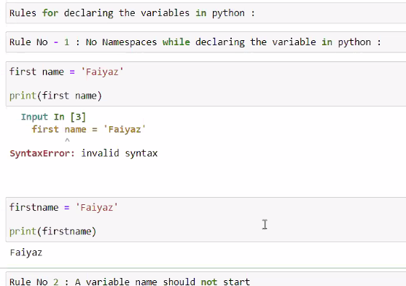

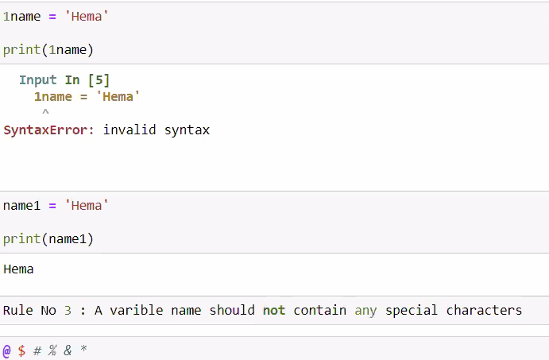

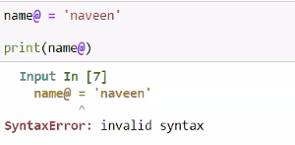

**Data Types in Python:**

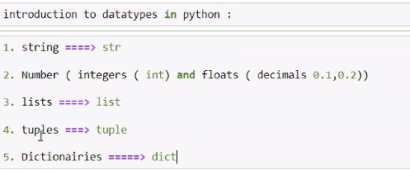

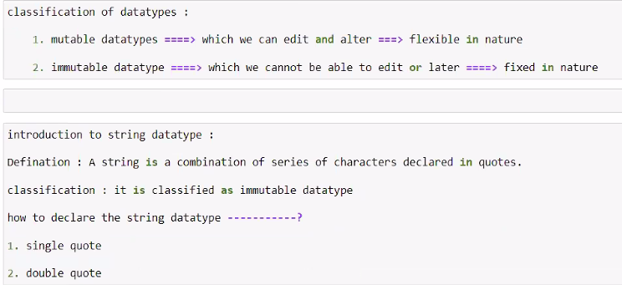

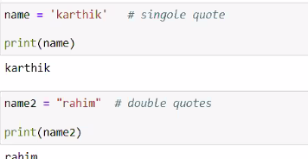

#Introduction to string methods:

Print(type(name)====🡺str

Print(type(name2)==== 🡺str

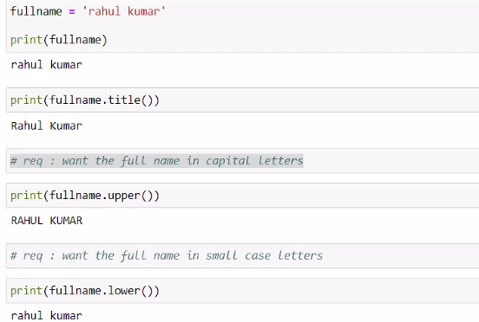

# is used for commenting lines.

**DAY-4:**

**#Introduction to f string: (keyword is f)**

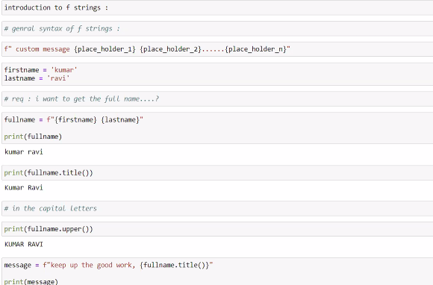



**#understandig the concept of delimiter:**

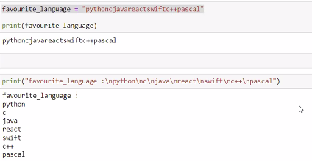

* /n is new line delimiter.

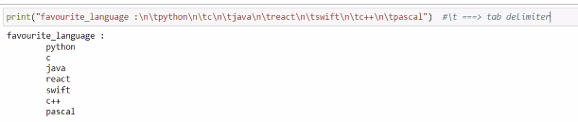

* /t is tab delimiter.
* /n/t is newline with tab delimiter.

**#Removing spaces using strips:**

Strips are of 3 types:

1)Left Strip: (keyword is lstrip) And this process is called Left Striping. This is used when you have space on left side.

2)Right Strip: (keyword is rstrip) And this process is called Right Striping. This is used when you have space on right side.

3)Strip: (keyword is strip) And this process is called Striping. This is useful when you don’t know where the space is.

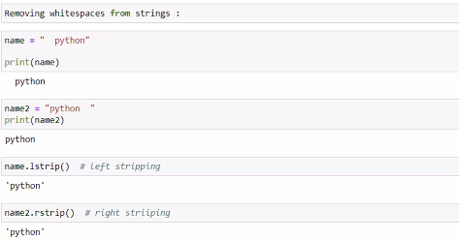

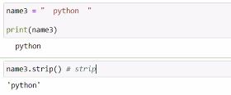

**#Zen of Python:** (By import this)

* 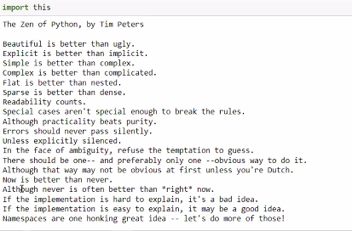
* Don’t worry about the errors.