Olist E-Commerce Analysis
This project documents the initial environment setup and data import process for the Olist Brazilian E-Commerce dataset. The objective of this phase is to prepare the dataset for analysis by creating a database in SQL Server and importing all CSV files into the database.
The Olist dataset represents a real-world Brazilian e-commerce marketplace and includes information about customers, orders, products, sellers, payments, reviews, and geolocation data.
The imported data will later be used for SQL – based analytical queries and dashboard development in Power BI.
Project Details
Field: Domain
Value: E-Commerce (Brazilian Marketplace)
Field: Dataset
Value: Olist Dataset (Kaggle)
Field: Database
Value: SQL Server Express
Field: Interface Tool
Value: SQL Server Management Studio (SSMS)
Field: Database Name
Value: olist_ecommerce
Phase
Phase 1 – Core Foundation
Status
Setup Completed Successfully

2. Dataset Description
The Olist E-Commerce dataset was downloaded from Kaggle. It contains multiple CSV files that represent different components of the marketplace ecosystem.
These datasets together simulate the structure of a real e-commerce platform and allow analysts to perform customer behavior analysis, revenue analysis, delivery performance analysis, and product performance evaluation.
Dataset Files
olist_customers_dataset
Contains customer identification, location details including city, state, and zip code.
olist_orders_dataset
Contains order status information along with purchase timestamp and delivery timestamps.
olist_order_items_dataset
Contains information about the products included in each order including price and freight value.
olist_order_payments_dataset
Contains payment details such as payment type, number of installments, and payment value.
olist_order_reviews_dataset
Contains customer review scores and review comments.
olist_products_dataset
Contains product attributes including product category and physical dimensions.
olist_sellers_dataset
Contains seller information including seller city, state, and zip code.
olist_geolocation_dataset
Contains geographic coordinates (latitude and longitude) associated with zip code prefixes.
product_category_name_translation
Provides translation of product category names from Portuguese to English.
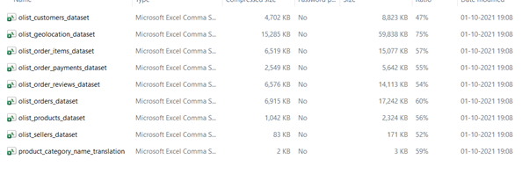

3. Database Creation
After downloading the dataset, the next step was to create a database in SQL Server Express to store the imported data.
SQL Server Management Studio (SSMS) was used to execute the SQL script and manage the database environment.
SQL Script Used
CREATE DATABASE olist_ecommerce;
GO
USE olist_ecommerce;
GO
The database was successfully created and appeared in the SSMS Object Explorer under the Databases section. The system returned the confirmation message Commands completed successfully.
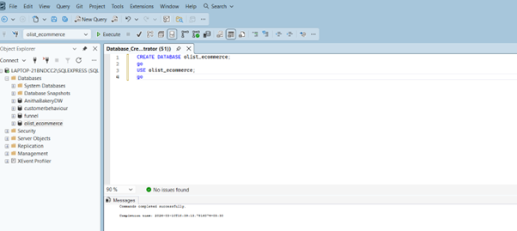

4. Importing CSV Files into SQL Server
Each CSV dataset file was imported into the SQL Server database using the Import Flat File Wizard in SSMS.
This wizard automatically detects column names and attempts to infer appropriate data types based on the CSV content.
Import Process
The following steps were followed for importing each dataset file:
- Right-click the database olist_ecommerce in Object Explorer
- Select Tasks → Import Flat File
- Browse and select the CSV dataset file
- Review the preview to verify column structure
- Confirm or adjust column data types if necessary
- Proceed through the wizard by clicking Next
- Click Finish to complete the import process
Once the import process completed, the wizard displayed the message:
Operation Complete – Insert Data: Success
This process was repeated for all nine dataset files.
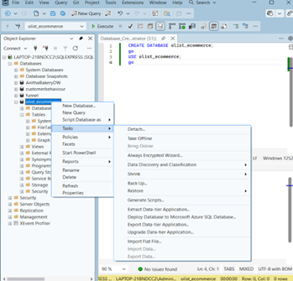

5. Database Schema Verification
After importing all tables, the database schema was reviewed to confirm that all datasets were successfully loaded.
The Entity Relationship Diagram (ERD) was examined to understand the relationships between the tables.
The orders table acts as the central table connecting several other tables in the database.
Key Table Relationships
orders.customer_id → customers.customer_id
order_items.order_id → orders.order_id
order_items.product_id → products.product_id
order_items.seller_id → sellers.seller_id
order_payments.order_id → orders.order_id
order_reviews.order_id → orders.order_id
These relationships enable complex SQL queries involving joins across multiple tables for deeper analysis.
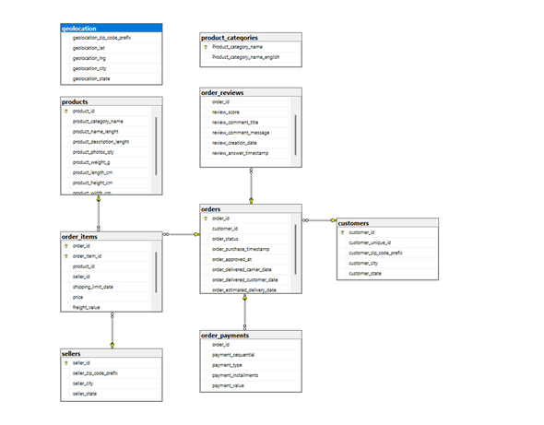

6. Summary
The initial environment setup for the Olist E-Commerce project has been successfully completed.
Tasks Completed
Downloaded the Olist dataset from Kaggle
Created the database olist_ecommerce in SQL Server
Imported all CSV files into SQL Server tables
Verified successful import for each dataset file
Reviewed the database schema and table relationships

7. Next Steps
The next phase of the project will focus on data analysis and insights generation using SQL queries.
Planned analysis tasks include:
Analyzing monthly and yearly order trends
Calculating total revenue by product category
Identifying top customers based on lifetime spending
Analyzing delivery performance and late delivery patterns
Writing advanced SQL queries using joins, window functions, and common table expressions
Developing a Power BI dashboard to visualize key business metrics and insights

