**Week – 7**

**9. cricketapp**  
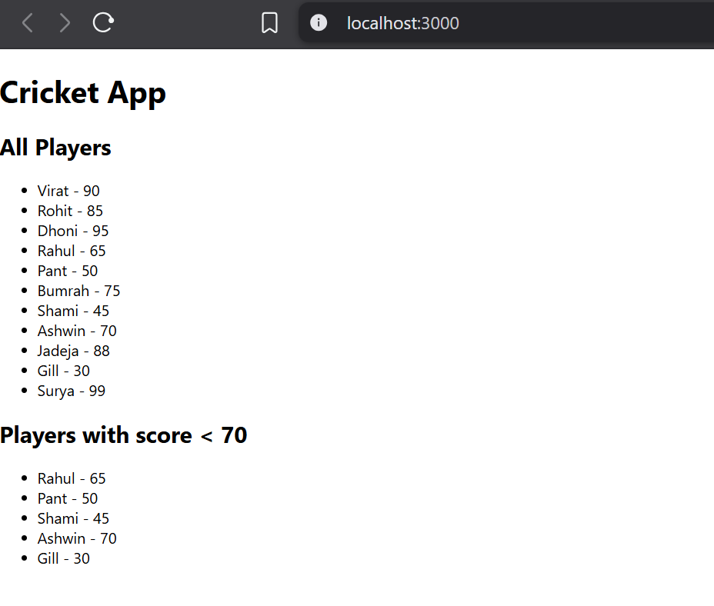  
  
**10.** **officespacerentalapp**

**

**12.** **ticketbookingapp**  
  
