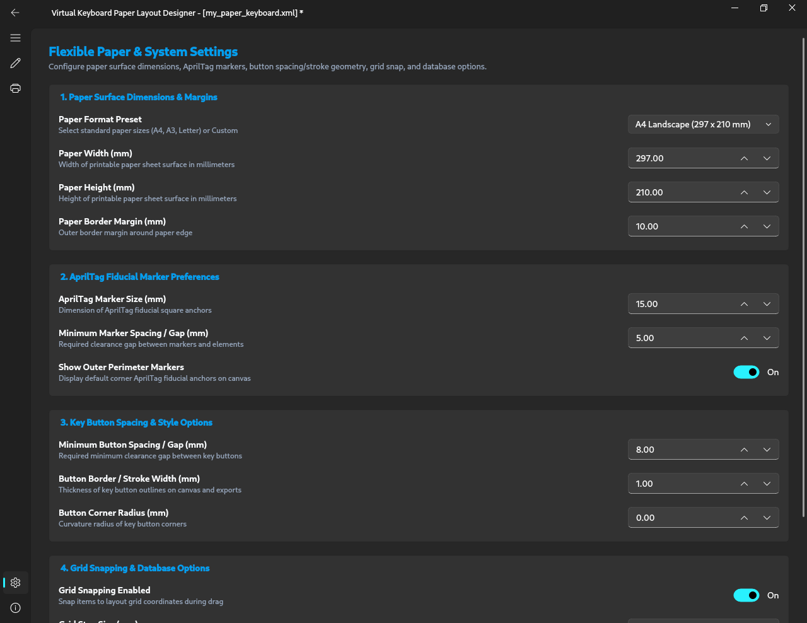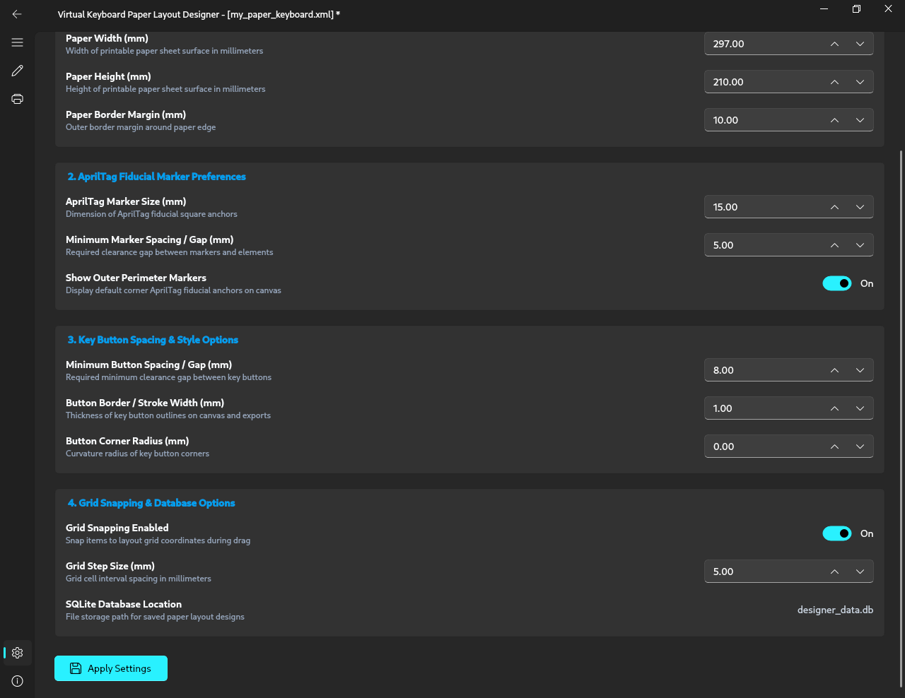
Figure B.4: Application 1 preference settings for canvas metrics and geometric constraints.

