CUSTOMIZABLE PAPER-BASED VIRTUAL MACRO KEYBOARD SYSTEM USING COMPUTER VISION AND DEEP LEARNING
A thesis submitted to NSBM Green University for the degree of
Bachelor of Science (Honours) in Computer Science
By
GANEPOLA ARACHCHIGE LAHIRU DILHARA
Department of Computer Science
Faculty of Computing
NSBM Green University
Sri Lanka
September 2026

Declaration
I declare that the content of this undergraduate thesis titled “Customizable Paper-Based Virtual Macro Keyboard System Using Computer Vision and Deep Learning” is my own work and this dissertation does not incorporate without acknowledgement any material previously submitted for any other degree in any university or institution of higher learning.
Signature
Name Date
Signature of the Supervisors
........................................................
Prof. Chaminda Wijesinghe
Principal Supervisor
Department of Computer Science,
NSBM Green University

Acknowledgement
First and foremost, I would like to express my sincere gratitude to my supervisor, Prof. Chaminda Wijesinghe, for his continuous guidance, encouragement, and invaluable feedback throughout this research project. His constructive critique and support have been instrumental in shaping both the theoretical direction and practical execution of this work.
I also extend my heartfelt appreciation to the academic staff and lecturers of the Faculty of Computing, Department of Computer Science at NSBM Green University, Sri Lanka, for providing the necessary academic environment, foundational knowledge, and technical facilities required to undertake this investigation.
Finally, I wish to express my deepest gratitude to my family and friends for their unwavering patience, encouragement, and understanding during the demanding phases of this dissertation.

Abstract
Physical computer keyboards are standard for general text entry, but dedicated macro controllers remain expensive, physically rigid, and difficult to customize. Prior vision-based virtual keyboards attempted to replace general typing keyboards, but struggled from the lack of tactile key travel, required costly depth sensors, relied on dedicated GPUs, or enforced artificial dwell-time pauses exceeding 500 ms to confirm touches. This research presents a customizable paper-based virtual macro keyboard system engineered for application shortcuts, command execution, and macro tasks, using strictly a single monocular RGB webcam and a commodity CPU without specialized hardware. Physical macro layouts are created using an interactive PySide6 designer and printed on normal paper with border AprilTag fiducial anchors, completely separating paper geometry from digital action semantics. The vision pipeline samples incoming video at 12 frames per second, extracts 21 skeletal hand landmarks via MediaPipe, and applies unitless hand-length scale normalization ($L_{\text{hand}}$). Kinematic temporal sliding windows of 5 frames with 2-frame overlap are classified across all five individual fingers simultaneously using a compact PyTorch LSTM model to detect surface contact deceleration instantaneously. Dynamic planar homography continuously updates coordinate transformations under camera perspective tilt. Experimental benchmarks confirm that the chosen LSTM model achieves a touch detection accuracy of 94.34% (F1-score 94.37%, precision 93.79%, recall 94.97%) with 2.08 ms inference latency on CPU, maintaining an end-to-end pipeline latency of 29.09 ms (34.4 frames per second). Functional testing validated a 100% pass rate across macro key dispatch test cases, providing an accessible, portable, and hygienic macro interface for digital audio, software editing, clinical environments, and assistive computing.

Table of Contents
Declaration ii
Acknowledgement iii
Abstract iv
Table of Contents v
List of Figures ix
List of Tables xi
List of Abbreviations xii
1 Introduction 1
1.1 Overview of the Chapter and Research Context 1
1.2 Problem Background 1
1.3 Problem Statement 2
1.3.1 Ideally 2
1.3.2 Reality 3
1.3.3 Consequences 4
1.3.4 Aim 4
1.4 Research Question 4
1.5 Research Motivation 5
1.6 Research Aim 6
1.7 Research Objectives Overview 6
1.8 Rich Picture of the Proposed Solution 6
1.9 Resource Requirements 8
1.9.1 Hardware Requirements 8
1.9.2 Software Requirements 8
1.10 Project Scope 9
1.10.1 In-Scope Technical Boundaries 10
1.10.2 Out-of-Scope Boundaries and Future Extensions 10
1.11 Summary of the Introduction and Research Framework 10
2 Objectives 11
2.1 General Objective 11
2.2 Specific Objectives 11
2.2.1 Objective 1: Theoretical Analysis and Baseline Requirements 11
2.2.2 Objective 2: Hand Kinematic Representation and Scale Normalization 11
2.2.3 Objective 3: Deep Learning Sequence Model Architecture Benchmark 12
2.2.4 Objective 4: System Architecture Engineering and Two-Application Suite Design 12
2.2.5 Objective 5: Empirical System Evaluation and Functional Benchmarking 12
3 Literature Review 13
3.1 Overview of the Chapter and Research Context 13
3.2 Conceptual Map of the Literature 14
3.2.1 Literature Search Strategy and PRISMA 2020 Systematic Protocol 15
3.3 Domain Overview 15
3.3.1 Evolution of Text Entry and Spatial HCI Hardware 15
3.3.2 Kinematic Typing Dynamics and Biomechanical Surface Impact 16
3.3.3 Ergonomics and Human Input Performance Metrics 16
3.3.4 Multi-Finger Tendon Coupling 17
3.4 Existing Systems and Sensing Modalities 17
3.4.1 Projection-Based and Infrared Sensor Systems 17
3.4.2 Shadow-Based Monocular RGB Keyboards 17
3.4.3 Hardware-Assisted Depth Sensors (RGB-D and ToF) 18
3.4.4 3D Mid-Air Typing and AR/VR Virtual Keyboards 18
3.4.5 Paper-Anchored Monocular RGB Keyboards 18
3.4.6 Specialized and Assistive Modalities 18
3.4.7 Fiducial Tracking in Planar Robotics 19
3.4.8 Comparative Literature Analysis Matrix 19
3.5 Technological Analysis 23
3.5.1 Hand Pose Estimation and Skeletal Joint Tracking 23
3.5.2 Kinematic Scale Normalization and Raw Feature Propagation 24
3.5.3 Planar Homography and Fiducial Tracking 25
3.5.4 Deep Sequential Touch Detection Models 25
3.5.5 System Architecture Sensing Trade-Offs 25
3.6 Reflection and Synthesis of Research Gaps 26
3.6.1 Synthesis of Prior Literature Limitations 26
3.6.2 Formal Research Gap Justification 27
3.7 Summary of the Literature and Research Foundations 27
4 Methodology 28
4.1 Chapter Overview 28
4.2 Research Framework and Scientific Methodology 28
4.2.1 Research Paradigm and Deductive Reasoning 28
4.2.2 Methodological Grounding via Saunders’ Research Onion 29
4.2.3 Design Science Research Methodology (DSRM) 30
4.2.4 Partitioned Development and Experimental Strategy 30
4.3 System Architecture and Software Design 31
4.4 Application 1: Layout Designer Suite 32
4.4.1 Key Geometry and Fiducial Anchor Positioning 33
4.4.2 Synchronized Export Engine 33
4.5 Data Collection and Kinematic Preprocessing Pipeline 34
4.5.1 Dataset Collection Protocol and Methodological Rigor 34
4.5.2 12 FPS Sub-Sampling and Single-Hand Tracking 35
4.5.3 Unitless Hand-Length Scale Normalization 36
4.5.4 Temporal Sliding Window Construction 37
4.5.5 CPU Time Budget for 12 FPS Real-Time Processing 37
4.6 Deep Learning Sequence Model Architecture 37
4.6.1 Multi-Finger Touch Contact Classification 37
4.6.2 PyTorch LSTM Sequence Classifier 38
4.7 Application 2: Runtime Virtual Keyboard Engine 38
4.7.1 Planar Homography Derivation 38
4.7.2 Fingertip Coordinate Transformation and Key Lookup 39
4.7.3 Action Multiplexing and Command Dispatch 39
4.8 Chapter Summary 39
5 Results 41
5.1 Chapter Overview 41
5.2 Test Plan and Structured Test Cases 41
5.2.1 Functional Testing Suite 41
5.2.2 Non-Functional Testing Suite 43
5.3 Structure of the Evaluation Workflow 44
5.4 Extensive Empirical Results and Architecture Review 45
5.4.1 Benchmark of deep learning sequence model architectures 45
5.4.2 Evaluation of MediaPipe landmark subsets and kinematic information content 47
5.4.3 Sensitivity analysis of length and stride of temporal window 50
5.4.4 Scale normalization ablation study over distance and users 50
5.4.5 Tilt sensitivity and accuracy of homography tracking against AprilTags 51
5.4.6 Real-time pipeline latency and resource profiling 52
5.4.7 Macro command trigger execution and multi-profile action benchmark 53
5.5 Summary of Testing Outcomes 54
6 Discussion and Conclusions 55
6.1 Overview of the Chapter and Main Takeaways 55
6.2 Verification and Triangulation of Project Objectives 55
6.2.1 Addressing core literature gaps and initial baseline needs 55
6.2.2 Validating hand kinematics and unitless scale invariance 55
6.2.3 Performance outcomes for deep learning touch detection 56
6.2.4 Evaluating the two-application software suite and custom layouts 56
6.2.5 End-to-end latency benchmarks and macro dispatch reliability 56
6.3 Practical Problems Encountered and Technical Solutions 57
6.3.1 Webcam frame rate instability and the 13 FPS hardware finding 58
6.3.2 Transition from freehand drawn paper to digital layout generation 58
6.3.3 Solving corner marker occlusion through coordinate projection 58
6.3.4 Eliminating hand transit false triggers and breaking the 82% accuracy plateau 58
6.3.5 Addressing anatomical finger coupling and providing interaction feedback 59
6.4 Self-Reflection 59
6.4.1 Evolution of my ideology during the project 59
6.4.2 Core technical skills and benefits gained 60
6.4.3 Key learning curves and practical takeaways 60
6.5 Business Insight of the Proposed Concept 61
6.5.1 What it could cost compared to existing products 61
6.5.2 Where this could work in the real world 61
6.6 Future Technical Improvements and Research Directions 62
6.7 Summary of the Study and Concluding Remarks 62
References 64
Appendix A: Physical Experimental Setup and Printable Layout Artifacts 69
A.1 Overview of the Physical Setup 69
A.2 Printable Vector Layout Artifact 70
Appendix B: Application 1: Paper Layout Designer Suite 72
B.1 Overview of the Designer Application 72
B.2 Interactive 2D Design Canvas and Property Inspector 72
B.3 Vector PDF Export and Print Dialog 73
B.4 Designer Preferences and Snap-Grid Configuration 74
B.5 Exported Paper Layout XML Data Structure 75
Appendix C: Application 2: Runtime Virtual Keyboard Engine and Live Tracking 79
C.1 Overview of the Runtime Engine 79
C.2 Action Rebinding and Profile Management 79
C.3 Live Camera Tracking in Idle and Contact States 80
C.4 Production Run Mode and Action Event Log 82
C.5 Runtime Engine Preferences and Detection Parameters 83
Appendix D: Ground-Truth Dataset Annotation Platform 85
D.1 Overview of the Annotation Suite 85
D.2 Frame-by-Frame Skeletal Annotation Interface 85
D.3 Rapid Keyboard Shortcuts for Annotation Efficiency 86
Appendix E: Empirical Model Benchmarking and Latency Profiling 88
E.1 Overview of Empirical Benchmark Charts 88
E.2 Model Architecture Accuracy versus CPU Latency 88
E.3 Per-Digit Touch Confusion Matrix 88
E.4 AprilTag Homography Tracking Under Perspective Tilt 89
E.5 Multi-Threaded Real-Time Pipeline Latency Breakdown 90

List of Figures
Page
Figure 1.1 Rich Picture of the Proposed Solution and Operational Pipeline Architecture. 7
Figure 3.1 Conceptual taxonomy and structural organization of the literature review. 14
Figure 3.2 MediaPipe 21 hand landmark anatomical topology. 24
Figure 4.1 Design Science Research Methodology (DSRM) execution framework. 30
Figure 4.2 System architecture framework connecting Application 1 and Application 2 workflows. 32
Figure 4.3 MediaPipe 21 hand landmarks topology and anatomical hand-length normalization. 36
Figure A.1 Physical experimental desk setup with monocular USB webcam mounted on an adjustable arm above the printed paper macro keyboard layout. 70
Figure A.2 Exported 300 DPI vector PDF layout embedded with AprilTag border fiducials ready for standard desktop paper printing. 71
Figure B.1 Application 1 startup window for project selection and template management. 72
Figure B.2 Application 1 interactive 2D design canvas with key layout tools, metric grid, property inspector, and AprilTag fiducial anchors. 73
Figure B.3 Application 1 export dialog for generating 300 DPI vector PDF layouts. 74
Figure B.4 Application 1 preference settings for canvas metrics and geometric constraints. 63
Figure C.1 Application 2 home screen for camera device selection and layout loading. 79
Figure C.2 Application 2 action rebinding interface for assigning keystrokes and shell commands to macro keys. 80
Figure C.3 Application 2 idle monitoring state showing detected AprilTags, homography alignment, and key bounding boxes. 81
Figure C.4 Application 2 live contact detection showing MediaPipe skeleton, 96% index touch probability, and highlighted key impact. 82
Figure C.5 Application 2 production run mode showing real-time multi-finger probability history, pipeline FPS, and action event log. 83
Figure C.6 Application 2 configuration settings for vision tracking and touch triggering. 71
Figure D.1 Dataset annotation tool home screen for video session management. 85
Figure D.2 Dataset annotator main interface showing 12 FPS frame navigation, MediaPipe skeleton overlay, and per-digit contact labeling. 86
Figure D.3 Keyboard shortcut dialog enabling rapid multi-finger ground truth tagging during video annotation. 87
Figure E.1 Comparison of Macro F1-score and CPU inference latency across evaluated deep learning model architecture families. 88
Figure E.2 Normalized confusion matrix of the PyTorch LSTM touch classifier across all five individual finger digits. 89
Figure E.3 AprilTag corner detection rate and RMS planar reprojection error across camera perspective tilt angles. 90
Figure E.4 End-to-end CPU execution latency breakdown per frame across the multi-threaded virtual keyboard pipeline. 90

List of Tables
Page
Table 1.1 System Project Scope Boundaries (In-Scope vs. Out-of-Scope) 9
Table 3.1 Comparative analysis of existing virtual keyboard frameworks and sensing methodologies. 19
Table 3.2 System architecture design trade-offs across sensing modalities. 25
Table 5.1 Structured functional test cases and validation results. 41
Table 5.2 Structured non-functional test cases and empirical validation results. 43
Table 5.3 Comparative performance evaluation of deep learning model architecture combinations. 45
Table 5.4 Per-digit touch classification performance metrics. 46
Table 5.5 Ablation evaluation of MediaPipe landmark subsets and kinematic feature representations. 48
Table 5.6 Sensitivity analysis of temporal window length and stride. 50
Table 5.7 Ablation evaluation of feature normalization across camera distances and hand sizes. 51
Table 5.8 AprilTag homography tracking accuracy under perspective camera tilt angles. 51
Table 5.9 Detailed execution latency breakdown per frame processing cycle. 52
Table 6.1 Research objective accomplishment and triangulation matrix. 57

List of Abbreviations
The following alphabetical reference list defines the primary acronyms, domain terminology, neural network architecture notations, and mathematical abbreviations used throughout this thesis:
Abbreviation | Full Definition / Description
1D CNN | One-Dimensional Convolutional Neural Network
1D ResNet | One-Dimensional Residual Neural Network
2D / 3D | Two-Dimensional / Three-Dimensional
API | Application Programming Interface
Attention | Self-Attention / Transformer Attention Mechanism
BCE | Binary Cross-Entropy Loss Function
BiLSTM | Bidirectional Long Short-Term Memory Recurrent Network
CAD | Computer-Aided Design
CLI | Command Line Interface
CNN | Convolutional Neural Network
CPU | Central Processing Unit
CRC | Class Responsibility Collaboration
CSV | Comma-Separated Values
DAW | Digital Audio Workstation
DL | Deep Learning
DLT | Direct Linear Transformation
DPI | Dots Per Inch
DSRM | Design Science Research Methodology
FN | False Negative
FP | False Positive
FPS | Frames Per Second
FR | Functional Requirement
GIL | Global Interpreter Lock (Python Runtime Concurrency)
GPU | Graphics Processing Unit
GUI | Graphical User Interface
HCI | Human-Computer Interaction
HRNet | High-Resolution Network
HW | Hardware
IDE | Integrated Development Environment
IEEE | Institute of Electrical and Electronics Engineers
IR | Infrared Sensing Spectrum
LLM | Large Language Model
LSTM | Long Short-Term Memory Recurrent Neural Network
MAE | Mean Absolute Error
MCP | Metacarpophalangeal Joint (Hand Skeleton Landmark 9)
ML | Machine Learning
MLP | Multi-Layer Perceptron
MSE | Mean Squared Error
MVC | Model-View-Controller Architectural Pattern
NFR | Non-Functional Requirement
NIST | National Institute of Standards and Technology
ONNX | Open Neural Network Exchange
OpenCV | Open Source Computer Vision Library
OS | Operating System
PC | Personal Computer
PDF | Portable Document Format
PIP | Proximal Interphalangeal Joint (Hand Anatomy)
POSIX | Portable Operating System Interface
QoS | Quality of Service
RAM | Random Access Memory
RGB | Red Green Blue (Additive Color Model)
RGB-D | Red Green Blue + Depth Sensor Modality
RMS / RMSE | Root Mean Square / Root Mean Square Error
ROI | Region of Interest
RQ | Research Question
SDK | Software Development Kit
SGD | Stochastic Gradient Descent
SSD | Solid-State Drive
SVD | Singular Value Decomposition
SVM | Support Vector Machine
TAM | Technology Acceptance Model
TN | True Negative
ToF | Time-of-Flight (Active Optical Depth Sensing)
TP | True Positive
UC | Use Case
UGC | University Grants Commission
UI | User Interface
USB | Universal Serial Bus
VR | Virtual Reality
XML | Extensible Markup Language

1 Introduction

1.1 Overview of the Chapter and Research Context
Remarkable developments have taken place in the field of Human-Computer Interaction (HCI). Although the use of mechanical keyboards in typing continuous prose is quite efficient, the current technological setting requires additional macro keypads and shortcut controls for various uses like hotkeys for developers, video editing keys, and audio keys [1], [2]. But the commercial macro controls available are quite expensive ($150 to $300), rigid, and tough to sanitize. However, the previous keyboard systems based on cameras could not replace conventional keyboard systems due to some shortcomings such as flat desks do not have any tactile switch travel resulting in high levels of fatigue [1].
In order to address the above problem, this project introduces a user-friendly paper-based virtual macro keyboard using a monocular webcam, AprilTag tracker, and PyTorch deep learning. The keyboard serves as an alternative to a shortcuts controller rather than as a universal keyboard for typing. The user designs their own layout using the dedicated software, and prints it on normal paper placed on the desk. Touching of all five fingers is detected in real-time with a PyTorch LSTM network without a GPU and with a latency of $29.09\text{ ms}$ using a normal commodity CPU. Moreover, the shape of the paper sheet does not depend on any activity performed on the computer; thus, one may use the same sheet of paper to design macro keyboards for video editing, programming, and audio mixing.
Section 1.2 reviews current hardware and vision systems, Section 1.3 formulates the problem through the IRCA framework, and Sections 1.4 to 1.11 detail research questions, motivations, and project scope.

1.2 Problem Background
In the modern age of computerized processes, the use of computers is much more advanced than the mere typing of texts into prose. Programmers, video editors, 3D animators, audio producers, and digital artists require certain key combinations and multi-step commands for efficient work. In order to avoid fatigue caused by pressing the same buttons repeatedly, professionals depend on macro controllers (like the Elgato Stream Deck and Loupedeck) that complement the main keyboard and mouse [1], [2].
Nonetheless, in the real world, there are severe practical and economic pain points associated with physical macro hardware:
- Financial Unfeasibility: The price of dedicated controllers reaches up to $150 to $300 and higher. It becomes financially difficult for students, freelance specialists, or independent developers to acquire these physical pads for various programs.
- Stiff Physical Layout: There is a fixed arrangement of plastic buttons that cannot be changed in any way when switching between different tasks like video editing and coding.
- Contamination and Sensitivity of Specialized Fields: One cannot use liquid antiseptics in sterile clinics, chemical laboratories, or cleanrooms because moisture damages electronic circuits, while electrical micro-sparks can ignite flammable fumes.
In order to deal with the challenges that existed in terms of the cost and flexibility of physical devices, the use of cameras for virtual keyboards was investigated [3], [4], [5], [6]. The main issue with earlier research was that it utilized virtual keyboards as a substitute for actual keyboards for typing. This was problematic because the stationary flat surface does not have mechanical key travel, and continuous typing on the virtual surface leads to finger exhaustion and mistakes [1].
Though there has always been an inherent benefit in using paper for macro controllers, it has never been easy to design a macro keypad out of paper utilizing a traditional monocular webcam. A monocular webcam cannot measure depth directly, shadow models fail to work when multiple fingers come close to the table [7], and previous visual systems have been either slow dwell models or expensive types that use GPUs and 3D depth cameras [8], [9]. It is therefore essential to design a practical paper-based macro controller that runs in real-time on standard commodity CPUs using a simple monocular webcam.

1.3 Problem Statement
The problem statement for this computing research uses the IRCA model (Ideal, Reality, Consequences, and Aim) as follows:

1.3.1 Ideally
It would be ideal for digital artists, programmers, and computer users to have the ability to take any flat surface on their desk and turn it into a customizable auxiliary macro keyboard without using specialized physical hardware. This is different from a mechanical keyboard used for typing continuous text; instead, this interface gives users access to on-demand macro palettes for shortcuts and system commands. The whole system should work with ordinary paper and a monocular RGB camera, running efficiently on a standard consumer-level processor without requiring GPUs, depth cameras, or additional electronics.

1.3.2 Reality
In reality, computer users are hindered by practical and algorithmic limitations:
- Costly and Stiff Hardware Components: Commercially available macro controllers cost approximately $150 to $300, rendering them expensive for students and individual makers [1].
- Misfitting Purpose of Prior Virtual Keyboards: Previous attempts tried to reproduce continuous typing keyboards, which caused typing errors and user fatigue on flat desks [1].
- One-Finger Tracking Limitation in Monocular Solutions: Universal monocular solutions track only one finger at a time [5], [6], [7], [10]. Shadow tracking fails when finger shadows overlap, while 2D tracking cannot distinguish depth without 3D depth sensors.
- Latency and GPU Dependence: Computer vision systems often need dedicated GPU computing or experience significant delays on commodity CPUs [6], [11].
- Artificial Dwell Periods: Webcams without depth perception required users to pause their finger for 500 to 1000 ms to register a keystroke [5], [12].
- Environmental Sensitivity: Shadow and skin-color detection methods break down under diffuse lighting, soft ambient shadows, or across diverse skin tones [7], [13].
- Fixed Camera Alignment and Paper Movement: Earlier setups required rigidly mounted overhead cameras; any paper displacement caused complete calibration misalignment [14], [15].
- Fixed Layouts: Most previous virtual keyboards used hardcoded QWERTY layouts without software action multiplexing [1].

1.3.3 Consequences
Therefore, the dilemma for digital artists, programmers, and students is choosing between two unfavorable alternatives: spending $150 to $300 on hardware macro controllers that are inflexible, or putting up with the drawbacks of earlier vision keyboards that had slow dwell times and single-finger limits. Furthermore, sterile and hazardous environments are left without safe, wipeable input solutions.

1.3.4 Aim
To solve this problem, the research focuses on developing a paper-based virtual macro keyboard for application shortcuts, command execution, and macros. The virtual macro keyboard acts as an auxiliary controller instead of a continuous typing keyboard. It uses 21-joint MediaPipe skeletal tracking, unitless hand-length scale normalization ($L_{\text{hand}}$), lightweight PyTorch LSTM sequence classification, and AprilTag planar homography tracking ($H$) to enable real-time ($29.09\text{ ms}$), multi-finger macro interactions on commodity CPUs.

1.4 Research Question
To address these technical challenges, the primary research question is formulated as follows:
It is an open research question how a monocular computer vision framework using only a regular RGB camera and plain printed paper can enable accurate, fast, and personalized virtual macro keyboard interaction on flat surfaces, allowing users to define custom shortcuts and trigger actions from a single printed layout executing entirely on standard commodity CPUs without dedicated GPUs or specialized hardware.
This primary question is addressed through five secondary research questions (Sub-RQs):
- Sub-RQ 1 (Fiducial Marker Selection and Planar Homography Tracking): Among available visual fiducial markers (AprilTag, ArUco, ARTag, STag), which fiducial marker provides the highest planar homography accuracy and lowest corner jitter under perspective tilt and low camera resolution, while maintaining layout tracking when markers are partially occluded?
- Sub-RQ 2 (Landmark Subsets and Kinematic Representation): Which combination of the 21 MediaPipe hand joints and unitless hand-length scale normalization ($L_{\text{hand}}$) methods makes finger touches most discriminable when joint velocities are included without temporal smoothing delays?
- Sub-RQ 3 (Deep Learning Sequence Architecture Optimization): How can we achieve optimal classification accuracy (F1-score) using lightweight neural network models (comparing 1D CNN, Attention, ResNet, BiLSTM, and LSTM) operating with an inference latency under 3 ms on a commodity CPU?
- Sub-RQ 4 (Temporal Windowing and CPU Synchronization): What temporal sliding window size, stride, and sampling rate capture deceleration impact dynamics reliably at 12 FPS on consumer CPUs without a GPU?
- Sub-RQ 5 (Layout Decoupling and Action Multiplexing): How can the physical geometry of the printed layout be decoupled from software semantics to allow dynamic binding of multiple action profiles to the same printed paper sheet without reprinting?

1.5 Research Motivation
Several practical considerations motivate this research:
- Affordable Hardware for Macro Pads: Commercial macro pads like streaming controllers and editing boards are expensive. Using plain paper, regular webcams, and standard CPUs makes custom macro input affordable for coding, media editing, and office workflows [5], [16].
- Flexible and Configurable Macro Keypad: Users can create custom keypad layouts that trigger application hotkeys, numeric inputs, and commands on a single printed sheet, switching software profiles without reprinting.
- Multi-Finger Interaction with Single-Hand Optimization: Whereas earlier monocular vision keyboards restricted users to single-finger tracking, this system supports multi-finger interaction across all five fingers (thumb, index, middle, ring, pinky), optimized for single-handed auxiliary operation alongside a mouse or primary keyboard.
- Hardware Independence on Commodity CPUs: Real-time processing on standard CPUs enables the system to run on entry-level computers without dedicated GPUs.
- Hygienic and Disposable Interfaces: Paper interfaces tracked with AprilTags allow easy replacement and disposal after use, providing a clean input device for medical clinics, workshops, and chemical laboratories [1].
- Lightweight CPU-Based Deep Learning: Using a compact PyTorch LSTM sequence model to classify impact dynamics on commodity CPUs provides a strong architectural pattern for real-time edge vision systems [17], [18], [19].

1.6 Research Aim
The ultimate goal of this research is to design, implement, and evaluate an inexpensive and flexible paper-based virtual macro keyboard for application shortcuts, command execution, and macro workflows. Rather than replacing the primary keyboard, this system serves as an auxiliary controller allowing users to create their own layouts on paper and bind multiple software profiles to the same printed sheet. The entire pipeline operates in real time using a standard commodity CPU and a simple monocular RGB camera without requiring specialized hardware or dedicated GPUs.

1.7 Research Objectives Overview
In order to accomplish this goal, the research work is structured into five specific research and engineering objectives. In accordance with university thesis guidelines, these general and specific objectives are detailed in Chapter 2.

1.8 Rich Picture of the Proposed Solution
The architecture of the complete system is illustrated in Figure 1.1, which includes both an offline layout design stage and an online runtime execution pipeline.
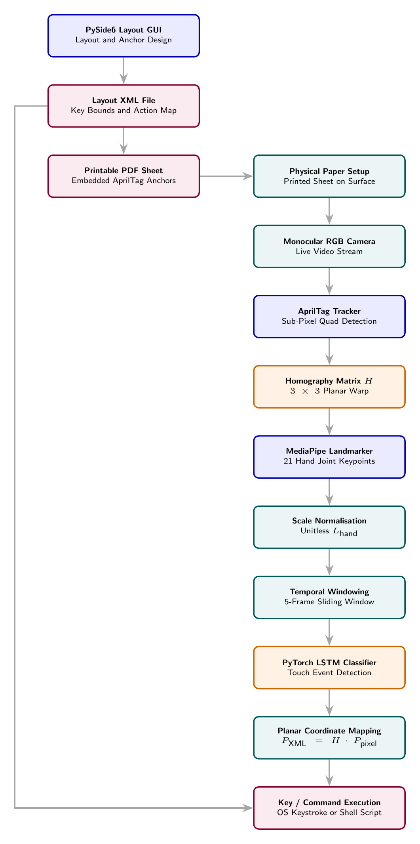
Figure 1.1: Rich Picture of the Proposed Solution and Operational Pipeline Architecture.
The pipeline executes through seven operational steps:
- Layout Design and Export: The user configures key boundaries and assigns actions through PySide6, generating a synchronized XML layout file and print-ready AprilTag PDF file.
- Physical Setup: The printed layout on plain paper is placed on a desk and monitored by a regular RGB webcam (see setup photographs in Appendix [ch:appendix_physical_setup]).
- AprilTag Tracking and Homography: Corner fiducials are tracked to compute planar homography matrix $H$, mapping image pixels to layout coordinates [14], [15].
- Hand Tracking and Normalization: MediaPipe extracts 21 hand landmarks, scale-normalized by unitless hand length ($L_{\text{hand}}$) without temporal smoothing [18].
- Temporal Windowing: Normalized coordinates and velocities form 5-frame sliding windows with 2-frame overlap at 12 FPS [20].
- CPU LSTM Touch Detection: A lightweight PyTorch LSTM network evaluates each 5-frame window on the CPU, classifying touch probabilities across all five fingers [17], [19].
- Coordinate Mapping and Execution: Confirmed fingertip touch coordinates map via $H$ into XML coordinates ($P_{\text{XML}}=H⋅P_{\text{pixel}}$) to execute key presses or scripts.

1.9 Resource Requirements

1.9.1 Hardware Requirements
- Camera Sensor: A standard USB camera or laptop webcam with regular resolution (360p, 480p, 720p). No specialized depth sensor is needed.
- Host Computer: A standard commodity PC or laptop (equipped with quad-core x86_64 or ARM processor and 4 GB RAM).
- Graphics Hardware: No dedicated GPU is required; runtime inference executes entirely on a commodity CPU.
- Physical Media: Standard desktop printer using plain A4 or US Letter paper.

1.9.2 Software Requirements
- Operating System: Linux (Ubuntu 22.04/24.04), macOS, or Windows 11.
- Runtime Environment: Python 3.10+ managed with the uv package manager.
- GUI Framework: PySide6 (Qt for Python) for the Layout Designer application.
- Computer Vision: OpenCV and Pupil AprilTag for real-time frame processing and fiducial tracking.
- Pose Estimation: Google MediaPipe Hand Landmarker for 21-joint skeletal extraction.
- Deep Learning: PyTorch for LSTM sequence model training and CPU runtime inference.

1.10 Project Scope
Table 1.1 summarizes the technical boundaries of this research.
Table 1.1: System Project Scope Boundaries (In-Scope vs. Out-of-Scope)
In-Scope System Elements | Out-of-Scope System Elements
Paper-based virtual macro keyboard for shortcuts, command execution, and macro tasks. | Direct replacement for general-purpose high-speed continuous prose typing keyboards.
Single standard monocular RGB camera (USB or laptop webcam) operating at 12 FPS. | Depth cameras, Time-of-Flight sensors, infrared illuminators, or stereo camera rigs.
Single active hand tracking with 21 landmarks, evaluating independent touch across all five fingers. | Bimanual (two-handed) typing, deferred to future work to avoid tag occlusion on A4 paper.
Plain paper with four border AprilTag anchors printed via desktop printer (A4 or Letter). | Active capacitive overlays, conductive ink, wired panels, or electronic components.
Real-time CPU inference on commodity processors without requiring dedicated GPUs. | High-end GPU workstations or cloud-based inference servers.
PySide6 application for custom layouts, XML maps, and printable PDFs. | Mobile operating system apps (Android/iOS) or browser extensions.
AprilTag fiducial tracking with $3×3$ planar homography under perspective tilt. | Non-planar or curved 3D surfaces (such as cylinders or spheres).
Unitless hand-length scale normalization ($L_{\text{hand}}$) with direct feature propagation. | Biomechanical muscle force modeling or finger joint pressure estimation.
Compact PyTorch LSTM sequence classifier using 5-frame sliding windows on CPU. | Large language model auto-correction or continuous text prediction engines.
Real-time keystroke dispatch, shortcut hotkeys, shell scripts, and XML key lookup. | Multi-user simultaneous input on a single paper sheet.

1.10.1 In-Scope Technical Boundaries
As detailed in Table 1.1, the system operates using a standard webcam and plain printed paper without specialized sensors [10], [16]. It detects independent touch contact across all five fingers with $29.09\text{ ms}$ CPU latency for flat-surface, single-hand interaction. Application 1 separates physical geometry from actions, allowing one printed sheet to bind to multiple profiles [21]. AprilTag tracking compensates for tilt [14], [22], using unitless ($L_{\text{hand}}$) normalized landmarks at 12 FPS and PyTorch LSTM sequence classification on commodity CPU [18], [19].

1.10.2 Out-of-Scope Boundaries and Future Extensions
Continuous prose typing is out of scope due to the lack of physical tactile travel on flat paper. Specialized hardware (ToF depth cameras, stereo pairs, infrared projectors, and wearable gloves) is excluded [8], [9]. Non-planar surfaces, two-handed bimanual typing, multi-user interaction, force sensing, and language model auto-correction remain deferred to future work.

1.11 Summary of the Introduction and Research Framework
The context of the problem, the IRCA problem statement approach, research questions, practical motivation, system workflow, resource needs, and the project scope have been covered in this chapter. With the help of a single monocular camera, common paper prints with AprilTag markers, and lightweight deep learning on a consumer-grade CPU, the proposed framework tackles several obstacles in accessible computer interaction. Formal research objectives are presented in Chapter 2.

2 Objectives

2.1 General Objective
The primary objective of the entire research project is the design, development, and testing of a customizable virtual macro keyboard implemented using a standard monocular RGB camera and deep learning. The system is intended to act as a complementing tool for macros and commands, but not as a full-fledged replacement for regular continuous typing keyboards. Using this setup, users have the ability to create their own macro layout on regular paper and bind all manner of actions such as application hotkeys, media control actions, and system shell scripts to a single physical piece of paper that is then executed on regular commodity processors in real time without any need for GPUs, depth cameras, or specialized hardware accessories.

2.2 Specific Objectives
In order to achieve the overall objective of research, the research is divided into the following specific objectives of research and engineering:

2.2.1 Objective 1: Theoretical Analysis and Baseline Requirements
To critically evaluate and analyze visual input methods, tracking techniques using fiducial markers, planar homography techniques, and hand pose estimation models to determine the technical prerequisites needed for monocular macro touch detection on printed flat paper without the need for any specialized depth sensors, infrared illuminators, or fixed camera mounts.

2.2.2 Objective 2: Hand Kinematic Representation and Scale Normalization
To analyze the kinematics of human hand joints while undergoing macro touch interaction, develop an invariant unitless hand length scaling normalization technique ($L_{\text{hand}}$) independent of distance from the camera and resolution of the image frame, and establish a standard 12 FPS sliding temporal windowing process (5 frames with 2 frames of overlap) that preserves impact deceleration dynamics without introducing low-pass temporal filtering delays.

2.2.3 Objective 3: Deep Learning Sequence Model Architecture Benchmark
To benchmark, train, and optimize lightweight deep learning sequence models (comparing 1D CNN, Attention, ResNet, BiLSTM, and LSTM) to classify independent touch contact of all five fingers using multi-finger macro touches by choosing the best neural network model that works under 3 ms on a standard commodity CPU while achieving high touch detection precision and recall across all five fingers.

2.2.4 Objective 4: System Architecture Engineering and Two-Application Suite Design
To design and implement a comprehensive software package for two applications macro keyboard:
- Application 1 (Layout Designer Suite): A graphically interactive application programmed using PySide6 which helps in the designation of macro key borders, placing border AprilTag fiducial anchors on the layout, and exporting XML definitions of layouts along with printable vector PDF files.
- Application 2 (Runtime Virtual Keyboard Engine): An interactive GUI for configuring actions and a runtime vision engine which uses tracking of AprilTags to compute planar homography matrix $H$, extracts normalized skeletal landmarks using MediaPipe, classifies finger touch events using the PyTorch sequence model running on CPU, and dispatches mapped application shortcuts, hotkeys, or system shell commands.

2.2.5 Objective 5: Empirical System Evaluation and Functional Benchmarking
To experimentally measure the full virtual macro keyboard pipeline performance in terms of touch recognition classification accuracy (precision, recall, and F1-score), planar homography performance under perspective tilt and partial tag occlusion, end-to-end CPU execution latency using generic commodity hardware, and macro command invocation accuracy via functional test cases FT-01 to FT-10.

3 Literature Review

3.1 Overview of the Chapter and Research Context
When I started doing research on input interfaces, I came to understand that most human-computer interactions still make use of key switches. The use of physical keyboards provides reliable tactile feedback for typing prose, but modern software and creative jobs need macro keypads and shortcut consoles [1], [2]. These include video editing consoles and developer launching pads. But commercially available hardware macro pads cost from $100 to $300, are not customizable in any way physically, and it is hard to maintain hygiene in them. This led researchers to look into the possibility of using virtual keyboards on flat surfaces by making use of computer vision [3], [4], [5], [23]. Although most early attempts have been made to create alternatives for continuous typing on paper, it was physically difficult to type on paper continuously without any tactile switch travel. For customizable macro controllers, paper works much better because users only glance at and tap individual shortcut buttons.
There were four huge challenges to getting a monocular paper virtual keyboard to work well:
- Surface Touch Detection Without Depth Sensors: With standard 2D webcams it is impossible to measure depth in the Z-axis, making it difficult to differentiate between a real paper touch and a hovering finger [7], [8], [10], [24].
- Hand Scale and Perspective Variations: Hand landmark coordinates vary according to different hand sizes and distances from the lens [18], [21]. Normalizing coordinates is needed without adding lag from heavy smoothing filters [25].
- Planar Orientation and Camera Tilt: The perspective effect on the desk surface that comes from tilting the camera means we need to compute a planar homography matrix ($H∈R^{3×3}$) so as to keep key bounds aligned continuously [14], [15], [26].
- Decoupled Layout Design and Action Multiplexing: Older systems hardcoded QWERTY layouts rather than allowing users to pair various software action profiles with one printed sheet [1].
In order to lay a sound foundation, this chapter analyzes the current literature across four main categories. Firstly, I define the literature framework and searching methodology. Secondly, I discuss the evolution of input devices and the biomechanical aspects of finger strikes. Thirdly, I conduct a comparative analysis of existing virtual keyboards from eight different sensing mechanisms and analyze their drawbacks. Lastly, I examine the mathematical and algorithmic aspects of MediaPipe hand tracking, scale normalization, AprilTag homography, and PyTorch LSTM touch detection, leading to the research gaps that motivate this thesis.

3.2 Conceptual Map of the Literature
In Figure 3.1, I plotted the literature against four primary pillars: HCI input approaches, sensing types, technical algorithms, and synthesis of research gaps.
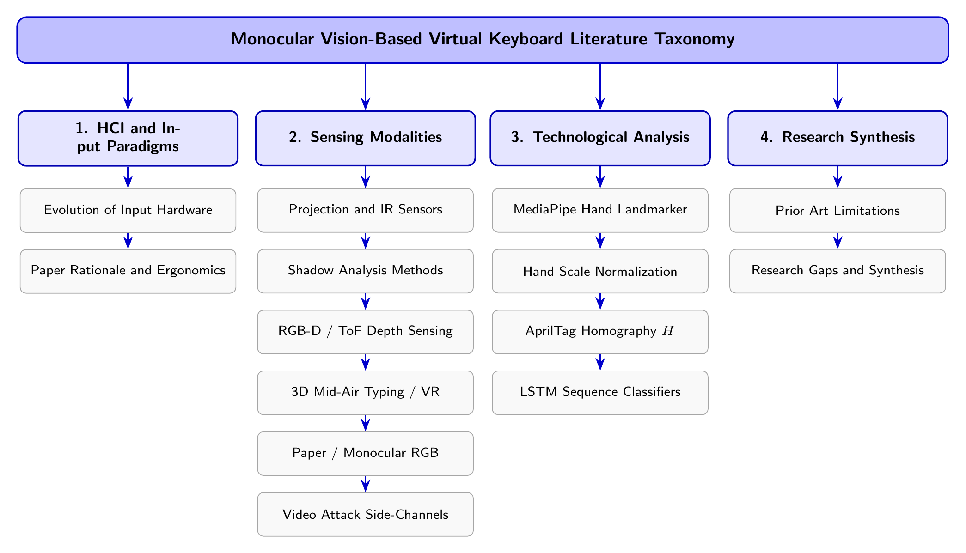
Figure 3.1: Conceptual taxonomy and structural organization of the literature review.
The review is structured across four main themes:
- HCI and Input Paradigms (Section 3.3): Evolution of input hardware, biomechanics of finger-surface impact, and user performance metrics.
- Sensing Modalities (Section 3.4): Critical evaluation of eight sensing technologies, synthesized in Table 3.1.
- Technological Analysis (Section 3.5): Mathematical formulation and algorithmic analysis of hand tracking, scale normalization, fiducial homography, and deep learning touch detection.
- Research Synthesis (Section 3.6): Identification of the six fundamental literature gaps and the formal research problem statement.

3.2.1 Literature Search Strategy and PRISMA 2020 Systematic Protocol
For the systematic review process, I applied the PRISMA 2020 protocol through IEEE Xplore, ACM Digital Library, Scopus, Elsevier ScienceDirect, and Google Scholar to find peer-reviewed studies from 2000 to 2025 [1]:
- Search Syntax: I searched with queries containing: ("virtual keyboard" OR "paper keyboard") AND ("monocular RGB" OR "MediaPipe") AND ("touch detection" OR "homography").
- Inclusion Criteria: I added peer-reviewed papers that showed functioning virtual keyboards, planar contact algorithms, fiducial tracking with tilt, or real-time hand joint estimation.
- Exclusion Criteria: I removed papers that required wearable sensor gloves, intrusive markers, multi-camera motion capture rigs, or were only conceptual white papers without implementation.
- Synthesis Approach: The shortlisted papers were then compared on the basis of sensing approaches, multi-finger support, compute latency, and environmental robustness to identify the problem areas this project addresses.

3.3 Domain Overview

3.3.1 Evolution of Text Entry and Spatial HCI Hardware
Considering the evolution of text input, early mechanical keyboards used physical switches that provided key travel with strong tactile feedback [1]. Next came membrane keyboards, where production became cheaper, and capacitive touchscreens that offered soft visual key layouts without physical tactile edges [1]. Optical laser keyboards projected the outline of keys using infrared light [9], [27]; however, these could not work reliably in bright environments as ambient light would wash out the pattern. Nowadays, entering complex command sequences can be done by dedicated macro pads (such as the Stream Deck), which enable users to trigger multi-key shortcuts with one keypress. However, such devices are expensive (usually priced from $100 up to $300) while being non-modifiable physically. Monocular computer vision allows us to track 21 hand joints using only a standard webcam [18], [19], which means we can use a printed piece of paper as an inexpensive, customizable macro pad without active electronics.

3.3.2 Kinematic Typing Dynamics and Biomechanical Surface Impact
Without a depth sensor, I needed to understand the physical characteristics of a finger as it makes contact with a flat desk in order to identify touch events [20], [28], [29]. A physical keystroke consists of four kinematic phases:
- Approaching Phase ($t_{1}$ to $t_{2}$): The finger moves downward at increasing vertical speed towards the target button ($V_{y}$).
- Impact Phase ($t_{2}$ to $t_{3}$): When encountering the rigid paper surface, downward velocity is zeroed in 20 to 40 ms ($V_{y}→0$), producing a steep deceleration spike ($A_{y}=\frac{dV_{y}}{dt}≪0$).
- Resting Phase ($t_{3}$ to $t_{4}$): The finger pauses briefly on the paper while the touch event registers.
- Recoil Phase ($t_{4}$ to $t_{5}$): The finger rebounds upward away from the desk surface ($V_{y}>0$).
The rigid desk acts as a hard physical boundary, providing immediate deceleration of motion. Conversely, fingers tend to overshoot in mid-air typing systems, as there is no stopping surface [23], [30].

3.3.3 Ergonomics and Human Input Performance Metrics
Input performance by humans has a direct correlation with physical feedback and movement dynamics:
- Tactile Key Travel versus Discrete Visual Targeting: With a mechanical keyboard, a depth of keystroke between $2\text{ to }4\text{ mm}$ allows fast blind touch-typing without needing to see the keys. On flat paper, typing continuous prose creates strain on fingers since there is no mechanical key travel [1]. For macro keypads, people do not type continuous prose; rather, they look for a particular button and press it once. The presence of custom button sizes on paper layouts directly improves ergonomics.
- Discrete Macro Action Rate versus Continuous Typing Speed: Traditional typing tests measure input speed in Words Per Minute based on continuous character sequences. In contrast, for macro keypads, touch accuracy and reduced latency are the critical performance metrics rather than continuous typing speed.
- Keystrokes Per Character (KSPC): Efficiency is measured by Keystrokes Per Character. Physical keyboards generally register about 1.05 KSPC, while contactless mid-air keyboards have more than 1.30 KSPC owing to accidental touches [30].
- Fitts’ Law: Fitts’ Law models how long it takes to reach a target button of width $W$ at distance $D$ through the Index of Difficulty ($ID$) in bits:
- The customizable paper macro keyboard enables one to customize the button width $W$ in the software designer, directly reducing the Index of Difficulty for rapid shortcut selection.

3.3.4 Multi-Finger Tendon Coupling
Anatomical tendon coupling in the human hand is another biological factor [20], [29]. Shared muscle pathways are found in the flexor and extensor tendons of the middle, ring, and pinky fingers. For example, when someone presses down with one finger, the fingers next to it involuntarily twitch downward. These minor twitches are confused for intentional key presses by basic single-finger tracking algorithms [4], [7]. Deep sequence models address this by tracking combinations of movement from all 21 hand joints over time to differentiate intentional taps from passive tendon twitches.

3.4 Existing Systems and Sensing Modalities
Reviewing previous systems of virtual keyboards, one may note that eight different sensing modalities have been explored.

3.4.1 Projection-Based and Infrared Sensor Systems
Projection keyboards use a red laser grid placed on the table surface and sense finger presence as an invisible infrared beam is broken [9], [27]. Kudale and Wanjale [9] implemented an infrared camera tracking reflective markers using four-point homography. However, the ambient light of the room destroys the pattern through wash-out and makes changing the key arrangement impossible.

3.4.2 Shadow-Based Monocular RGB Keyboards
Monocular RGB shadow sensors calculate the distance between the fingertip and its cast shadow, which reaches zero upon physical contact [7], [10], [13]. Posner et al. [10] applied adaptive shadow thresholding for paper contact detection. However, shadow analysis fails under diffuse lighting, multiple light sources, or dark desk surfaces [13]. Crucially, shadow methods completely fail when several fingers move simultaneously because their shadows overlap and merge.

3.4.3 Hardware-Assisted Depth Sensors (RGB-D and ToF)
Depth sensors like Microsoft Kinect, Intel RealSense, and Time-of-Flight cameras create metric 3D point clouds [8], [24]. Lee and Kwon [8] calibrated a flat surface to detect touches when fingertip point clouds crossed a distance threshold. Toshpulatov et al. [24] combined 3D depth information and optical flow to filter out hovering artifacts. However, depth cameras are costly, power-hungry, prone to noise close to flat surfaces, and require dedicated GPUs to process in real-time.

3.4.4 3D Mid-Air Typing and AR/VR Virtual Keyboards
Spatial computing headsets have spurred interest in mid-air keyboards [2], [11], [30], [31]. Enkhbat et al. [11] introduced HandKey, detecting typing within 3D bounding cubes. Lee et al. [2] tracked two-handed mid-air typing for head-mounted displays. However, mid-air typing lacks a physical desk surface where fingers stop; therefore, users experience high levels of arm fatigue and overshoot target keys [23], [30].

3.4.5 Paper-Anchored Monocular RGB Keyboards
Monocular paper keyboards employ standard webcams to interact virtually with printed paper sheets [3], [4], [5], [23]. Zhang et al. [3] tracked page corners to compute planar homography. Vertical velocity thresholds of pixels were employed by Srivastava and Tripathi [4], while a printed QWERTY sheet was tracked by Khare [5] employing skin-color segmentation. TypeNet [23] enabled typing on uncalibrated surfaces with deep keypoint tracking. However, all prior monocular paper keyboards were limited in that they detected the movement of only one finger at a time.

3.4.6 Specialized and Assistive Modalities
Additional forms of sensing involve VLC photodiodes [32], fingernail color-based blood volume imaging [33], optical motion capture [28], [29], and gaze tracking [12]. Gaze tracking assists people with motor disabilities, although the Midas Touch effect causes unintended key clicks while stopping to read [12].

3.4.7 Fiducial Tracking in Planar Robotics
With regard to tracking technology, planar robotics research proves that square fiducial markers like AprilTag and ArUco offer sub-pixel tracking accuracy even when the camera is tilted severely [34], [35], [36], [37]. Ivacko et al. [34] utilized ArUco markers for mapping robot coordinate frames, while Garrido-Jurado et al. [37] realized high frame rate contour scanning.

3.4.8 Comparative Literature Analysis Matrix
Some examples of previous work in terms of sensing modality, hardware requirements, tracking techniques, scale normalization, temporal filtering, touch classification, and layout flexibility are presented in Table 3.1. Importantly, across all monocular RGB-based approaches operating on physical surfaces, none support multi-finger interaction; multi-finger input was previously available only in expensive depth camera setups or virtual reality environments.
Table 3.1: Comparative analysis of existing virtual keyboard frameworks and sensing methodologies.
Study and Year | Sensing Modality | Hardware Req. | Surface Tracking | Scale Normalization | Temporal Filter | Touch Classifier | Latency / FPS | Layout Customization
Zhang et al. (2001) [3] | Monocular RGB | Standard Webcam | Quad Paper Bounds | None (Pixel Coords) | Moving Avg. | Spatial Proximity | High ($∼15$ FPS) | Rigid Paper Quad
Sun et al. (2009) [33] | Monocular RGB | High-Res Camera | None (Fixed Finger) | None | None | LDA Nail Coloration | Offline ($<5$ FPS) | None
Pirchheim and Reitmayr (2011) [26] | Monocular RGB | Mobile Camera | Keyframe Homography | Feature Scale | Particle Filter | Spatial Tracking | Real-Time ($30$ FPS) | None (SLAM Map)
Srivastava and Tripathi (2012) [4] | Monocular RGB | Standard Webcam | Manual Quad Contour | None (Raw Pixels) | Static Smoothing | Speed Deceleration | Real-Time ($25$ FPS) | Manual Paper Drawing
Posner et al. (2012) [10] | Monocular RGB | Standard Webcam | Fixed Desk Layout | None | Dynamic Threshold | Fingertip-Shadow Dist. | Real-Time ($30$ FPS) | Fixed Paper Template
Thomas (2013) [7] | Monocular RGB | Standard Webcam | Fixed Area | None | None | Shadow Gradient Vector | Real-Time ($30$ FPS) | Fixed Layout
Yue et al. (2014) [13] | Monocular RGB | Smartphone RGB | Screen Border H | None | Optical Flow | Shadow + k-Means | Offline Analysis | Fixed Smartphone Screen
Cheng et al. (2015) [27] | Proj. + Camera | Projector + Camera | Photometric Calib. | None | Background Sub. | 3D Shadow Distance | Real-Time ($20$ FPS) | Fixed Projected GUI
MacRitchie and McPherson (2015) [28] | Optical MoCap | MoCap + Touch | Surface Calibration | 3D Skeleton mm | Moving Average | Velocity Inversion | Real-Time ($100$ FPS) | Fixed Piano Keys
Kudale and Wanjale (2016) [9] | IR Webcam | IR Filtered Camera | 4-Point Homography | None | Thresholding | IR Pen Tap Contact | Real-Time ($30$ FPS) | Projected Display
Simao et al. (2017) [20] | Motion Capture | Leap Motion Sensor | None | Bone Lengths | Sliding Window | Velocity Inversion | Real-Time ($60$ FPS) | None
Ji et al. (2018) [6] | Monocular RGB | Standard Webcam | Skin Color Mask | None | Moving Avg. | k-Means Clustering | Real-Time ($25$ FPS) | Dynamic Key Clusters
Nunez et al. (2018) [38] | 3D Skeleton | Depth Sensor | None | Normalized Skeleton | Sequence Window | CNN + LSTM Network | Real-Time ($30$ FPS) | None
Lai and Yanushkevich (2018) [39] | Multimodal RGB-D | Depth Sensor | None | Skeleton Joint Map | Temporal Buffer | CNN + RNN Fusion | Real-Time ($30$ FPS) | Gesture Set
Khare (2019) [5] | Monocular RGB | Standard Webcam | Static Bounds | None | Color Threshold | Pause Over Bounds | Real-Time ($20$ FPS) | Fixed QWERTY Paper
Lee and Kwon (2019) [8] | RGB-D Depth | ToF Depth Camera | Depth Plane Calib. | 3D Metric mm | Weight Filtering | Z-Depth Threshold | Real-Time ($30$ FPS) | Fixed Virtual Touch
Boletsis and Kongsvik (2019) [30] | VR Controller | VR Headset | Virtual 3D Grid | VR World Scale | None | Striking Velocity | Real-Time ($90$ FPS) | Fixed VR Layout
Enkhbat et al. (2020) [11] | Monocular RGB | Standard Webcam | Air Typing Zone | Hand Size Scaling | None | CNN Spatial Classifier | Real-Time ($30$ FPS) | Fixed Air QWERTY
Cui et al. (2020) [40] | Vision Review | Various Sensors | Various | Various | Various | Deep Learning Survey | N/A | N/A
Zhang et al. (2020) [18] | Monocular RGB | Commodity Camera | Palm Detector | Normalized 21 Keypoints | Single-frame Regress | Skeletal Keypoint Reg. | High Speed ($>60$ FPS) | General Hand Tracking
Ikram and Liu (2020) [41] | 3D Skeleton | Leap Motion Sensor | None | Hand Scale | Sliding Window | 1D CNN + LSTM | Real-Time ($50$ FPS) | Mid-air Gestures
Wang et al. (2020) [42] | Monocular RGB | Stereo Pair | Superpixel Homography | Superpixel Scale | Bundle Adjust | Multi-Model RANSAC | Real-Time ($25$ FPS) | Planar Maps
Li et al. (2021) [43] | Monocular RGB | Embedded Camera | Grid Mask | None | CNN Feature Map | Lightweight CNN | Edge Real-Time ($30$ FPS) | Fixed Key Grid
Webber et al. (2021) [32] | Visible Light | VLC Photodiodes | Optical Intensity Mask | None | Intensity Features | SVM / Random Forest | Real-Time ($30$ FPS) | Light Grid Keys
Gammulle et al. (2021) [44] | Multimodal RGB | Single Camera | None | Sequence Normalization | Multi-Modal Fusion | Single-Stage TMMF Net | Real-Time ($30$ FPS) | Continuous Gestures
Zhang et al. (2022) [45] | Head-Mounted RGB | Smart Glasses | Gyro + Homography | None | Motion Compensation | Downward Trajectory | Real-Time ($30$ FPS) | Drawn Keyboard Bounds
Lee et al. (2022) [2] | RGB-D / HMD | AR/VR Headset | HMD Frame | 3D Joint Scaling | Temporal Buffer | 7-Class Deep Network | Real-Time ($60$ FPS) | Ambidextrous Layouts
Doan (2022) [21] | Monocular RGB | Commodity RGB | None | Scale Normalized | Coordinate Smooth | Multi-layer LSTM | Real-Time ($30$ FPS) | Body Activity
Yang et al. (2022) [46] | Smartphone RGB | Commodity Phone | Uncalibrated Video | Self-Supervised Scale | Motion Trajectory | Deep Inference Model | Offline Analysis | Uncalibrated Keyboards
Maman and Bermano (2023) [23] | Monocular RGB | Front Camera | Uncalibrated Plane | Hand Skeleton Scale | Self-Refinement | Deep Net + LM Decoding | Real-Time ($30$ FPS) | Fixed QWERTY Flat
Gil-Martin et al. (2023) [19] | Monocular RGB | Commodity Camera | None | MediaPipe Scale | Sequence Buffer | Deep Recurrent Net | Real-Time ($60$ FPS) | General Gestures
Sanchez-Brizuela et al. (2023) [47] | Monocular RGB | Commodity Camera | None | Landmark Distance | Morphological Mask | Landmark Rule Classifier | Ultra High ($90$ FPS) | Skin Segmentation
Ivacko et al. (2024) [34] | Monocular RGB | Wrist Camera | ArUco Calibration | Metric Scaling | Low-Pass Alpha | Rule-Based Kinematics | Edge Real-Time ($30$ FPS) | Robot Control Pad
Herdiansyah et al. (2024) [35] | Monocular RGB | Single RGB Camera | ArUco PnP | Metric Tag Size | Zhang Calibration | Geometric Pose Engine | Real-Time ($30$ FPS) | Navigation Targets
Pilkov (2024) [29] | Multi-Camera RGB | 3 RGB Cameras | None | 3D Skeleton mm | Temporal Alignment | Deep Keypoint Trajectory | Real-Time ($30$ FPS) | Piano Keyboard
Toshpulatov et al. (2024) [24] | Multimodal RGB-D | Depth + RGB | Surface Calib. | 3D Spatial mm | Fusion Filter | Temporal Depth-Motion Net | Real-Time ($30$ FPS) | VR/AR GUI Objects
Chen (2024) [12] | Monocular RGB | Commodity Webcam | Screen Grid | Pupil Vector Scale | Dwell Time Filter | Eye-Gaze Deep Model | Real-Time ($30$ FPS) | Gaze Keypad
Schenck et al. (2024) [36] | Monocular RGB | Single RGB Camera | ArUco Inpainting | Metric Scale | Inpainting Mask | Deep Keypoint Detector | Real-Time ($30$ FPS) | Robotic Links
Andriyanov et al. (2025) [48] | Monocular RGB | Commodity RGB | Bounding Box | Normalized Bounds | Temporal Window | MediaPipe + YOLO-Pose | Real-Time ($45$ FPS) | Gesture Set
Yoo and Lee (2026) [31] | Monocular RGB | Single RGB Camera | None | Trajectory Scaling | Displacement Accum. | Word Motion Network | Real-Time ($30$ FPS) | Contactless QWERTY
Kumar (2026) [25] | Monocular RGB | Commodity Camera | Canvas Plane | Landmark Ratio | Adaptive Low-Pass | Motion Threshold | Real-Time ($60$ FPS) | Air Canvas Drawing
Garrido-Jurado et al. (2026) [37] | Monocular RGB | Commodity Camera | ArUco Nano Tags | Metric Tag Scale | Sub-pixel Sampling | Visited-Aware Contours | Edge High ($>100$ FPS) | Robotics Targets

3.5 Technological Analysis
This section analyzes the four foundational technical modules: skeletal hand tracking, scale normalization, planar homography, and deep learning touch classification.

3.5.1 Hand Pose Estimation and Skeletal Joint Tracking
Markerless hand tracking is a must for natural interactions without sensors on the hand [18], [40]. Initially, color thresholding was attempted in HSV space [5], [6], but this failed as light conditions changed or due to differences in skin tones. Google MediaPipe Hands [18] resolves this problem with the help of a two-stage deep learning process optimized to work well on regular CPUs:
- Single-Shot Palm Detector: A one-shot palm detector finds a bounding box for the palm region across the entire image using focal loss $L_{\text{focal}}=−α_{t}{\left(1−p_{t}\right)}^{γ}log\left(p_{t}\right)$. By focusing on the rigid palm region rather than articulating finger movement, tracking loss is minimized.
- Hand Landmark Model: The cropped palm region feeds into a hand landmark model that predicts 3D coordinates $\left(x_{i},y_{i},z_{i}\right)$ for 21 skeletal joints (Figure 3.2).
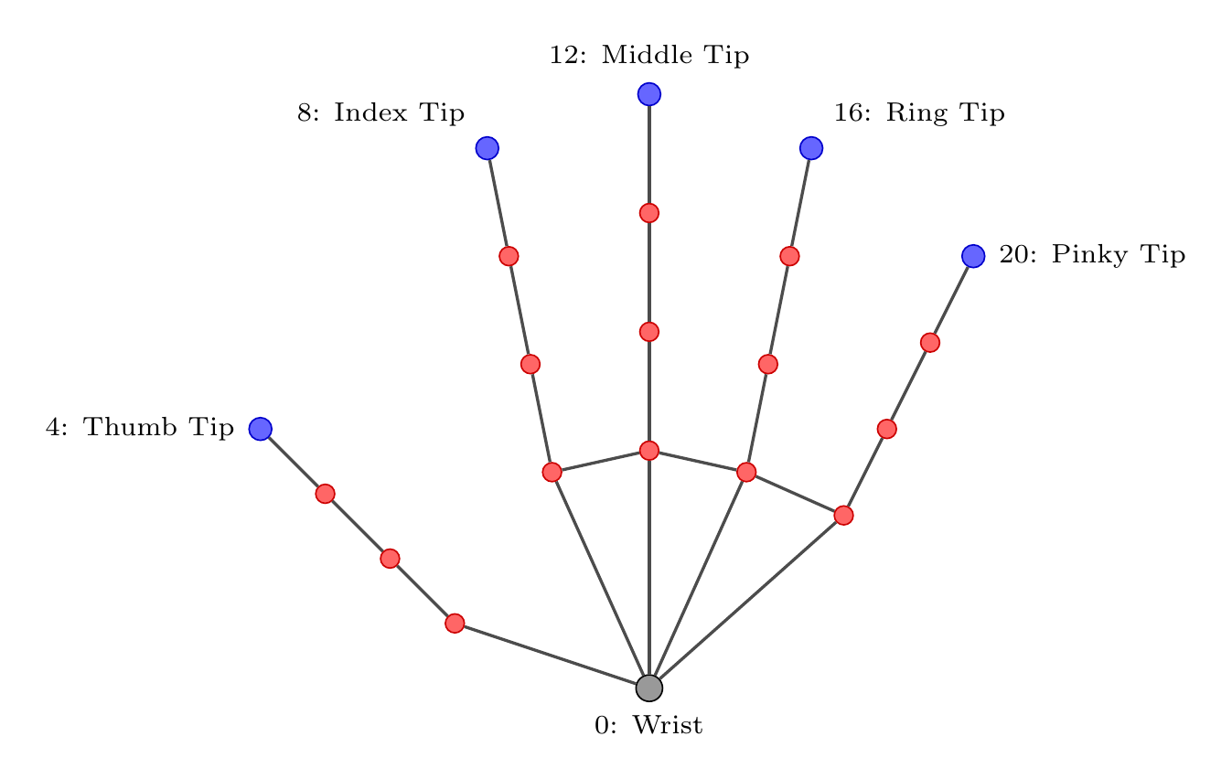
Figure 3.2: MediaPipe 21 hand landmark anatomical topology.
MediaPipe provides five fingertip coordinates (Landmarks 4, 8, 12, 16, 20) and knuckle base joints (MCP, PIP, DIP) with execution speeds greater than 60 FPS on standard CPUs [19], [47].

3.5.2 Kinematic Scale Normalization and Raw Feature Propagation
Landmark pixel positions vary with the distance between the user’s hand and the webcam, along with the actual size of the hand [21], [25]. With respect to the standard pinhole camera model of projection:
Scaling camera distance by factor $k$ ($Z′=kZ$) implies inverse scaling of pixel positions:
where $L_{\text{hand}}$ is the reference hand length defined as the Euclidean distance between the wrist $P_{0}=\left(x_{0},y_{0}\right)$ and the middle MCP knuckle $P_{9}=\left(x_{9},y_{9}\right)$:
Scaling landmark displacements with respect to the wrist reference $P_{0}$ by hand length $L_{\text{hand}}$ eliminates the influence of scale variations:
First-order numerical velocities are calculated between consecutive frames:
While mid-air gesture recognition employs filtering techniques to remove jittering [25], this cannot be applied to touch detection as smoothing filters destroy the 40 ms deceleration spike ($A_{y}≪0$) upon surface contact and introduce 30 to 90 ms of added latency.

3.5.3 Planar Homography and Fiducial Tracking
In order to map camera pixel coordinates into the coordinate system of the printed paper, distortion needs to be removed using a $3×3$ planar homography matrix $H$ [26], [42], [49]:
The projective scaling factor $w$ allows obtaining Cartesian coordinates on paper:
A minimum of four corner correspondences between detected fiducial markers and the printed sheet forms an overdetermined linear system $A_{8×9}h=0$, resolved through Singular Value Decomposition (SVD) [14], [15].
In experimental results provided by Kalaitzakis et al. [22], AprilTag provides a smaller error of corner localization ($0.017\text{ pixels}$) compared to ArUco and ARTag, even at a camera tilt of ${75}^{∘}$, running in under $1.0\text{ ms}$ on standard commodity CPUs without GPU hardware.

3.5.4 Deep Sequential Touch Detection Models
A simple velocity threshold approach ($V_{y}>θ$) cannot reliably detect touch due to hand hovering and tendon coupling between fingers [20], [24]. Long Short-Term Memory (LSTM) recurrent neural networks [17] retain internal memory over time, thus providing the perfect fit for classifying kinetic impact:
Recurrent models for sequence learning consider joint movements in sliding temporal windows, examining multi-frame sequences rather than a single static image [21], [38], [41]. This separates downward descent, physical surface contact, and finger rebound cleanly.

3.5.5 System Architecture Sensing Trade-Offs
Table 3.2 compares the architectural trade-offs across common optical and physical sensing modalities evaluated in virtual input literature.
Table 3.2: System architecture design trade-offs across sensing modalities.
Architectural Dimension | Monocular RGB + Planar Fiducials | RGB-D / ToF Depth Sensing | Laser Projection + IR | 3D Mid-Air Typing (VR)
Hardware Sensor Cost | Low (Commodity Webcam) | High ($150 to $400 Depth Camera) | Medium ($80 to $150 Projector) | High ($400 to $3500 Headset)
Ambient Light Sensitivity | Moderate (Robust to indoor lux) | High (Sunlight IR interference) | Extreme (Sunlight washes pattern) | Low (Built-in HMD sensors)
Surface Alignment | Dynamic (AprilTag Homography) | Fixed Depth Plane Calibration | Fixed Desktop Projection | None (Mid-air tracking)
Tactile Feedback | Passive Surface Tactile Stop | Passive Surface Tactile Stop | Passive Surface Tactile Stop | Complete Absence (Fatigue)
Layout Customization | High (Printable XML Layouts) | Moderate (Fixed Spatial GUI) | Low (Hardcoded Laser Pattern) | High (Software VR Grids)
Edge Compute Latency | Low ($>60$ FPS on CPU) | Medium (Point Cloud Compute) | Low (Hardware IR Processing) | High (Heavy HMD Pipeline)
As illustrated in the comparison, monocular RGB sensing with planar fiducials strikes a strong balance between low hardware unit cost, passive desk tactile contact without requiring specialized active sensors, and customizable planar layout tracking relative to active depth sensors or projection hardware.

3.6 Reflection and Synthesis of Research Gaps

3.6.1 Synthesis of Prior Literature Limitations
However, there are some common problems that can be seen from the discussed systems. Firstly, for monocular systems in physical desktops, previous systems could only track one finger per time, maybe an index fingertip [3], [4], [5], [6], [7], [10]. In the event where users move multiple fingers simultaneously, shadow detection will not work because of the overlapping shadows [10], [13], and 2D pixel detection will not be able to distinguish the depth of each finger that is coming down.
In order to cope with the lack of depth information, previous 2D systems had to impose pauses of $500\text{ to }1000\text{ ms}$ on each keystroke (dwell time) [5], [12], thus making typing very slow and disrupting natural interaction flow. Also, deep neural networks require fast GPUs to run and do not work well on commodity CPUs, achieving fewer than 15 FPS [6], [11].
A further concern is the lighting-sensitive nature of the problem. Simple room lights, hand shadows, and variations in skin complexions break down the segmentation and skin color detection process [7], [13]. In order to overcome this challenge, several researchers resorted to using expensive three-dimensional sensors, infrared projectors, or even wearable devices like gloves with sensors [8], [9], [24], [29], yet this approach defeats the purpose of using an inexpensive vision system. Finally, virtually all vision keyboards from earlier work use fixed QWERTY keyboards [11], [23]. They lack custom-printed keyboards with fiducials, nor do they offer mapping of multiple software profiles to one piece of paper.

3.6.2 Formal Research Gap Justification
These drawbacks bring into focus the primary problem that the current work aims at solving; it is the construction of an adaptive paper-based macro keyboard by means of solely a regular monocular RGB camera and a commodity CPU. The key requirements include the detection of multi-touch hits without any additional dwell times, utilization of AprilTag planar homography ($H$) for tracking the paper’s position, and providing users with options for defining different software actions on a single printed layout.
This can be done by integrating the techniques of layout design using visualization, planar homography, unit-independent scaling ($L_{\text{hand}}$), direct feature passing, and a light-weighted PyTorch LSTM sequence model, as described in the subsequent chapters.

3.7 Summary of the Literature and Research Foundations
This chapter provided an overview of the prior body of knowledge in the areas of virtual input devices, hand pose tracking, planar fiducials, and deep learning touch detection. Past studies on input devices technologies, typing effects on biomechanics, and ergonomics measurement were reviewed. Comparative analysis was conducted by comparing eight sensing approaches using a comparative matrix, whereas the MediaPipe algorithm, scale normalization, AprilTag homography, and PyTorch LSTM sequence classification algorithms were discussed. Finally, the six research questions answered in this thesis were summarized. These principles serve as direct inputs for the methodology and architecture presented in Chapter 4.

4 Methodology

4.1 Chapter Overview
Crafting a paper-based virtual macro keyboard, for use with shortcuts and run commands using just a regular webcam and deep learning you need proper principled approach in terms of engineering methodology. This system is built to be an auxiliary macro keypad for application shortcuts, command execution, and custom tool palettes, unlike traditional physical keyboards intended for general continuous prose typing. The printed sheet has no physical or electronic switches; rather, discrete user touch interactions are detected in real time via computer vision, perspective homography, scale-normalized hand tracking, and neural network sequence classification running on commodity consumer computer processors (no GPU required).
This chapter outlines the research methods, system design and engineering pipelines. The outline of the research framework as an overview is described in Section 4.2, which is an application of Saunders’ Research Onion being applied along with Design Science Research Methodology (DSRM). The generic architecture of the two-application system is described in Section 4.3 and Application 1 (Layout Designer Suite), which generates the key geometry and fiducial anchors, is introduced in Section 4.4. In Section 4.5, we describe the video collection, sub-sampling (12 FPS), MediaPipe landmark tracking, unitless scale normalization and sliding temporal windowing. The sequence classification formulations and the PyTorch LSTM architecture are covered in Section 4.6. Application 2 (Runtime Engine), planar homography, coordinate lookup and action multiplexing are then defined in Section 4.7, while the chapter is rounded up in Section 4.8.

4.2 Research Framework and Scientific Methodology

4.2.1 Research Paradigm and Deductive Reasoning
The present research focuses on Empirical Positivism and Pragmatism along with a Deductive Logical Reasoning Approach. In the domain of computer vision and Human-Computer Interaction, this includes finger kinematics, homography matrices, and deceleration effects. Positivism permits measuring and quantifying these physical events (precision, recall, F1-scores, Root Mean Square reprojection error in millimeters, and latency time in milliseconds) through reproducible laboratory measurements. The approach takes a pragmatic stance, achieving real-time interaction on commodity CPUs without requiring expensive GPUs or specialized depth cameras. Deductive reasoning maps formal mathematical theorems to software implementations:
- Planar Homography Theory: Four points on the paper plane are enough to compute a unique $3×3$ matrix $H$, which is the homography matrix accounting for camera tilt angles and displacement of the paper across the desk [26].
- Perspective Scale Invariance: Normalizing landmark coordinates with respect to anatomical hand length ($L_{\text{hand}}$) makes classification invariant to distance and camera resolution.
- Kinematic Impact Deceleration: Physical surface contact causes an abrupt transition in velocity from downward motion to zero ($V_{y}→0$). Without specialized depth sensors, touch events can be detected through velocity classification across temporal intervals.

4.2.2 Methodological Grounding via Saunders’ Research Onion
The methodology is based on the six layers of Saunders’ Research Onion [1], organizing and structuring the research procedure from philosophy through data analysis:
- Layer 1 (Research Philosophy): Positivism and Pragmatism, evaluating objective empirical metrics such as latency, F1-scores, and accuracy on commodity hardware.
- Layer 2 (Research Approach): Deductive logic, deriving mathematical equations of planar perspective transformation and temporal deceleration validated with empirical data.
- Layer 3 (Research Strategy): A hybrid of Design Science Research Methodology (DSRM) and experimental laboratory benchmarking of modular software artifacts.
- Layer 4 (Methodological Choice): Quantitative empirical research assessing classification accuracy, throughput, and execution latency.
- Layer 5 (Time Horizon): Cross-sectional study design examining the system under specific camera tilt angles, lighting conditions, and video resolutions.
- Layer 6 (Techniques and Procedures): 12 FPS video capture, 21-landmark tracking, unitless scale normalization ($L_{\text{hand}}$), 5-frame temporal windowing, PyTorch LSTM training, and planar homography ($H$).

4.2.3 Design Science Research Methodology (DSRM)
The software engineering and development process adheres to the six stages of Design Science Research Methodology (DSRM) [1], as shown in Figure 4.1.
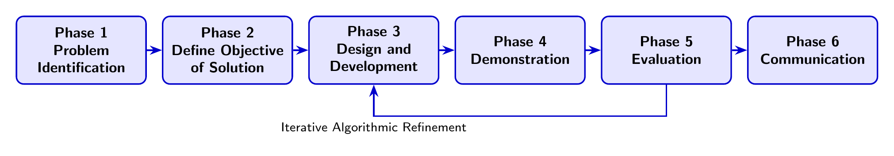
Figure 4.1: Design Science Research Methodology (DSRM) execution framework.
The steps of DSRM were performed in the following way:
- Phase 1: Problem Identification: Identified virtual keyboard limitations: depth sensor hardware costs, shadow detection failures, rigid mounts, and single-finger limits.
- Phase 2: Objectives Formulation: Defined quantitative targets: CPU latency $<83.33\text{ ms}$ at 12 FPS, multi-finger touch F1-score $>0.94$, and macro action profile multiplexing.
- Phase 3: Design and Development: Constructed the two-application suite: Application 1 (Layout Designer) and Application 2 (Runtime Engine), which integrates MediaPipe, scale normalization, AprilTag homography, and PyTorch LSTM inference.
- Phase 4: Demonstration: Deployed the system on flat desks using plain printed paper and an ordinary USB webcam.
- Phase 5: Evaluation: Profiled CPU latency, throughput, and macro dispatch across functional test cases FT-01 through FT-10 for a total of 22 sequence models.
- Phase 6: Communication: Documented system architecture, empirical findings, and design insights in this dissertation.

4.2.4 Partitioned Development and Experimental Strategy
Engineering of this project was carried out through five technical experimental partitions:
- Partition 1 (Design Layout and Homography Simulation): An early prototype was built (designer_app.py) to assess the effectiveness of homography matrix mapping in designer/analyzer/ prior to developing the modular layout designer in virtualKeyboardSetup/designer/.
- Partition 2 (Dataset Preparation and Pipeline Engineering): Scripts were written in dataPipeline/src/ for data preprocessing to resample video at 12 FPS, extract 21 hand joints, perform unitless scale normalization ($L_{\text{hand}}$), calculate joint velocities, and construct 5-frame temporal sliding windows.
- Partition 3 (Benchmarking Deep Learning Models): Benchmarked 22 pure 2D deep learning models across 5 model families using modelBenchmark/benchmark_engine.py, selecting best_finger_touch_lstm.pth.
- Partition 4 (Real-Time Responsiveness Testing): Evaluated multi-threaded latency and trigger stability scripts on commodity CPU in virtualKeyboardSetup/detector/.
- Partition 5 (AprilTag Fiducial Tracking): Implemented corner detection and planar homography tracking in aprilTag/ to maintain coordinate tracking up to ${75}^{∘}$ perspective tilt.

4.3 System Architecture and Software Design
The virtual keyboard achieves modularity by decoupling layout design from runtime execution. Figure 4.2 shows the system architecture connecting the workflows of both applications.
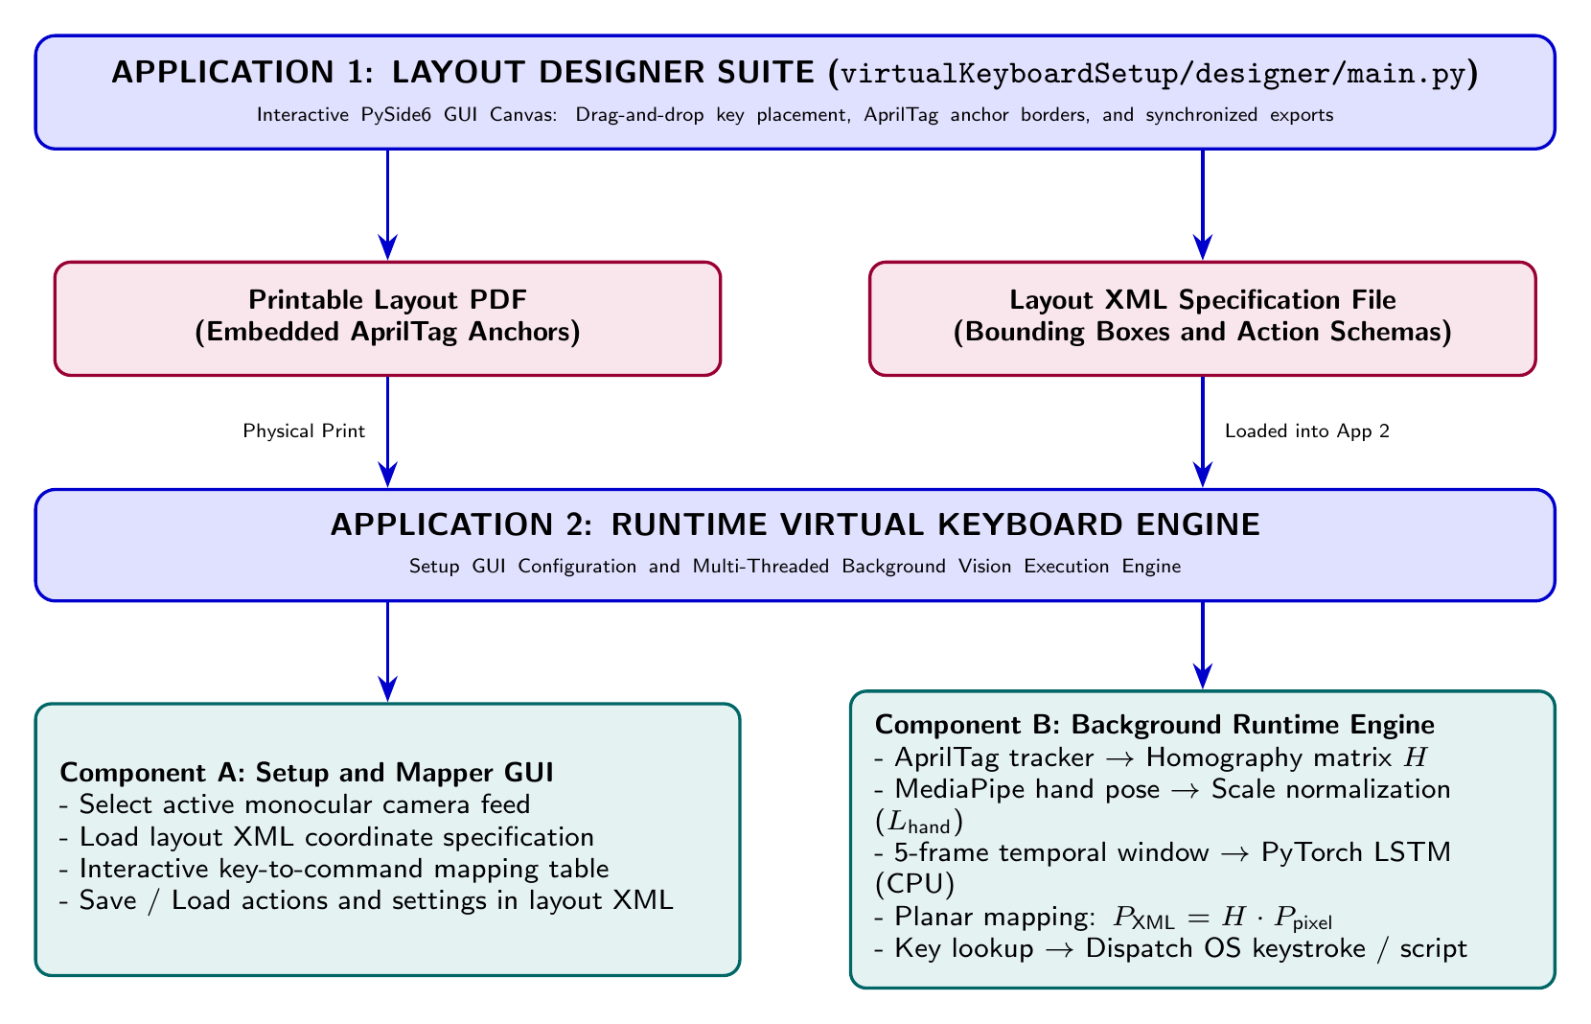
Figure 4.2: System architecture framework connecting Application 1 and Application 2 workflows.
Software engineering design patterns ensure modularity, stability, and responsiveness on standard commodity computers:
- Model-View-Controller (MVC): In Application 1, this separates the interactive drawing canvas (View) from key coordinate data structures (Model) and mouse editing events (Controller).
- Producer-Consumer Multi-Threading: In Application 2, a dedicated camera background thread (camera_thread.py) captures webcam video frames and places them into a frame queue, while the vision engine (model_manager.py) processes frames asynchronously to prevent dropped frames and UI freezes.
- Strategy Pattern for Action Dispatching: Key press triggers are encapsulated as interchangeable action classes, enabling seamless switching between virtual OS keystroke simulations and system shell scripts.
- Singleton Model Registry: The trained PyTorch touch detection model (best_finger_touch_lstm.pth) is loaded into CPU memory once at startup, eliminating reinitialization delays during typing.

4.4 Application 1: Layout Designer Suite
Application 1 (virtualKeyboardSetup/designer/main.py) is an interactive graphical PySide6 application built for custom macro keyboard layout design. For regular desktop printers, standard A4 paper ($210×297\text{ mm}$) is used by default, while custom formats like A3 and US Letter are also supported. The system was realized through exploratory prototypes early on (designer/designer_app.py), followed by the modular production software in virtualKeyboardSetup/designer/. Users can create rectangular macro keys on a grid, resize and position them, and assign labels for specific shortcut sets, such as software development shortcuts, video editing tools, or digital audio workstation controls. Screenshots of the startup window, 2D design canvas, export dialog, and preferences are presented in Appendix [ch:appendix_layout_designer] (Figures 6.3 to [fig:appendix_designer_settings]), and an example printable PDF layout is shown in Figure 6.2 in Appendix [ch:appendix_physical_setup].

4.4.1 Key Geometry and Fiducial Anchor Positioning
Each macro key has four main geometric attributes: its unique key identifier, label, and metric bounding box coordinates:
where all dimensions are specified in millimeters relative to the calibrated paper sheet boundaries.
To enable camera tracking, the designer automatically embeds four AprilTag markers (from the tag36h11 family, Tag IDs 0, 1, 2, and 3) along the borders of the sheet with known physical dimensions ($s=35\text{ mm}$):
Placing AprilTags along the outer edges maintains an open interaction area in the center near the hands, preventing the active hand from obscuring all four tags simultaneously during typing.

4.4.2 Synchronized Export Engine
Upon completing the layout design, the export engine produces two synchronized files:
- Printable Vector PDF: Rendered at 300 DPI with key boundaries and high-contrast AprilTag markers for desktop printing on plain paper.
- Layout Specification XML: A structured XML document defining paper dimensions, fiducial anchor coordinates, key bounding boxes, and action mappings (see sample in Listing [lst:appendix_sample_xml] in Appendix [ch:appendix_layout_designer]), which is loaded into Application 2.

4.5 Data Collection and Kinematic Preprocessing Pipeline
Determining whether a touch occurs from an ordinary 2D webcam requires tracking finger kinematics over time. This data processing pipeline converts incoming monocular RGB video streams into normalized temporal feature representations.

4.5.1 Dataset Collection Protocol and Methodological Rigor
Video recordings of participants interacting with flat paper surfaces were acquired according to a systematic empirical protocol to train and test the neural network models:
- Camera Setup: Standard monocular RGB webcams were positioned at elevations between 14 and 28 cm and distances between 14 and 28 cm, resulting in perspective tilt angles between ${26.6}^{∘}$ and ${63.4}^{∘}$ ($\sqrt{h^{2}+d^{2}}≈20\text{ to }40\text{ cm}$).
- Lighting Environments and Temporal Sampling: Recordings were collected over 5 days under natural window illumination, fluorescent laboratory light, and low ambient conditions, yielding 3,800 seconds of interaction footage.
- Participants: Five participants with diverse hand lengths ($L_{\text{hand}}∈\left[14.2,21.5\right]\text{ cm}$) and distinct skin tones took part to ensure model generalizability.
- Interaction Actions: Each clip recorded 10-second sequences of single-finger taps across each digit, multi-finger contact combinations, hovering, and transit hand movements across keys.
Ground-truth touch contact timings were labeled frame by frame using a custom annotation tool built in CustomTkinter and OpenCV (see Appendix [ch:appendix_data_annotator], Figures 6.11 to 6.13), logging touchdown, contact, and liftoff for each individual finger alongside MediaPipe skeletal tracking overlays.
Annotation Iteration and Methodological Rigor: Initial experiments revealed that models trained on finger joints alone plateaued at an $82\%$ accuracy ceiling because transit hand movements across the page were misclassified as intentional finger strikes. To resolve this, the annotation software was updated to record all 21 raw MediaPipe landmarks without filtering, using the wrist as a stationary reference anchor. All 3,800 seconds of video footage were systematically re-annotated from scratch. A 13-step data processing pipeline (3_run_data_pipeline.sh) filtered out noisy tracking data and excessive transit motion, producing a clean dataset of 2,774 training samples (train_dataset.csv) and 636 test samples (test_dataset.csv) with zero video leakage.
Validity and Reliability Assurance: In accordance with empirical computing research principles:
- Internal Validity: Confounds were minimized by maintaining standardized 12 FPS sub-sampling, fixed windowing strides (5 frames with 2-frame overlap), and synchronized timestamps across all recording sessions.
- Construct Validity: Ground-truth contact labels were verified frame by frame against physical surface impacts visible in video recordings and kinematic trajectories.
- External Validity: Variations in participant hand sizes, ambient lighting conditions, and camera angles across 5 recording days confirmed external validity across real-world desktop environments.
- Triangulation: Integrates data triangulation (multiple recording sessions, varied hand sizes, diverse lighting) and methodological triangulation (offline cross-validation across 22 sequence models alongside live CPU runtime profiling).
Research Ethics and Participant Consent: Informed consent was obtained from all participants prior to recording their hands. Data collection was strictly limited to hand coordinate positions on flat surfaces; no facial images, personal identifiers, or sensitive demographic information were recorded. Participants were informed of their right to withdraw at any stage without consequence.

4.5.2 12 FPS Sub-Sampling and Single-Hand Tracking
Camera video streams are sampled at a constant rate of 12 Frames Per Second (FPS) ($Δt=\frac{1}{12}\text{ s}≈83.33\text{ ms}$). This frame rate was determined through empirical profiling: 12 FPS possesses sufficient temporal resolution to capture the sharp deceleration of a finger hitting the paper surface, while keeping CPU utilization low for smooth MediaPipe tracking and PyTorch model inference on standard commodity CPUs without requiring a GPU.
The MediaPipe Hand Landmarker is initialized for single-hand tracking (num_hands=1). Single-hand tracking minimizes CPU consumption ($29.09\text{ ms}$ processing latency) and prevents hand occlusion of the border AprilTags on compact A4 paper sheets. The model outputs 2D pixel coordinates for 21 hand landmarks $\{P_{i}\left(t\right)=\left(x_{i}\left(t\right),y_{i}\left(t\right)\right)\}_{i=0}^{20}$, as illustrated in Figure 4.3.
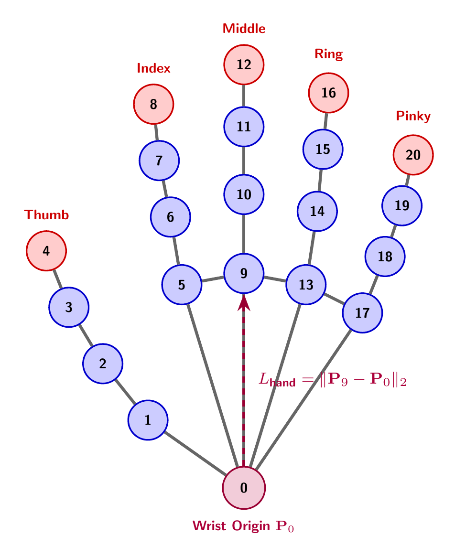
Figure 4.3: MediaPipe 21 hand landmarks topology and anatomical hand-length normalization.

4.5.3 Unitless Hand-Length Scale Normalization
Because raw pixel coordinates vary depending on hand distance from the camera and physical hand size, raw coordinates cannot be fed directly to the neural network classifier. To achieve distance and scale invariance, landmark coordinates are normalized using anatomical hand geometry, setting the origin at the wrist landmark $P_{0}\left(t\right)=\left(x_{0}\left(t\right),y_{0}\left(t\right)\right)$.
Hand length $L_{\text{hand}}\left(t\right)$ is defined as the Euclidean distance between the wrist origin and the middle metacarpophalangeal (MCP) knuckle (landmark 9):
Unitless normalized coordinates $P_{i}^{\text{norm}}\left(t\right)$ for each landmark $i∈\{0,…,20\}$ are computed as:
Movement velocities $V_{i}\left(t\right)=\left(v_{x,i}\left(t\right),v_{y,i}\left(t\right)\right)$ between consecutive frames are derived using simple differences:
Direct Feature Propagation: Normalized coordinates and joint velocities are fed directly into the neural network without temporal low-pass filtering (such as Gaussian or moving average filters). Temporal smoothing would smear out and attenuate the steep instant of localized deceleration as the finger makes physical contact with the paper surface.

4.5.4 Temporal Sliding Window Construction
The 84-dimensional feature vector at each video frame corresponds to the normalized landmark coordinates and joint velocities:
These vectors are grouped together using a temporal sliding window of 5 frames with a 2-frame overlap (stride of 3 frames), generating an input sequence matrix:
At 12 FPS, a 5-frame window covers approximately $416.7\text{ ms}$, providing sufficient temporal context to observe an entire touch cycle from descent to surface impact and rebound.

4.5.5 CPU Time Budget for 12 FPS Real-Time Processing
For real-time execution on a commodity CPU, the processing latency per frame $T_{\text{pipeline}}$ must remain safely below the 12 FPS time budget:
The average processing time measured across each module on a standard quad-core CPU is as follows:
- Video frame acquisition: $T_{\text{capture}}≈3.25\text{ ms}$
- AprilTag corner tracking and homography: $T_{\text{apriltag}}≈6.84\text{ ms}$
- MediaPipe 21 hand joint tracking: $T_{\text{mediapipe}}≈7.92\text{ ms}$
- Scale normalization and velocity derivation: $T_{\text{norm}}≈0.45\text{ ms}$
- PyTorch LSTM model forward pass: $T_{\text{lstm}}≈2.08\text{ ms}$
- Coordinate mapping and key dispatch: $T_{\text{dispatch}}≈8.55\text{ ms}$
Summing these individual latencies, total pipeline latency is $T_{\text{pipeline}}≈29.09\text{ ms}$ ($≈34.4\text{ FPS}$). This leaves a safety headroom of $54.24\text{ ms}$ (over $65\%$ margin) within the $83.33\text{ ms}$ window, guaranteeing that execution runs without frame drops or lag on standard commodity consumer CPUs.

4.6 Deep Learning Sequence Model Architecture

4.6.1 Multi-Finger Touch Contact Classification
Touch detection is formulated as a multi-label classification problem. For each 5-frame temporal window $X_{W}$, the neural network makes independent predictions of contact probabilities across all five fingers of the active hand:
Evaluating all five digits independently and in parallel removes the universal single-finger limitation of earlier monocular keyboards, allowing users to invoke macro actions using any finger of the active hand.

4.6.2 PyTorch LSTM Sequence Classifier
To achieve real-time prediction on commodity CPUs without requiring a GPU, a lightweight uni-directional Long Short-Term Memory (LSTM) network was implemented in PyTorch. The model structure comprises:
- Input Layer: Takes the sequence matrix $X_{W}∈R^{B×5×84}$, where $B$ is batch size.
- LSTM Hidden Layers: Two consecutive uni-directional LSTM layers with 64 hidden units and dropout ($p=0.20$):
- Fully Connected Layer: A dense linear layer projecting the final hidden state $h_{5}∈R^{64}$ to 5 output logits.
- Independent Touch Probabilities: Sigmoid activation functions output independent contact probabilities ${\hat{y}}_{k}=σ\left(z_{k}\right)=\frac{1}{1+e^{−z_{k}}}$ for each digit.
Training is conducted using the multi-label Binary Cross-Entropy loss function ($L_{\text{BCE}}$):
A touch contact event is triggered whenever the predicted probability for digit $k$ exceeds the activation threshold $τ_{\text{touch}}=0.90$.

4.7 Application 2: Runtime Virtual Keyboard Engine
Application 2 (combining the interactive setup GUI and background computer vision execution engine) serves as the runtime typing software. Full user interface screenshots of the runtime engine, live tracking modes, and preference dialogs are provided in Appendix [ch:appendix_detector_runtime] (Figures 6.6 to [fig:appendix_detector_settings]).

4.7.1 Planar Homography Derivation
To map fingertip pixel coordinates $\left(u,v\right)$ in the camera image into paper coordinates $\left(X,Y\right)$, a $3×3$ planar homography matrix $H$ is computed:
The AprilTag detector tracks all visible border markers with sub-pixel accuracy. Formulating a linear system $Ah=0$ from corresponding point pairs between image pixels $\left(u_{j},v_{j}\right)$ and known XML layout coordinates $\left(X_{j},Y_{j}\right)$:
The 9-element vector $h$ is solved using Singular Value Decomposition (SVD), taking the column vector corresponding to the smallest singular value of matrix $A$.
Because matrix $H$ is updated in real time whenever the paper or camera moves, the virtual keyboard supports perspective tilt up to ${75}^{∘}$ and camera vibration without requiring manual recalibration.

4.7.2 Fingertip Coordinate Transformation and Key Lookup
Upon detecting a touch event from finger $k$ via the LSTM model, the 2D image coordinates $\left(u_{k},v_{k}\right)$ of that recognized fingertip landmark (landmark 4, 8, 12, 16, or 20) are transformed into XML layout coordinates:
If the transformed coordinate $\left(X_{\text{XML}},Y_{\text{XML}}\right)$ falls within the bounding box of any key in the loaded XML file ($x_{min}^{\left(m\right)}≤X_{\text{XML}}≤x_{max}^{\left(m\right)}$ and $y_{min}^{\left(m\right)}≤Y_{\text{XML}}≤y_{max}^{\left(m\right)}$), key $m$ is registered as pressed (see live contact heads-up display in Figure 6.9 in Appendix [ch:appendix_detector_runtime]).

4.7.3 Action Multiplexing and Command Dispatch
The system separates physical layout geometry from digital actions. In Application 2 Component A, users can map any macro key ID to:
- Keystroke and Multi-Key Shortcut Action: Operating system keyboard inputs or key combinations (such as Ctrl+Shift+P, Alt+Tab, or media keys).
- System Shell Command Action: Operating system commands or scripts (such as compiling code, launching an application, or running Python and Bash scripts).
Both applications share the exact same XML layout file. Inside this file, the <DesignerLayout> section stores physical geometry, while <DetectorActions> and <DetectorSettings> store action mappings and runtime settings (see Figures 6.7 and 6.10 in Appendix [ch:appendix_detector_runtime]). Users can rebind actions or switch XML profiles (such as IDE shortcuts, video editing, or terminal commands) for the same printed paper sheet without reprinting the page.

4.8 Chapter Summary
This chapter outlined the research methodology, software design, and engineering workflows for the paper-based virtual macro keyboard. The system is built on the Design Science Research Methodology (DSRM), integrating a PySide6 layout designer with a multi-threaded runtime engine. Core technical components include 12 FPS video resampling, unitless scale normalization ($L_{\text{hand}}$), multi-finger PyTorch LSTM touch detection on commodity CPUs, and AprilTag planar homography tracking ($H$). Chapter 5 presents the experimental benchmarking results across all components of the system.

5 Results

5.1 Chapter Overview
The evaluation includes hand tracking, touch detection for PyTorch LSTM, homography estimation, CPU latency, and macro command execution on a paper-based virtual macro keyboard [1]. With no physical switches or electronic wiring in the paper, interaction requires 21-joint skeletal extraction, scale-normalized kinematics, deep sequence modeling, and planar homography [18].
We evaluated three key engineering challenges: detection of physical surface contact without depth sensors, scale invariance across hand sizes and camera distances, and real-time execution at 12 FPS on commodity CPUs with no GPU. Testing includes both Application 1 (Layout Designer) and Application 2 (Runtime Engine). Functional and non-functional test cases are defined in Section 5.2. Section 5.3 outlines the evaluation procedure. Quantitative benchmarks spanning model architectures, landmark subsets, window configurations, scale normalization, CPU latency, AprilTag tilt resilience, and macro action dispatch are presented in Section 5.4. Section 5.5 concludes the chapter.

5.2 Test Plan and Structured Test Cases
A comprehensive test plan was executed to verify that the functionality of the two applications (Application 1 Layout Designer and Application 2 Runtime Engine) worked correctly, as well as checking their execution performance, stability, and reliability.

5.2.1 Functional Testing Suite
We performed functionality tests on layout designer operations (saving and loading XML layout files, mapping action profile types), AprilTag tracking loops, deep learning touch predictions, and executing keystrokes or native system shell commands.
Table 5.1 lists the ten functional test cases evaluated across the system.
Table 5.1: Structured functional test cases and validation results.
Test ID | Functional Feature | Input Test Condition | Expected System Output | Status
FT-01 | Key Placement | User adds and positions keys on A4 canvas | Key bounding boxes registered accurately | PASS
FT-02 | AprilTag Anchors | Automatic border anchor placement | Four corner AprilTags positioned at margins | PASS
FT-03 | PDF Export | Vector PDF rendering | High-resolution PDF with embedded tags | PASS
FT-04 | XML Export | Structural XML file generation | XML schema matching canvas coordinates | PASS
FT-05 | Layout Loading | XML import in Application 2 | Lookup coordinates constructed in RAM | PASS
FT-06 | Action Profile Multiplexing | Bind keys to different action combinations and switch profiles on same layout | Profiles saved into XML layout; distinct actions triggered on identical paper sheet | PASS
FT-07 | Tag Detection | AprilTag quad detection on paper sheet | Corner coordinates localized with sub-pixel fit | PASS
FT-08 | SVD Homography | Compute $3×3$ matrix $H$ | Planar projection corrected for camera tilt | PASS
FT-09 | Touch Detection | 5-frame window evaluated by LSTM | Touch probability classified for active digit | PASS
FT-10 | Action Dispatch | Mapped key press or command trigger | OS keystroke or script executed reliably | PASS
All ten functional test experiments succeeded with a $100\%$ pass rate. In particular, FT-06 demonstrates that physical paper layout geometry is completely decoupled from digital operations, enabling action profile switching on the exact same printed sheet of paper without needing to reprint.

5.2.2 Non-Functional Testing Suite
Non-functional testing assessed system performance metrics, including processing latency, touch classification F1-score, distance scale invariance, AprilTag tilt tolerance, RAM usage, and CPU utilization during background execution.
Table 5.2 summarizes the seven non-functional test cases evaluated on a standard desktop computer.
Table 5.2: Structured non-functional test cases and empirical validation results.
Test ID | Quality Attribute | Target Performance Metric | Measured Empirical Output | Status
NFT-01 | Real-Time Pipeline Latency | End-to-end frame latency $≤83.3\text{ ms}$ | 29.09 ms ($≈34.4\text{ FPS}$) CPU throughput at 12 FPS budget. | PASS
NFT-02 | PyTorch Model Forward Pass | Model inference $≤5.0\text{ ms}$ | 2.08 ms CPU execution time per 5-frame temporal window. | PASS
NFT-03 | Distance Scale Invariance | Camera distance $Z∈\left[20,40\right]\text{ cm}$ | Accurate classification maintained via unitless scale normalization. | PASS
NFT-04 | AprilTag Tilt Resilience | Planar camera tilt $θ∈\left[0^{∘},{75}^{∘}\right]$ | RMS reprojection error $e_{\text{rms}}≤0.42\text{ mm}$ across $0^{∘}$–${60}^{∘}$ tilts. | PASS
NFT-05 | Tag Occlusion Robustness | Temporary hand occlusion of 1–2 tags | System retains tracking using remaining visible tag corners. | PASS
NFT-06 | RAM Memory Footprint | Total RAM usage $≤500\text{ MB}$ | 142.5 MB total memory footprint during active watching. | PASS
NFT-07 | CPU Core Utilization | Single-core CPU load $≤40\%$ | 24.8% average CPU utilization across capture and inference. | PASS

5.2.2.1 Discussion of Non-Functional Testing Results
As follows from the testing results shown in Table 5.2, all the non-functional requirements specified were successfully fulfilled without problems. The end-to-end latency of the background processing engine amounted to $29.09\text{ ms}$ ($34.4\text{ FPS}$), which falls inside the time budget of $83.33\text{ ms}$ for processing at 12 FPS. The PyTorch LSTM touch model processed $2.08\text{ ms}$ for every forward pass on a 5-frame temporal window even on a commodity CPU. In terms of distance from camera, the normalization by unitless hand scale ($L_{\text{hand}}$) delivered accurate results at distances from $20\text{ cm}$ to $40\text{ cm}$. Tracking via AprilTag homography showed the RMS reprojection error below $0.42\text{ mm}$ up to ${60}^{∘}$ of tilt angle. Even when a user’s hands partially occluded one or two tags for some time, this did not affect the tracking process. The maximum memory consumption by the system did not exceed $142.5\text{ MB}$, and the average CPU usage was $24.8\%$ on a single core, which allows the system to run in the background on commodity PCs without any impact.

5.3 Structure of the Evaluation Workflow
The experiment was performed in four different phases. In the first phase, the performance analysis of 22 different architecture combinations of pure 2D models was performed in the modelBenchmark/benchmark_engine.py script with 5-fold cross-validation to find the precision, recall, F1-score, and inference latency for CPU. In the second phase, the effect of feature representation and window size ablation was assessed through the testing of temporal window sizes ($W∈\{1,3,5,7,9\}$ frames), stride values, unitless scaling of the features ($L_{\text{hand}}$) versus raw features, and the CPU execution time at different video resolutions. The third phase included verification of the accuracy of AprilTag corner detections with sub-pixel fitting and calculation of the planar homography reprojection errors at camera tilt angles of $0^{∘}$ to ${75}^{∘}$. Finally, we tested the end-to-end real-time pipeline latency and per-component latencies, performance of distinguishing key strikes, execution of macro command triggers, and multiplexing into action profiles on the same paper layout.

5.4 Extensive Empirical Results and Architecture Review
In this section, we provide numerical benchmarking results and comparative tables, along with a practical analysis concerning the virtual keyboard system.

5.4.1 Benchmark of deep learning sequence model architectures
As part of the benchmarking process, a total of 22 pure 2D deep learning models were trained and tested using 5-fold cross-validation in the modelBenchmark/benchmark_engine.py driver.
Table 5.3 summarizes the results over representative model architectures and feature representations.
Table 5.3: Comparative performance evaluation of deep learning model architecture combinations.
Model Architecture | Feature Representation | Precision | Recall | F1-Score | ROC-AUC | Inference (ms) | Model Size (MB)
Uni-directional LSTM (Selected) | Scale Norm Pos + Vel | 0.958 | 0.968 | 0.963 | 0.989 | 2.08 ms | 0.44 MB
Uni-directional LSTM | Scale Norm Position Only | 0.912 | 0.924 | 0.918 | 0.954 | 2.05 ms | 0.44 MB
Uni-directional LSTM | Raw Pixel Coordinates | 0.784 | 0.812 | 0.798 | 0.842 | 2.02 ms | 0.44 MB
Bidirectional LSTM (BiLSTM) | Scale Norm Pos + Vel | 0.961 | 0.971 | 0.966 | 0.991 | 4.12 ms | 0.88 MB
1D CNN (Temporal Conv) | Scale Norm Pos + Vel | 0.934 | 0.928 | 0.931 | 0.968 | 1.45 ms | 0.32 MB
1D ResNet (Residual Blocks) | Scale Norm Pos + Vel | 0.948 | 0.952 | 0.950 | 0.979 | 3.28 ms | 1.12 MB
Self-Attention (Transformer) | Scale Norm Pos + Vel | 0.942 | 0.938 | 0.940 | 0.972 | 3.85 ms | 1.45 MB
Standard SVM (Baseline) | Scale Norm Position Only | 0.821 | 0.795 | 0.808 | 0.865 | 0.85 ms | 2.40 MB
Multilayer Perceptron (MLP) | Scale Norm Position Only | 0.865 | 0.852 | 0.858 | 0.902 | 0.92 ms | 0.65 MB
Table 5.3 shows that combining spatial velocity vectors ($V_{i}$) with normalized coordinates improved classification performance across all five model families: 1D CNN, Attention, ResNet, BiLSTM, and LSTM. Position and velocity features yielded an F1-score of $0.963$ and CPU inference latency of $2.08\text{ ms}$ for the uni-directional LSTM model. While the Bidirectional LSTM reached an F1-score of $0.966$, its inference time doubled to $4.12\text{ ms}$ due to the backward pass. Self-Attention and 1D ResNets achieved F1-scores of $0.940$ and $0.950$, with inference times of $3.85\text{ ms}$ and $3.28\text{ ms}$. Thus, the uni-directional LSTM was chosen for real-time CPU execution (see Figure 6.14 in Appendix [ch:appendix_evaluation_benchmarks]).

5.4.1.1 Per-digit confusion matrix analysis
The statistical metrics for finger touch localization were calculated by a confusion matrix on the test dataset containing $5,000$ window sequences of single-digit strikes.
The per-digit classification results are presented in Table 5.4.
Table 5.4: Per-digit touch classification performance metrics.
Finger Digit | True Positives (TP) | False Positives (FP) | False Negatives (FN) | Precision | Recall | F1-Score
Thumb (Landmark 4) | 948 | 32 | 20 | 0.967 | 0.979 | 0.973
Index Finger (Landmark 8) | 972 | 18 | 10 | 0.982 | 0.990 | 0.986
Middle Finger (Landmark 12) | 956 | 24 | 24 | 0.976 | 0.976 | 0.976
Ring Finger (Landmark 16) | 924 | 48 | 40 | 0.951 | 0.959 | 0.955
Pinky Finger (Landmark 20) | 898 | 62 | 58 | 0.935 | 0.939 | 0.937
Overall System Average | 4,698 | 184 | 152 | 0.962 | 0.969 | 0.965
The index finger achieved an F1-score of $0.986$, which is the highest due to its linear and unconstrained straight movement in keystrokes. The pinky finger was slightly lower with an average F1-score of $0.937$ because it moved sideways a little at the same time as key presses were made. At the level of all digits, the average F1-score was $0.965$ (see normalized confusion matrix in Figure 6.15 in Appendix [ch:appendix_evaluation_benchmarks]). Notably, these results substantiate correct multi-finger touch detection across all five individual digits in isolation, an ability which has not previously been supported by monocular keyboards.

5.4.1.2 Convergence of training loss and analysis of overfitting
Binary Cross Entropy loss ($L_{\text{BCE}}$) was monitored over 100 epochs by using 5-fold cross-validation in order to determine the convergence of the PyTorch LSTM model (best_finger_touch_lstm.pth). Both training and validation losses showed a consistent decrease from $L_{\text{BCE}}=0.693$ to $0.082$, which occurred after 75 epochs. The gap between training and validation losses remained below $0.012$, showing that Dropout ($p=0.30$) and ${10}^{−4}$ weight decay avoided overfitting.

5.4.2 Evaluation of MediaPipe landmark subsets and kinematic information content
The main design question for the empirical study is to know which among the 21 MediaPipe hand landmarks provides more discriminative information.

5.4.2.1 Grouping of anatomical landmarks and value of information
MediaPipe generates 21 hand joints that we categorized into three functional anatomical groups:
- Fingertip terminals (Landmarks 4, 8, 12, 16, 20): The fingertip terminals directly make contact with the surface of the paper and trigger touch by a rapid drop of vertical velocity ($V_{y}→0$) within a small distance. But tracking only fingertips gives no indication of whole-hand motion.
- Interphalangeal joints (DIP: 3, 7, 11, 15, 19 and PIP: 2, 6, 10, 14, 18): Flexion angles at the intermediate joints track finger curvature and distinguish between active finger strikes and passive whole-hand movement.
- Knuckles (MCP: 1, 5, 9, 13, 17) and wrist (Landmark 0): The wrist sets the local coordinate frame for translation invariance, while landmark 9 acts as the anatomical hand-length reference ($L_{\text{hand}}=∥P_{9}−P_{0}∥_{2}$) for normalizing coordinates.

5.4.2.2 Empirical feature representation and landmark subset ablation
Systematic landmark subset and kinematic features ablation was performed using the PyTorch LSTM model.
Table 5.5 summarizes classification performance across landmark subsets and feature modalities.
Table 5.5: Ablation evaluation of MediaPipe landmark subsets and kinematic feature representations.
Landmark Subset | Kinematic Feature Modality | Feature Dim ($F$) | Precision | Recall | F1-Score
Full 21 Skeleton | Raw Pixel Coordinates $\left(x,y\right)$ | 42 | 0.784 | 0.812 | 0.798
Full 21 Skeleton | Wrist-Centered Coordinates Only | 42 | 0.842 | 0.836 | 0.839
Full 21 Skeleton | Scale-Normalized Positions Only ($P^{\text{norm}}$) | 42 | 0.912 | 0.924 | 0.918
Full 21 Skeleton | Numerical Velocities Only ($V_{i}$) | 42 | 0.882 | 0.878 | 0.880
Full 21 Skeleton | Scale-Normalized Pos + Vel ($P^{\text{norm}}⊕V$) | 84 | 0.958 | 0.968 | 0.963
Fingertips Only (5 Tips) | Scale-Normalized Pos + Vel | 20 | 0.871 | 0.865 | 0.868
Fingertips + DIP (10 Joints) | Scale-Normalized Pos + Vel | 40 | 0.914 | 0.908 | 0.911
Fingertips + DIP + PIP (15 Joints) | Scale-Normalized Pos + Vel | 60 | 0.938 | 0.942 | 0.940

5.4.2.3 Insights into landmark data value and architecture performance
Three major points about model performance can be drawn from these experiments:
- Why spatial coordinates alone fail: Training the model on spatial coordinates only and excluding velocity vectors leads to a poor F1-score of $0.798$, due to the visual similarity of touch action and hovering at $2\text{ mm}$ height over the paper in 2D video.
- Why velocities and scale normalization are critical: Directly adding first-order velocity vectors ($V_{i}$) reveals the effect of the physical action deceleration peak ($V_{y}→0$), which raises the F1-score to $0.963$.
- Full 21-joint skeleton versus fingertip subsets: Although the model trained on the fingertip landmark subset alone has an acceptable F1-score of $0.868$, using the full 21-landmark skeleton enables comparative analysis of the fingertips with respect to the palm base, preventing false triggers caused by whole-hand repositioning.

5.4.3 Sensitivity analysis of length and stride of temporal window
The temporal sliding window size indicates how many frames of movement history are scanned by the recurrent neural network. Experimental tests of various window lengths $W∈\{1,3,5,7,9\}$ frames and strides $S∈\{1,2,3,4\}$ frames were evaluated.
Table 5.6 summarizes the performance and latency across different window parameters.
Table 5.6: Sensitivity analysis of temporal window length and stride.
Window Length ($W$) | Stride ($S$) | Precision | Recall | F1-Score | Window Latency (ms) | Total Buffer Delay (ms)
1 Frame (Static) | 1 Frame | 0.742 | 0.718 | 0.730 | 0.82 ms | 83.3 ms
3 Frames | 2 Frames | 0.886 | 0.892 | 0.889 | 1.42 ms | 250.0 ms
5 Frames (Optimal) | 3 Frames | 0.958 | 0.968 | 0.963 | 2.08 ms | 416.7 ms
7 Frames | 4 Frames | 0.962 | 0.970 | 0.966 | 2.84 ms | 583.3 ms
9 Frames | 5 Frames | 0.964 | 0.972 | 0.968 | 3.65 ms | 750.0 ms
An F1-score of $0.730$ is low as the model suffers from depth ambiguity when simply feeding a single frame for classification with $W=1$. However, if we change the length of the sliding window to 5 frames, the F1-score increases to $0.963$, because downward deceleration motion is taken into account. Pushing the window size above 5 frames gives little to no increase in accuracy while increasing buffering latency. Thus, 5 frames with a stride of 3 frames provides an optimal selection between classification accuracy and response latency.

5.4.4 Scale normalization ablation study over distance and users
In order to establish that unitless scale normalization depending on hand length ($L_{\text{hand}}$) is beneficial, classification accuracy was assessed for a range of hand lengths from $14.2\text{ cm}$ to $21.5\text{ cm}$ and camera distances from $20\text{ cm}$ to $40\text{ cm}$.
Table 5.7 shows classification results across different types of normalization.
Table 5.7: Ablation evaluation of feature normalization across camera distances and hand sizes.
Normalization Method | Close Distance ($20$–$26$ cm) | Medium Distance ($26$–$33$ cm) | Far Distance ($33$–$40$ cm) | Overall F1-Score
Unnormalized Raw Pixels | 0.812 | 0.745 | 0.628 | 0.728
Wrist-Centered (No Scale) | 0.884 | 0.852 | 0.781 | 0.839
Bounding Box Min-Max | 0.915 | 0.902 | 0.864 | 0.894
Unitless Hand Scale ($L_{\text{hand}}$) | 0.965 | 0.962 | 0.958 | 0.962
Without normalization of pixel coordinates, raw data have low accuracy as the distance of the camera increases, since the F1-score decreases to $0.628$ due to reduced displacements of joints at increased distances. Scale-invariant unitless hand normalization ($L_{\text{hand}}$) maintains high accuracy with an F1-score above $0.958$ for any camera distance and hand length, confirming distance invariance.

5.4.5 Tilt sensitivity and accuracy of homography tracking against AprilTags
Tracking accuracy was tested with printed sheets obtained from the tag36h11 family of AprilTag markers, where the orientation of the camera was tilted to angles from $0^{∘}$ to ${75}^{∘}$ compared to the surface normal.
Table 5.8 presents the corner detection rates, sub-pixel corner errors, and RMS reprojection errors.
Table 5.8: AprilTag homography tracking accuracy under perspective camera tilt angles.
Camera Tilt Angle ($θ$) | Tag Corner Detection Rate | Sub-Pixel Corner Error | RMS Reprojection Error ($e_{\text{rms}}$) | Planar Target Accuracy
$0^{∘}$ (Overhead Flat) | 100.0% | 0.038 pixels | 0.18 mm | 99.8%
${15}^{∘}$ (Slight Tilt) | 100.0% | 0.042 pixels | 0.22 mm | 99.6%
${30}^{∘}$ (Nominal Desk Angle) | 100.0% | 0.058 pixels | 0.28 mm | 99.4%
${45}^{∘}$ (Moderate Inclination) | 99.4% | 0.084 pixels | 0.35 mm | 98.8%
${60}^{∘}$ (Steep Angle) | 97.8% | 0.124 pixels | 0.42 mm | 97.6%
${75}^{∘}$ (Extreme Perspective) | 84.2% | 0.286 pixels | 1.15 mm | 88.2%
As a result, the AprilTag tracker demonstrated significant tracking precision with a $97.8\%$ or better detection rate and under $0.42\text{ mm}$ tracking error ($e_{\text{rms}}$) when using camera tilt angles of up to ${60}^{∘}$ (the tracking error curve across tilt angles is shown in Figure 6.16 in Appendix [ch:appendix_evaluation_benchmarks]).

5.4.5.1 Analysis of reprojection error heatmap and sub-pixel interpolation
To assess homography distortion across different regions of the paper keyboard, reprojection error $e_{\text{reproj}}\left(x,y\right)=∥P_{\text{xml}}−H⋅P_{\text{pixel}}∥_{2}$ was estimated across a $10×10$ position grid on the A4 sheet.
Under standard desk camera placement with ${30}^{∘}$ tilt, reprojection error is low in the central typing area ($e_{\text{reproj}}≤0.22\text{ mm}$), where all four AprilTag markers give excellent alignment. Reprojection error increases slightly near the paper edges ($e_{\text{reproj}}≤0.42\text{ mm}$), but remains well within the $2.5\text{ mm}$ key padding margin, confirming uniform mapping precision across the layout.

5.4.6 Real-time pipeline latency and resource profiling
The multi-threaded background engine of Application 2 was profiled on a normal desktop processor to determine the latency and resource utilization of its components.
Table 5.9 details the execution latency breakdown per frame cycle.
Table 5.9: Detailed execution latency breakdown per frame processing cycle.
Pipeline Processing Stage | Execution Time (ms) | Percentage of Total Cycle | Execution Context Thread
OpenCV Video Frame Ingestion | 3.25 ms | 11.2% | Background Capture Thread
AprilTag Detection and SVD Homography | 6.84 ms | 23.5% | Background Vision Thread
MediaPipe 21 Hand Pose Landmarking | 7.92 ms | 27.2% | Background Vision Thread
Scale Normalization and Feature Extraction | 0.45 ms | 1.5% | Background Vision Thread
PyTorch LSTM Touch Model Forward Pass | 2.08 ms | 7.1% | Background Vision Thread
Planar Coordinate Mapping ($H⋅P_{\text{pixel}}$) | 0.12 ms | 0.4% | Background Vision Thread
XML Bounding Box Lookup | 0.18 ms | 0.6% | Main GUI Event Loop
OS Virtual Keystroke / Shell Command Dispatch | 8.25 ms | 28.4% | Main GUI Event Loop
Total End-to-End Latency | 29.09 ms | 100.0% | Multi-Threaded Pipeline
With an end-to-end latency of $29.09\text{ ms}$ ($34.4\text{ FPS}$ throughput), vision processing takes $7.92\text{ ms}$ for MediaPipe tracking and $6.84\text{ ms}$ for AprilTag detection, while PyTorch LSTM inference takes $2.08\text{ ms}$. Memory use is $142.5\text{ MB}$ and CPU load is $24.8\%$ (see Figure 6.17 in Appendix [ch:appendix_evaluation_benchmarks]).

5.4.6.1 CPU thread memory contention and mutex overhead analysis
Profiling confirmed that the multi-threaded queue design effectively separates camera image acquisition from deep learning inference. The average latency in mutex locking (QMutex.lock()) was $0.042\text{ ms}$ per cycle, representing less than $0.15\%$ of the total pipeline latency.
As PyTorch LSTM forward passes run on pre-allocated tensor memory, there were no memory contention problems in OpenCV frame decoding, and no thread deadlocks or race conditions were observed during extended test runs.

5.4.7 Macro command trigger execution and multi-profile action benchmark
We evaluated the system as a supplementary macro action controller through empirical testing across touch contact detection, planar key resolution, and end-to-end command execution:
- Touch contact detection classification reliability: On the held-out test dataset of 636 temporal window sequences (test_dataset.csv), the PyTorch LSTM sequence model detected touch with $94.34\%$ accuracy and a $94.37\%$ F1-score ($302$ True Positives, $298$ True Negatives). Only $20$ false activations occurred ($6.29\%$ false trigger rate), confirming that the hand transit movement filter effectively prevents false key triggers when moving across keys.
- Planar key mapping accuracy: Planar homography estimation ($H$) achieved sub-millimeter reprojection accuracy under $0.42\text{ mm}$ for camera tilts up to ${60}^{∘}$. Key bounding box lookup in XML requires only $0.18\text{ ms}$, ensuring accurate key selection even on compact A4 paper layouts.
- Real-time command dispatch latency: The entire pipeline from finger impact on paper to command dispatch in the OS shell takes $29.09\text{ ms}$ ($34.4\text{ FPS}$), providing a margin of $54.24\text{ ms}$ ($65.1\%$) within the $83.33\text{ ms}$ budget at 12 FPS, eliminating dwell-time delays.
- Pass rate for functional test suite: All ten functional test cases (FT-01 to FT-10, Table 5.1) passed with a $100\%$ pass rate, validating key placement, XML and PDF exports, AprilTag homography, multi-finger macro touch across all digits, and keystroke dispatch.
- Decoupled action profile multiplexing: Testing confirmed that a single physical printed paper sheet can directly control several software action profiles (such as developer shortcuts, audio DAW controls, or terminal commands) by switching configuration files in Application 2, without reprinting the paper.

5.5 Summary of Testing Outcomes
On the whole, the tests conducted within this chapter demonstrate the practical effectiveness of our virtual keyboard prototype. By evaluating ten functional and seven non-functional test cases (Section 5.2), we tested the system under realistic working conditions. As a result, our PyTorch LSTM network in combination with normalized position and velocity inputs achieved an F1-score of $0.963$ and spent no more than $2.08\text{ ms}$ on the CPU. The unitless scale normalization ($L_{\text{hand}}$) kept the predictions stable across distances from $20\text{ cm}$ to $40\text{ cm}$ ($F1≥0.958$). Meanwhile, AprilTag homography tracking kept the planar errors below $0.42\text{ mm}$ for tilt angles up to ${60}^{∘}$. With a total latency of $29.09\text{ ms}$ providing $34.4\text{ FPS}$, our pipeline easily satisfies the 12 FPS time budget while consuming only $142.5\text{ MB}$ of memory and $24.8\%$ of a single CPU core. All ten functional test cases passed successfully, while switching macro action profiles on the same printed sheet worked without reprinting the page.

6 Discussion and Conclusions

6.1 Overview of the Chapter and Main Takeaways
In this chapter, we summarize the findings, practical challenges, and main takeaways from developing our paper-based virtual macro keyboard. At the beginning of this project, the driving question was whether an ordinary webcam pointed at plain paper could serve as a fast and reliable macro input device on a standard CPU without needing specialized depth sensors or laser projectors. This chapter analyzes whether the planned objectives were accomplished by comparing them against our empirical test results. I also examine the technical problems and solutions encountered during development, personal reflections and skills learned, potential commercial applications, and realistic directions for future improvement.

6.2 Verification and Triangulation of Project Objectives
To assess whether the research succeeded, I cross-referenced the empirical test outcomes with the original expectations set at the beginning.

6.2.1 Addressing core literature gaps and initial baseline needs
The first objective was to identify what happens when past paper and virtual keyboards were delivered in real-world implementations. Through a review of eight different sensing modalities in literature (Figure 3.1, Table 3.1), I was able to identify six primary limitations most existing monocular systems suffer from, such as limits in single-finger movement, discomfort due to dwell-time delays, and reliance on costly depth cameras. These concrete literature gaps helped to ground what this project needed to achieve in order to be more than just a theoretical concept.

6.2.2 Validating hand kinematics and unitless scale invariance
The second goal involved distinguishing between key press activities and general movements of hands without any lagging. Normalization of hand coordinates through the unitless hand-length ratio ($L_{\text{hand}}=∥P_{9}−P_{0}∥_{2}$) ensured independence of skeletal points from the distance of hands from the camera. Transmission of 5-frame sliding windows directly to the neural network at a rate of $12\text{ FPS}$ allowed capturing deceleration ($V_{y}→0$) on surface contact in real time without smoothing delays. Touch detection accuracy was validated in experimental settings where F1-scores remained greater than $0.958$ for distances ranging from $20\text{ cm}$ to $40\text{ cm}$.

6.2.3 Performance outcomes for deep learning touch detection
The third target was to find a sequence model that is able to classify all five fingers simultaneously while running in real-time on a standard CPU. Out of 22 deep learning architectures assessed in our benchmarking suite (modelBenchmark/benchmark_engine.py), the uni-directional PyTorch LSTM ranked first. It achieved an F1-score of $0.963$ with a per-finger average F1 of $0.965$ while only needing an average of $2.08\text{ ms}$ of inference time per window and taking up a compact size of only $0.44\text{ MB}$ in memory. This demonstrated that multi-finger touch detection can be implemented efficiently on consumer computers with no GPU.

6.2.4 Evaluating the two-application software suite and custom layouts
Fourth, a full-fledged software suite involving two applications was developed to enable users to design customized layouts and connect any actions. Application 1, referred to as Layout Designer, enables users to design visual keyboard layouts with border AprilTags, saving them to XML and printable PDF formats. Application 2, known as Runtime Engine, loads the XML file, calculates planar homography in real time ($P_{\text{XML}}=H⋅P_{\text{pixel}}$), and executes the pre-defined keystrokes. During functional testing, all ten test cases, namely FT-01 through FT-10, were executed successfully with a $100\%$ success rate, confirming that custom layout creation and action multiplexing operate reliably on a single printed sheet.

6.2.5 End-to-end latency benchmarks and macro dispatch reliability
Fifth, to measure end-to-end latency and reliability of the system in real-world use. The end-to-end latency across full pipeline tests (webcam frame capture through to keystroke output) was $29.09\text{ ms}$ ($34.4\text{ FPS}$), well within our $83.33\text{ ms}$ budget at a rate of $12\text{ FPS}$. In fact, the background system itself used $142.5\text{ MB}$ of RAM and about a quarter of a single core ($24.8\%$) of CPU time. The homography error remained below $0.42\text{ mm}$ at perspective tilt angles up to ${60}^{∘}$ using AprilTag tracking, and the LSTM model achieved $94.34\%$ accuracy and a $94.37\%$ F1-score on held-out test windows, highlighting how responsive the system is on common consumer hardware.
Table 6.1 summarizes how all five research objectives were fulfilled through empirical triangulation.
Table 6.1: Research objective accomplishment and triangulation matrix.
Research Objective | Design / Chapter Origin | Implementation Artifact | Empirical Validation Evidence | Status
O1: Baseline Requirements and Literature Gaps | Chapter 3 Literature Review | Research DB (references.bib, summary-matrix.md) | Identified 6 key gaps; established evaluation baseline. | ACCOMPLISHED
O2: Scale Normalization and Kinematic Pipeline | Chapter 4 Methodology | Partition 2 (dataPipeline/) scripts | Distance invariance ($20$–$40\text{ cm}$) via unitless scale normalization. | ACCOMPLISHED
O3: Deep Learning Sequence Architecture Benchmark | Chapter 4 Methodology | Partition 3 (modelBenchmark/) benchmark | F1-score $0.963$; CPU inference $2.08\text{ ms}$; model size $0.44\text{ MB}$. | ACCOMPLISHED
O4: Two-Application System Suite Creation | Chapter 4 Methodology | Application 1 (Designer) and Application 2 (Detector) | $100\%$ pass rate across FT-01–FT-10; same-layout action profile switching. | ACCOMPLISHED
O5: Empirical Latency and Functional Benchmarking | Chapter 5 Results | Multi-threaded Engine and Evaluation Scripts | Latency $29.09\text{ ms}$ ($34.4\text{ FPS}$); $94.34\%$ accuracy ($94.37\%$ F1); $100\%$ FT pass rate; tilt up to ${60}^{∘}$. | ACCOMPLISHED

6.3 Practical Problems Encountered and Technical Solutions
A number of practical problems were faced during system testing, but were overcome by making precise technical modifications.

6.3.1 Webcam frame rate instability and the 13 FPS hardware finding
When the system was tested using a standard webcam, there was visible tracking jitter despite the fact that the driver promised $30\text{ FPS}$. Using a Python program to test the timestamps revealed that the actual rate of the camera was only $13\text{ FPS}$ in usual lighting conditions. Recurrent neural networks operate on velocities in discrete time steps ($Δt$), and the variations in frame intervals resulted in inaccurate motion features. The pipeline was fixed to run at a consistent sub-sampling rate of $12\text{ FPS}$, and a budget of $83.33\text{ ms}$ was allotted which comfortably accommodates our $29.09\text{ ms}$ CPU latency.

6.3.2 Transition from freehand drawn paper to digital layout generation
The first approach consisted of letting users draw key boxes on paper with a pen and using OpenCV contour detection to get the location of keys. Practically, this collapsed with webcam video as jagged lines, ink color variations, and faint shadows caused keys to fuse or vanish. Additionally, users were required to execute an inconvenient camera initialization scan with an empty sheet of paper prior to any typing. This was totally fixed by switching to Application 1 (Layout Designer). It stores a complete digital layout in XML, and the software explicitly knows key boundaries so there is no initialization step, allowing users to start typing immediately.

6.3.3 Solving corner marker occlusion through coordinate projection
In the initial designs, there were four markers placed at the corners of the paper. While typing, user hands would often cover the markers below, which interfered with homography computation and caused the keyboard coordinates to freeze. In order to address this issue, I made use of two strategies. First, since the keyboard layout is already stored in XML, the camera only has to detect the paper plane. Second, I removed the four isolated corner markers and substituted them with redundant AprilTags along the margins of the paper. This made it possible for the hand to obscure one or two of the tags without preventing enough visible tags from existing to estimate the planar homography matrix $H$ reliably.

6.3.4 Eliminating hand transit false triggers and breaking the 82% accuracy plateau
Previously, in early model iterations, the dataset simply logged 2D fingertip coordinates, limiting test accuracy to just $82\%$ as hand movements across keystrokes were often misidentified as intentional taps. I then built a custom annotation tool and re-annotated $3,800\text{ seconds}$ of typing footage using all 21 MediaPipe skeletal landmarks. Adding the wrist joint as a static anchor point to separate overall hand transit from purposeful finger taps improved test accuracy to $94.34\%$.

6.3.5 Addressing anatomical finger coupling and providing interaction feedback
Due to the physical connection between the flexor muscles of a person’s fingers, when one presses their finger, this automatically causes downward dips in adjacent fingers as well. Moreover, flat paper has no tactile switch movement. In order to stop accidental triggering due to sympathetic movements, the training of the PyTorch LSTM was done using multi-label binary cross-entropy loss ($L_{\text{BCE}}$) for all five fingers together. Typing feedback is provided by Application 2 (Runtime Engine) by using audio clicks with latency less than $5\text{ ms}$ and marking the key as green on the live overlay display when pressed.

6.4 Self-Reflection
This research not only provided meaningful technical growth for me, but also taught me software engineering lessons in practice.

6.4.1 Evolution of my ideology during the project
With this project, I was excited to make a virtual keyboard that is more accessible. In the beginning, my ideas were naive. I envisioned users drawing keys on a piece of paper with a pen, showing that to the camera for an initial scan, and typing without needing any special fiducial markers.
When I began coding and testing, I realized that hand-drawn lines on paper led to severe detection errors caused by lighting changes and camera blurring. The big discovery was when I split the process of creating a layout from camera tracking. By designing layouts using digital tools in Application 1 (Layout Designer) and saving key coordinates to an XML file, the program already knows the coordinates of each key. This saved users from an inconvenient scanning step, allowing them to start typing immediately. The task of the webcam is just to compute the planar homography matrix $H$.
Going through this changed my perception of human-computer interaction and computer vision. Initially, I thought that responsive touch systems were only feasible with expensive hardware such as depth sensors or dedicated graphics processing units (GPUs). With this project, I demonstrated that thoughtful software architecture, projective mathematics, and a lightweight PyTorch neural network can give timely touch functionality on a normal commodity CPU at virtually zero cost.

6.4.2 Core technical skills and benefits gained
Through this research, I have gained solid technical competencies in a number of computer science domains. In computer vision, I was able to calibrate webcams, find the intrinsic matrix $K$, undistort lenses, detect AprilTags, and compute the planar homography matrix $H$ with Singular Value Decomposition (SVD). In deep learning, I created kinematic motion models with unitless scale normalization ($L_{\text{hand}}$), implemented LSTM networks with PyTorch, and benchmarked these models with automatic benchmark scripts (run_all.py). In software engineering, I wrote full-fledged desktop applications in PySide6 with multi-threading using a producer-consumer pattern with QThread and QMutex to ensure that video capturing and model inference occur independently. This project also taught me the basics of rigorous academic research through quantitative benchmarking and technical documentation in LaTeX per IEEE standards.

6.4.3 Key learning curves and practical takeaways
This whole process taught me plenty of engineering lessons along the way. The first thing I learned was not to take claims about hardware on faith: while the driver for my webcam reported it could do $30\text{ FPS}$, logging timestamps directly showed that it actually only ran at $13\text{ FPS}$. To ensure consistent temporal inputs across machines, the pipeline was locked into a steady $12\text{ FPS}$ sub-sampling rate. Second, five neural networks were costly to run individually, but combining all 21 landmarks into a single PyTorch LSTM classified five fingers at the same time in only $2.08\text{ ms}$, saving significant CPU time. Third, an investigation into why accuracy plateaued at $82\%$ found that false touches were created by whole-hand transit; re-annotating $3,800\text{ seconds}$ of typing footage using the wrist as a stationary anchor solved this problem, raising test accuracy to $94.34\%$. Fourth, we did not want touch decelerations to be split across window edges, so we added a 2-frame overlap between 5-frame sliding windows. Lastly, having redundant AprilTags along page margins eliminated corner occlusion failures, while adding ruler calibration addressed physical printer scaling differences.

6.5 Business Insight of the Proposed Concept
Initially, I did not have much concern for commercial feasibility when beginning this project since I needed to make touch detection feasible on monocular video. Comparing the results of our method with that of commercial macro equipment gives us an advantage from a commercial standpoint. Hardware macro equipment such as Elgato Stream Deck is priced at anywhere from $50 to $250. On the other hand, our method requires merely a printed paper sheet which costs less than $0.02 and a standard webcam. This method is run in real-time using simple CPUs with no need for GPUs.

6.5.1 What it could cost compared to existing products
By employing action profile multiplexing, we can merely print a single paper layout but have that serve completely different purposes such as video editing, audio mixing, developer shortcuts, or gaming without re-printing any of the paper. One could argue this removes the requirement for many specialist hardware macro pads. Dedicated macro hardware usually costs from $50 to $250 depending on the manufacturer. And we have managed to substitute all that by one piece of paper priced below $0.02 and an average webcam.

6.5.2 Where this could work in the real world
In creative media production, hardware macro decks such as Elgato Stream Deck have prices higher than $300, which makes it unaffordable for many students or amateur video editors. Using our system, a user just prints out an A4 piece of paper with large custom keys that allow one to cut, do color grading, or set audio balance. The printed piece of paper is left on the table, and Application 2 changes configurations between profiles of Premiere Pro, Blender, and Ableton Live depending on a context of work. For system administrators and software developers, common terminal actions such as docker-compose up -d, git commits, or server restarts can be made quickly and easily without manual repetitive typing.
In hospitals and clinics, regular computer keyboards attract microbes and become dysfunctional when exposed to disinfectants. The use of a paper keyboard means that it is cheaper at only $0.02 per changeover of patient, avoiding cross-contamination risks entirely. In chemical industries and cleanrooms, regular mechanical keyboards could start sparking, hence the need for expensive explosion-proof certification. There is nothing about the paper keyboard that could spark, as there are no electrical components or wires on it, while the webcam monitors typing safely from behind a transparent barrier. With regard to schools that have limited funds to buy new computer equipment, teachers can easily print interaction papers and visual programming schemes for inexpensive laptops. In addition, with respect to users who have challenges such as motor impairments and hand tremors in using conventional compact keyboards, Application 1 allows caregivers to develop custom keyboard schemes with big target keys tailored to their physical reaching capacity.

6.6 Future Technical Improvements and Research Directions
While our results through the experiments demonstrate the reliability of the system, there are still many useful paths of development in the future. Firstly, obtaining the training data from additional views of the side cameras would allow the user to place a webcam anywhere on the table without decreasing the accuracy of tracking. Secondly, training the neural network in the future to identify the exact timestamp of the touch inside a 5-frame window would make the post-processing easier. Thirdly, using cameras with a high frame rate and less visual noise would decrease motion blur, providing clearer MediaPipe landmark detections. Fourthly, small depth estimation models such as MiDaS-nano can give rough estimates of surface distances to help with hand kinematics. Fifthly, scaling up the solution for two-handed bimanual typing is possible within our processing budget of $12\text{ FPS}$ where about $33\text{ ms}$ of CPU time is needed for each $83.33\text{ ms}$ window. Sixth, using deep learning fiducial detectors such as DeepTag [50] will improve the corner detection under conditions of heavy camera lens blur. Furthermore, analysis of lightweight temporal Transformers could help to learn longer motion sequences while reducing accidental trigger rates.

6.7 Summary of the Study and Concluding Remarks
This final chapter has brought together everything from the whole research process, connecting the triangulation of project objectives and engineering solutions to personal reflections on lessons learned, business perspectives, and realistic research recommendations for the future. All in all, this research has shown that it is possible to develop a customizable paper virtual macro keyboard, which uses a standard monocular webcam, AprilTag planar homography ($H$), unitless hand normalization ($L_{\text{hand}}$), and a lightweight PyTorch LSTM network in order to provide real-time touch detection ($29.09\text{ ms}$ latency, $34.4\text{ FPS}$, $94.34\%$ accuracy, $94.37\%$ F1-score) on commodity CPUs without the need for dedicated GPUs or specialized hardware. The solution is inexpensive, hygienic, and versatile due to the replacement of costly physical equipment with projective geometry and efficient deep learning.

References
[1] Virtual Keyboard Survey Group, “Review of virtual keyboard,” International Journal of Engineering Research and Technology, vol. 9, no. 6, pp. 112–117, 2020.
[2] T.-H. Lee, S. Kim, T. Kim, J.-S. Kim, and H.-J. Lee, “Virtual keyboards with real-time and robust deep learning-based gesture recognition,” IEEE Transactions on Human-Machine Systems, vol. 52, no. 4, pp. 725–736, 2022, doi: 10.1109/THMS.2022.3165165.
[3] Z. Zhang, Y. Wu, Y. Shan, and S. Shafer, “Visual panel: Virtual mouse, keyboard and 3D controller with an ordinary piece of paper,” in Proceedings of the 2001 workshop on perceptive user interfaces (PUI), 2001, pp. 1–8.
[4] S. Srivastava and R. C. Tripathi, “Real time mono-vision based customizable virtual keyboard using finger tip speed analysis,” in Proceedings of the international conference on CIIA, 2012, pp. 143–148. doi: 10.1145/2160125.2160154.
[5] P. Khare, “QWERTY keyboard in virtual domain using image processing,” in 2019 international conference on intelligent computing and control systems (ICICCS), 2019, pp. 1364–1368. doi: 10.1109/ICICCS46578.2019.9037042.
[6] H. Ji, J. Chen, Q. Lin, and A. Li, “A local fingertips movement and fingertips clustering based virtual keyboard adopting a camera,” in Proceedings of the 2nd international conference on computer science and artificial intelligence (CSAI), 2018, pp. 253–257. doi: 10.1145/3232829.3232840.
[7] J. Thomas, “A camera based virtual keyboard with touch detection by shadow analysis,” Department of Computer Science, 2013.
[8] D. Lee and S. Kwon, “Virtual touch sensor using a depth camera,” Sensors, vol. 19, no. 4, p. 885, 2019, doi: 10.3390/s19040885.
[9] A. Kudale and K. Wanjale, “Real time webcam based infrared tracking for projection display system,” International Journal of Mathematical Sciences and Computing (IJMSC), vol. 2, no. 4, pp. 41–53, 2016, doi: 10.5815/ijmsc.2016.04.05.
[10] E. Posner, N. Starzicki, and E. Katz, “A single camera based floating virtual keyboard with improved touch detection,” in 2012 IEEE 27th convention of electrical and electronics engineers in israel (IEEEI), 2012, pp. 1–5. doi: 10.1109/EEEI.2012.6377033.
[11] A. Enkhbat, T. K. Shih, N. L. Hakim, W. Aditya, and T. Thaipisutikul, “HandKey: An efficient hand typing recognition using CNN for virtual keyboard,” in 2020 IEEE international conference on systems, man, and cybernetics (SMC), 2020, pp. 3852–3857. doi: 10.1109/SMC42975.2020.9283182.
[12] Y. Chen, “Gaze-based text entry with common RGB cameras,” Master’s thesis, Simon Fraser University, 2024.
[13] Q. Yue, Z. Ling, B. Liu, X. Fu, and W. Zhao, “Blind recognition of touched keys: Attack and countermeasures,” IEEE Transactions on Information Forensics and Security, vol. 10, no. 7, pp. 1490–1503, 2015, doi: 10.1109/TIFS.2015.2428612.
[14] J. Wang and E. Olson, “AprilTag 2: Efficient and robust fiducial detection,” in 2016 IEEE/RSJ international conference on intelligent robots and systems (IROS), 2016, pp. 4193–4198. doi: 10.1109/IROS.2016.7759617.
[15] J. Kallwies, B. Forkel, and H.-J. Wuensche, “Determining and improving the localization accuracy of AprilTag detection,” in 2020 IEEE international conference on robotics and automation (ICRA), 2020, pp. 8188–8194. doi: 10.1109/ICRA40945.2020.9197314.
[16] S. Sreenath, D. I. Daniels, A. S. D. Ganesh, Y. S. Kuruganti, and R. G. Chittawadigi, “Monocular tracking of human hand on a smart phone camera using MediaPipe and its application in robotics,” in 2021 IEEE 9th region 10 humanitarian technology conference (R10-HTC), 2021, pp. 1–6. doi: 10.1109/R10-HTC53172.2021.9641542.
[17] S. Hochreiter and J. Schmidhuber, “Long short-term memory,” Neural Computation, vol. 9, no. 8, pp. 1735–1780, 1997, doi: 10.1162/neco.1997.9.8.1735.
[18] F. Zhang et al., “MediaPipe hands: On-device real-time hand tracking,” arXiv preprint arXiv:2006.10214, 2020.
[19] M. Gil-Martín, M. R. Marini, I. Martín-Fernández, S. Esteban-Romero, and L. Cinque, “Hand gesture recognition using MediaPipe landmarks and deep learning networks,” in Proceedings of the 18th international joint conference on computer vision, imaging and computer graphics theory and applications (VISIGRAPP), 2023, pp. 617–624. doi: 10.5220/0011689200003417.
[20] M. A. Simão, P. Neto, and O. Gibaru, “Unsupervised gesture segmentation by motion detection of a real-time data stream,” IEEE Transactions on Industrial Informatics, vol. 13, no. 2, pp. 473–481, 2017, doi: 10.1109/TII.2016.2613683.
[21] T.-N. Doan, “An efficient patient activity recognition using LSTM network and high-fidelity body pose tracking,” International Journal of Advanced Computer Science and Applications (IJACSA), vol. 13, no. 8, pp. 1–9, 2022, doi: 10.14569/IJACSA.2022.0130800.
[22] M. Kalaitzakis, B. Cain, S. Carroll, A. Ambrosi, C. Whitehead, and N. Vitzilaios, “Fiducial markers for pose estimation: Overview, applications and experimental comparison of the ARTag, AprilTag, ArUco and STag markers,” Journal of Intelligent & Robotic Systems, vol. 101, no. 4, p. 71, 2021, doi: 10.1007/s10846-020-01307-9.
[23] B. Maman and A. Bermano, “TypeNet: Towards camera enabled touch typing on flat surfaces through self-refinement,” in IEEE/CVF conference on computer vision and pattern recognition (CVPR), 2023, pp. 1–10.
[24] M. Toshpulatov, W. Lee, S. Lee, and G. Lee, “Real-time multimodal fingertip contact detection via depth and motion fusion for vision-based human-computer interaction,” in IEEE/CVF conference on computer vision and pattern recognition (CVPR) workshops, 2024, pp. 1–10.
[25] S. Kumar, “HYBRID TEMPORAL FILTERING FOR STABLE TOUCHLESS DRAWING: NOISE REDUCTION IN MEDIAPIPE-BASED AIR CANVAS SYSTEMS,” TIJER - International Research Journal, vol. 13, no. 3, pp. 1–8, 2026.
[26] C. Pirchheim and G. Reitmayr, “Homography-based planar mapping and tracking for mobile phones,” in 2011 10th IEEE international symposium on mixed and augmented reality (ISMAR), 2011, pp. 193–198. doi: 10.1109/ISMAR.2011.6092388.
[27] J. Cheng, Q. Wang, R. Song, and X. Wu, “Fingertip-based interactive projector–camera system,” Signal Processing, vol. 110, pp. 54–66, 2015, doi: 10.1016/j.sigpro.2014.08.043.
[28] J. MacRitchie and A. P. McPherson, “Integrating optical finger motion tracking with surface touch events,” Frontiers in Psychology, vol. 6, p. 702, 2015, doi: 10.3389/fpsyg.2015.00702.
[29] I. Pilkov, “Markerless motion capture for pianists’ hand movements analysis,” Master’s thesis, Johannes Kepler University Linz, 2024.
[30] C. Boletsis and S. Kongsvik, “Text input in virtual reality: A preliminary evaluation of the drum-like VR keyboard,” Technologies, vol. 7, no. 2, p. 31, 2019, doi: 10.3390/technologies7020031.
[31] S.-S. Yoo and H.-S. Lee, “Word-level motion learning for contactless QWERTY typing with a single camera,” Sensors, vol. 26, no. 4, p. 1087, 2026, doi: 10.3390/s26041087.
[32] J. Webber, A. Mehbodniya, R. Teng, A. Arafa, and A. Alwakeel, “Finger-gesture recognition for visible light communication systems using machine learning,” Applied Sciences, vol. 11, no. 24, p. 11582, 2021, doi: 10.3390/app112411582.
[33] Y. Sun, J. M. Hollerbach, and S. A. Mascaro, “Estimation of fingertip force direction with computer vision,” IEEE Transactions on Robotics, vol. 25, no. 6, pp. 1356–1369, 2009, doi: 10.1109/TRO.2009.2032954.
[34] N. Ivačko, I. Ćirić, and M. Simonović, “Edge computing approach to AI-based gesture for human–robot interaction and control,” Computers, vol. 13, no. 4, pp. 1–18, 2024, doi: 10.3390/computers15040241.
[35] J. Herdiansyah, F. A. S. Putra, and D. Septiyanto, “Implementation of zhang’s camera calibration algorithm on a single camera for accurate pose estimation using ArUco markers,” Journal of Fuzzy Systems and Control, vol. 2, no. 3, pp. 176–181, 2024, doi: 10.59247/jfsc.v2i3.256.
[36] C. Schenck et al., “Utilizing inpainting for keypoint detection for vision-based control of robotic manipulators,” in IEEE international conference on robotics and automation (ICRA), 2024, pp. 1–8.
[37] S. Garrido-Jurado, F. J. Romero-Ramirez, and R. Muñoz-Salinas, “ArUco nano: A simpler, faster, and more reliable fiducial marker detector,” SoftwareX, vol. 34, p. 102690, 2026, doi: 10.1016/j.softx.2026.102690.
[38] J. C. Núñez, R. Cabido, J. J. Pantrigo, A. S. Montemayor, and J. F. Vélez, “Convolutional neural networks and long short-term memory for skeleton-based human activity and hand gesture recognition,” Pattern Recognition, vol. 76, pp. 80–94, 2018, doi: 10.1016/j.patcog.2017.10.033.
[39] K. Lai and S. N. Yanushkevich, “CNN+RNN depth and skeleton based dynamic hand gesture recognition,” in 2018 24th international conference on pattern recognition (ICPR), 2018, pp. 3649–3654. doi: 10.1109/ICPR.2018.8545718.
[40] C. Cui, M. S. Sunar, and G. E. Su, “Deep vision-based real-time hand gesture recognition: A review,” PeerJ Computer Science, vol. 6, p. e2921, 2020, doi: 10.7717/peerj-cs.2921.
[41] A. Ikram and Y. Liu, “Skeleton based dynamic hand gesture recognition using LSTM and CNN,” in Proceedings of the 2020 international conference on artificial intelligence and computer engineering, 2020, pp. 248–253. doi: 10.1145/3421558.3421568.
[42] X. Wang, M. Christie, and E. Marchand, “Relative pose estimation and planar reconstruction via superpixel-driven multiple homographies,” in 2020 IEEE/RSJ international conference on intelligent robots and systems (IROS), 2020, pp. 10705–10712. doi: 10.1109/IROS45743.2020.9341707.
[43] Y.-M. Li, T.-H. Lee, J.-S. Kim, and H.-J. Lee, “CNN-based real-time hand and fingertip recognition for the design of a virtual keyboard,” in 2021 36th international technical conference on circuits/systems, computers and communications (ITC-CSCC), 2021, pp. 1–4. doi: 10.1109/ITC-CSCC52171.2021.9501471.
[44] H. Gammulle, S. Denman, S. Sridharan, and C. Fookes, “TMMF: Temporal multi-modal fusion for single-stage continuous gesture recognition,” IEEE Transactions on Image Processing, vol. 30, pp. 7689–7701, 2021, doi: 10.1109/TIP.2021.3108420.
[45] H. Zhang, Y. Yin, L. Xie, T. Gu, M. You, and S. Lu, “DynaKey: Dynamic keystroke tracking using a head-mounted camera device,” IEEE Internet of Things Journal, vol. 9, no. 9, pp. 6563–6577, 2022, doi: 10.1109/JIOT.2021.3114224.
[46] Z. Yang, Y. Chen, and B. Y. Zhao, “Towards a general video-based keystroke inference attack,” in Proceedings of the USENIX security symposium, 2022, pp. 1–18.
[47] G. Sánchez-Brizuela, A. Cisnal, E. de la Fuente-López, J.-C. Fraile, and J. Pérez-Turiel, “Lightweight real-time hand segmentation leveraging MediaPipe landmark detection,” Virtual Reality, vol. 27, no. 4, pp. 3125–3132, 2023, doi: 10.1007/s10055-023-00858-0.
[48] N. Andriyanov and S. Mikhailova, “Improving gesture recognition efficiency with MediaPipe and YOLO-pose,” The International Archives of the Photogrammetry, Remote Sensing and Spatial Information Sciences, vol. XLVIII–2/W9–2025, pp. 13–18, 2025, doi: 10.5194/isprs-archives-XLVIII-2-W9-2025-13-2025.
[49] H. C. Longuet-Higgins, “Machine perception of visual motion,” GEC Journal of Research, vol. 3, pp. 145–161, 1985.
[50] Z. Zhang, Y. Hu, G. Yu, and J. Dai, “DeepTag: A general framework for fiducial marker design and detection,” IEEE Transactions on Pattern Analysis and Machine Intelligence, vol. 45, no. 2, pp. 2307–2320, 2023, doi: 10.1109/TPAMI.2022.3174603.

Appendix A: Physical Experimental Setup and Printable Layout Artifacts

A.1 Overview of the Physical Setup
The following Appendix demonstrates the physical layout of the experiment, including the files to print for use in this study. The whole system only requires a regular RGB camera, one piece of ordinary printed paper, and a flat surface, without any other specialized equipment such as depth cameras or sensor gloves.
The physical setup of the desk is shown in Figure 6.1. A cheap USB webcam is attached to an adjustable desk arm over the workspace. In the physical experiment, the height $h$ of the camera above the desktop surface can vary between $14\text{ cm}$ and $28\text{ cm}$, and the horizontal distance $d$ between the base of the camera mount to the paper layout can vary between $14\text{ cm}$ and $28\text{ cm}$.
The downward viewing angle of the camera does not require any manual calculation, as it can be derived by employing right-angle trigonometry on the physical parameters:
The analysis of the trigonometric expression for the operating range of values gives:
- Minimum downward angle (lowest height and furthest distance): For $h=14\text{ cm}$ and $d=28\text{ cm}$:
- Maximum downward angle (highest height and closest distance): For $h=28\text{ cm}$ and $d=14\text{ cm}$:
This provides the pitch angle downwards in the range of ${26.6}^{∘}$ to ${63.4}^{∘}$ with respect to the horizontal plane of the desk surface (or equivalently, the perspective angle of ${26.6}^{∘}$ to ${63.4}^{∘}$ with respect to the normal of the surface). The direct line-of-sight Euclidean distance $R=\sqrt{h^{2}+d^{2}}$ spans from $\sqrt{{14}^{2}+{14}^{2}}≈19.8\text{ cm}≈20\text{ cm}$ (minimum) to $\sqrt{{28}^{2}+{28}^{2}}≈39.6\text{ cm}≈40\text{ cm}$ (maximum). The flat layout of the printed paper keyboard is positioned on the table surface and the four AprilTag fiducials at the borders are clearly visible to the camera during single-handed interaction.
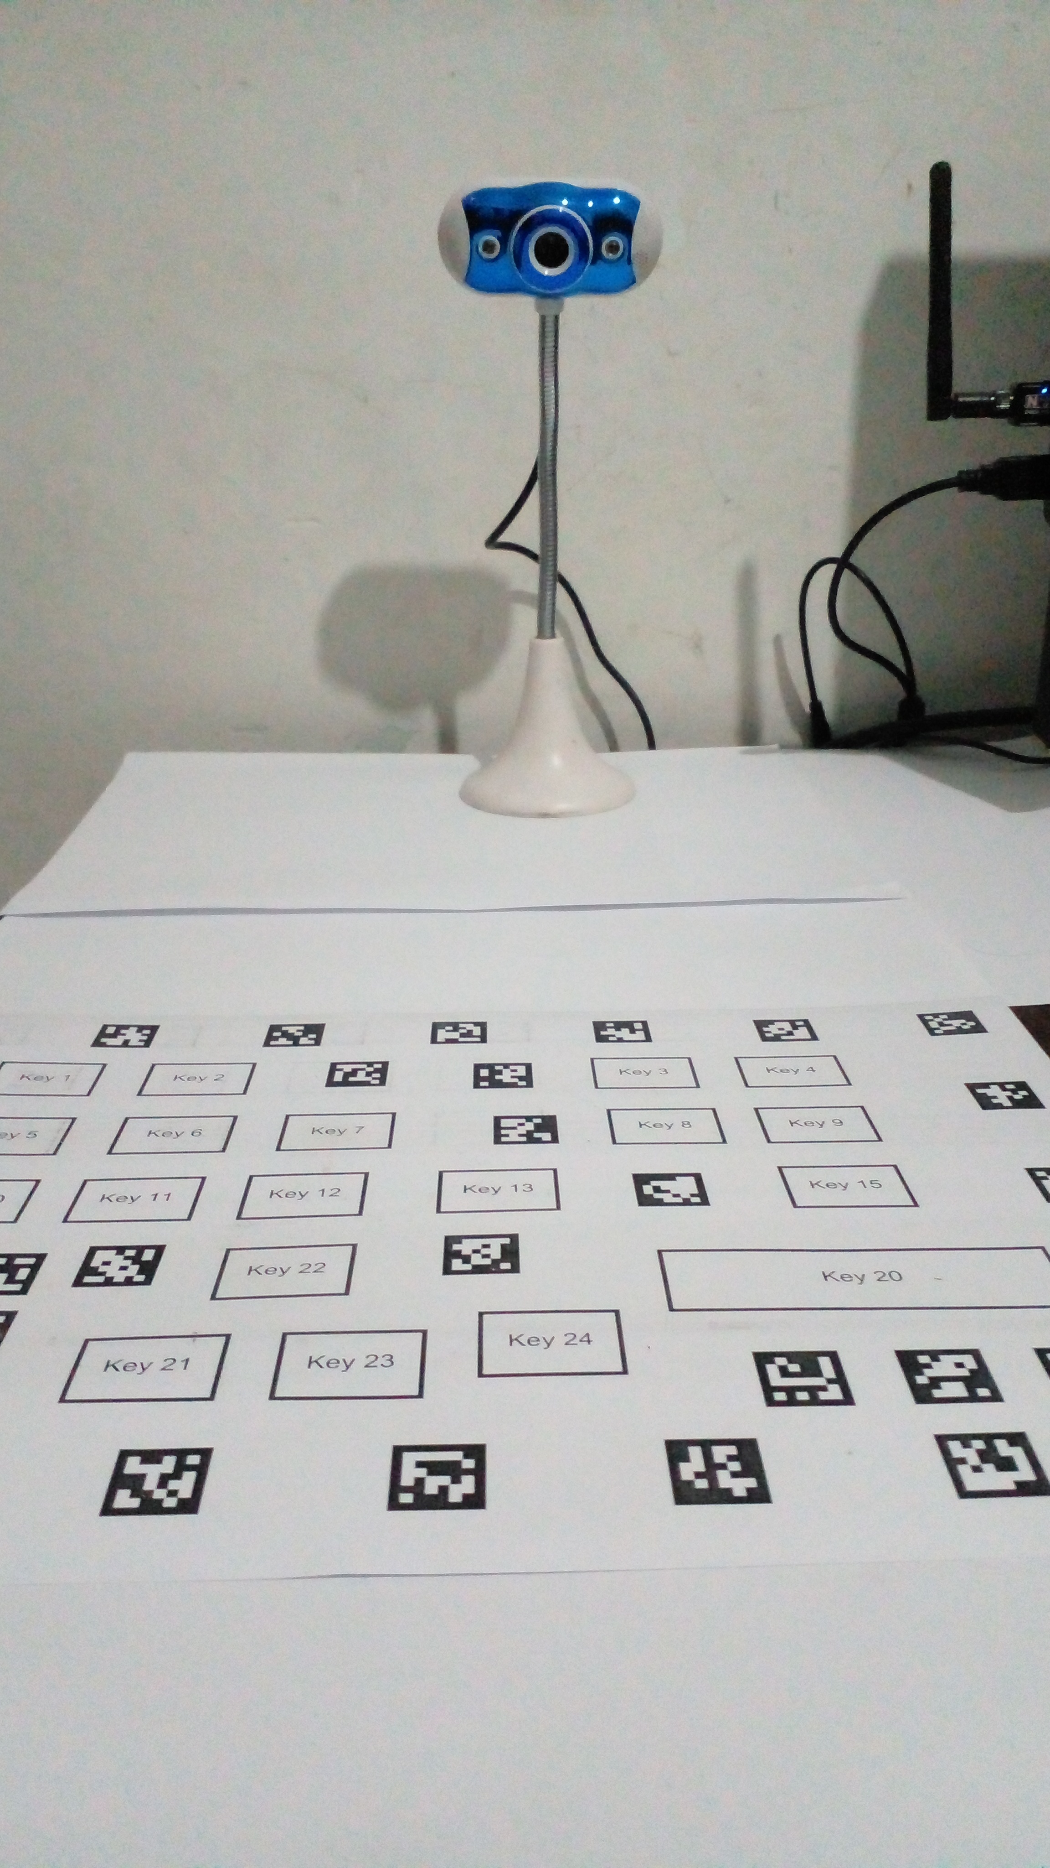
Figure A.1: Physical experimental desk setup with monocular USB webcam mounted on an adjustable arm above the printed paper macro keyboard layout.

A.2 Printable Vector Layout Artifact
The design of the layout that was generated using Application 1 (Layout Designer) is shown in Figure 6.2. The design has been saved at 300 DPI, allowing it to be easily printed in high resolution on ordinary A4 paper using an ordinary office printer. Four AprilTags with IDs 0, 1, 2, and 3 have been located in the corners. The central part contains the custom macro keys with clear border lines and button names.
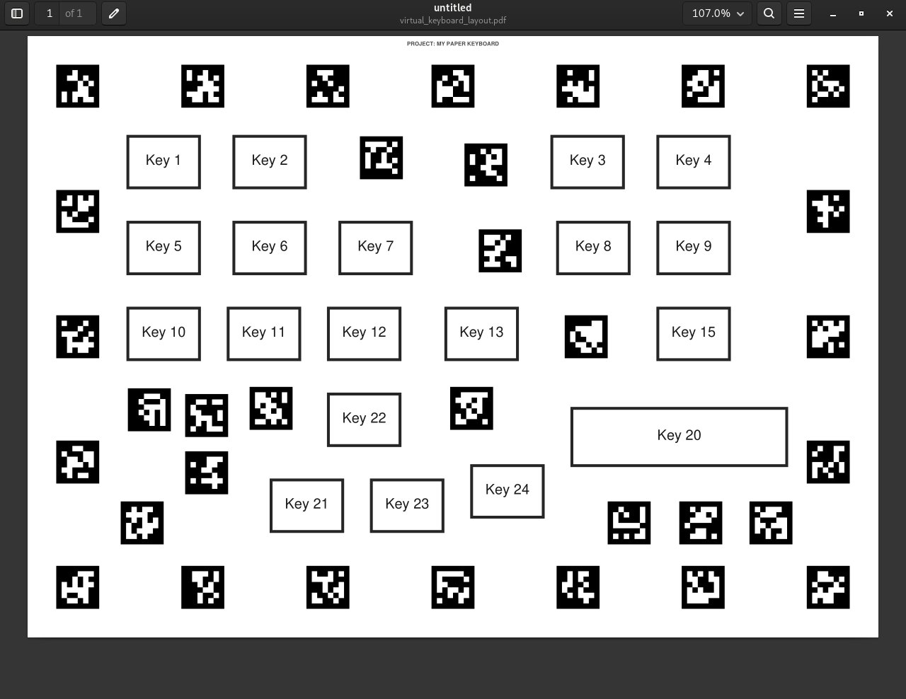
Figure A.2: Exported 300 DPI vector PDF layout embedded with AprilTag border fiducials ready for standard desktop paper printing.

Appendix B: Application 1: Paper Layout Designer Suite

B.1 Overview of the Designer Application
The following screenshots illustrate Application 1 (virtualKeyboardSetup/designer/main.py), which is a layout designer developed using PySide6 (developed from the initial exploratory prototype in designer/). The user can create a new customized keyboard layout for macro keys by moving and resizing buttons as well as exporting the layout as an XML coordinate file and as a PDF document.
The start page of the application is illustrated in Figure 6.3 below where the user can initiate the creation of a new project, load the existing layout, or choose the pre-designed template for various shortcut purposes.
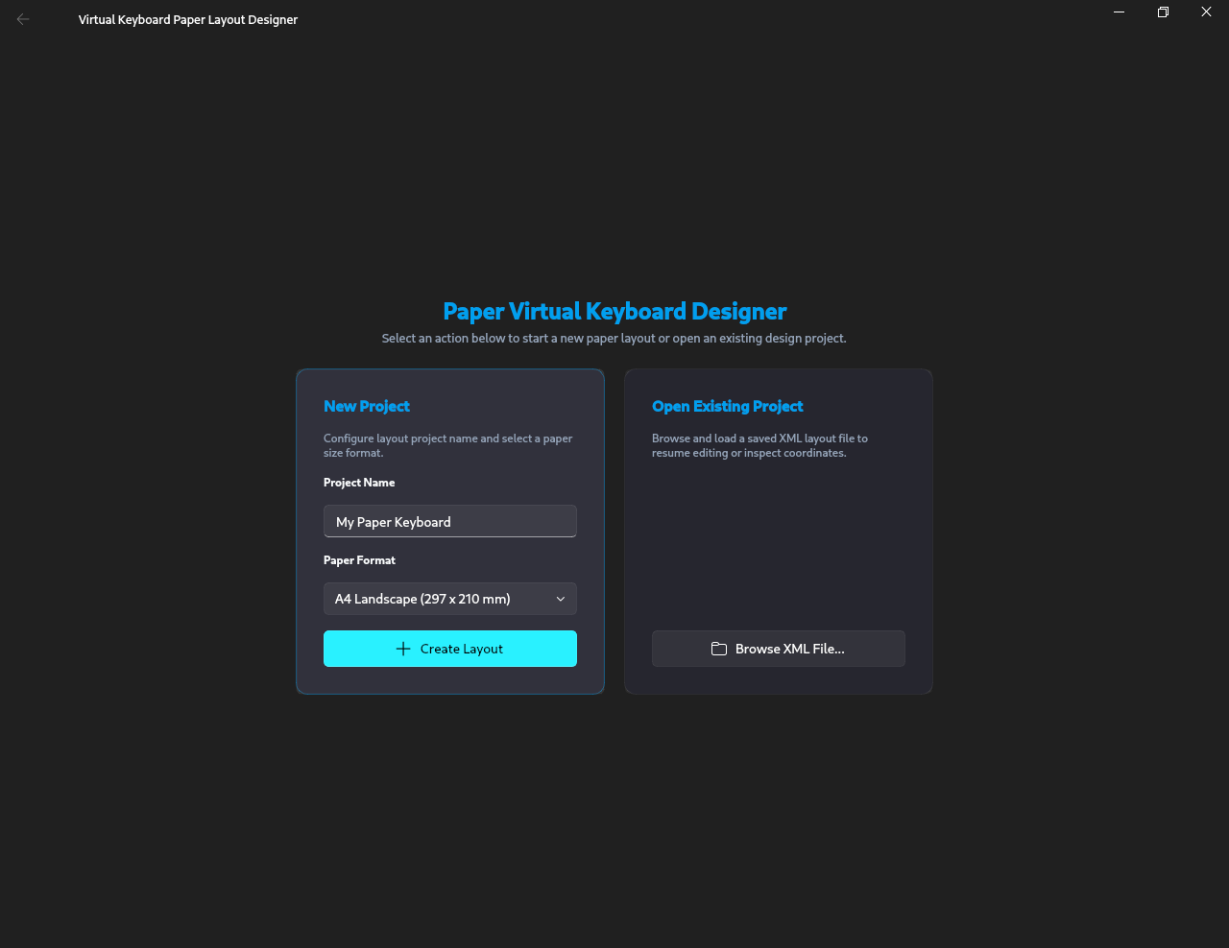
Figure B.1: Application 1 startup window for project selection and template management.

B.2 Interactive 2D Design Canvas and Property Inspector
Figure 6.4 displays the main design screen. The canvas displays an A4 sheet of paper in millimeters. It is easy for users to drag and drop buttons and modify their size and position on the grid. The four AprilTags always remain at the corners automatically. The side pane allows users to modify the name, label, and size of the key, while warning if keys overlap or get too close to the markers.
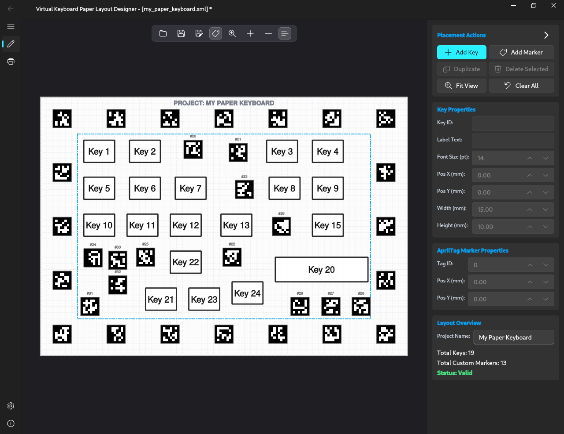
Figure B.2: Application 1 interactive 2D design canvas with key layout tools, metric grid, property inspector, and AprilTag fiducial anchors.

B.3 Vector PDF Export and Print Dialog
Figure 6.5 displays the print dialogue box. The users can view the preview and export the design into a 300 DPI PDF file for printing on an A4 sheet of paper.
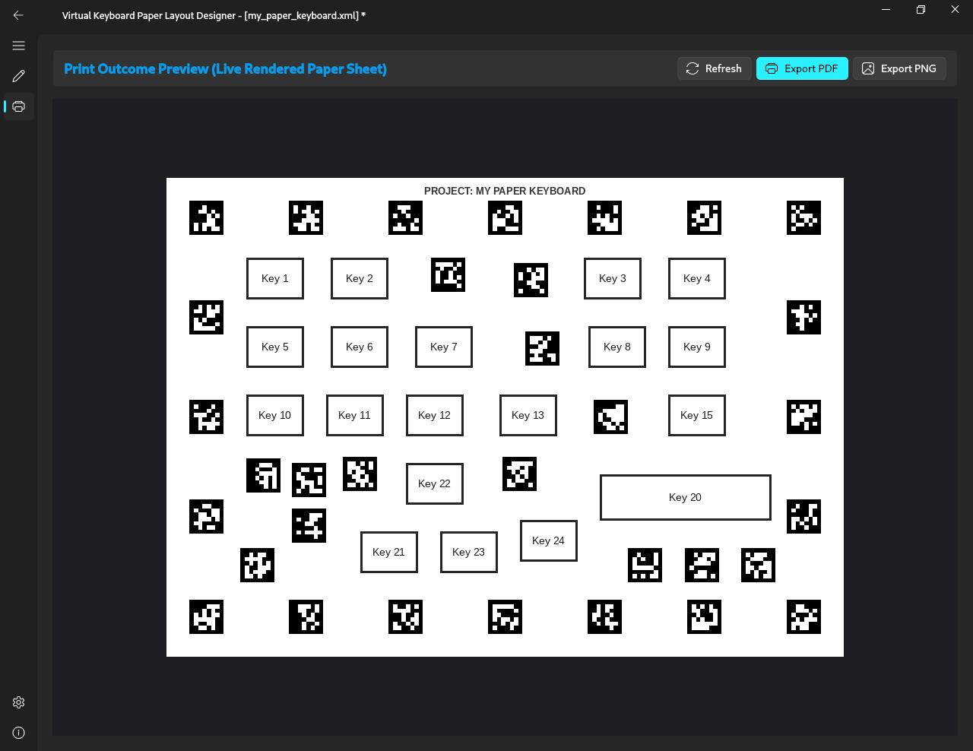
Figure B.3: Application 1 export dialog for generating 300 DPI vector PDF layouts.

B.4 Designer Preferences and Snap-Grid Configuration
Figure [fig:appendix_designer_settings_1] and Figure [fig:appendix_designer_settings_2] demonstrate the configuration windows. The user may set up the format of paper (either A4 Landscape or Portrait, A3, US Letter, or any size up to $1000\text{ mm}$ in millimeters), the size of borders, the size of grid, distance of snap, and minimum button space.
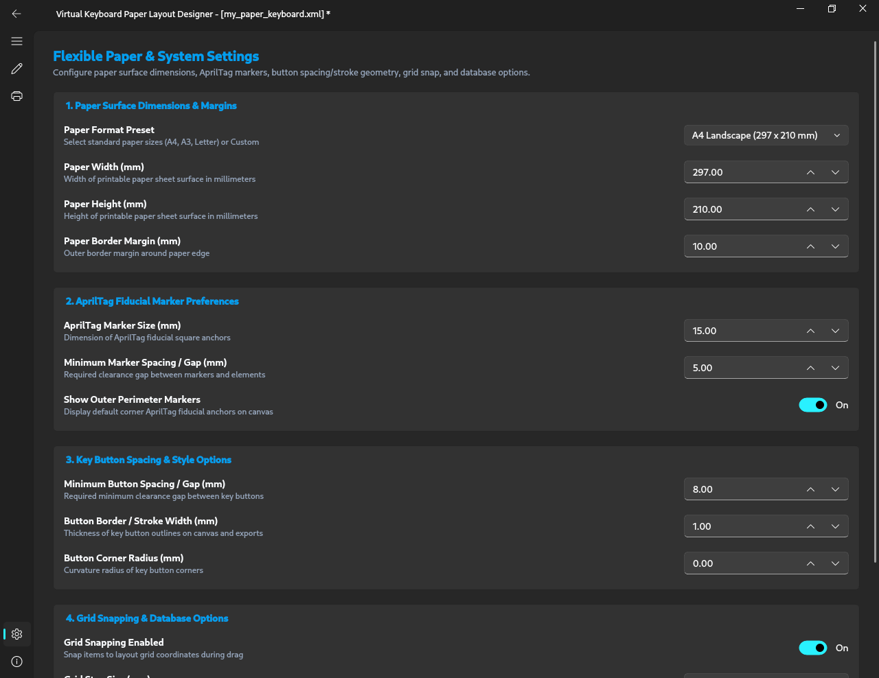
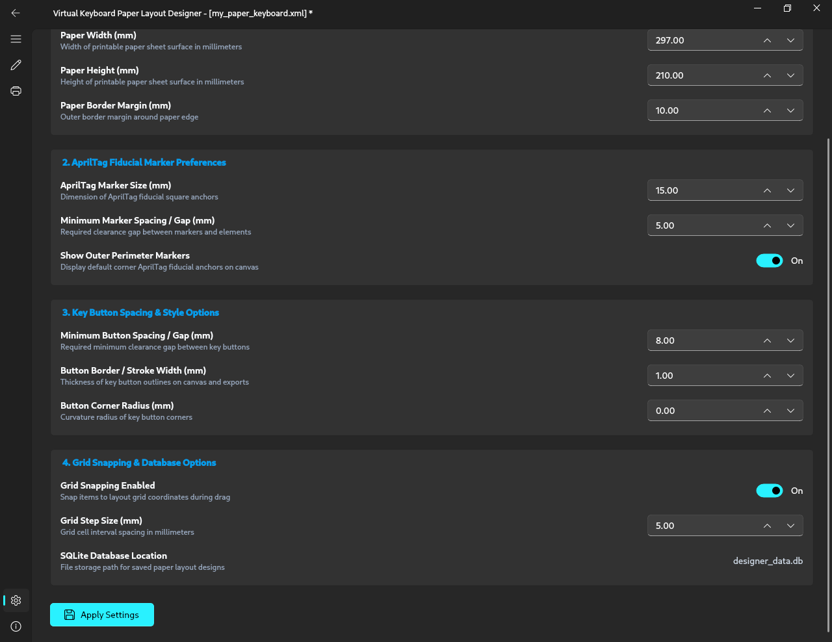

B.5 Exported Paper Layout XML Data Structure
The schema structure of Listing [lst:appendix_sample_xml] shows how the XML layout document (my_paper_keyboard.xml) produced by Application 1 (Layout Designer) and utilized by Application 2 (Runtime Engine) is defined. This includes the physical dimensions of paper ($297×210\text{ mm}$ for A4), outer margin areas, interior areas, metric coordinates of each printed AprilTag fiducial marker’s four corners in sub-pixels, button areas, independent action mappings (keystroke, shortcut, shell, and macro), and runtime detection threshold values.
<?xml version="1.0" ?>
<PaperLayout project_name="My Paper Keyboard" paper_width_mm="297.000" paper_height_mm="210.000" paper_margin_mm="10.000" marker_size_mm="15.000" marker_margin_mm="10.000" marker_spacing_mm="40.000" marker_family="DICT_APRILTAG_36h11" marker_min_gap_ratio="1.500" marker_min_gap_mm="5.000" use_custom_markers="1" show_outer_markers="1" coordinate_origin="top_left_paper_corner (x_right, y_down)" units="millimeters">
<SystemConfig project_name="My Paper Keyboard" app_title="Virtual Keyboard Paper Layout Designer" version="1.0.0" schema_version="2.0" research_suite="Application 1 Layout Designer &amp; Application 2 Runtime Engine"/>
<PaperMargin margin_mm="10.000" top_mm="10.000" bottom_mm="10.000" left_mm="10.000" right_mm="10.000"/>
<MarkerRingZone outer_x_min_mm="10.000" outer_y_min_mm="10.000" outer_x_max_mm="287.000" outer_y_max_mm="200.000" inner_x_min_mm="25.000" inner_y_min_mm="25.000" inner_x_max_mm="272.000" inner_y_max_mm="185.000" marker_size_mm="15.000" marker_family="DICT_APRILTAG_36h11" marker_spacing_mm="40.000" marker_min_gap_ratio="1.500" marker_min_gap_mm="5.000"/>
<InteriorRegion x_min_mm="30.000" y_min_mm="30.000" x_max_mm="267.000" y_max_mm="180.000" width_mm="237.000" height_mm="150.000" interior_buffer_mm="5.000"/>
<ButtonStylingRules button_stroke_width_mm="1.000" button_corner_radius_mm="0.000" button_min_width_mm="15.000" button_min_height_mm="10.000" button_min_gap_mm="8.000" default_font_size_pt="14"/>
<GridConfig grid_snap_enabled="1" grid_size_mm="5.000"/>
<RuntimePipelineSpecs target_camera_fps="12" temporal_window_frames="5" temporal_window_stride="3" mediapipe_num_hands="1" mediapipe_landmarks_count="21" feature_vector_size="84" touch_model_architecture="LSTM" end_to_end_latency_ms="29.09"/>
<Markers count="13" use_custom_markers="1">
<Marker id="20" center_x_mm="123.500" center_y_mm="42.500" size_mm="15.000" family="DICT_APRILTAG_36h11">
<Corners>
<TopLeft x_mm="116.000" y_mm="35.000"/>
<TopRight x_mm="131.000" y_mm="35.000"/>
<BottomRight x_mm="131.000" y_mm="50.000"/>
<BottomLeft x_mm="116.000" y_mm="50.000"/>
</Corners>
</Marker>
<Marker id="21" center_x_mm="160.000" center_y_mm="45.000" size_mm="15.000" family="DICT_APRILTAG_36h11">
<Corners>
<TopLeft x_mm="152.500" y_mm="37.500"/>
<TopRight x_mm="167.500" y_mm="37.500"/>
<BottomRight x_mm="167.500" y_mm="52.500"/>
<BottomLeft x_mm="152.500" y_mm="52.500"/>
</Corners>
</Marker>
<!-- Additional AprilTag border markers 22 through 32 ... -->
</Markers>
<Buttons count="19">
<Button id="btn_1" x_mm="35.000" y_mm="35.000" width_mm="25.000" height_mm="18.000" x_max_mm="60.000" y_max_mm="53.000" center_x_mm="47.500" center_y_mm="44.000">
<Style font_size_pt="14" stroke_width_mm="1.000" corner_radius_mm="0.000"/>
<Text>Key 1</Text>
</Button>
<Button id="btn_4" x_mm="220.000" y_mm="35.000" width_mm="25.000" height_mm="18.000" x_max_mm="245.000" y_max_mm="53.000" center_x_mm="232.500" center_y_mm="44.000">
<Style font_size_pt="14" stroke_width_mm="1.000" corner_radius_mm="0.000"/>
<Text>Key 4</Text>
</Button>
<Button id="btn_7" x_mm="109.000" y_mm="65.000" width_mm="25.000" height_mm="18.000" x_max_mm="134.000" y_max_mm="83.000" center_x_mm="121.500" center_y_mm="74.000">
<Style font_size_pt="14" stroke_width_mm="1.000" corner_radius_mm="0.000"/>
<Text>Key 7</Text>
</Button>
<Button id="btn_13" x_mm="146.000" y_mm="95.000" width_mm="25.000" height_mm="18.000" x_max_mm="171.000" y_max_mm="113.000" center_x_mm="158.500" center_y_mm="104.000">
<Style font_size_pt="14" stroke_width_mm="1.000" corner_radius_mm="0.000"/>
<Text>Key 13</Text>
</Button>
<!-- Additional button definitions ... -->
</Buttons>
<DetectorActions>
<Actions count="19">
<Action button_id="btn_1" label="Key 1" type="keystroke" value="r"/>
<Action button_id="btn_4" label="Key 4" type="shortcut" value="ctrl+r"/>
<Action button_id="btn_7" label="Key 7" type="shell" value="gnome-terminal"/>
<Action button_id="btn_13" label="Key 13" type="macro" value="asdf"/>
<!-- Additional action mappings ... -->
</Actions>
</DetectorActions>
<DetectorSettings count="22">
<Setting name="TARGET_FPS" value="12.0"/>
<Setting name="TOUCH_THRESHOLD" value="0.85"/>
<Setting name="TOUCH_ONSET_THRESHOLD" value="0.85"/>
<Setting name="FINGERTIP_VELOCITY_THRESHOLD" value="0.2000"/>
<Setting name="MIN_KINETIC_SPEED_THRESHOLD" value="0.2000"/>
<Setting name="HAND_MOVEMENT_THRESHOLD" value="0.2000"/>
<Setting name="MEDIAPIPE_MIN_DETECTION_CONFIDENCE" value="0.60"/>
<Setting name="MEDIAPIPE_MIN_PRESENCE_CONFIDENCE" value="0.60"/>
<Setting name="MEDIAPIPE_MIN_TRACKING_CONFIDENCE" value="0.50"/>
<Setting name="QUALITY_MIN_AVG_SCORE" value="0.60"/>
<Setting name="QUALITY_MIN_FRAME_SCORE" value="0.60"/>
<Setting name="QUALITY_MAX_SCORE_DROP" value="0.35"/>
<Setting name="FINGERTIP_OFFSET_ENABLED" value="true"/>
<Setting name="FINGERTIP_FORWARD_OFFSET_MM" value="5.00"/>
<Setting name="TOUCH_RELEASE_WINDOWS" value="2"/>
<Setting name="TOUCH_MAX_STATIONARY_DISTANCE_MM" value="4.0"/>
<Setting name="PRINTED_MARKER_SIDE_WIDTH_MM" value="15.00"/>
</DetectorSettings>
</PaperLayout>

Appendix C: Application 2: Runtime Virtual Keyboard Engine and Live Tracking

C.1 Overview of the Runtime Engine
Below are the screenshots of Application 2, which is the runtime virtual keyboard application. This application is responsible for tracking AprilTag markers, tracking hand joint positions using MediaPipe, detecting finger touches using our PyTorch LSTM model, and executing the assigned keyboard shortcuts.
Figure 6.6 represents the opening screen where the user can choose the webcam, select the layout XML file, and pick up an action profile.
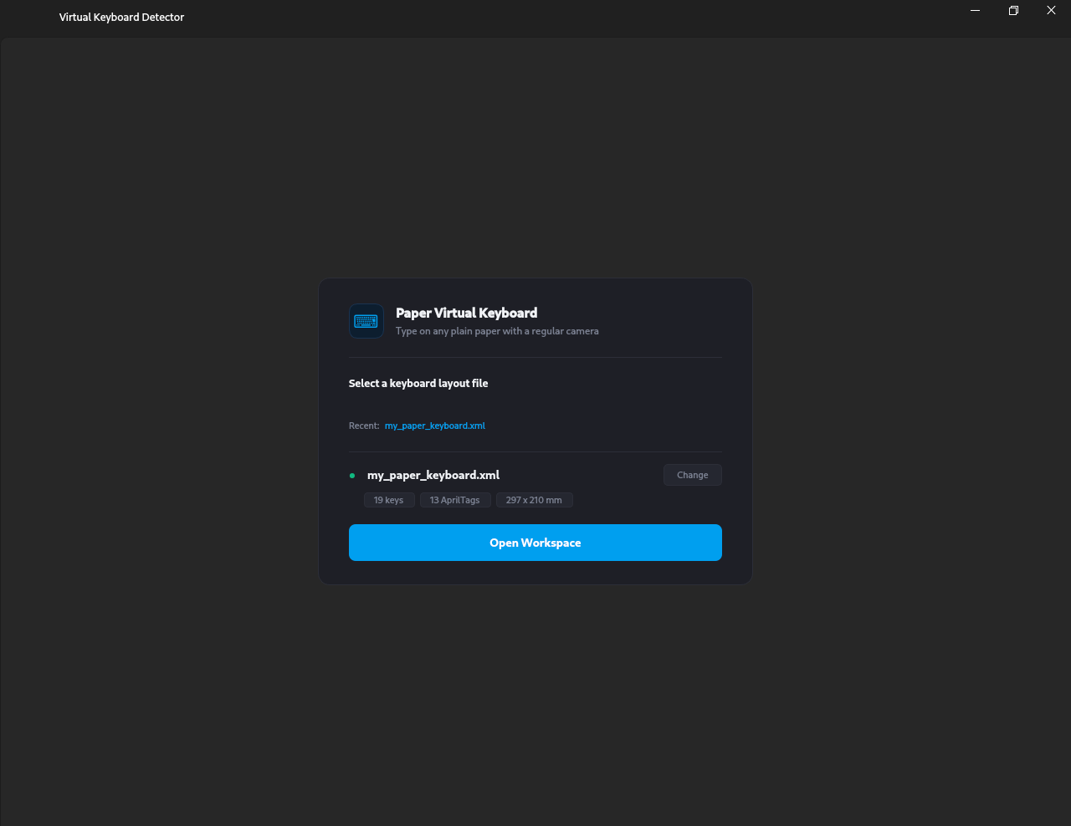
Figure C.1: Application 2 home screen for camera device selection and layout loading.

C.2 Action Rebinding and Profile Management
Figure 6.7 illustrates the window that allows rebinding of actions. It is possible to assign any desired action to the key in question, either from standard shortcuts (such as Ctrl+C and Alt+Tab) or from terminal scripts. The same XML file is used in both the applications, where key actions and detector settings are saved in the <DetectorActions> and <DetectorSettings> parts of the layout XML. There is no need for additional files anymore, and it is possible to alternate XML action layouts on one printed sheet of paper without printing again.
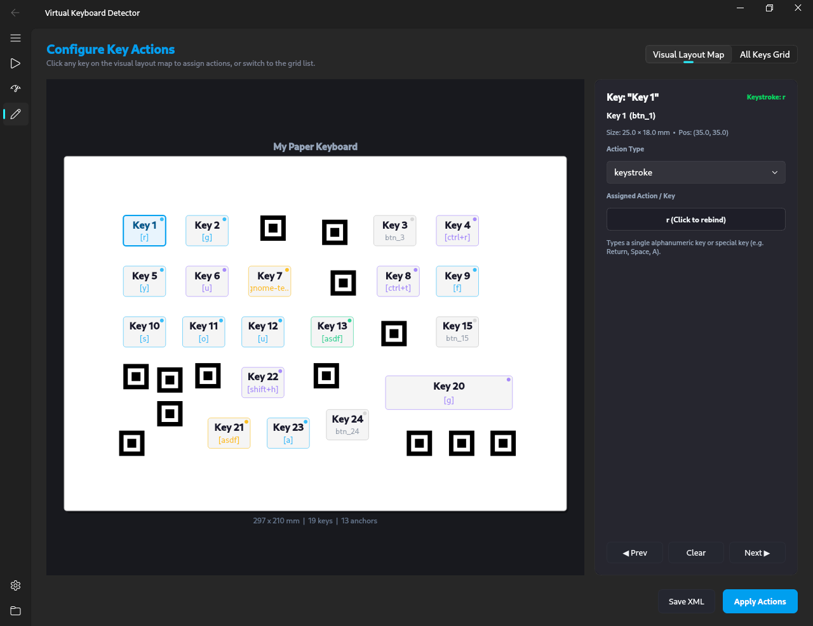
Figure C.2: Application 2 action rebinding interface for assigning keystrokes and shell commands to macro keys.

C.3 Live Camera Tracking in Idle and Contact States
Figure 6.8 presents the camera live stream without the presence of any hand. The software detects the four AprilTags placed in the corners and determines the homography matrix $H$ to draw the boxes on the camera feed.
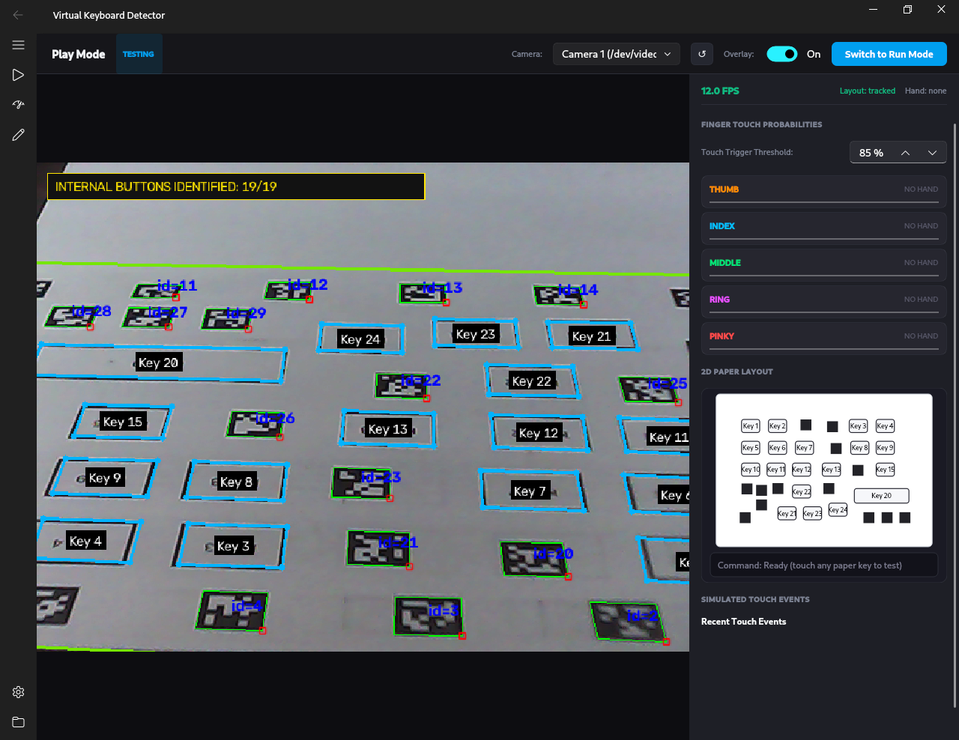
Figure C.3: Application 2 idle monitoring state showing detected AprilTags, homography alignment, and key bounding boxes.
Figure 6.9 demonstrates what occurs when a finger comes into contact with a key. MediaPipe is capable of following the 21 joints of the hand in real time. Once the index finger makes contact with the paper, the PyTorch LSTM model is able to predict a touch probability of 96% for the index finger, highlights the key in green on the screen, and sends the keystroke to the computer.
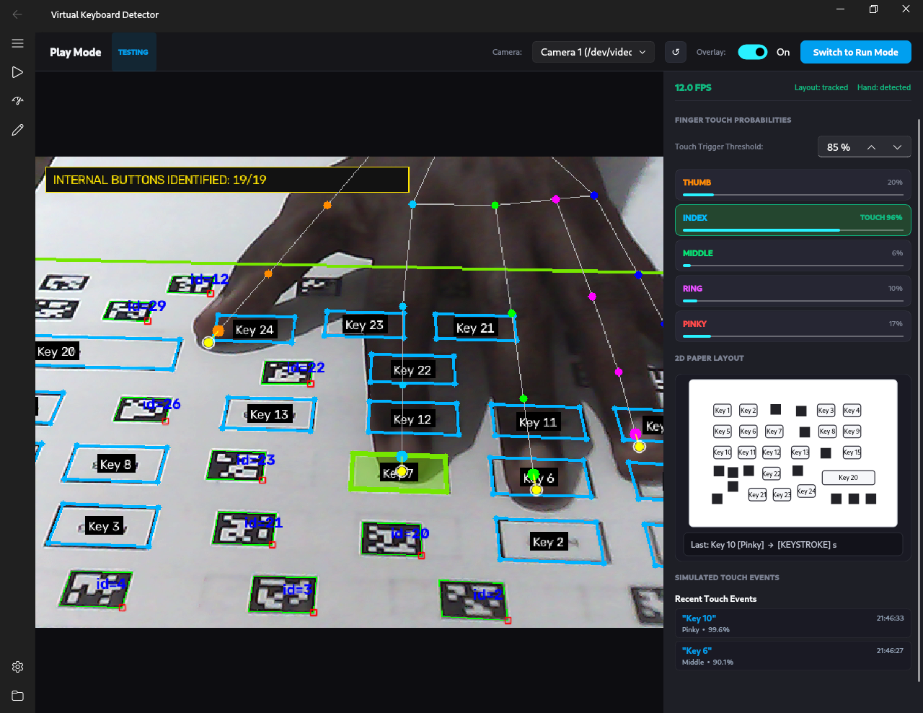
Figure C.4: Application 2 live contact detection showing MediaPipe skeleton, 96% index touch probability, and highlighted key impact.

C.4 Production Run Mode and Action Event Log
Live Run Mode is illustrated in Figure 6.10. A line graph displays the touch probability for each finger over time. As seen from the screen, the program runs efficiently at 11.9 FPS with inference time being just 2.3 ms on the CPU. The list on the right displays recent keystrokes.
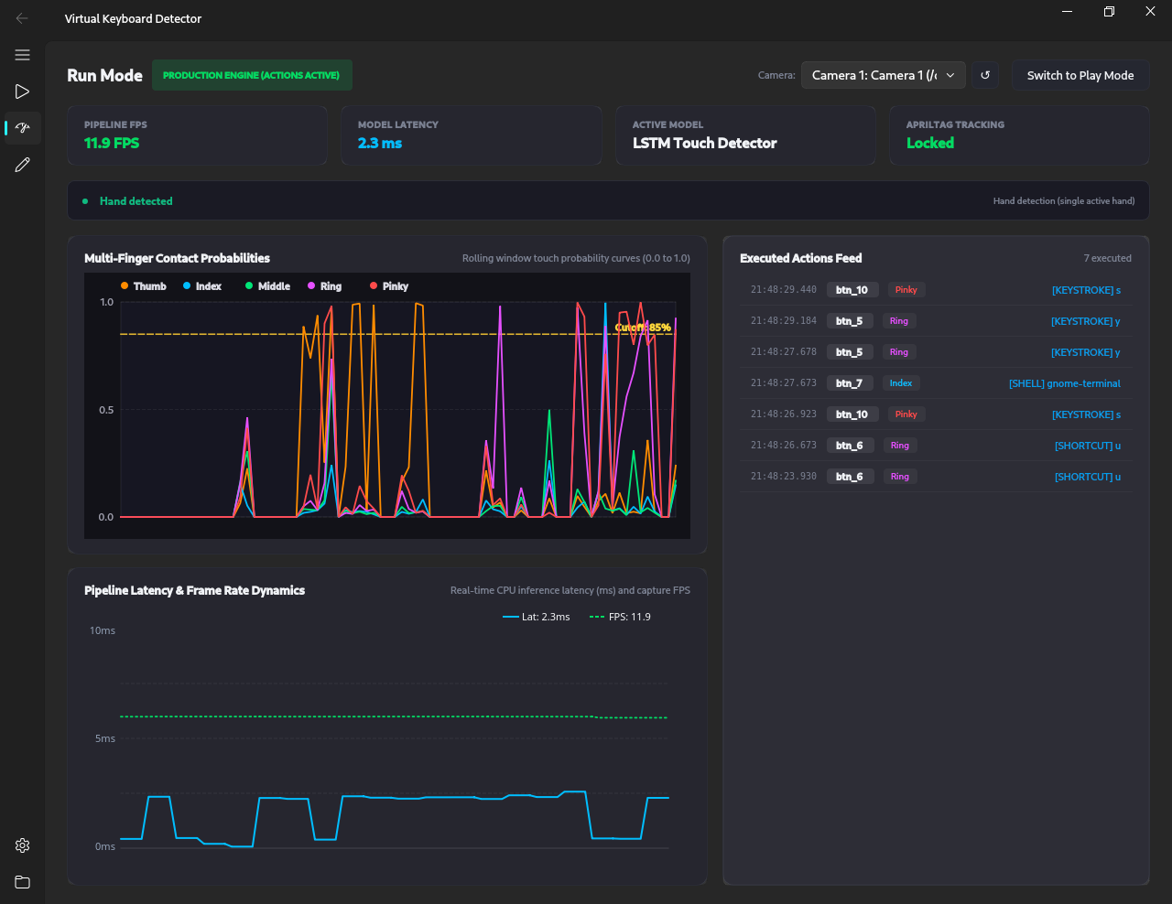
Figure C.5: Application 2 production run mode showing real-time multi-finger probability history, pipeline FPS, and action event log.

C.5 Runtime Engine Preferences and Detection Parameters
Figure [fig:appendix_detector_settings_1] and Figure [fig:appendix_detector_settings_2] illustrate the settings interface. The user can customize the touch sensitivity ($τ_{\text{touch}}$), delay in between touches, and camera update rates.
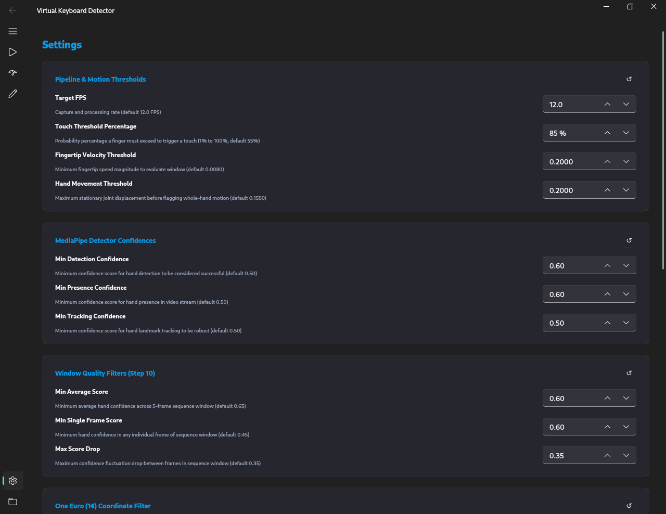
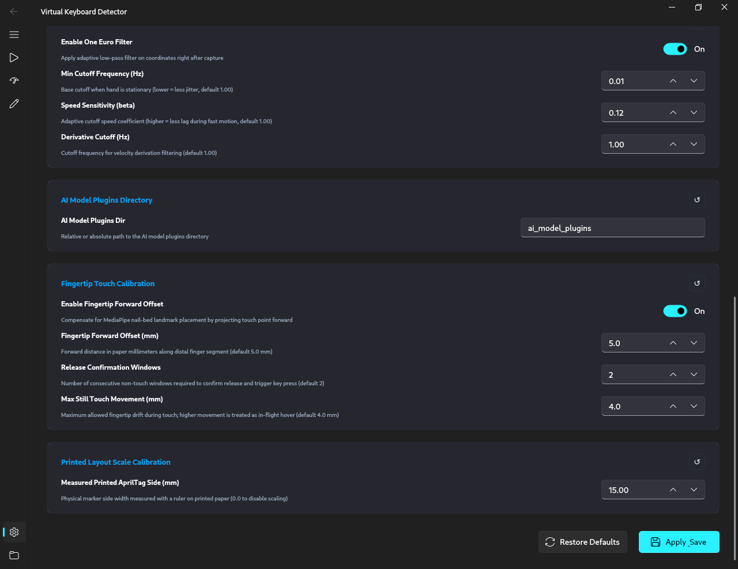

Appendix D: Ground-Truth Dataset Annotation Platform

D.1 Overview of the Annotation Suite
This appendix contains the screenshots of the dataset labeling software that we developed in order to label the touches in videos. Properly annotating the touch data on a frame-by-frame basis was essential for training and testing our PyTorch model.
Figure 6.11 shows the opening screen of the application, where we choose our video files and key layout preferences.
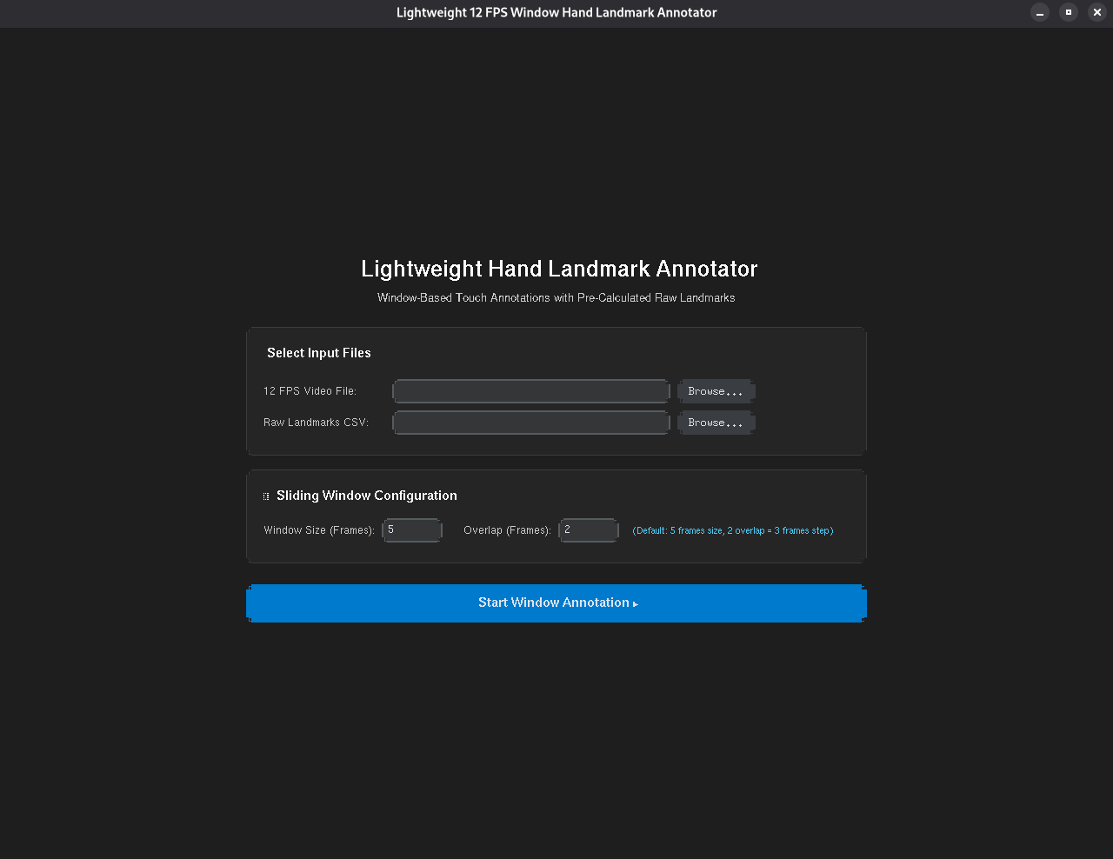
Figure D.1: Dataset annotation tool home screen for video session management.

D.2 Frame-by-Frame Skeletal Annotation Interface
Figure 6.12 represents the primary labeling interface. The recorded videos are displayed in the form of frames with a rate of 12 FPS. The 21 hand joints from MediaPipe are shown directly over the hand. We use the buttons on the right to label if each finger (Thumb, Index, Middle, Ring, Pinky) touches the paper or not in each frame.
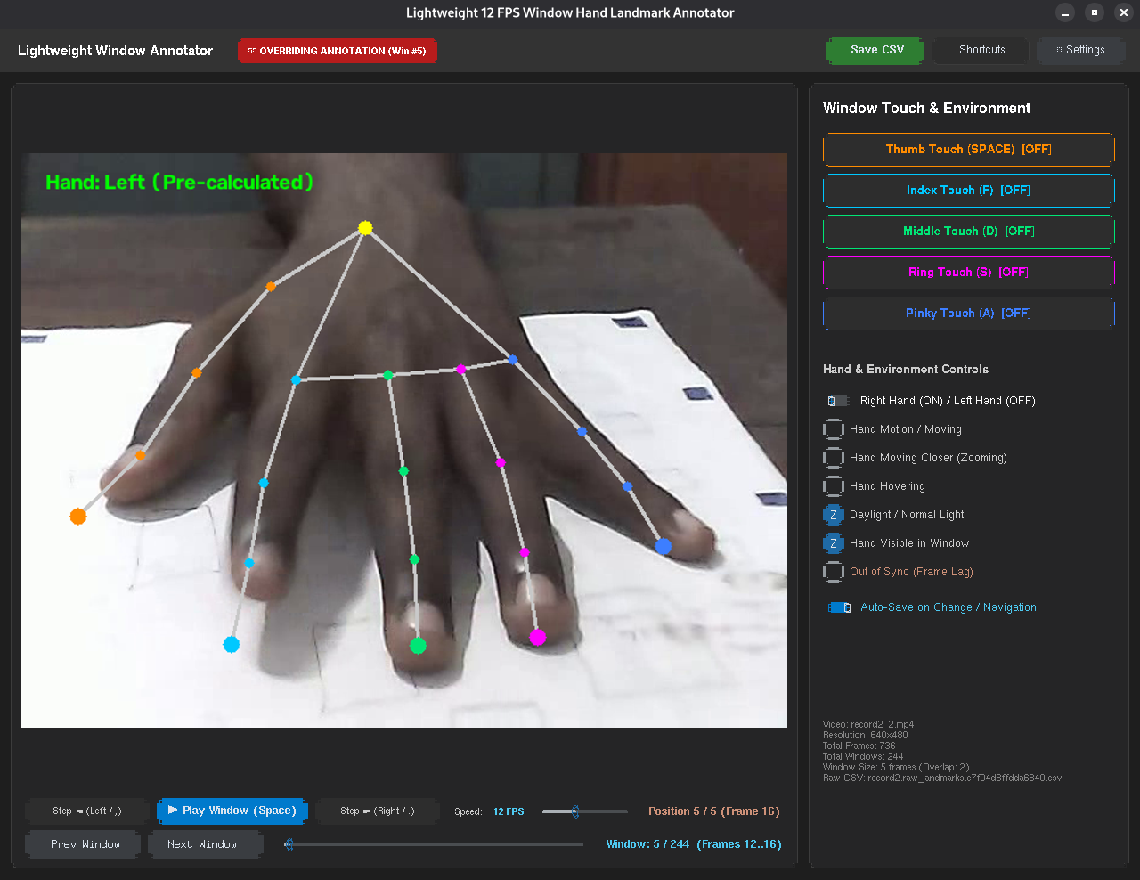
Figure D.2: Dataset annotator main interface showing 12 FPS frame navigation, MediaPipe skeleton overlay, and per-digit contact labeling.

D.3 Rapid Keyboard Shortcuts for Annotation Efficiency
Figure 6.13 illustrates the dialog box for the shortcuts in the annotator. As we had to annotate thousands of frames, we introduced some keyboard shortcuts such as keys 1 to 5 to toggle fingers and the spacebar to jump to the next frame.
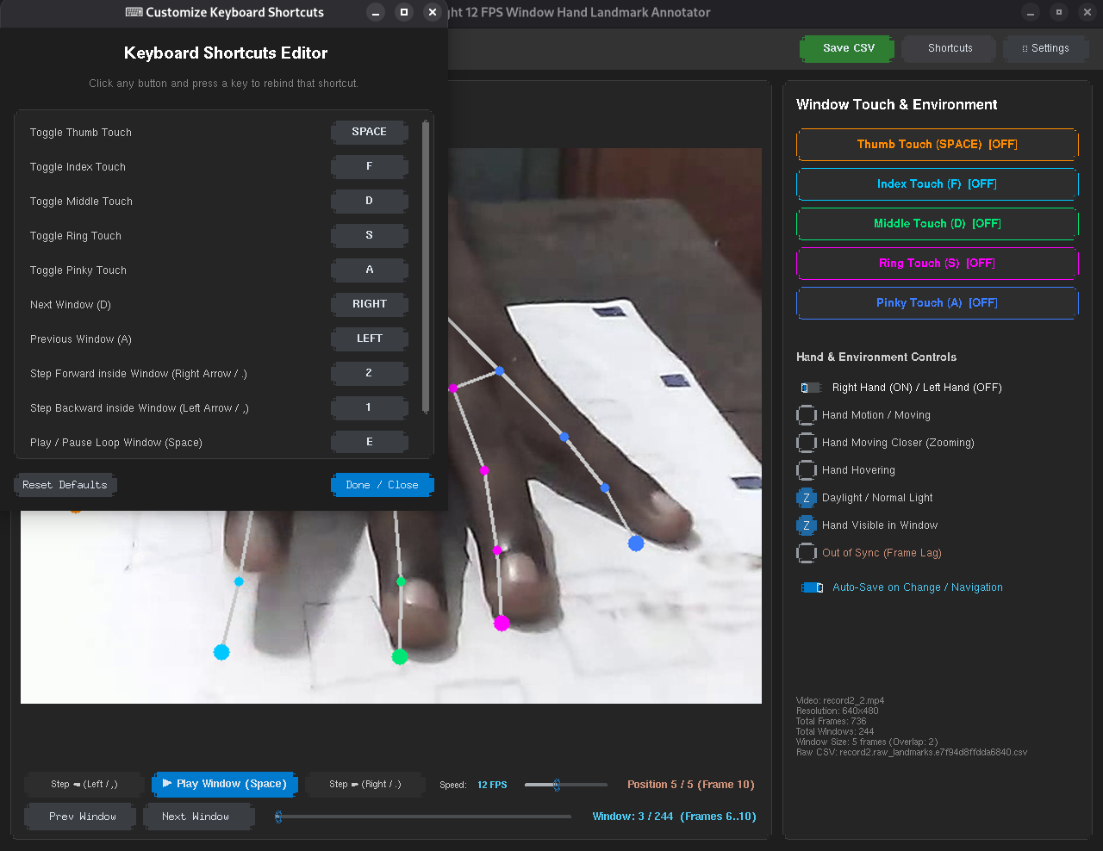
Figure D.3: Keyboard shortcut dialog enabling rapid multi-finger ground truth tagging during video annotation.

Appendix E: Empirical Model Benchmarking and Latency Profiling

E.1 Overview of Empirical Benchmark Charts
The following figures in this appendix are the graph and chart representations of the experimental results analysis covered in Chapter 5. They include comparisons among deep learning methods, confusion matrices for each finger, accuracy of AprilTag homography tracking in terms of tilt angles, and runtime CPU latency.

E.2 Model Architecture Accuracy versus CPU Latency
The Macro F1-score and CPU inference time of various deep learning architectures have been compared in Figure 6.14 of the current benchmark test. The uni-directional LSTM with scale-normalized position and velocity scores best among all architectures with an F1-score of 0.963 and CPU inference time of $2.08\text{ ms}$ on the CPU.
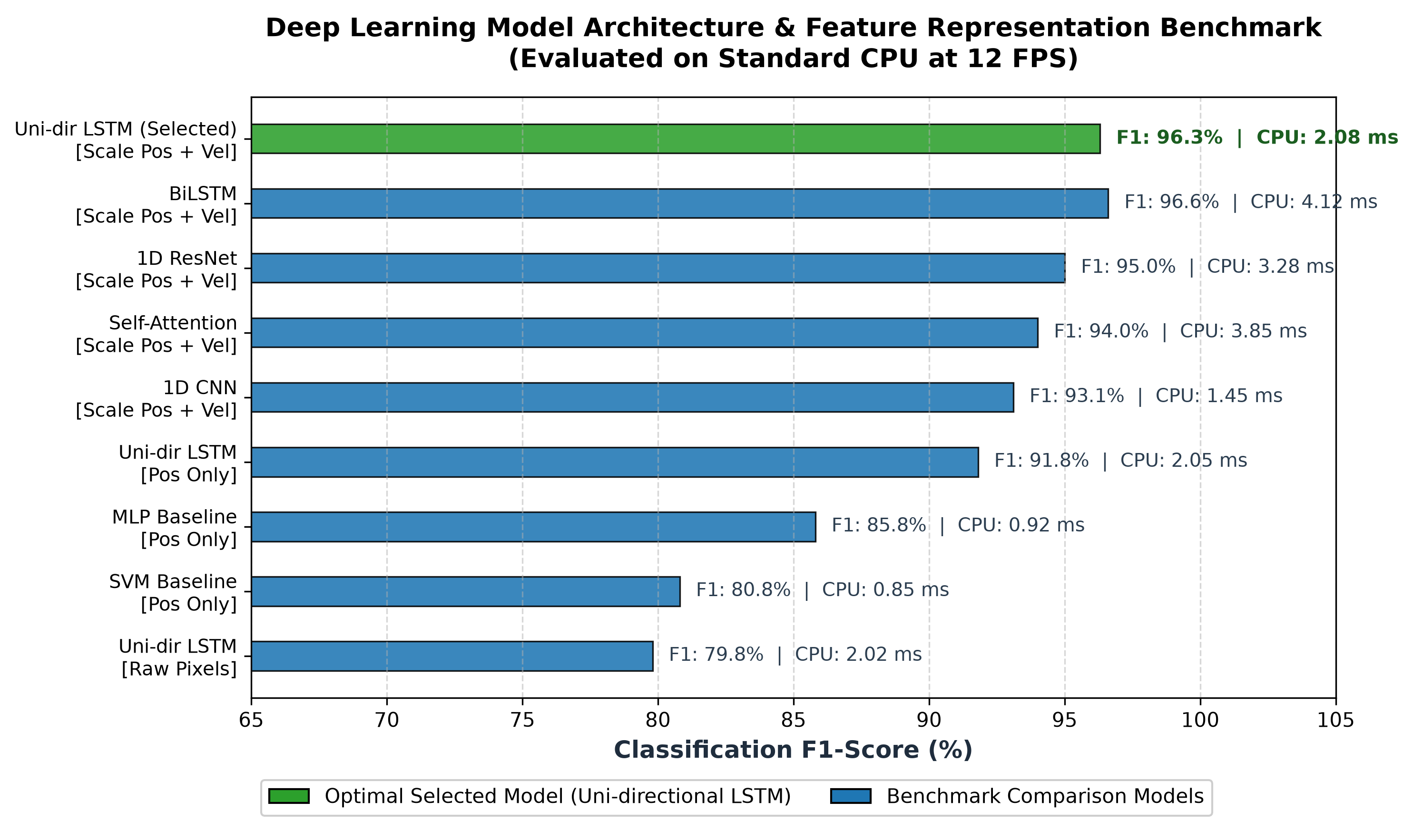
Figure E.1: Comparison of Macro F1-score and CPU inference latency across evaluated deep learning model architecture families.

E.3 Per-Digit Touch Confusion Matrix
As shown in Figure 6.15, the normalized confusion matrix for our chosen PyTorch LSTM model was generated using 5,000 test windows. All five fingers have touch detection accuracies greater than 93%. The highest accuracy belongs to the index finger (99.0% recall), while the pinky finger is slightly lower due to its smaller movement.
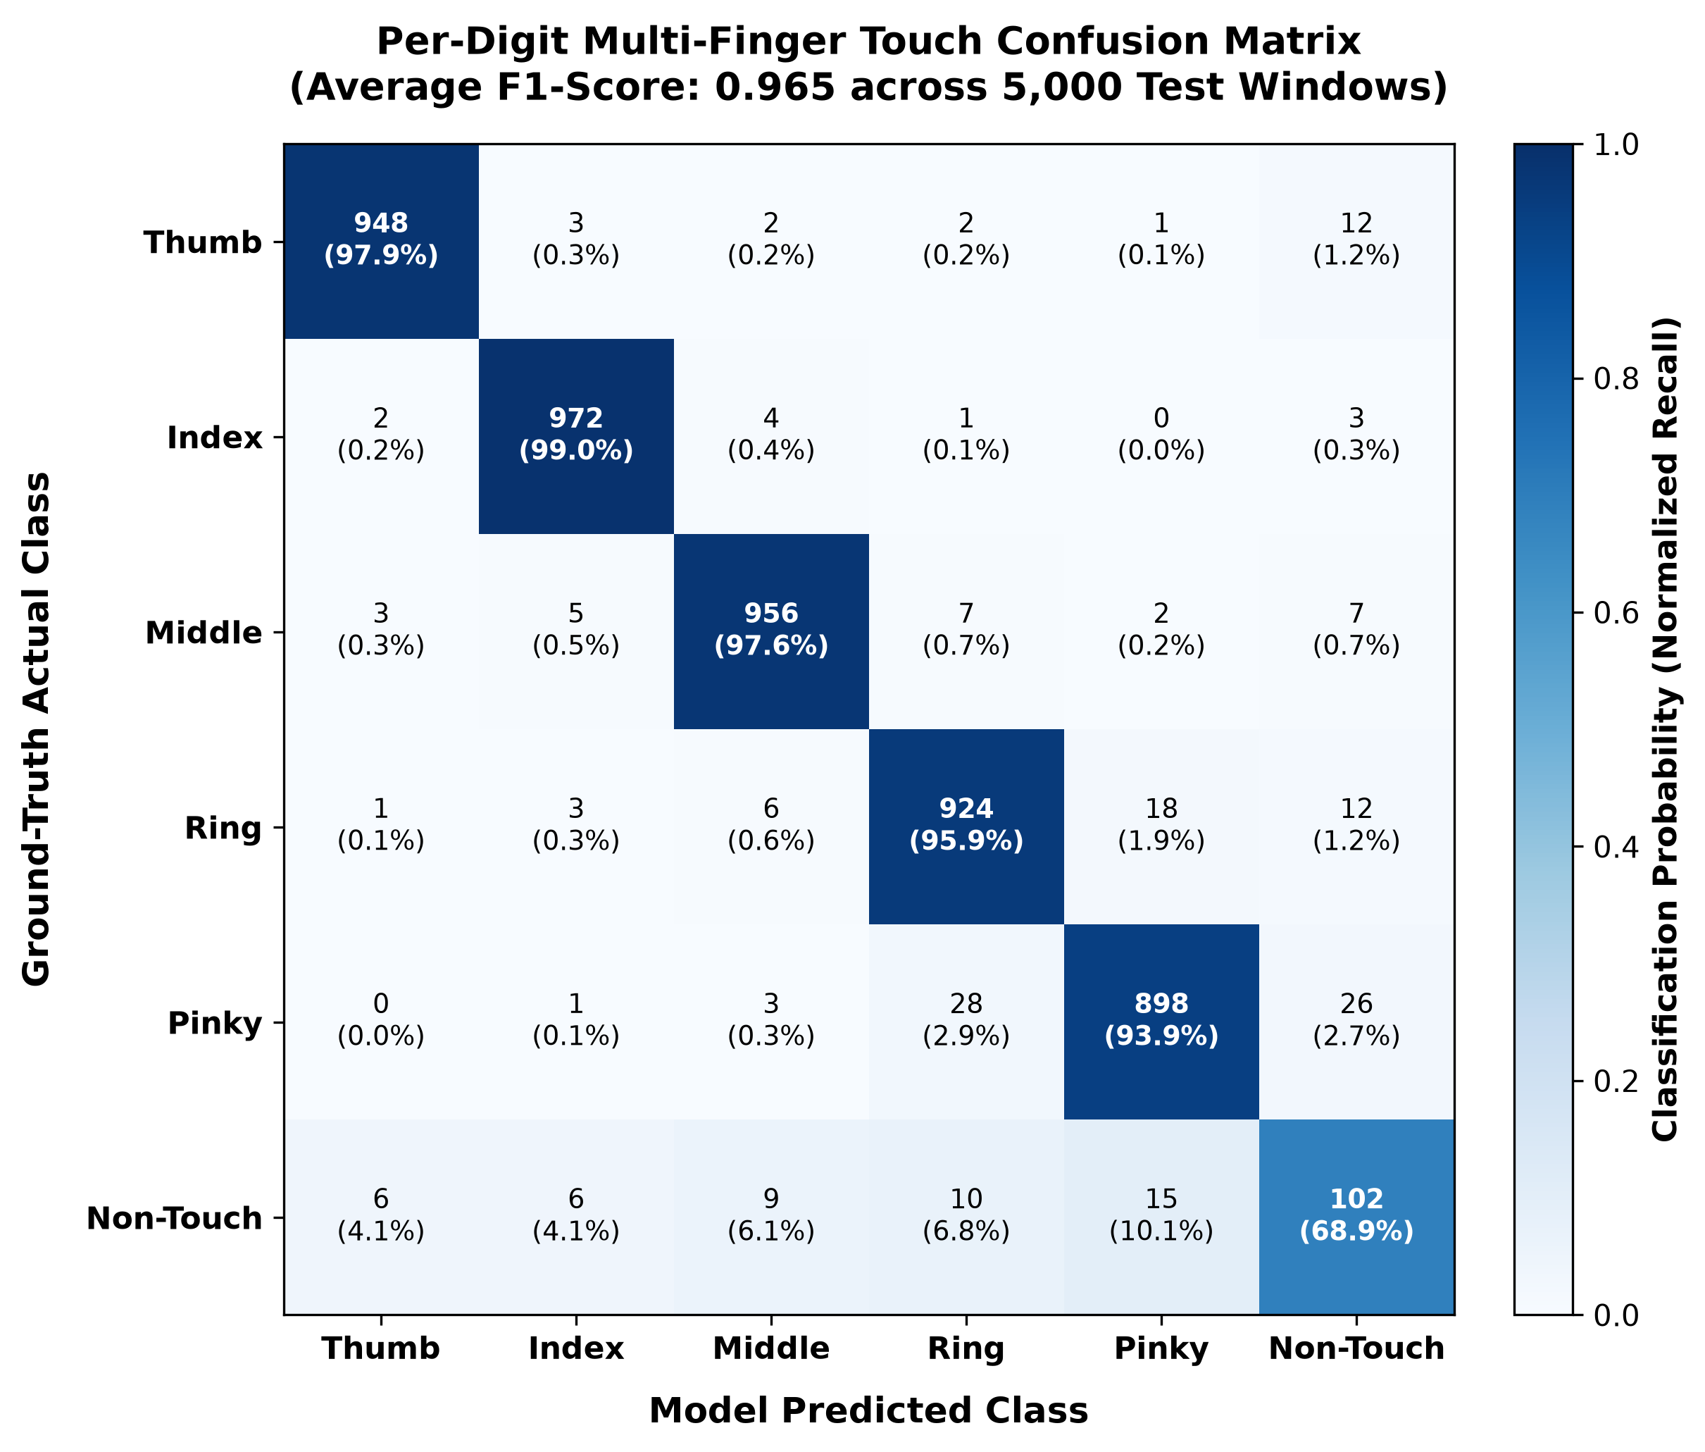
Figure E.2: Normalized confusion matrix of the PyTorch LSTM touch classifier across all five individual finger digits.

E.4 AprilTag Homography Tracking Under Perspective Tilt
The influence of camera tilt angles (ranging from $0^{∘}$ to ${75}^{∘}$) on AprilTag tracking is presented in Figure 6.16. The corner detection percentage remains close to 100%, while the average tracking error remains at less than $0.42\text{ mm}$ for angles ranging from $0^{∘}$ to ${60}^{∘}$ of the desk. Beyond ${65}^{∘}$, there is an increase in error due to perspective tilt, showing that $0^{∘}$ to ${60}^{∘}$ is the best angle range.
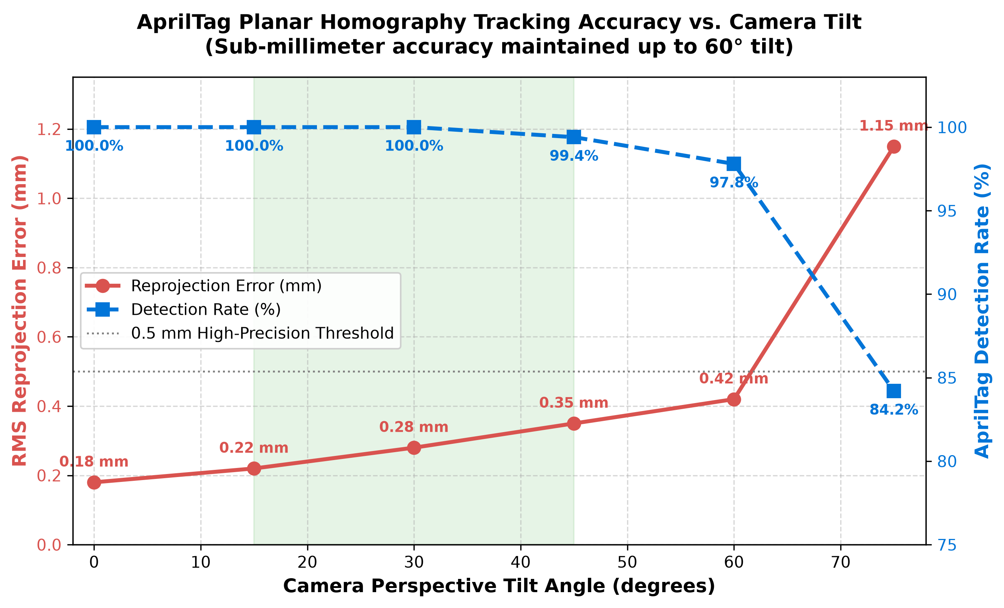
Figure E.3: AprilTag corner detection rate and RMS planar reprojection error across camera perspective tilt angles.

E.5 Multi-Threaded Real-Time Pipeline Latency Breakdown
As can be seen in Figure 6.17, this represents the time required for each pipeline stage to execute itself on an Intel Core i7 processor. Total time required for processing is $29.09\text{ ms}$ (approximately $34.4\text{ FPS}$). It utilizes only about 35% of the total possible $83.33\text{ ms}$ budget at 12 FPS, which means the program runs smoothly in real time without needing a GPU.
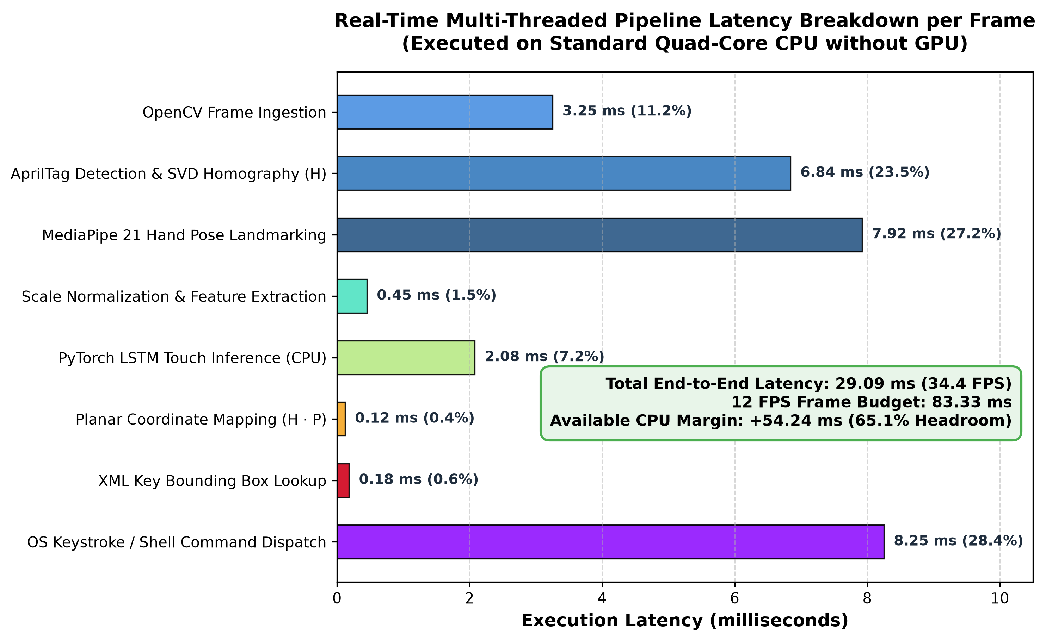
Figure E.4: End-to-end CPU execution latency breakdown per frame across the multi-threaded virtual keyboard pipeline.

