2. Data Loading
df = pd.read_excel('Initial_Trial_results.xlsx', sheet_name='Sheet1', engine='openpyxl')
- pandas reads the Excel file into a DataFrame.
- Dataset columns: R, G, B (color channel values), PPM (target), Gray (derived intensity).
Theory:
- In supervised learning, features (X) are inputs (here, RGB values), and target (y) is the output we want to predict (PPM).
- The .describe() method gives statistical summaries: mean, std deviation, min, max, quartiles.
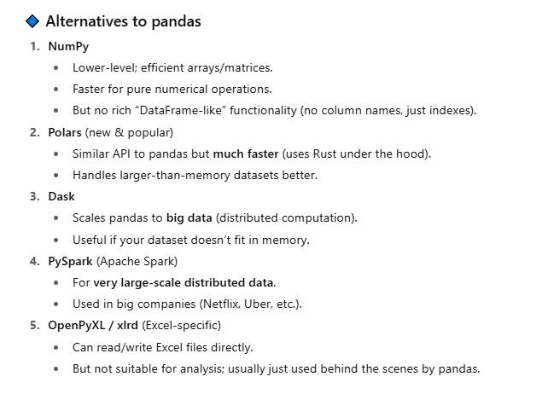
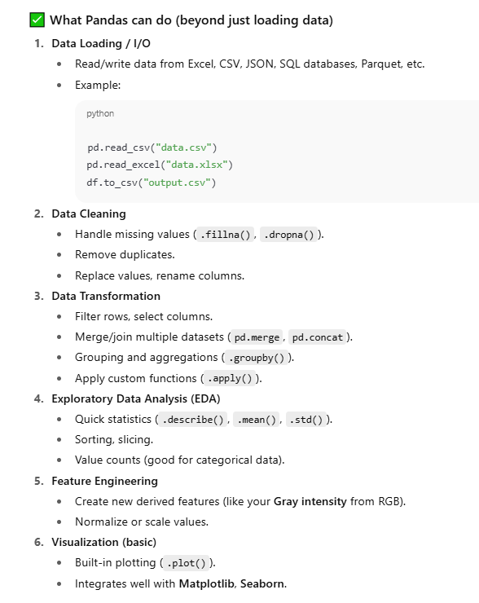

3. Data Preprocessing

3.1 Normalization
df[['R_norm', 'G_norm', 'B_norm']] = df[['R', 'G', 'B']] / 255
df['PPM_norm'] = df['PPM'] / max_ppm
- RGB values range 0–255 → scaled to 0–1.
- PPM normalized relative to its max value.
Theory:
- Normalization ensures features are on the same scale → improves model convergence.
- Many algorithms (including linear regression) work better when feature ranges are similar.
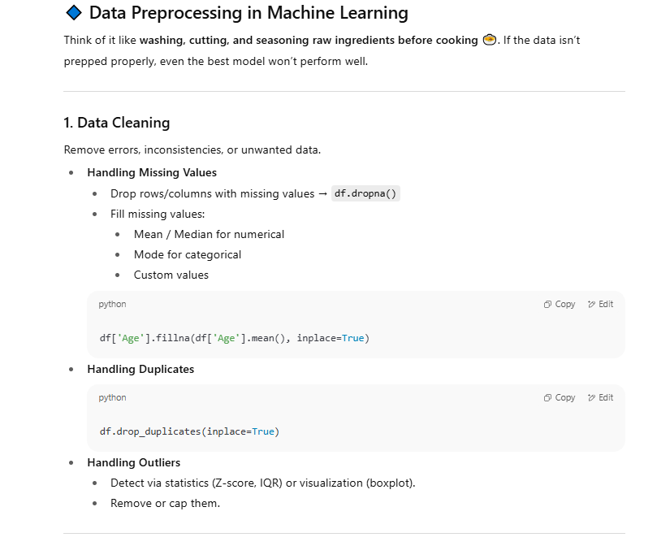
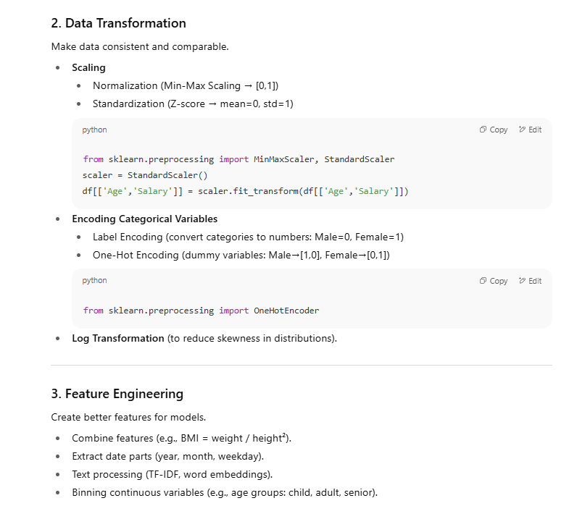
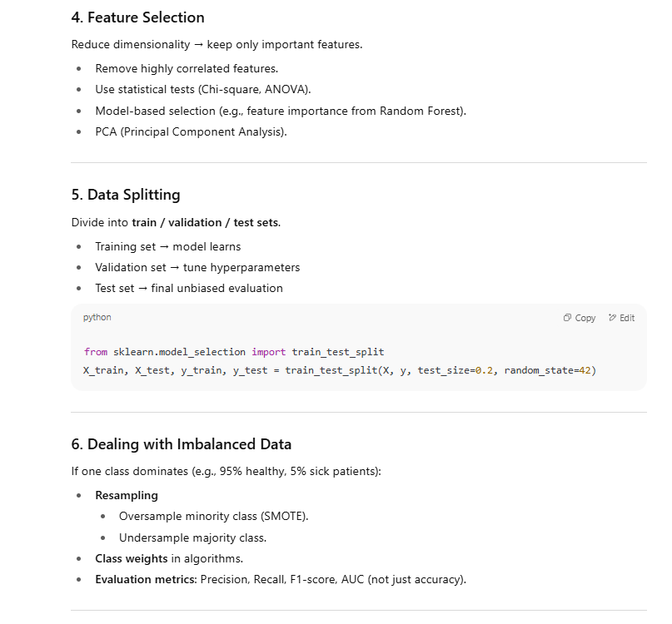
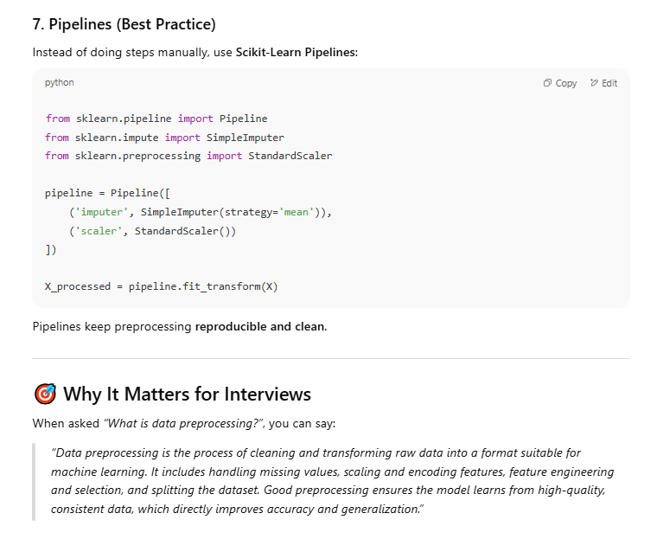

3.2 Outlier Removal using IQR
Q1 = df[['R', 'G', 'B', 'PPM']].quantile(0.25)
Q3 = df[['R', 'G', 'B', 'PPM']].quantile(0.75)
IQR = Q3 - Q1
mask = ~(((df[['R', 'G', 'B', 'PPM']] < (Q1 - 1.5 * IQR)) |
(df[['R', 'G', 'B', 'PPM']] > (Q3 + 1.5 * IQR))).any(axis=1))
filtered_df = df[mask]
- IQR (Interquartile Range): IQR=Q3−Q1IQR = Q3 - Q1IQR=Q3−Q1
- Outlier rule: values < Q1−1.5⋅IQRQ1 - 1.5 \cdot IQRQ1−1.5⋅IQR or > Q3+1.5⋅IQRQ3 + 1.5 \cdot IQRQ3+1.5⋅IQR are considered outliers.
Theory:
- Removing outliers reduces the effect of extreme values that can distort model training.
- Especially important for regression since it tries to fit a line to minimize error.

4. Data Visualization
The function plots:
- R vs PPM
- G vs PPM
- B vs PPM
- 3D RGB plot colored by PPM
Theory:
- Visualization helps understand feature-target relationships.
- In regression, seeing whether the target changes linearly or non-linearly with features guides model choice.
- 3D plots can reveal if combinations of features better explain the target.

5. Model Training
Two models:
- Linear Regression
- Polynomial Regression (degree=2)
# Linear Regression
lin_reg = LinearRegression()
lin_reg.fit(X_train, y_train)

# Polynomial Regression
poly_reg = make_pipeline(PolynomialFeatures(degree=2), LinearRegression())
poly_reg.fit(X_train, y_train)
Theory:
- Linear Regression: predicts y=β0+β1x1+β2x2+...y = \beta_0 + \beta_1 x_1 + \beta_2 x_2 + ...y=β0​+β1​x1​+β2​x2​+...
  - Assumes a straight-line relationship between inputs and output.
- Polynomial Regression: adds higher-order terms x2,x1x2,...x^2, x_1x_2, ...x2,x1​x2​,... for non-linear relationships.
  - Degree=2 means quadratic terms.
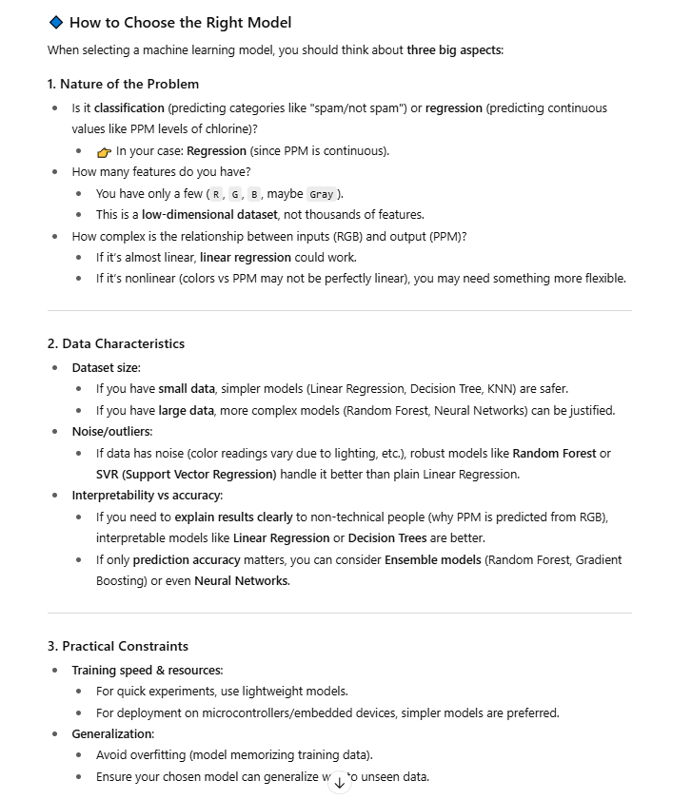

6. Data Splitting
X_train, X_test, y_train, y_test = train_test_split(X_clean, y_clean, test_size=0.2, random_state=42)
- 80% → training set
- 20% → test set
- random_state ensures reproducibility.
Theory:
- Train set is used to fit the model.
- Test set evaluates generalization performance.

7. Evaluation Metrics
mse = mean_squared_error(y_test, y_pred)
r2 = r2_score(y_test, y_pred)
- MSE (Mean Squared Error): 1n∑(yi−y^i)2\frac{1}{n}\sum (y_i - \hat{y}_i)^2n1​∑(yi​−y^​i​)2
  - Lower is better.
- R² Score: Proportion of variance explained by the model.
  - R² = 1 → perfect fit; R² = 0 → model no better than mean.
Theory:
- High R² (close to 1) means predictions closely match actual values.
- MSE in normalized scale and PPM scale is compared.

8. Imputation
imputer = SimpleImputer(strategy='mean')
X_imputed = imputer.fit_transform(X)
- Missing values are replaced with the mean of the column.
Theory:
- Missing data handling is critical; imputation avoids dropping rows unnecessarily.

9. Predictions
example_rgb = np.array([[200, 150, 50]]) / 255
lin_pred = lin_model.predict(example_rgb)
poly_pred = poly_model.predict(example_rgb)
- Takes new RGB values, normalizes them, and predicts PPM.
Theory:
- The model learns the mapping between RGB and PPM from training data.
- Predictions can be negative for polynomial regression if model overfits or if input is far from training range (extrapolation issue).

10. Key Machine Learning Concepts in This Code
- Supervised Learning: Labeled data (RGB → PPM).
- Regression: Predicts continuous values.
- Feature Scaling: Normalization for numerical stability.
- Outlier Removal: Improves model robustness.
- Train/Test Split: Prevents overfitting by testing on unseen data.
- Model Evaluation: MSE and R².
- Overfitting:
  - Linear Regression → simpler, less prone to overfit.
  - Polynomial Regression → can overfit with high degrees.
- Pipelines: Combine preprocessing and modeling in one workflow.
22222222222222222222222222222222222
Here’s a crisp, interview-ready explanation of your code that still sounds confident and complete:

"This code implements a supervised learning pipeline to predict chlorine concentration (PPM) from RGB values. The process has four main steps:
- Data Loading & Exploration – The dataset is read from Excel into a Pandas DataFrame. We inspect the first few rows and descriptive statistics to understand ranges, distributions, and possible anomalies.
- Preprocessing –
  - Normalization scales RGB values from 0–255 to 0–1, and PPM values to a 0–1 range.
  - Outlier removal uses the IQR method to drop extreme values that could distort model fitting.
  - Missing values are imputed with the column mean to keep the dataset complete.
- Visualization – We use scatter plots to explore correlations between each RGB channel and PPM, and a 3D scatter plot to visualize RGB space colored by PPM. This helps us see whether relationships are linear or non-linear.
- Model Training & Evaluation –
  - We split the data into 80% training and 20% test sets.
  - Linear Regression is used for a simple linear relationship.
  - Polynomial Regression (degree=2) captures potential non-linear patterns.
  - Models are evaluated with Mean Squared Error (MSE) and R² score. MSE measures average prediction error, while R² indicates how much variance in PPM is explained by the model.
  - Finally, we plot predicted vs. actual values to visually assess model performance.
In results, Linear Regression had lower error and higher R² than Polynomial Regression, indicating that the relationship in this dataset is mostly linear. The trained model can then take normalized RGB input and predict PPM for new samples."

If you deliver it like this, you show:
- Knowledge of the ML pipeline (load → preprocess → visualize → train → evaluate → predict)
- Understanding of why each step is done
- Awareness of metrics and model choice reasoning
3333333333333333333333333
In machine learning, random_state for reproducibility means:
When a process in your code involves randomness (like splitting data into train/test sets, shuffling, initializing model weights, etc.), the results will be different every time you run the code—unless you fix the "seed" for the random number generator.
random_state is essentially that seed.
If you set the same random_state every time, Python's random number generator will produce the same "random" sequence, so:
- Your train/test split will always be identical each run.
- Model performance metrics will be comparable across runs.

Example:
from sklearn.model_selection import train_test_split

X = [1, 2, 3, 4, 5]
y = [10, 20, 30, 40, 50]

# Without random_state
X_train1, X_test1, y_train1, y_test1 = train_test_split(X, y, test_size=0.4)
X_train2, X_test2, y_train2, y_test2 = train_test_split(X, y, test_size=0.4)

print(X_train1, X_train2) # Different outputs

# With random_state
X_train1, X_test1, y_train1, y_test1 = train_test_split(X, y, test_size=0.4, random_state=42)
X_train2, X_test2, y_train2, y_test2 = train_test_split(X, y, test_size=0.4, random_state=42)

print(X_train1, X_train2) # Same outputs

💡 In your code:
X_train, X_test, y_train, y_test = train_test_split(
X_clean, y_clean, test_size=0.2, random_state=42
)
- random_state=42 → ensures the same data points go into training and testing every time, making debugging and comparisons fair.
- 42 is just a common "magic number" people use; you could set it to any integer.

