**KAFKA**

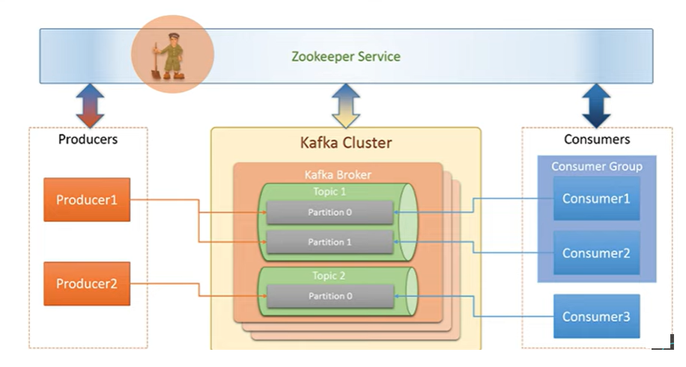

Kafka is distributed open source event streaming platform.

Zookeeper is a prerequisites for Kafka.

Kafka is a pub/sub messaging system.

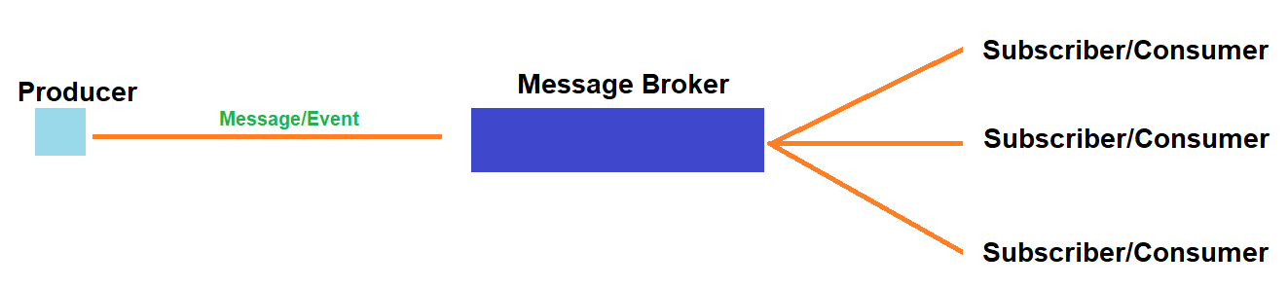

Major components KFKA.

Producer, Consumer, Broker, Cluster, Topic, Partitions, Offset, Consumer groups, Zookeeper.

**Broker**

Kafka server.

**Cluster**

Collection of Kafka services.

**Topic**

Used to categories different type of messages (category of messages).

Ex:

Order Processing Message -> Order-Process-Topic

Email Sending Message -> Email-Process-Topic

**Partition**

ඉතා විශාල messages ප්‍රමාණයක් topic එකකට එනවනම් ඒක handle කරගන්න බෑ topic එකට.ඒ වගේම ඒ messages consumer ට handle කරන්නත්බෑ. එක නිසා topic එක ඇතුලේ partition කඩලා message ඒවාට බෙදල දීලා ඒ ඒ partition වලින් consumers ලා ගොඩකට එම messsage බෙදල දෙනු ලබයි.(Consumers ලා වැඩි කරගනු ලබයි).

**OffSet**

Partition වලට message වැටුනම ඒ ඒ message වලට number එකක් assign වෙනවා.එය help වෙනවා consumer ට ඊළගට දෙන්න ඕනේ message එක මොකද්ද කියලා තීරණය කරන. Cosumer down වෙලා නැවත up කරද්දීඑහෙම consumer ට ඊළගට දෙන්න ඕනේ මොන message එකද කියලා තීරණය කරන්න පුලුවන් වෙන්නේ ඉත්කොට තමයි. .

In Kafka, a sequence number is assigned to each message in each partition of a Kafka topic.This sequence number I called Offset.

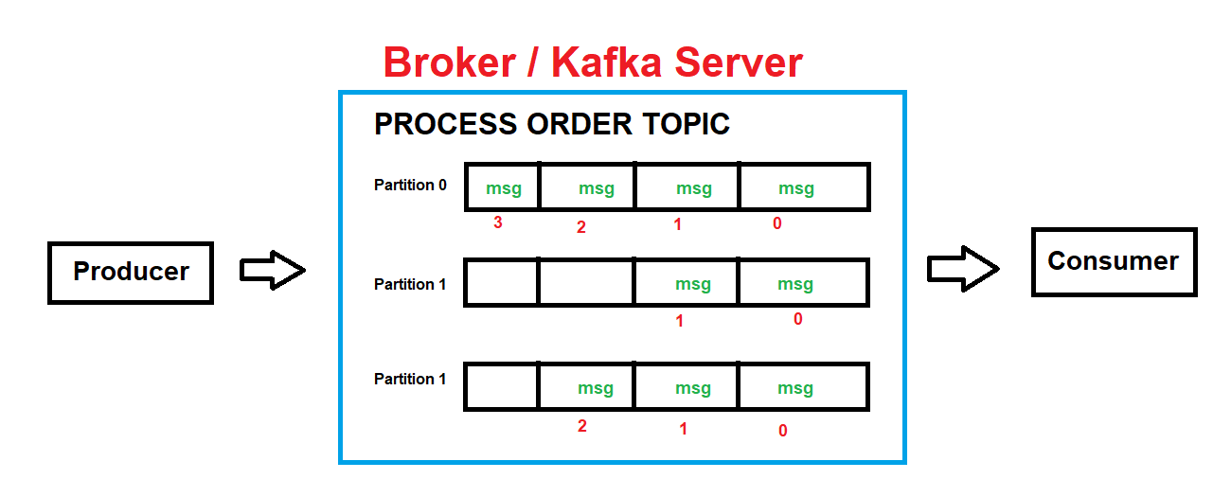

**Consumer groups**

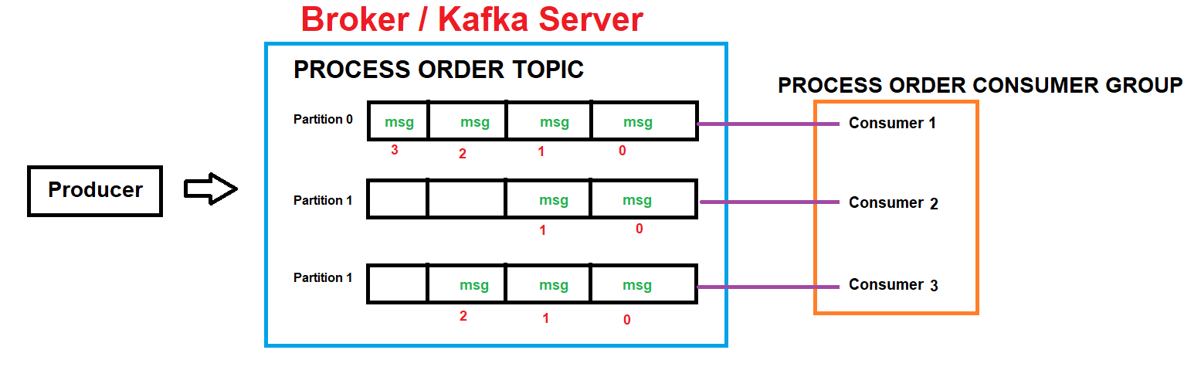

**Architecture**

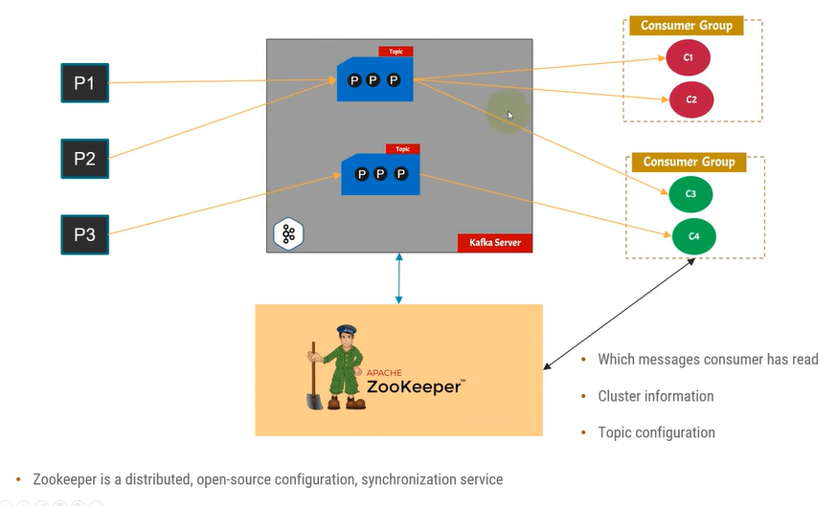

Zookeeper thama configuration handle kranne eka tama…

We have multiple groups topics etc.all the data are store in zookeeper.

Ex.Consumers la read kala message count tiyagena inna puluwan.Kafka CLustoers wlata informations tiyan innet meke(IPs,CPU,RAM,PArtition etc.).Topic ekak,partition ekak kafka walta add unoth eka zookeeper ta yanwa, zookeeper eka consumerslata kiynwa wagenama consumer deyak akalth eka zookeeper ta ynwa eka kafka walata yanwa.

Install Kafka and Zookeeper

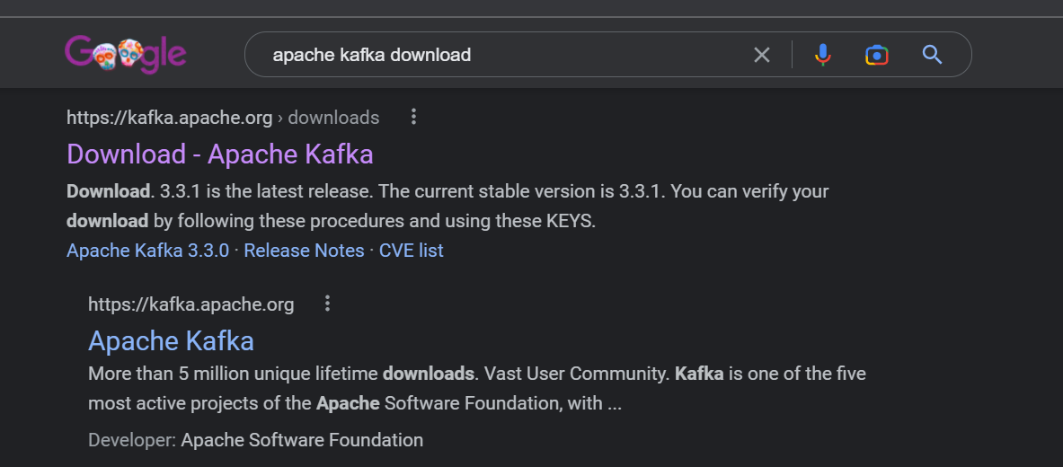

<https://kafka.apache.org/downloads>

GetStart - QuickStart

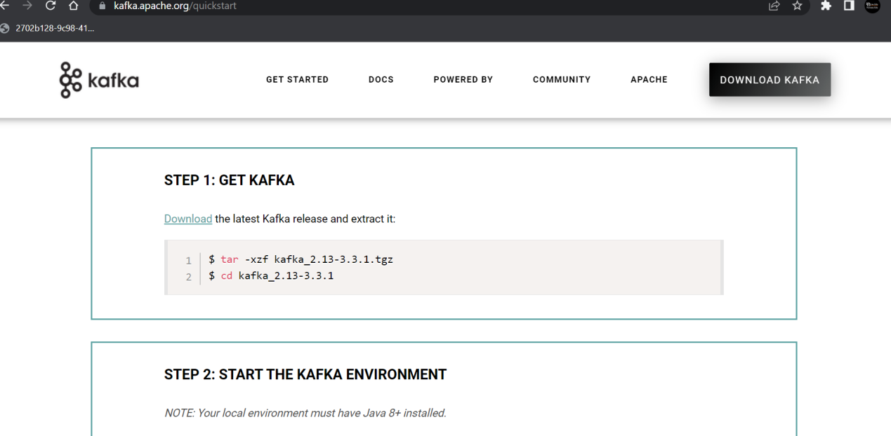

Download

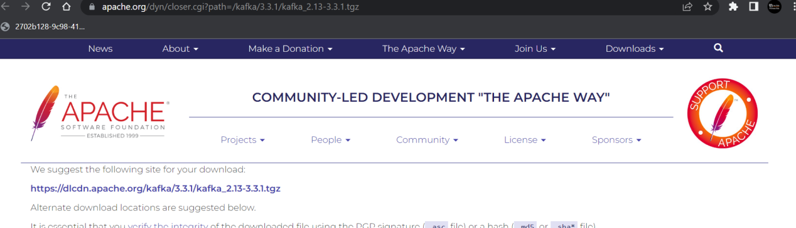

**01.DOWNLOAD AND EXTRACT**

*Note : Java 8 is needed.*

<https://kafka.apache.org/downloads>

After extracting the file then got to bin folder

(In my machine C:\kafka_2.13-3.3.1).

Open CMD and and run bellow command to run zookeeper and kafka.

**02.START THE KAFKA ENVIRONMENT**

*# Start the ZooKeeper service*

Run bellow command in CMD.

bin\windows\zookeeper-server-start.bat config\zookeeper.properties

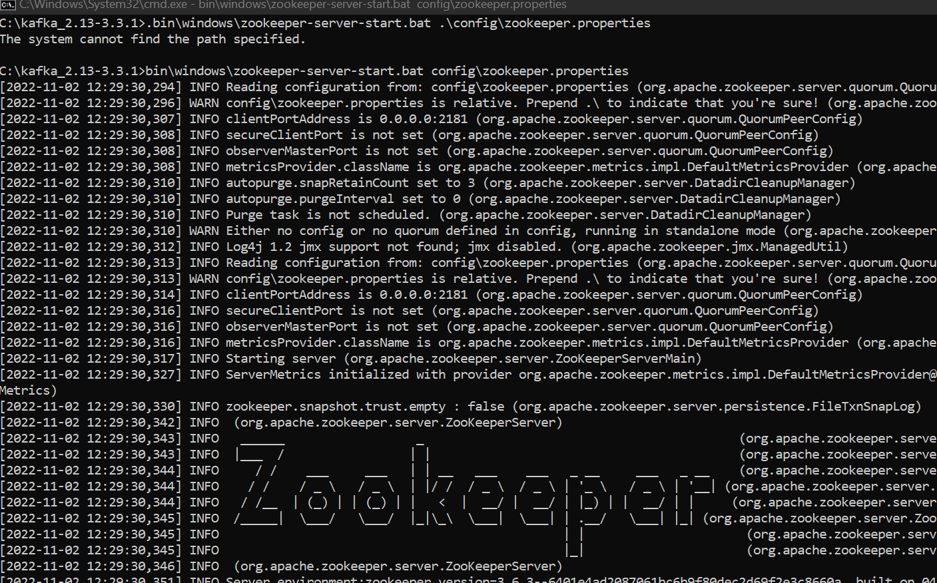

*# Start the Kafka broker service*

Run bellow command in CMD.

bin\windows\kafka-server-start.bat config\server.properties

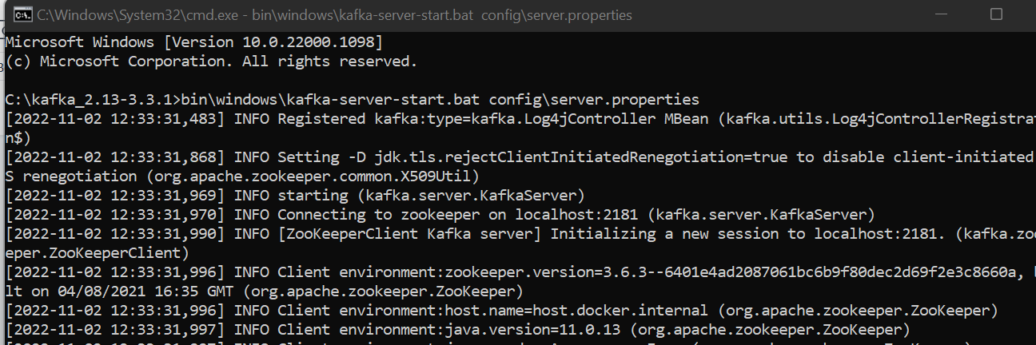

Zookeeper default port : 2181

Broker default port : 9091

Kafka default port : 9092

**03. CREATE A TOPIC TO STORE YOUR EVENTS**

bin\windows\kafka-topics.bat --create --topic topicName --bootstrap-server localhost:9092

bin\windows\kafka-topics.bat --list --bootstrap-server localhost:9092

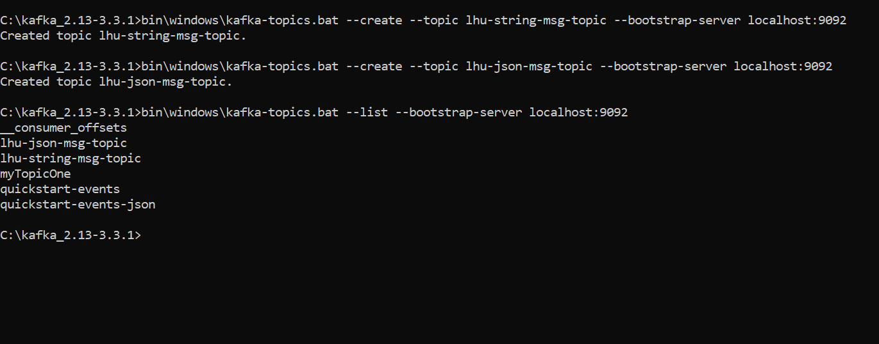

**04.WRITE SOME EVENTS INTO THE TOPIC (ctl+c)**

bin\windows\kafka-console-producer.bat --topic topicName --bootstrap-server localhost:9092

**05.READ THE EVENTS**

bin\windows\kafka-console-consumer.bat --topic topicName --from-beginning --bootstrap-server localhost:9092

hello world

topic demo

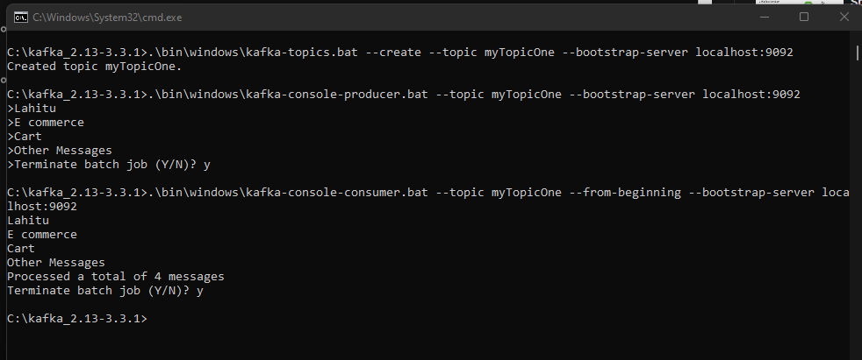

Code Example -

01.Producer

