In here one city can have multiple hotels and each hotel can be only belogn to a some perticuler city.Because of that there is a one to many relationship between the given two entity hotels and city.And city code is unique for any country and hotel table should have a some unique to identify each and each hotel separeatly.Because of that I have used hotel_id as unique key hotel table and it is auto increament attribute.Those uniques values are used as primary keys in each tables and in the table creation, I have to save city_code of city table inside the hotel table because there is one to many relationship(They primary key of one side table should be the foregn key as the many side table).

ER Diagrom

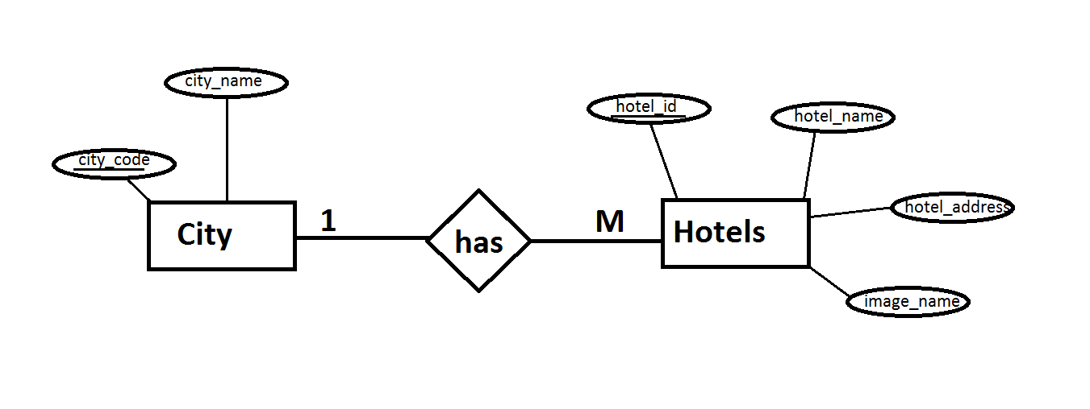

**Functionalities:**

1. In Administrative Part,
   * + Can insert a new hotel.
     + Can insert a new City.
2. In User Part,

* Can view all hotel.
* Can search hotel based on city.
* Can search hotel through a search box.
* Can view a descriptive details about a selected hotel.