Redis

What is redis?Use case and benefits of redis.

Remote dictionary server.

In-memory db - data stores in RAM.

Often used as cache to improve perforce.

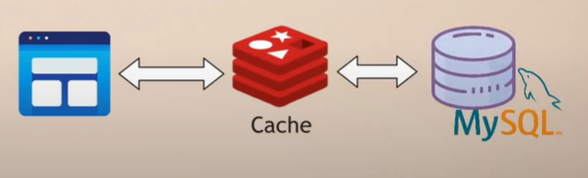

Redis primary DB ekak lesada use kala haka.

Elastic search data base -Faltering and searching the date.

Users la ekineka connect wela tiyenne.me wage ekak kranna thama neohj wage graph database use kranne.Thawa media content save krnan mongo db wage document database use krai.Btter performanc ekak sadaha cache server ekak one..ekata redis wage ekak use kranu labai.

Namuth mulpiple db samaga deal krna eka amrui main tain kranna ewa ewa athra connection eka tiyaganna wage..ithakota slow wenawa app ekath.So redis wage multimodule database use kranna puluwan.Run and maintain just one DB.Redis allows us to store different data types and no need to separate cache needed.

How redis support multiple data formats?

Key values tiyan inna redis core eka redis module samaga extend kala haka app ekata awashya wana different data types sadaha.

Module -That different ypes of database functionality not tightly intergrated with one database

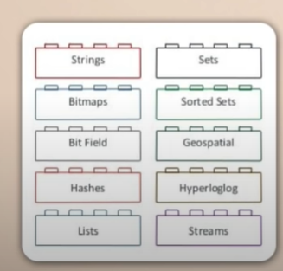

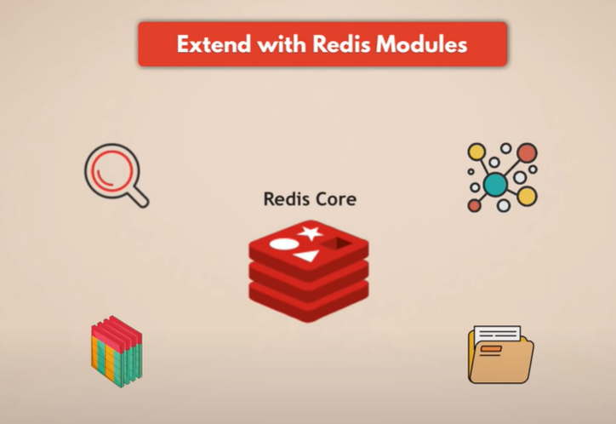

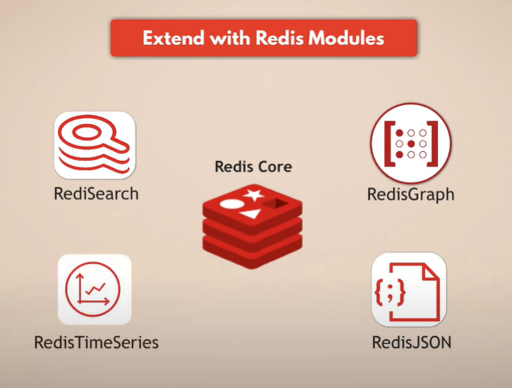

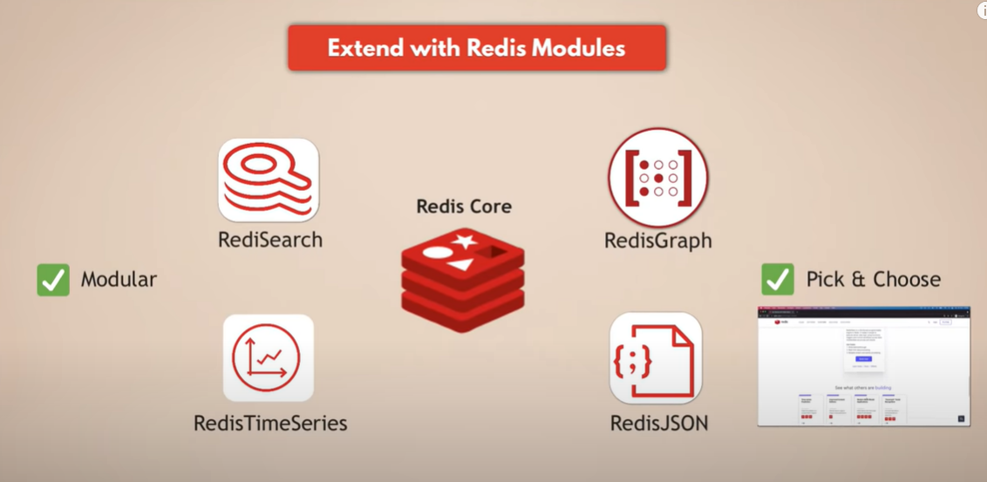

Redis is fast -

Redis walata schema one wenne naa anet DB wage ekata anet DB wlata wage, DB initialize kranna and build the schema walata time yanne naa e nisa speed wenna hethuwak wenwa.

How in memory db persists data?

01.Snapshotting

Time ekak anuwa hari request ganak anuwa ahri tham meka kranne

Produce singale file point inn time snapshots of your dataset.

Configure based on time or number of writes passed.

Stores on disk.

Namuth anthimata kala changes tika save wela nati wenna puluwan meken(Winadi 5n 5ta wage snapshot unoth).e nisa AOF kiyla ekak tiynwa.

02.Append Only FIle(AOF)

Logs every write operation continuously.

When restarting redis, it will re-paly the AOF to rebuild the state.

This more durable and slower than snapshot.

Ema nisa e dekema combination ekak use krai.

Where is these persistence files stored?

Cloud eke thama tiyenne..

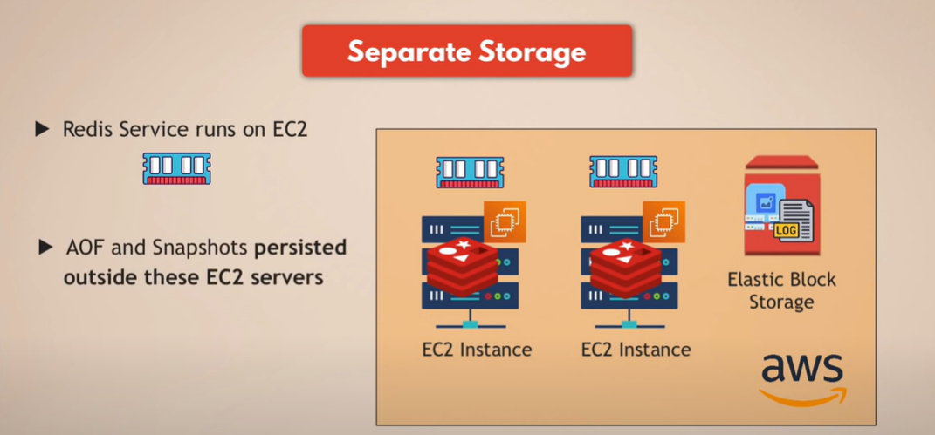

Saving costs with redis flash?

Hard ekata wada ram eke size eka podi nisa data store krgana ram godak onene..ekata solution denwa redis on flash kiyna service eka haraha.

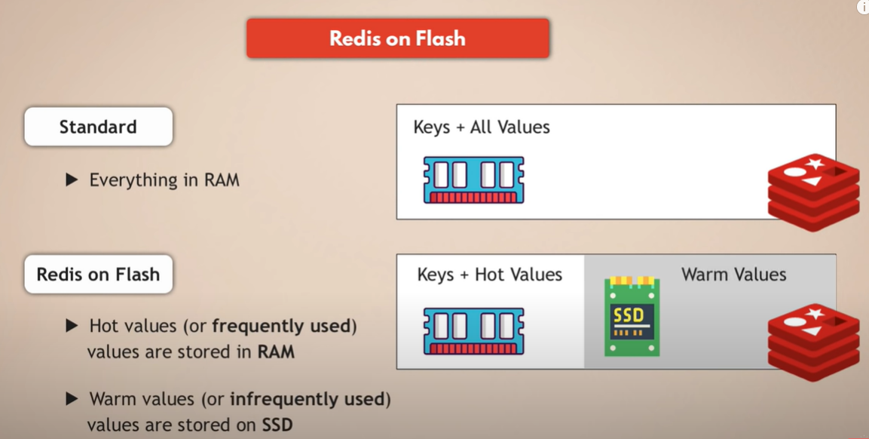

Scaling redis?

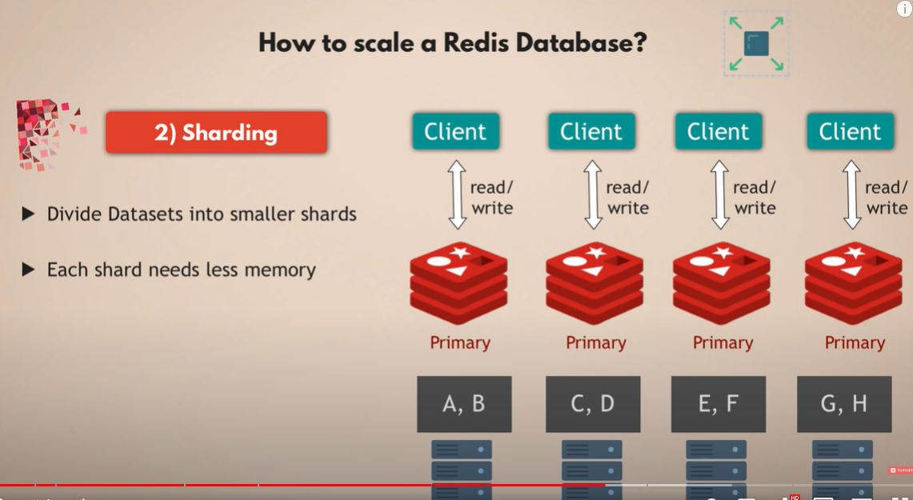

Way redis is suitalbe for microservices apps?

How redis supports multiple data formats?

Data persistance and recoverry with redis?

How to optimize memory cost with redis on flash?

Scalling redis and high avaliablitity across muliple geogropjhic location?

Go to <https://github.com/microsoftarchive/redis/releases/tag/win-3.2.100>

And download zip file.

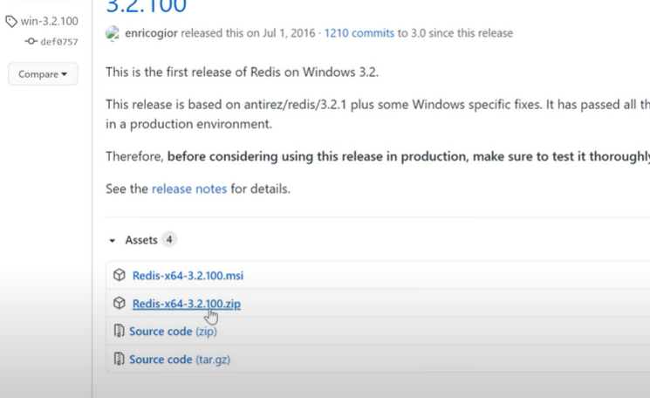

Extract downloaded file.

Go to the extracted file and double click to run the redis server.

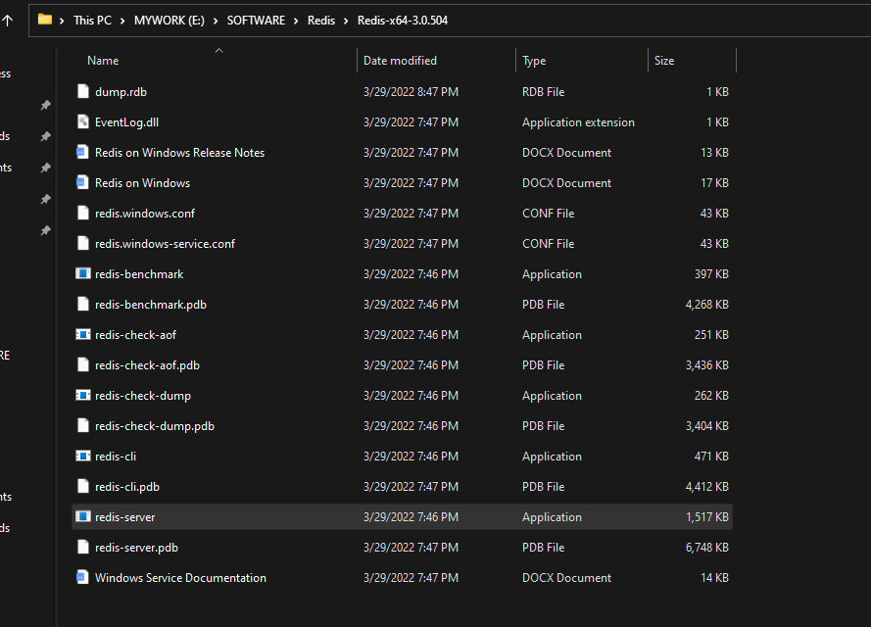

Server will be started as

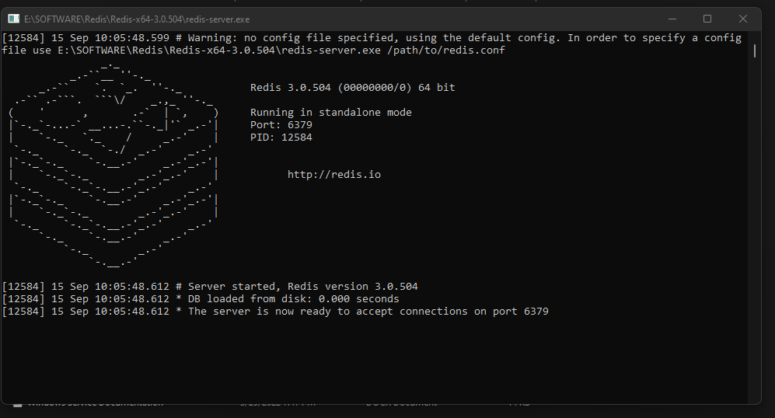

Create a spring boot project

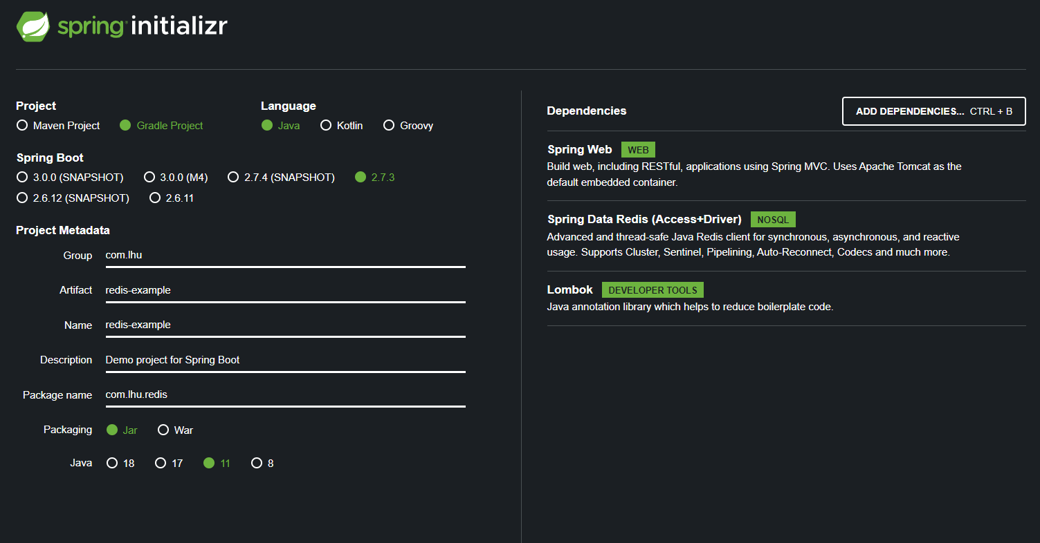

Extra plugging is needed.

implementation 'redis.clients:jedis:3.6.0'

If we want to enble redis chache, then need to add

@EnableCaching

@CachePut(key = "#id", value = AppConstant.*HASH_KEY*)  
public Student saveStudent(Student product) {  
 return repository.save(product);  
}  
  
@Cacheable(key = "#id", value = AppConstant.*HASH_KEY*, unless = "#result.age>10")  
public Student findStudent(int id) {  
 return repository.findStudentById(id);  
}  
  
@CacheEvict(key = "#id", value = AppConstant.*HASH_KEY*)  
public String removeStudent(int id) {  
 return repository.deleteStudent(id);  
}

SOLID

