Jefferson Creek

**AMATH 383**

**March 12th, 2014**

Just so that you don’t miss it.

Incompressible Navier-Stokes

Abstract:

This paper shows the derivation of the Navier-Stokes equation and explains the meaning behind each term. Currently there is no analytical solution to the equation, and so some of the numerical methods that are used to solve it are examined. Finally a numerical simulation of the two dimensional form of the Navier-Stokes equation is used to find the velocities in a lid driven cavity problem.

Problem:

$$\frac{∂\vec{u}}{dt}+\vec{u}·∇\vec{u}+ \frac{1}{p} ∇P=\vec{g}+v∇·∇\vec{u}, ∇·\vec{u}=0$$

The Navier-Stokes equation is the basis for most models involving the flow of fluids and so is used to examine most of the effects air flow and the movement of water can have on any number of variables. It is used to show turbulence, can predict the spread of smoke in a fire, models the movement of air over the wings of the airplanes, and is used to help predict the weather. Generally, the equation can track anything that can be associated with a fluid; speed, pressure, temperature…

Even given the large amount of use that the Navier-Stokes equation receives however, it still not completely understood. Along with the almost infamous “P=NP” problem, the Navier-Stokes Equation is listed as one of the seven Millennium Problems: whoever is able to determine that solutions to the equation always exist will be awarded one million dollars. While the goal of this paper is not to solve such a large problem, an inspection of the equation and the ways that it is currently solved may give more context on why no one has been able to claim the prize.

A lid driven cavity problem, where just the lid of a box full of air is rapidly moving, is briefly examined at the end to demonstrate what a simplistic two dimensional solution to the Navier-Stokes equation can look like.

Derivation of the Navier-Stokes Equation

To start with, the symbols in the equation need to be explained.

To start with the del operator, $∇$, is defined as the vector differential. It is simply given by

$$∇=\frac{∂}{∂x}, \frac{∂}{∂y}, \frac{∂}{∂z}$$

To understand the Navier-Stokes equation though, one needs to be able to understand both $∇$ times a vector means, as well as what taking the dot product with $∇$ does. When multiplying del by a function or a vector, the result is the gradient.

$$∇f(x, y, z)=\frac{∂f}{∂x}, \frac{∂f}{∂y}, \frac{∂f}{∂z}$$

When the dot product is taken between del and a vector field however, it is referred to as the divergence.

$$∇\vec{·u}=\frac{∂u}{∂x}+ \frac{∂v}{∂y}+ \frac{∂w}{∂z}$$

As in the Navier-Stokes equation, in this case $\vec{u}$ is a vector field with components u, v, w that give the velocity in the x, y and z directions.

The other variables in the Navier Stokes equation are given below.

$\vec{g}$ is the gravity vector.

*p* is the density of the fluid.

P is the pressure field.

*v* is the kinematic viscosity and is equal to μ/*p*, where μ is the dynamic viscosity coefficient.

Finally the derivation of the Navier-Stokes equation can began.

Allow $\vec{a}=\frac{D\vec{u}}{Dt}$, where ‘big D’ notation refers to the material derivative. Newton’s Second Law then becomes

$$m\frac{D\vec{u}}{Dt}=\vec{F}$$

Where m is the mass of the piece of fluid that is under consideration.

The possible forces that the piece of fluid could experience must now be considered.

Intuitively, any material on earth that has mass must feel the force of gravity. Classically, the force of gravity is given by

$$m\vec{g}$$

(It is important to note that buoyancy, or other body forces, can be worked into this term as needed).

Clearly the pressure in each direction on the fluid must also have an effect the force, as pressure is defined as force/area. After integrating over the volume,

$$-V∇P$$

is the force that the fluid of volume V experiences due to the imbalance of pressures near it (the pressure gradient).

Finally the forces due to viscosity of the fluid must be considered. This is done with the Laplacian term, and after multiplying by the volume of the piece of fluid, the force is due to viscosity is

$$(Vμ)(∇·∇\vec{u})=(Vμ)(\frac{∂^{2}u}{∂x^{2}}+ \frac{∂^{2}v}{∂y^{2}}+ \frac{∂^{2}w}{∂z^{2}})$$

The Laplacian term is therefore called the divergence of the gradient of the velocity: if the velocity was constant the fluid would not experience any viscous forces.

In the above terms, one assumption that was made is that any piece of fluid can be considered as a continuous term no matter the size, an assumption which tends to break down on the molecular scale. The larger assumption made though was that the velocity of the piece fluid is dependent on forces outside of it, such as gravity and the nearby materials. However, this would not be true if the fluid could expand or contract at any point. Therefore, the incompressibility constraint must be added, where the divergence of the velocity field must be equal to zero.

$$∇·\vec{u}=0$$

Combining all of the above, the original force equation becomes

$$m\frac{D\vec{u}}{Dt}= m\vec{g}-V∇P+Vμ∇·∇\vec{u}, ∇·\vec{u}=0$$

After dividing by m, and realizing that *p* = V/m, rearranging the equation results in

$$\frac{D\vec{u}}{Dt}+\frac{1}{p}∇P= \vec{g}+v∇·∇\vec{u}$$

By referencing the Navier-Stokes Equation, one can see that the initial derivation is almost complete.

At this point the material derivative $\frac{D\vec{u}}{Dt}$, must be clarified. To do this, the difference between Lagrangian approach and Eulerian approach has to be explained. In the Lagrangian approach each particle is labelled with a position and velocity, (and potentially other attributes), while in the Eularian approach measures the change of a quantity at a fixed position. The Eulerian approach is usually used for fluids: such as measuring the rate of flow out of the end of a pipe, or by monitoring the direction of the wind by placing a wind vane. The Lagrangian approach can be used to measure properties of fluids as well, such as by using a weather balloon. The equation that connects the two different approaches is obtained by using the chain rule on the material derivative, with an attribute ‘q’, and a position ‘ $\vec{x}$’

$$\frac{D\left(q, \vec{x}\right)}{Dt}= \frac{∂q}{∂t}+\frac{∂\vec{x}}{∂t}·∇q$$

$$=\frac{∂q}{∂t}+\vec{u}·∇q$$

$$≡\frac{Dq}{Dt}$$

Looking at the above equations, it is clear that $\frac{D\left(q, \vec{x}\right)}{Dt}$ is the Eulerian approach, while $\frac{∂q}{∂t}$ is independent of position as so is the Lagrangian approach.

When the q is taken as $\vec{u}$, then the Navier-Stokes derivation is complete.

$$\frac{D\vec{u}}{Dt}= \frac{∂\vec{u}}{∂t}+\vec{u}·∇\vec{u}, and so$$

$$\frac{∂\vec{u}}{dt}+\vec{u}·∇\vec{u}+ \frac{1}{p} ∇P=\vec{g}+v∇·∇\vec{u }, ∇·\vec{u}=0$$

Thus the Navier-Stokes Equation is Newton’s Second Law of motion applied to fluids, with an incompressibility constraint.

Numerical Solutions

While the Navier-Stokes equation as formulated may appear to be hard enough to solve analytically on its own, other changes must be taken into account. By looking at the ideal gas law

$$PV=nRT$$

as the amount of moles (n), R, and the volume must be constant (due to the incompressibility constraint), a change in temperature must somehow effect the solution to the equation. Similarly, an expected velocity change due to the pressure gradient could instead change the temperature. To this date no one has managed to prove that a solution is guaranteed for any set of starting conditions, or its converse. Therefore, numerical simulations are used to model to the Navier-Stokes equations.

One of the first assumptions that numerical calculations make is that, for most fluids, viscosity can be ignored. The reason that this assumption can be made is that small errors, due to the fact that the pressure and velocity fields are discrete, end up reintroducing viscosity like effects. Therefore, the (continuous) version of the Navier-Stokes equations looks like

$$\frac{∂\vec{u}}{dt}+\vec{u}·∇\vec{u}+ \frac{1}{p} ∇P=\vec{g} ∇·\vec{u}=0$$

which are known as the Euler Equations.

The pressure field is discretized to a set of cubes, and the velocity field is defined at the faces of the cubes (or boxes in two dimensions). Next, the fluid equation is split into the separate components

$$\frac{Dq}{Dt}=0 (advection)$$

$$\frac{∂\vec{u}}{dt}=\vec{g} (body forces)$$

$$\frac{∂\vec{u}}{dt}+\frac{1}{p} ∇P and ∇·\vec{u}=0 (pressure/ incompressibility)$$

Pressure at the edge of the system (such as at a solid wall), is allowed to be whatever keeps the divergence of the velocity zero, and so the constraint is tied with the pressure term.

Each of the above equations is used as the time goes from progresses to t 🡪 t+Δt, for each u,v,w in the velocity field. The change in pressure can be determined by comparing the new velocities to the previous one and seeing how it didn’t react in complete accord with the pressure gradient, using a five point stencil in two dimensions, and a seven-point stencil in tree dimensions.

Using a numerical approach is full of trade-offs: it has advantages and disadvantages. Besides the assumptions that are made by using the numerical method, the main disadvantage is that the only to minimize errors is by working with small cube sizes (small Δx) and small time jumps (small Δt), both of which dramatically increase the computational cost. Moreover the solution that is obtained isn’t guaranteed to be accurate, as the Navier-Stokes solution still could be flawed (and has not been proven to guarantee a solution). However as numerical simulations are currently the only way to model the Navier-Stokes equations, they are widely used throughout many fields.

Brief Example: Lid Driven Cavity

A typical problem that is used to test the accuracy of fluid modeling programs is where a box (a cavity) has the air in it moved by simulating the top of the box being slid rapidly in the positive direction. A large vortex develops in the box which moves along with the lid in the top of the box, and in the opposite direction at the bottom.

Here is a solution to the lid driven cavity modelled with the two dimensional form of the Navier-Stokes equation (software obtained from source ()). The colored sections represent different pressures, while the contour lines not (directly) related to the colors are the contour lines of the velocity field.

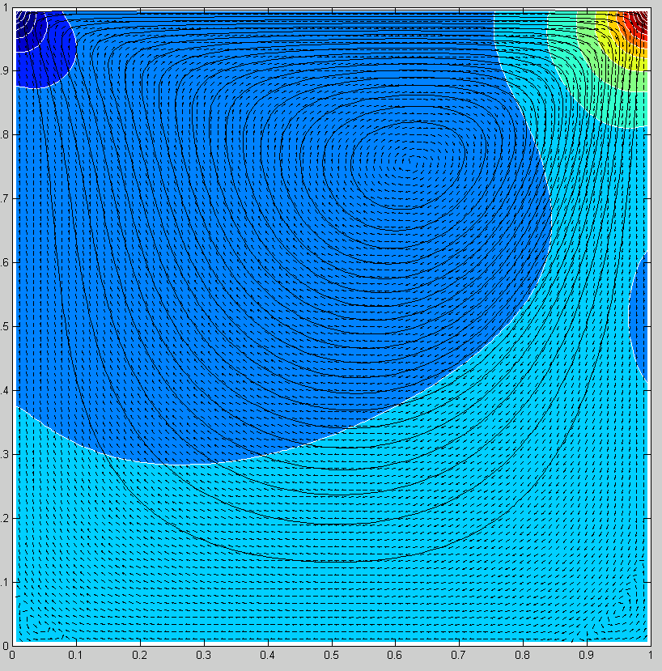

Top lid moving in the positive x direction

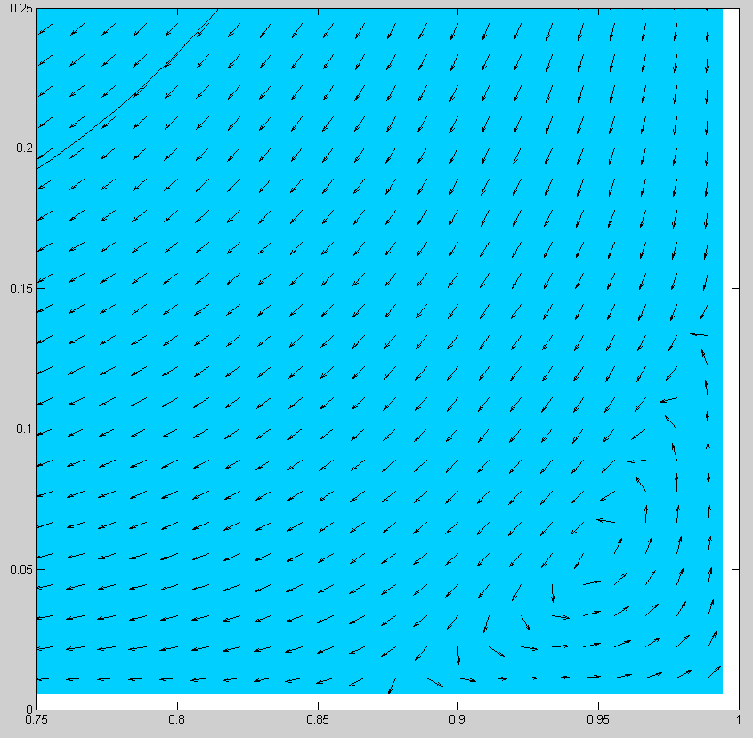

Zoomed in section of the bottom right showing additional vortexes.

To demonstrate the robustness of the Navier-Stokes numerical simulation, I let the top lid continue moving to the right, but then let the left wall slide down, and then right wall slide up. This simulation gives three vortexes at non-symmetric locations in the box.

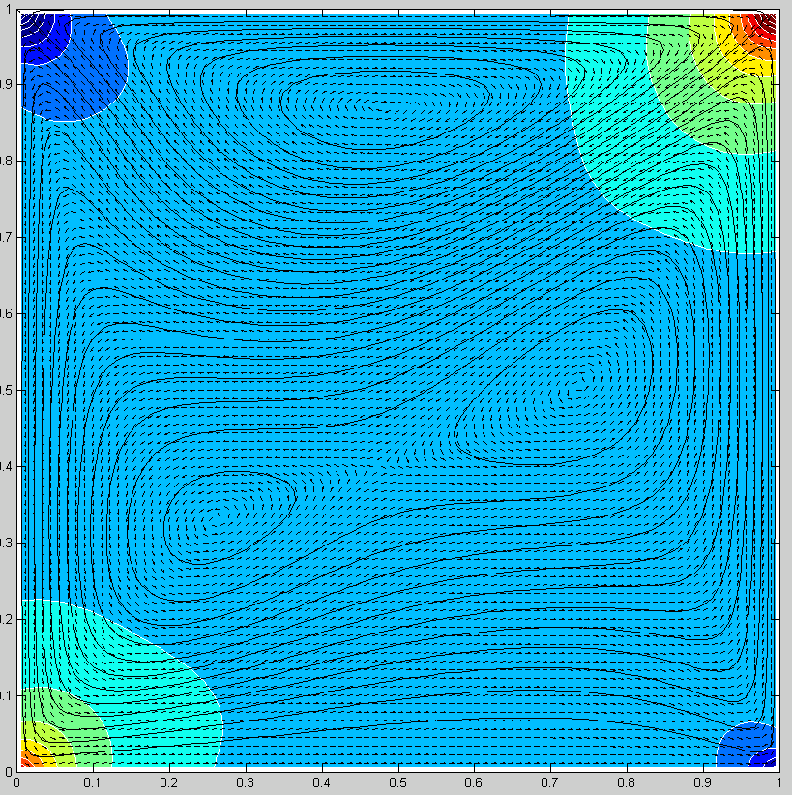

Either of the two previous simulations could be checked for accuracy using boxes and wind speed gauges in real life.

Conclusion

The Navier-Stokes equation is just Newton’s Second Law applied to fluids, with an incompressibility constraint. However the complexity of the resulting equation keeps it from being solved analytically, and a solution is not proven to always exist. Until the equation is completely solved numerical techniques can be used model the equations and obtain reasonable data, given by not only the few plots in this paper, but by the fact that wide use of the equation in many different situations all seem to give accurate results.

References

<http://gendocs.ru/docs/9/8674/conv_1/file1.pdf>

<http://www.claymath.org/millenium-problems/navier%E2%80%93stokes-equation>

<https://archive.org/details/nasa_techdoc_19880015218>

**An Introduction to Computational Fluid Mechanics by Example**  
Biringen, Sedat  
Chow, Chuen-Yen

<http://math.mit.edu/cse/codes/mit18086_navierstokes.pdf>