1. **Summary**

I’ve chosen to implement a trading strategy that is a twist on the common “Breakout Fading” strategy. Breakouts (referred to as “Gap” in my code and in this document) both up and down (referred to as GapUp and GapDown) movements tend to “fade” or “reverse” when traders (or their algos) need to close out their positions to realize profit or because a stop-loss limit is hit.

Commonly, algos and traders have stop orders around the support and resistance levels and, if a breakout breaches these levels, it is where one can expect a “fade” to occur for the breakout. This is, however, not always the case and not a great way to predict when a “fade” will occur or its magnitude.

I’ve used a simplified scientific formulation to identify a fade and estimate its magnitude. The idea is based on the path a ball takes when it bounces on a surface that absorbs some of its kinetic energy. If a ball is dropped from a height h0 (with 0 initial velocity) and it takes time t0 to reach the ground, then (given the coefficient of restitution is ε) the ball will bounce back to a height of h1 (h0 × ε2) in time t1 (t0 × ε). If I assume h0 to be the Gap magnitude and t0 the time taken for the Gap, then the fade will have a magnitude of h1 and occur within time t1.

1. **Implementation Logic**

The first step is to identify a Fade. The code follows a trend (GapUp or GapDown) till it reverses (here we have h0 and t0). Once it reverses and if the reversal/fade is greater than a level (e.g. 10% of h1), it assumes that a Fade is in progress and book a NEW trade. If the reversal/fade doesn’t touch this level, it goes back to monitoring for a Gap.

Using the above theory, the trigger levels of the “Fade” trade can be defined with “Take Profit” level set as h1 (h0 × ε2), “Time to live” (referred to as killTime in the code) for the trade as t1 (t0 × ε) and “Stop Loss” set as the level where the Fade started (i.e. traded price of NEW trade – 0.10×h0×ε2).

Once a NEW trade has been booked, it stops monitoring for a Gap till a trigger level (either TakeProfit, StopLoss or KillTime) is hit. Once a trigger is hit, a close-out trade is booked and the realized profit or loss for the pair of trades is calculated.

The details of the NEW trade and the subsequent close-out trade are captured in the log files (details in README.txt).

1. **Implementation Details**

In datamodel.h, the building blocks (implemented as struct) for tick data, currency pair (with calibrated parameters) and trade (with trigger levels and parent_id for the close-out trade to map with the origination trade) are defined.

In backtest.h/backtest.cpp, there are 2 classes implemented:

1. Rewind: It loads up the back-testing data (format of file name and data is provided in README.txt), creates tick structs and adds them into a queue.
2. Replay: Takes the queue of ticks as input, runs the strategies (gapDownFadeUp and gapUpFadeDown) against the back-testing data and outputs the results (tradeLog and P&L files; details in README.txt).

In calc.h/calc.cpp, 1 class is implemented to handle the P&L calculation and 1 function to handle the output of the P&L results.

In strategy.h/strategy.cpp, 2 classes are implemented to handle the 2 strategies.

1. The overall logic of the strategy is explained in the above section. The 2 strategies (gapDownFadeUp and gapUpFadeDown) are currently mirror images of each other and could be implemented as 1 class but they’ve been implemented separately in case we need to use different calibration parameters for each strategy.
2. When monitoring for a Gap, instead of comparing each tick (which tends to be volatile hence under-estimates the Gap magnitude and gives a false indication of a Gap reversing), the code uses a smoothing (i.e. uses an average of the last 4 ticks) to monitor a Gap and its reversal. The code also adds a tolerance level (e.g. 0.4 pips) before it assumes a reversal has occurred.
3. Once a fade/reversal has occurred, the code starts monitoring the fade trend and, if (a) the fade level is hit, (b) the Gap magnitude is greater than a level (so as not to chase small Gaps/Fades) and (c) the fade hasn’t already crossed 90% of h1(since most of the Fade won’t be captured), then we book a NEW trade.
4. Once a NEW trade is in progress, there is no more monitoring for a Gap till a close-out trigger is hit. The code adjust the trigger levels based on the tick moves before the trigger level is hit:
   1. If the price moves in the opposite direction of the fade, the code increases the StopLoss level and reduces the KillTime. Both actions are to reduce the loss on the trade in case the trend continues in the opposite direction
   2. If the price moves in the same direction of the fade, the code increases the TakeProfit level and increases the KillTime. Both actions are to increase the profit on the trade in case the trend continues in the same direction
5. Once a trigger level (TakeProfit, StopLoss or KillTime) is hit, a close-out trade is booked and the variables monitoring the Gap and Fade are reset to 0. When a StopLoss is triggered, the code only resets the Fade variables and continues to monitor the same Gap (i.e. assuming that the Fade was a false positive and that the Gap trend will continue beyond this point).
6. All trades are booked with a notional of 1,000,000 USD.
7. **Back-Testing & Calibration details**

Most of my back-testing and calibration of parameters has focussed on USD/JPY. I’ve used the calibration parameters got from USD/JPY testing to also back-test and generate results for EUR/USD. The same can be extended to other currency pairs. All back-testing has been done on data from the period between Jan to May 2024 and the results have been provided with a monthly, currency pair and strategy breakdown.

The variables that need to be calibrated (per Currency pair and per Strategy) are as below. These calibrated parameters are part of the Currency Pair definition:

1. Coefficient of restitution (ε): best results for USD/JPY were got for ε between 0.65 and 0.75. Final results are generated using ε as 0.70
2. Level at which we assume that a Fade is in progress: this is a ratio of h1 (10% of h0×ε2) and the ratio is referred to as jumpCheck in the code. jumpCheck equal to (1 – sqrt(ε)) yielded the best results (jumpCheck = 0.1633 for ε = 0.70).
3. Tolerance level (referred to as tolerance in the code): for USD/JPY, a tolerance of 0.4pips yielded best results
4. Gap magnitude (referred to as minGap in the code): the best results were got for 10pips for USD/JPY and 8pips for EUR/USD
5. **Examples**

Below we take a look at 3 examples for the GapDownFadeUp strategy (1 example each for a TakeProfit, Kill and StopLoss close-out event) for USD/JPY to illustrate the behaviour in each scenario. Details of these examples and 3 examples for the GapUpFadeDown strategy can be found in the “documentation” folder.

Example1: Take Profit trigger

Code identifies a GapDown trend (18.3pips in this case) and a FadeUp above required level (17.3% in this case). Since the price trend is in the same direction as the Fade, the TakeProfit level is increased along the way. In this case, the TakeProfit trigger is reached first and the trade is closed out. The P&L for the pair of trades is USD +650.63.

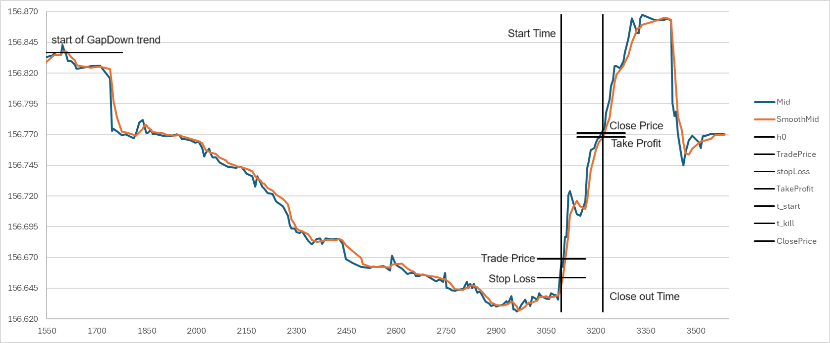

Example2: Kill (i.e. Time to Live) trigger

Code identifies a GapDown trend (27.5pips in this case) and a FadeUp above required level (20.6% in this case). Since the price trend is in the same direction as the Fade, the killTime is increased along the way. In this case, the killTime trigger (i.e. Time to Live has expired) is reached before the “Take Profit” level is hit and the trade is closed out. Most trades closed-out via the KILL trigger have a profit (evident in the “breakdown” tables in the next section). The P&L for the pair of trades is USD +387.95.

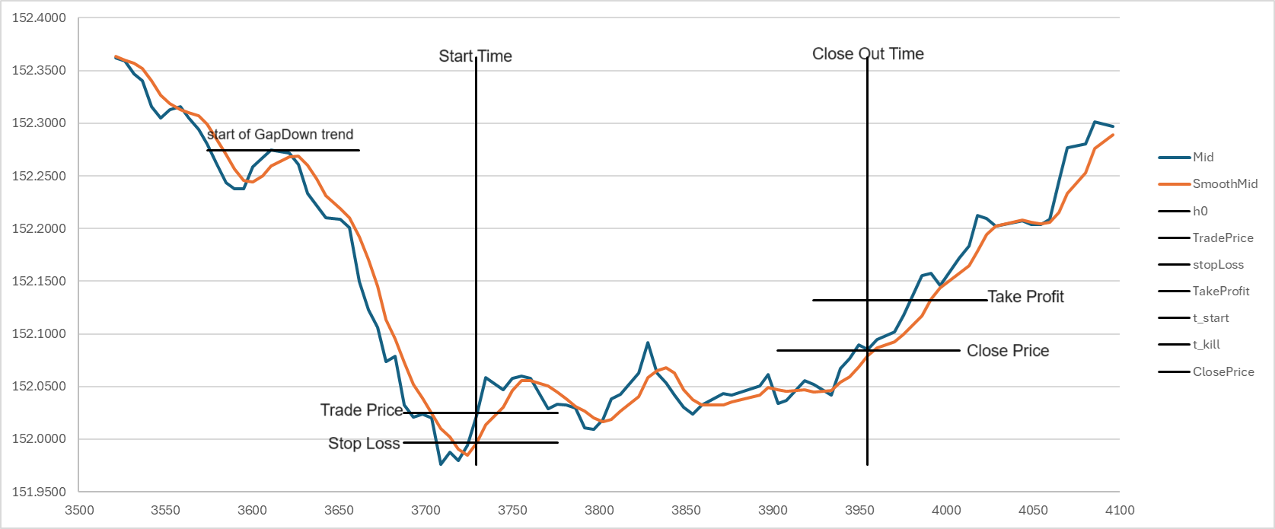

Example3: Stop Loss trigger

Code identifies a GapDown trend (22.1pips in this case) and a FadeUp above required level (40.6% in this case). Since the price trend is in the opposite direction as the Fade, the killTime is decreased along the way. However, due to a spike the “Close Price” goes below the “Stop Loss” trigger and the trade is closed out. The P&L for the pair of trades is USD -382.20.

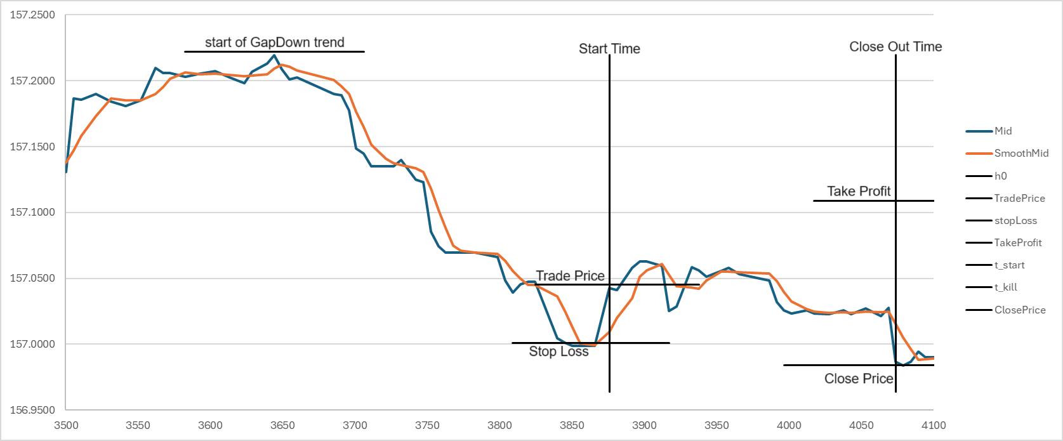

1. **Results**

The P&L results per month (Jan, Feb, Mar, Apr and May), per currency pair (USD/JPY and EUR/USD) and per data type (1sec interval data or tick data) are available in the “results” folder and Excel files containing the results summary per currency pair is also available in the same folder (P&L results_USDJPY.xlsx and P&L results_EURUSD.xlsx).

Below is a summary of the P&L results from the back-testing of tick data (NOTE: all trades are booked with a 1,000,000 USD notional)

USD/JPY summary:

|  |  |  |  |
| --- | --- | --- | --- |
| P&L Summary | GapDown | GapUp | Total |
| May | 4,920 | 6,903 | 11,823 |
| Apr | 11,878 | 15,869 | 27,748 |
| Mar | (2,292) | (2,376) | (4,668) |
| Feb | 1,213 | 542 | 1,755 |
| Jan | 2,673 | (3,228) | (554) |
|  | 18,393 | 17,710 | 36,103 |
| Avg Return/year | 4.41% | 4.25% | 8.66% |

USD/JPY Breakdown:

|  |  |  |  |  |  |  |  |  |
| --- | --- | --- | --- | --- | --- | --- | --- | --- |
|  | GapDown | | | Total | GapUp | | | Total |
| P&L Details | TakeProfit | StopLoss | Kill | TakeProfit | StopLoss | Kill |
| May | 13,625 | (14,546) | 5,841 | 4,920 | 17,770 | (13,346) | 2,478 | 6,903 |
| Apr | 34,940 | (27,908) | 4,847 | 11,878 | 35,448 | (25,041) | 5,462 | 15,869 |
| Mar | 3,519 | (6,201) | 390 | (2,292) | 2,214 | (5,306) | 716 | (2,376) |
| Feb | 1,527 | (1,356) | 1,042 | 1,213 | 3,412 | (3,452) | 582 | 542 |
| Jan | 10,042 | (8,144) | 776 | 2,673 | 6,874 | (10,456) | 354 | (3,228) |
|  | 63,652 | (58,156) | 12,897 | 18,393 | 65,719 | (57,602) | 9,593 | 17,710 |

EUR/USD summary:

|  |  |  |  |
| --- | --- | --- | --- |
| P&L Summary | GapDown | GapUp | Total |
| May | 498 | 1,720 | 2,217 |
| Apr | 211 | 1,650 | 1,861 |
| Mar | (1,283) | 438 | (846) |
| Feb | 397 | (441) | (44) |
| Jan | (1,166) | 3,415 | 2,250 |
|  | (1,344) | 6,782 | 5,438 |
| Avg Return/year | -0.32% | 1.63% | 1.31% |

EUR/USD breakdown:

|  |  |  |  |  |  |  |  |  |
| --- | --- | --- | --- | --- | --- | --- | --- | --- |
|  | GapDown | | | Total | GapUp | | | Total |
| P&L Details | TakeProfit | StopLoss | Kill | TakeProfit | StopLoss | Kill |
| May | 1,001 | (1,183) | 680 | 498 | 2,701 | (1,440) | 459 | 1,720 |
| Apr | 1,220 | (869) | (140) | 211 | 3,352 | (1,702) | 0 | 1,650 |
| Mar | 781 | (2,069) | 5 | (1,283) | 1,663 | (1,795) | 570 | 438 |
| Feb | 1,665 | (1,269) | 0 | 397 | 722 | (1,163) | 0 | (441) |
| Jan | 514 | (1,680) | 0 | (1,166) | 4,858 | (2,543) | 1,101 | 3,415 |
|  | 5,181 | (7,070) | 545 | (1,344) | 13,295 | (8,642) | 2,129 | 6,782 |