Nilavembu Case Study

SEA Region:

Resource-Group : SEA-RG

Vnet :SEAVNet

Subnet :

WebSubnet,MNGSUbnet

NSG:

WebNSG, MNGNSG

LoadBalancer:

MyLoadBalancer

VMs:

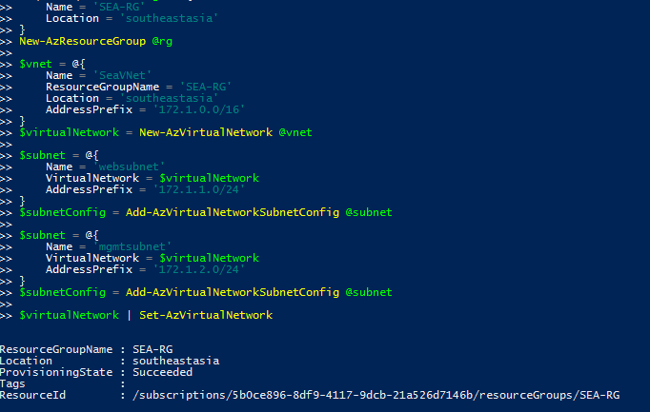

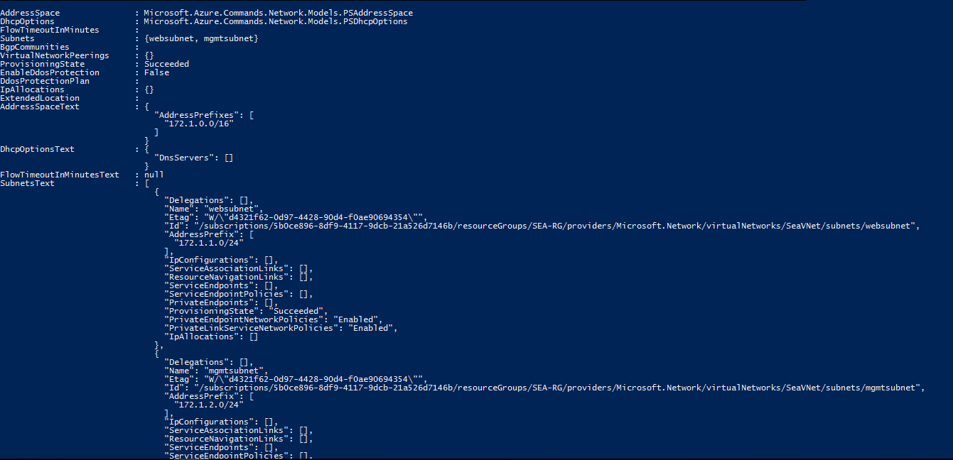

Load balancer:

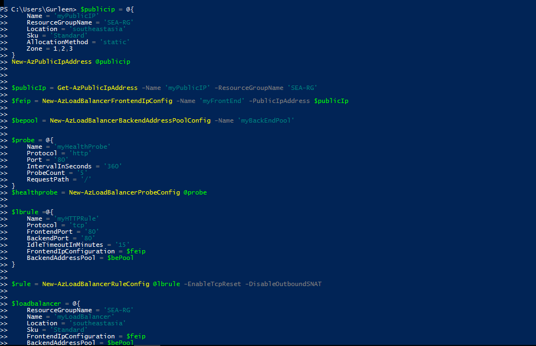

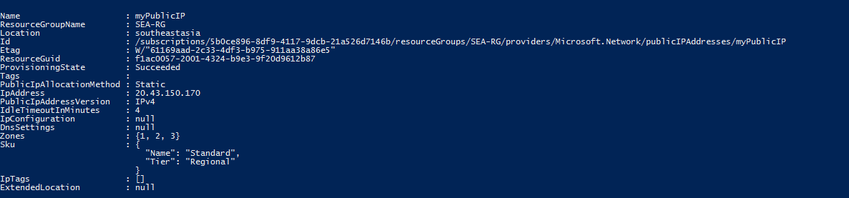

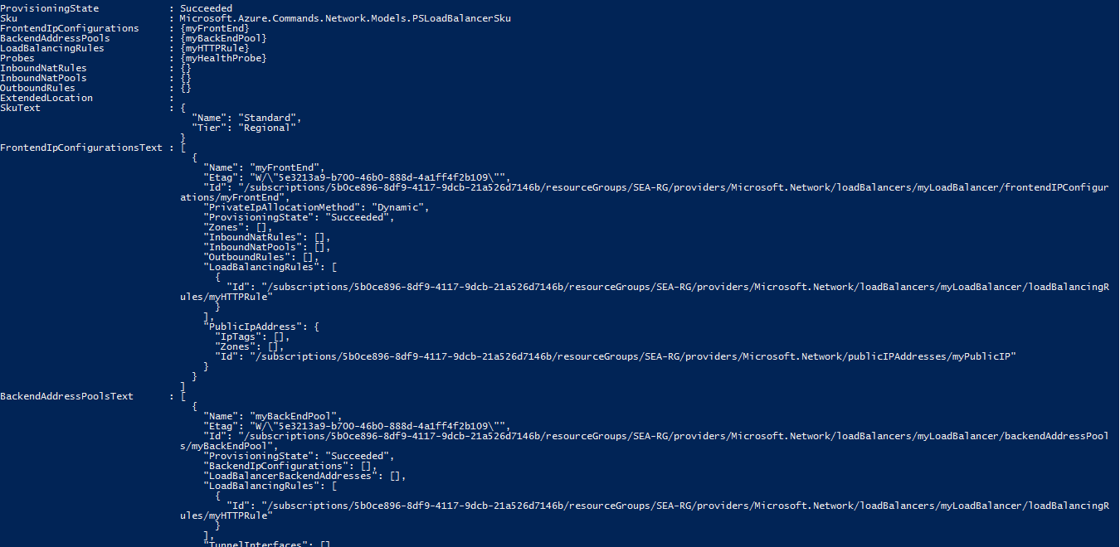

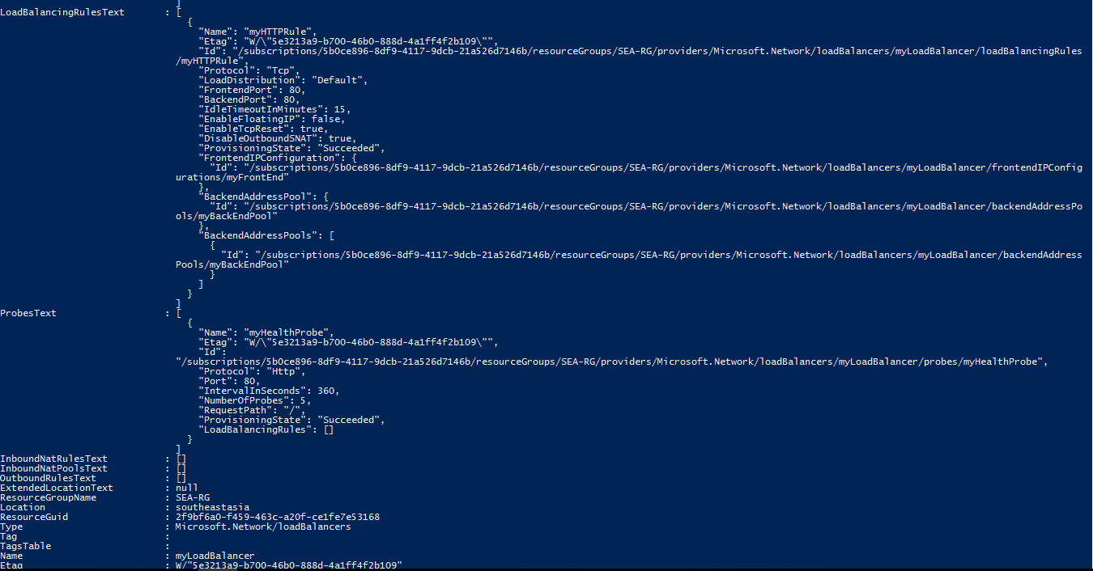

Creating NSG for websubnet:

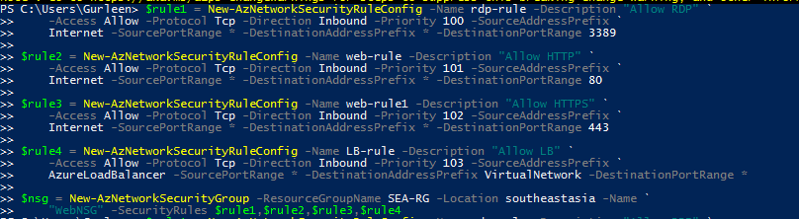

Creating NSG for MangementSubnet:

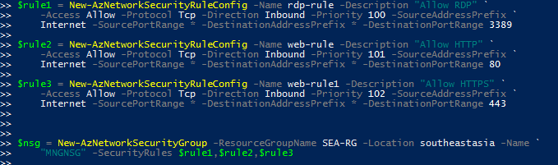

Viewing the insight preview:

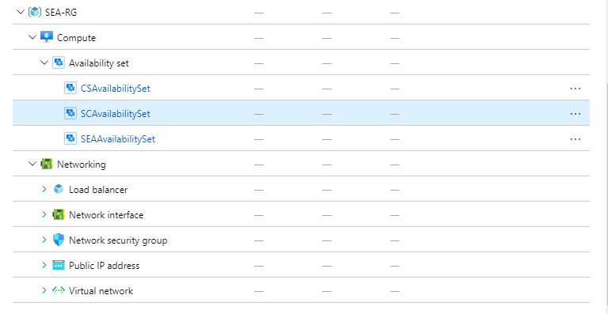

Diagram:

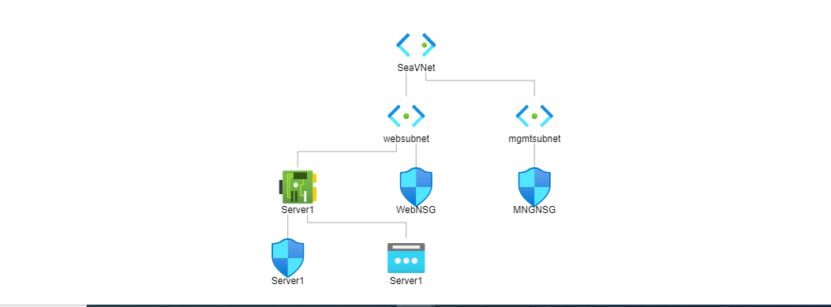

Creating availability set for the SEA region.. but facing issue due to subscription. We can create for regions as given below on need.

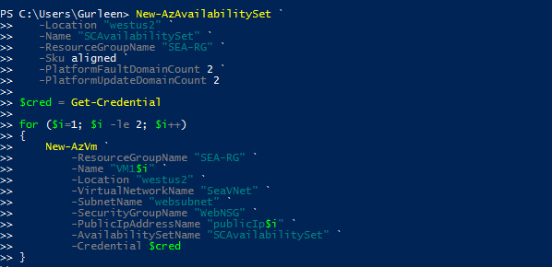

Creating Alert : When CPU Usage 80%:

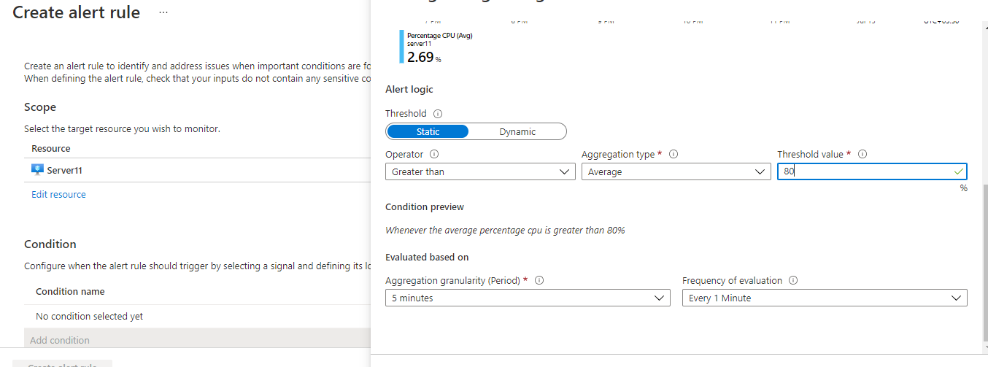

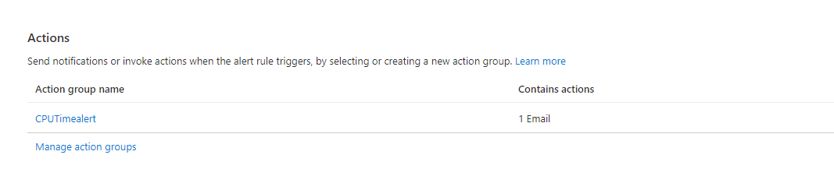

Once we select the option of alert to be notified we can go ahead and set the alert.

For now we haven’t added any actions in automation runbook. Just reviewed and created the alert.Notification has been sent as below.

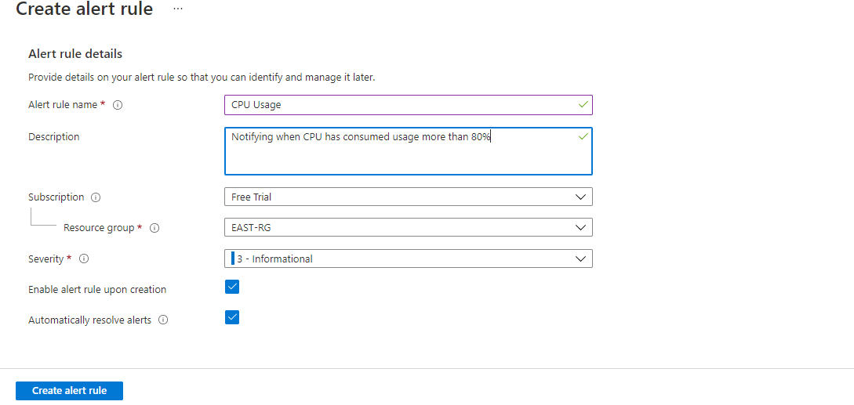

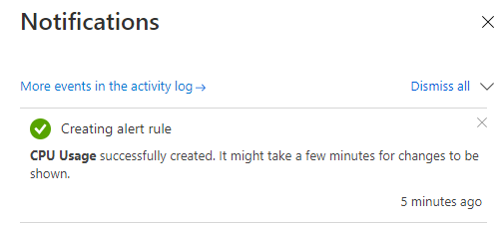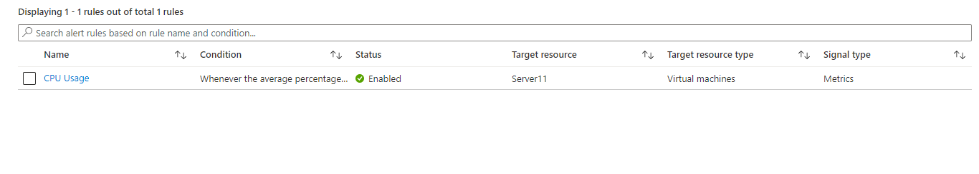

Now for the alert to be generated will increase the CPU ulitilisation as below; just to check the alert

Login to the VM:

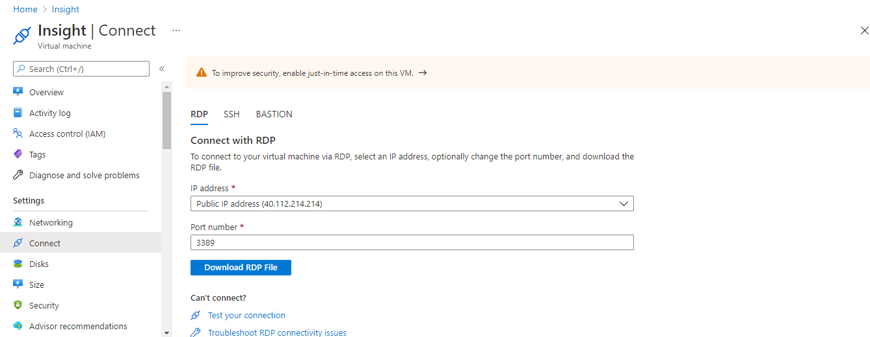

I have taken an example which I had created earlier. We can refer the same here:

Create a bat file and run on the VM

Now since the utilization has reached more than 80% percentage I got an email as well I can view on the portal alert has been generated as below:

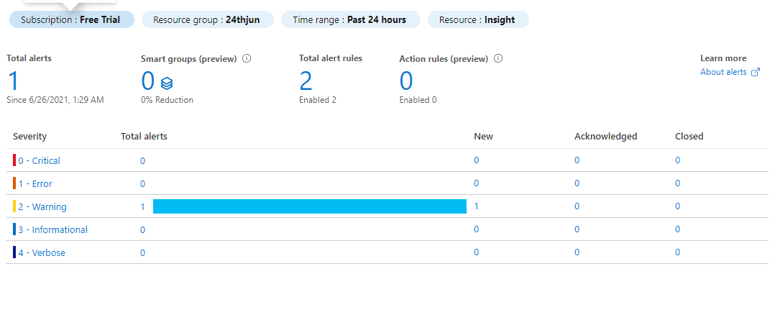



Also we have got the email as well as soon as the alert got generated on the portal:

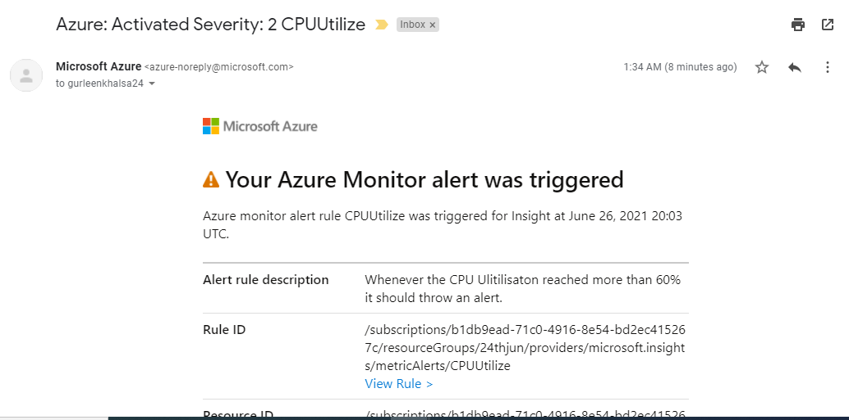

Login to the alert and check the problem and acknowledge it.

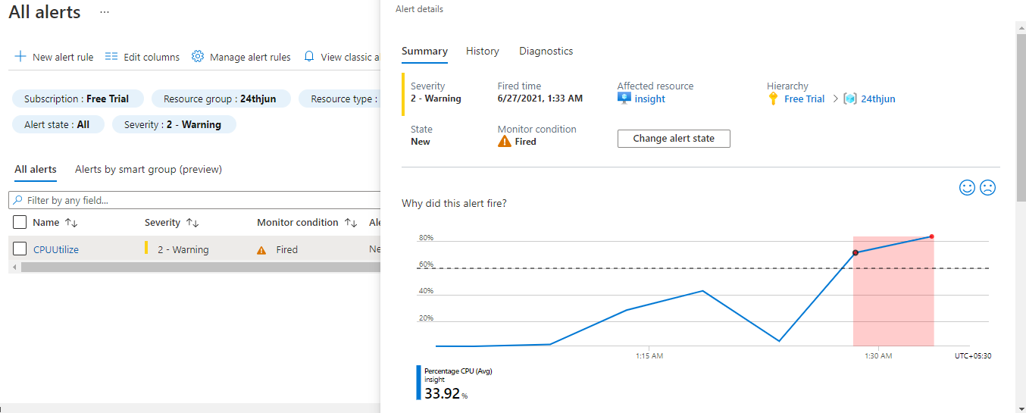

Change the state of the alert and go and check on the VM.

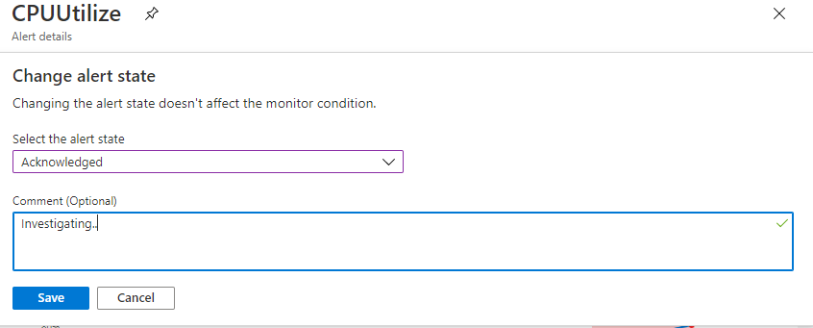

It will automatically suppress the alert then once the utilization percentage has gone down.

Received the alert mail also once the alert gets resolved.

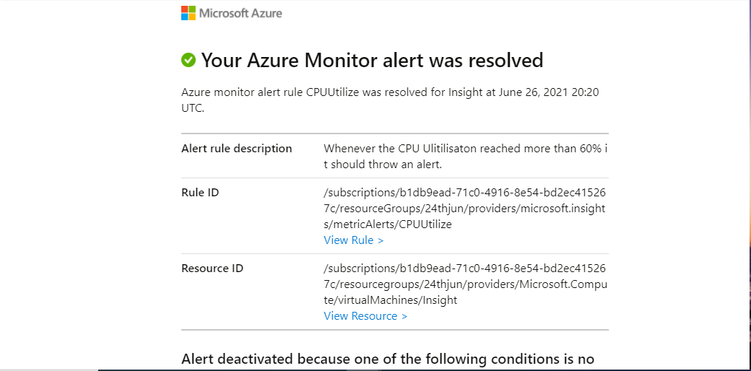

Now Alert has also cleared on the portal as well:

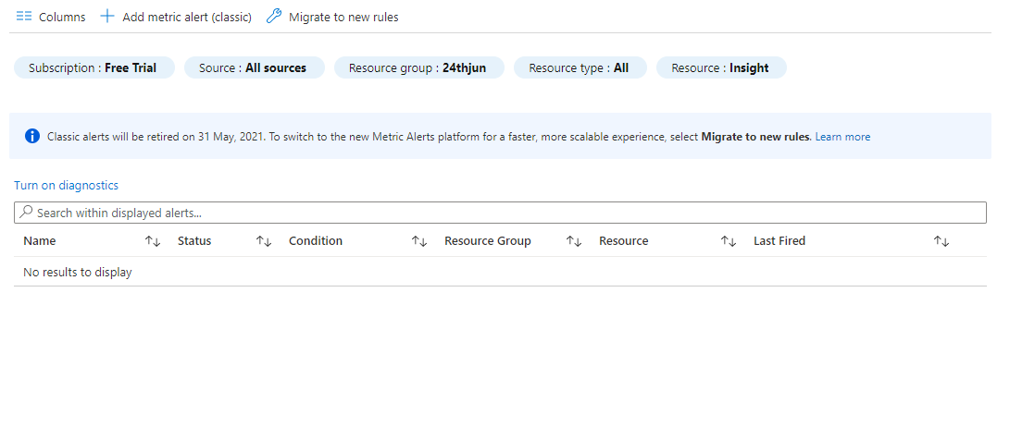We can also monitor the cpu level has gone down as well.

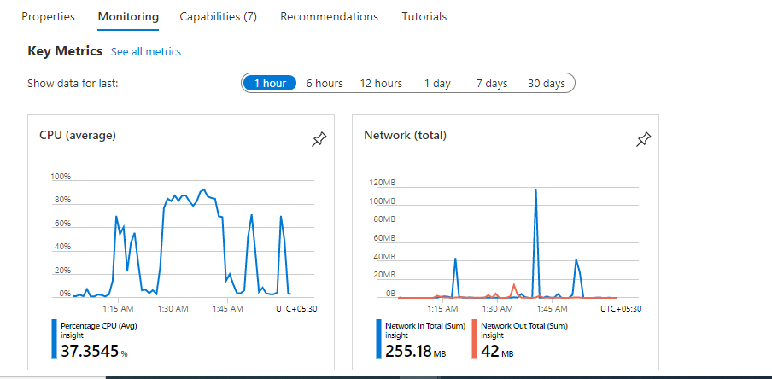

In order to take Backup for a VM:

Since we are using Azure backup for the first time we will need to set the RecoveryServices.

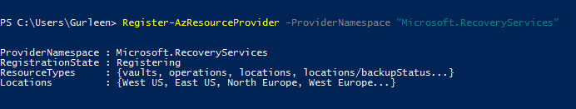

Created a service Vault: By default the vault uses GRS Geo-redundant storage. If we want to change it to LRS we can do so.

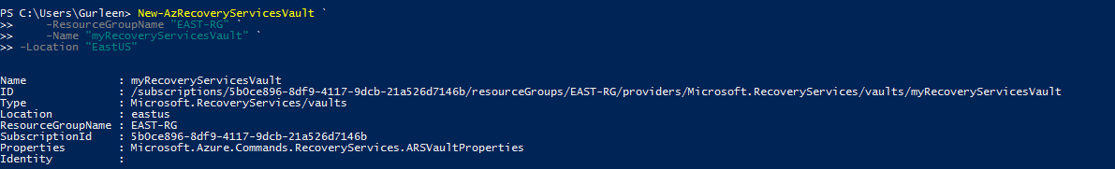

Added the service context and created a policy.



Now I have just enabled the backup :

I can also Monitor the backup Jobs which are running or completed.

If we need on-demand Jobs to be running we can check that aslo.

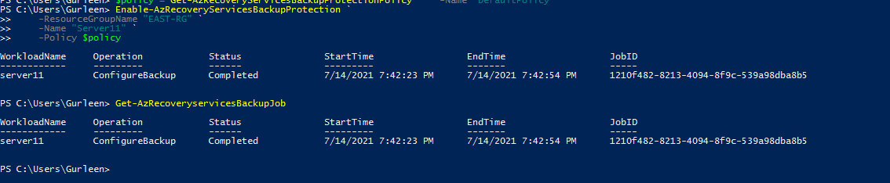

We can view the same on the portal:

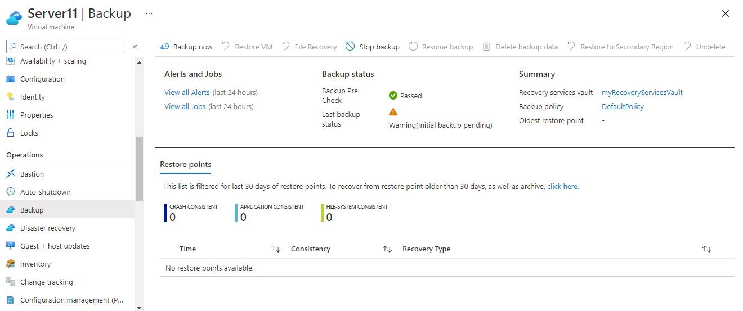

For EAST-US:

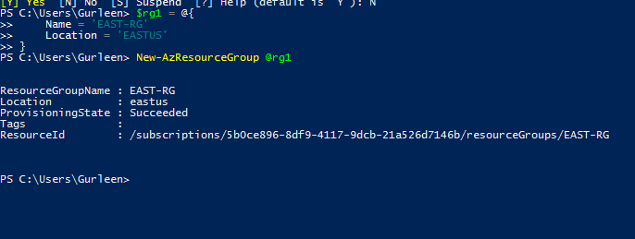. 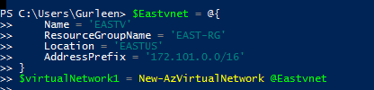

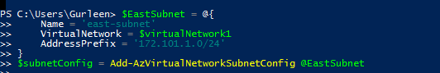

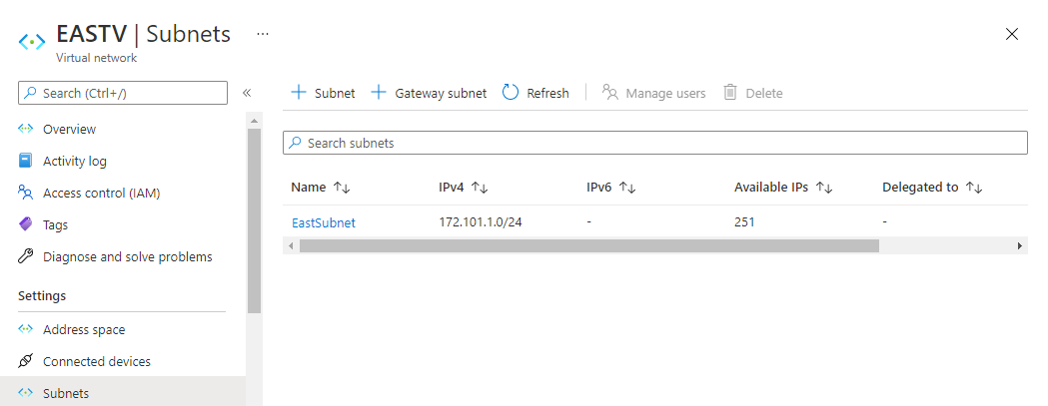

Creating the NSG for EastUS:

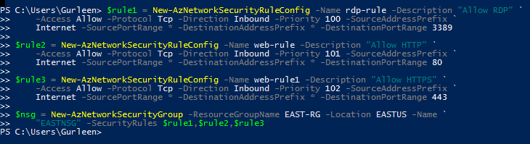

Created VM :

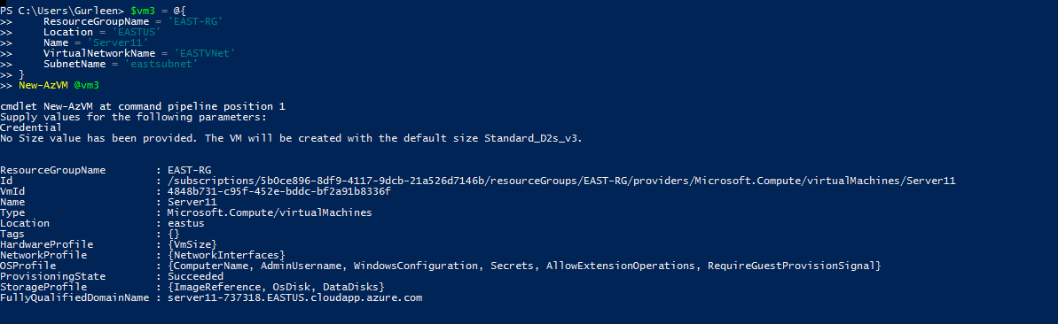

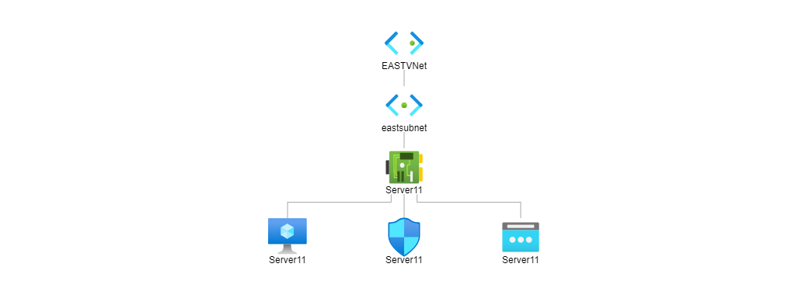

Vnet-Peering:

Storing in variables



Adding v-net peering:

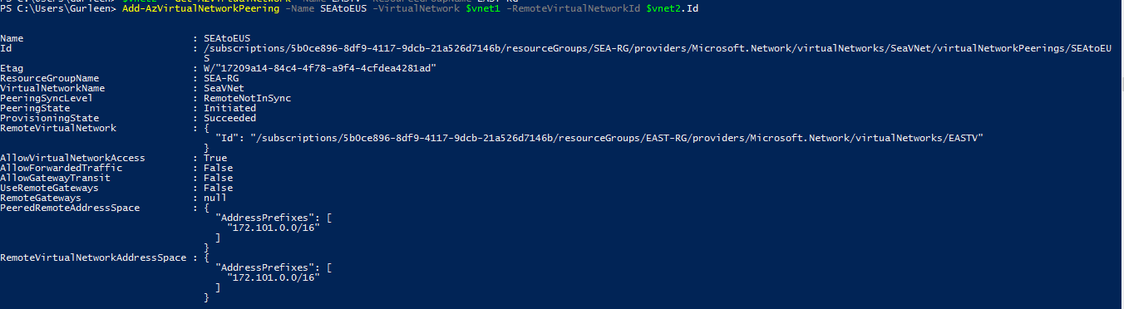

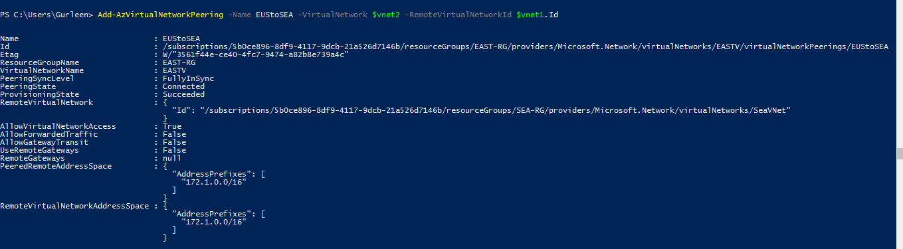

Viewing same on portal:

For SeaVNet:

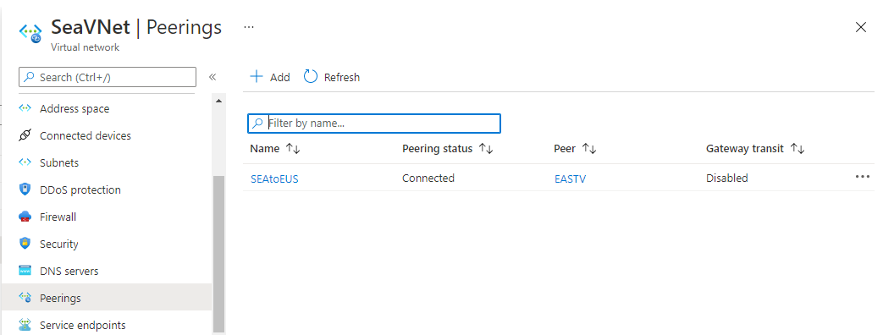

For EAStVNet:

