Final Diagram for SEA Region:

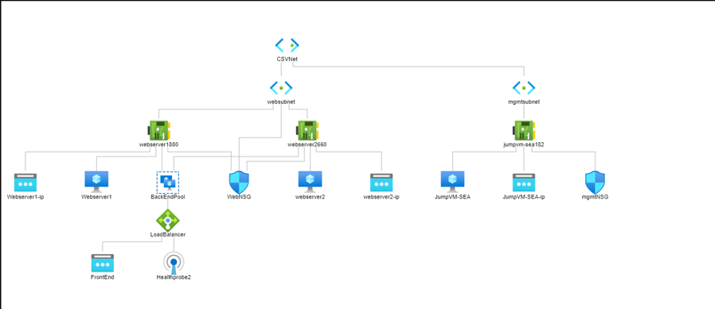

Final Diagram for EASTUSRegion:

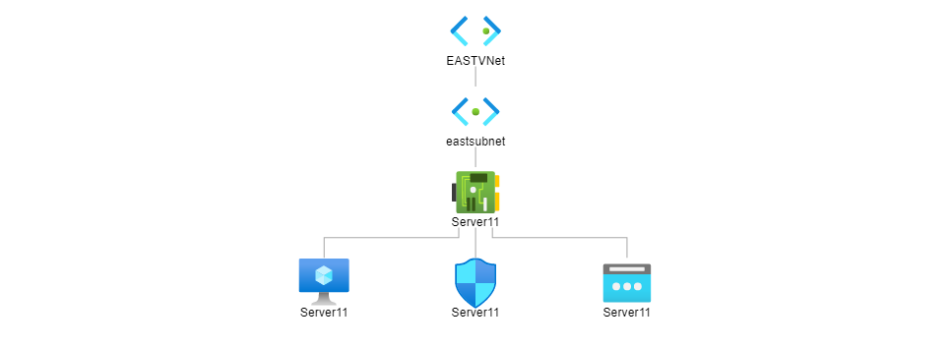

LB : PublicIP

20.43.150.170

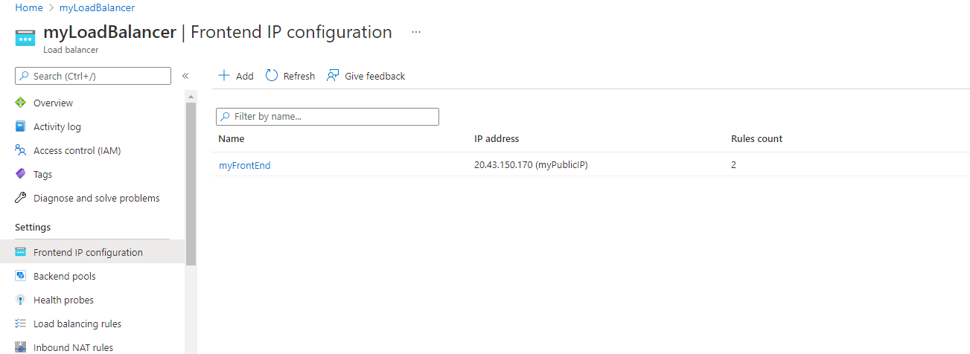

Creating healthProbe

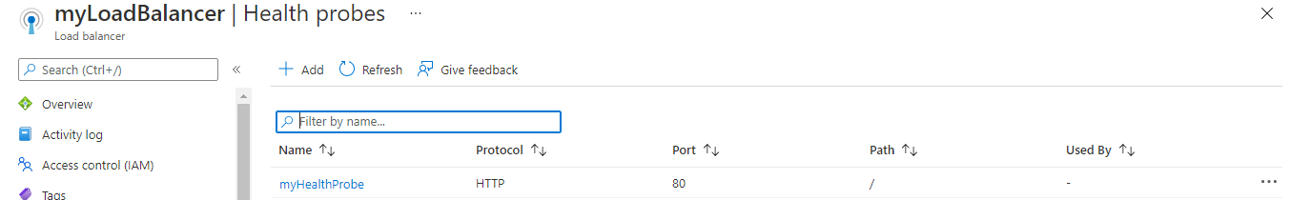

Creating LB Rule:

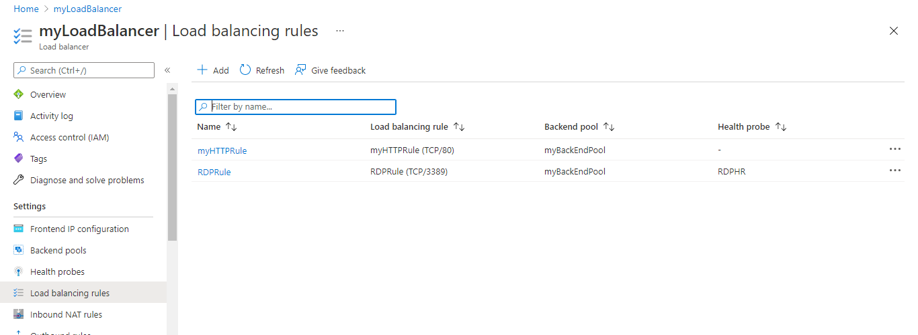

Creating the NAT Rule :

Installing IIS using powershell in both the VMs:

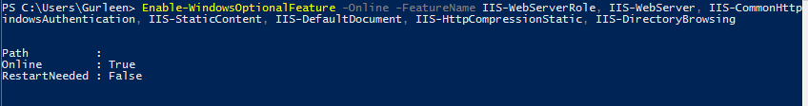

Checking the same on server. Adding Nat rule

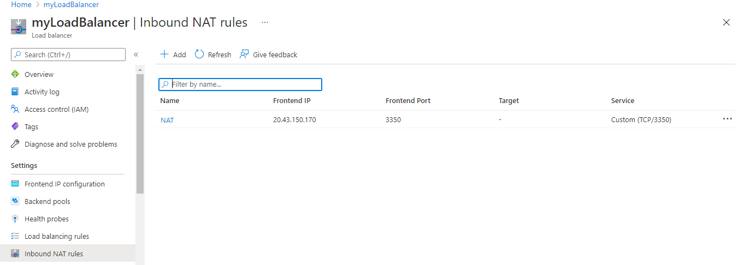

Hitting the Server:

