Report 4 110652034 賴羿茗
- Describe the input fields of each pipeline register.
- IF/ID:
Input: instruction
- ID/EX:
Input1: {RegWrite, ALUOp, ALUSrc, RegDst, MemRead, MemWrite, MemtoReg}
Input2: RSdata
Input3: RTdata
Input4: extendData
Input5: zeroData
Input6: IFinstruction (From IF/ID)
- EX/MEM:
Input1: {ID_RegWrite, ID_MemRead, ID_MemWrite, ID_MemtoReg} (From ID/EX)
Input2: ID_RTdata (From ID/EX)
Input3: Regdata
Input4: RegAddr
- MEM/WB:
Input1: {EX_RegWrite, EX_MemtoReg} (From EX/MEM)
Input2: EX_RegAddr (From EX/MEM)
Input3: EX_Regdata (From EX/MEM)
Input4: MemData
- Explain your control signals in the sixth cycle
Picture:
test_data test_1.txt
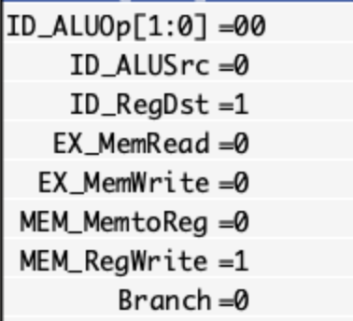

test_data test_2.txt
