**LAIBA SHOUKAT**

**MCSF19A002**

**Mobile Computing**

**Adding Repository:**

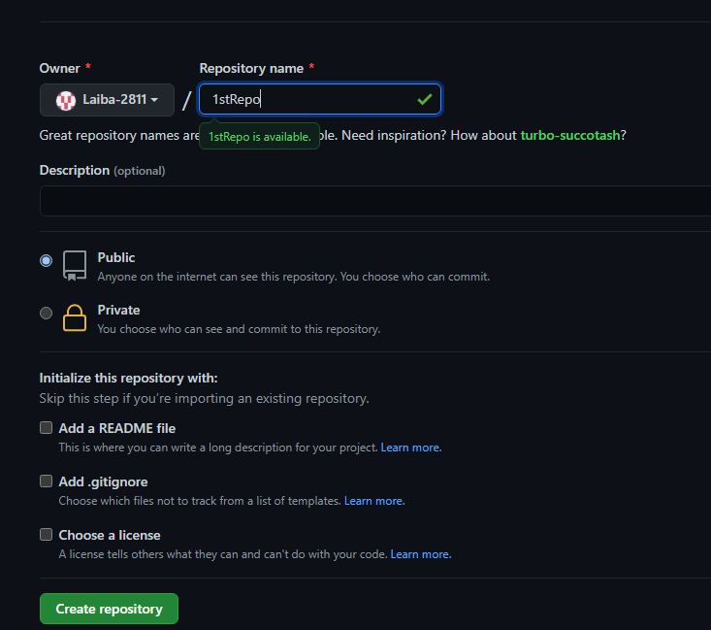

**Git init:**



**Git Clone:**

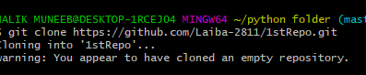

**Git Add:**



**Git Commit:**

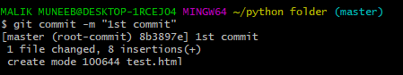

**Git Status:**

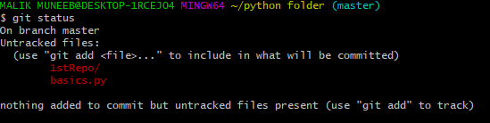

**Git Remote Add Origin:**



**Git Branch:**



**Git Push:**

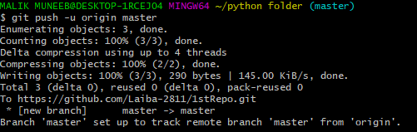

**Git Commit changes in local repository:**

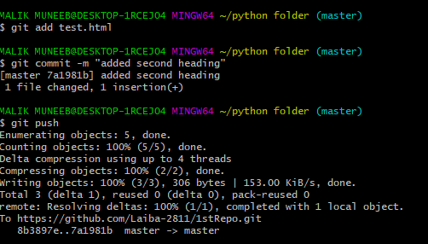

**Git Commit changes from central repository to Local Repository:**

**1.Edit:**



**2.Add Changes:**



**3.Commit Changes:**

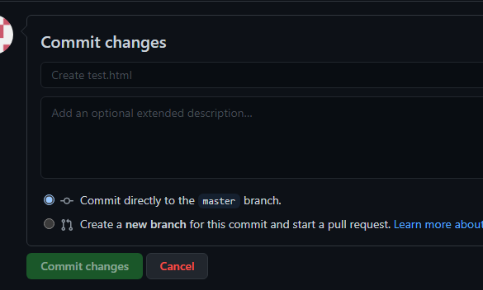

**4.Pull to the local Repository:**

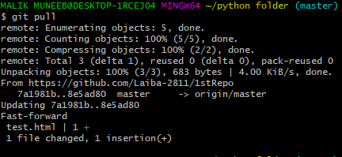

**Git log(to check the activitiesthat has been done)**

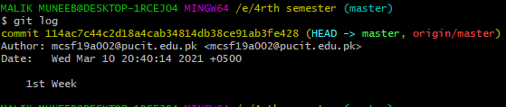

**After Changes in this document**

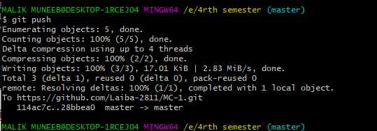

**Git Remove:**

git rm filename is used to remove any file.

**Branching:**





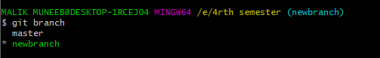

**Git commit –am “ ”(to implement add and commit in same line):**