Sentiment Analysis of Women's Clothing Reviews
Multiclass Logistic Regression (Built from Scratch) with L2 Regularization and SMOTE
Machine Learning Course Project

1. Introduction
Online customer reviews carry rich information about how buyers feel about a product, but this information is only useful if it can be organized automatically at scale. This project builds a multiclass sentiment classifier for Women's Clothing E-Commerce reviews, labelling each review as Negative, Neutral, or Positive. The main academic goal was not simply to reach high accuracy, but to implement Logistic Regression from first principles — the cost function, gradient descent update rule, and L2 regularization were all coded manually rather than imported from a library, so that the underlying mathematics of the model is fully understood and demonstrable.
A key practical challenge in this dataset is severe class imbalance: the large majority of reviews are Positive, while Negative and Neutral reviews are comparatively rare. To address this, the Synthetic Minority Over-sampling Technique (SMOTE) was applied to the training data so that the classifier does not simply learn to always predict the majority class.

2. Dataset Description
The dataset used is the Women's Clothing E-Commerce Reviews dataset, pre-processed into a clean CSV file (Preprocessed_Reviews_File.csv) containing review text and an associated sentiment label.
Property | Value
Total Rows | 23,465
Positive Reviews | 18,187
Neutral Reviews | 2,871
Negative Reviews | 2,407
Target Column | Sentiment (Negative / Neutral / Positive)
Table 1: Overview of the raw dataset and class distribution
The heavy skew toward Positive reviews (about 77% of all rows) is precisely the imbalance problem that SMOTE was later used to correct within the training set.

3. Methodology / Approach

3.1 Feature Extraction — TF-IDF
Raw review text cannot be fed directly into a mathematical model, so it was converted into numerical features using TF-IDF (Term Frequency – Inverse Document Frequency) vectorization. The vectorizer was configured with max_features = 5000 and an n-gram range of (1, 2), meaning both single words and two-word phrases were considered as features. This produced a feature matrix of shape (23,465 × 5,000).

3.2 Train / Validation / Test Split
The dataset was split into three parts using stratified sampling (to preserve class proportions in every split): 70% for training, 15% for validation (used for hyperparameter tuning), and 15% for a held-out test set (used only once, for the final unbiased evaluation).
Split | Size
Training Set | 16,425 rows
Validation Set | 3,520 rows
Test Set | 3,520 rows
Table 2: Train / Validation / Test split sizes

3.3 Handling Class Imbalance — SMOTE
SMOTE was applied only to the training set, and only on the raw TF-IDF features — before the bias (intercept) column was appended. This ordering matters: generating synthetic samples on a constant bias column would be meaningless, so bias was added only after resampling. Validation and test sets were left completely untouched, since SMOTE must never be applied to evaluation data — doing so would leak synthetic information into performance metrics and give an unrealistically optimistic result.
Class | Before SMOTE | After SMOTE
Negative | 1,685 | 12,730
Neutral | 2,010 | 12,730
Positive | 12,730 | 12,730
Table 3: Training-set class distribution before and after SMOTE (final training size: 38,190 rows)

3.4 Logistic Regression — Built From Scratch
Rather than using a library implementation, Logistic Regression was implemented manually, including:
- The sigmoid activation function, with input clipping to avoid numerical overflow.
- A regularized cross-entropy cost function, where the bias term (θ0) is intentionally excluded from the L2 penalty, in line with standard regularization convention.
- A regularized batch gradient descent update rule, again leaving the bias term unregularized.
- A One-vs-Rest (OvR) strategy to extend the binary logistic model to three classes — one classifier trained per class (Negative-vs-Rest, Neutral-vs-Rest, Positive-vs-Rest), with the final prediction taken as the class whose classifier outputs the highest probability.

3.5 Hyperparameter Tuning
Three hyperparameters were tuned in sequence, each building on the previous result:
- Learning Rate (α): tested over {0.001, 0.01, 0.1, 1, 3, 5, 7, 10} using a representative classifier, stopping as soon as the training cost started to increase rather than decrease.
- Regularization strength (λ): tested over {0, 0.001, 0.01, 0.1, 1, 10} at the best α, using validation error as the selection criterion (a classic bias–variance U-curve search).
- Number of iterations: chosen using a tolerance-based convergence check, tracking the average cost across all three One-vs-Rest classifiers rather than a single classifier, so the stopping point reflects the whole model.
The final selected hyperparameters were:
Hyperparameter | Selected Value
Learning Rate (α) | 7
Regularization (λ) | 1
Iterations | 1500 (maximum reached)
Table 4: Final tuned hyperparameters
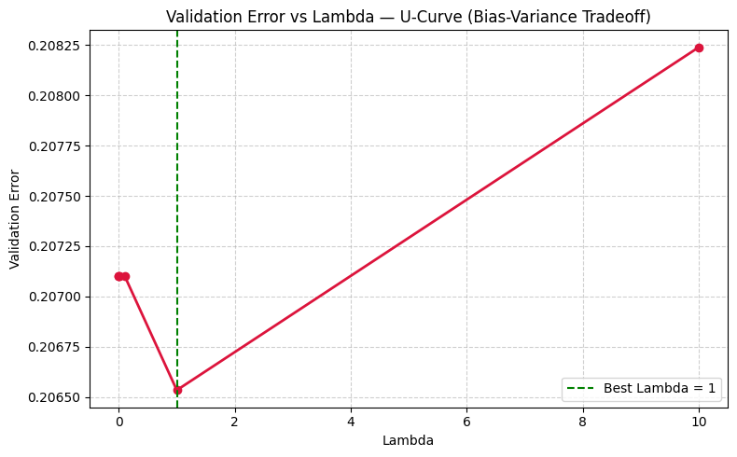
Figure 1: Validation error vs. Lambda (bias–variance U-curve) used to select λ = 1
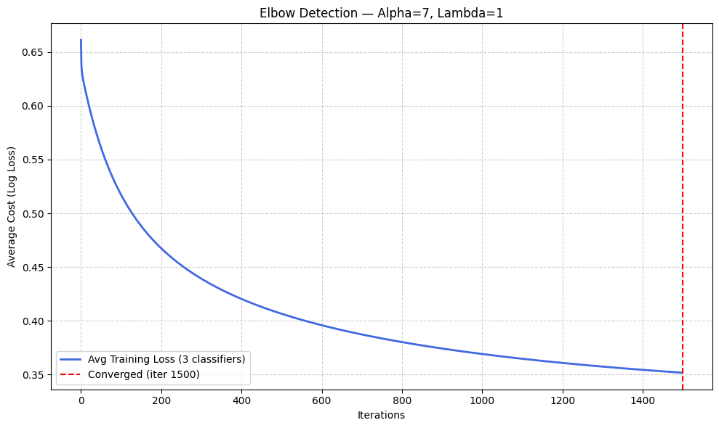
Figure 2: Average training cost across all three classifiers, used for the iteration/convergence check

4. Results

4.1 Validation Set Performance
With the tuned hyperparameters, the final One-vs-Rest model achieved a validation accuracy of 79.49%.
Class | Precision | Recall | F1-Score | Support
Negative | 0.48 | 0.59 | 0.53 | 361
Neutral | 0.36 | 0.45 | 0.40 | 430
Positive | 0.94 | 0.88 | 0.91 | 2,729
Table 5: Per-class classification report — Validation set
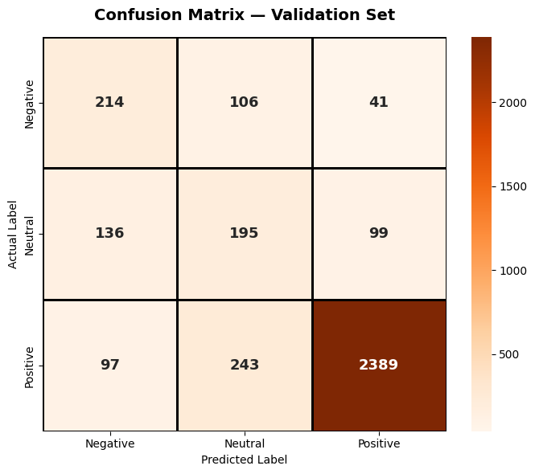
Figure 3: Confusion Matrix — Validation Set

4.2 Test Set Performance (Final, Held-Out)
The test set was evaluated exactly once, after all tuning was complete, giving an unbiased estimate of real-world performance.
Metric | Value
Accuracy | 79.60%
Precision (weighted) | 0.8236
Recall (weighted) | 0.7960
F1-Score (weighted) | 0.8079
Table 6: Overall weighted metrics — Test set
Class | Precision | Recall | F1-Score | Support
Negative | 0.48 | 0.59 | 0.53 | 361
Neutral | 0.35 | 0.44 | 0.39 | 431
Positive | 0.94 | 0.88 | 0.91 | 2,728
Table 7: Per-class classification report — Test set
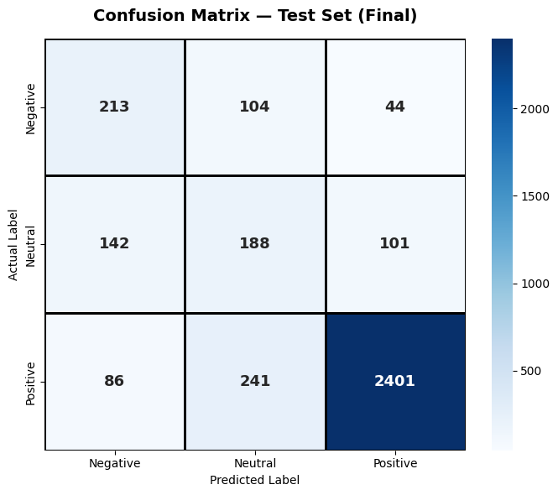
Figure 4: Confusion Matrix — Test Set

4.3 Convergence of Gradient Descent
The cost history of each of the three One-vs-Rest classifiers was tracked across training to confirm that gradient descent was converging rather than diverging or oscillating.
Table 8: Cost reduction summary for each One-vs-Rest classifier
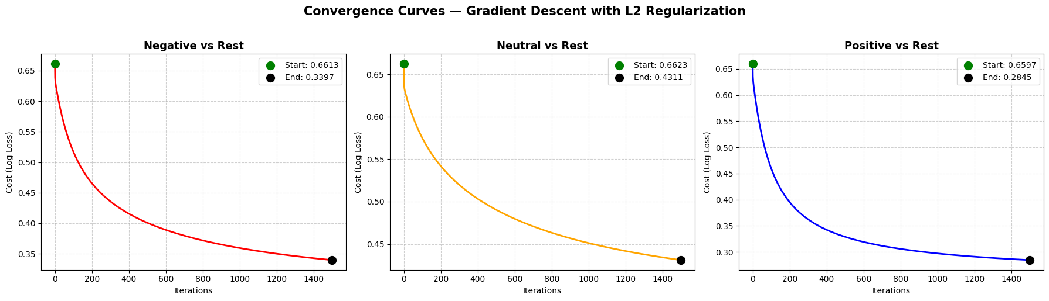
Figure 5: Convergence curves for all three One-vs-Rest classifiers

5. Discussion
The model performs very well on the Positive class (F1-score ≈ 0.91), which is expected since it is both the majority class and, presumably, the most linguistically distinct in the review text (clear positive language, exclamations, recommendation phrases, etc.). Performance on the Negative and Neutral classes is noticeably weaker (F1-scores around 0.53 and 0.39 respectively), even after SMOTE. This gap between Positive and the two minority classes suggests two things: first, Neutral and Negative reviews are harder to separate from each other, since customers often mix mild criticism with some positive remarks in the same review, making the sentiment boundary genuinely fuzzy rather than a limitation of the model alone. Second, while SMOTE balances the class counts numerically, it generates synthetic samples by interpolating in TF-IDF space, which does not always create linguistically realistic minority-class examples, so the boost it gives to minority-class recall is real but limited.
Classifier | Starting Cost | Final Cost | Cost Reduced
Negative vs Rest | 0.661 | 0.339 | 48.64%
Neutral vs Rest | 0.662 | 0.431 | 34.90%
Positive vs Rest | 0.659 | 0.284 | 56.87%
The learning-rate search correctly identified α = 7 as the point just before the cost started to increase again at α = 10, confirming that gradient descent becomes unstable at higher learning rates on this feature space. The lambda search showed only a very small U-curve effect (validation error changed by roughly 0.001–0.002 across most lambda values), indicating that this dataset is not strongly prone to overfitting at this feature size, so a small amount of regularization (λ = 1) was sufficient. The overall similarity between validation accuracy (79.49%) and test accuracy (79.60%) is a good sign: the model generalizes consistently and was not overfit to the validation set during tuning.

6. Conclusion
This project successfully implemented a multiclass Logistic Regression classifier entirely from scratch — including the cost function, regularized gradient descent, and One-vs-Rest extension — and combined it with TF-IDF feature extraction and SMOTE-based class balancing to classify Women's Clothing reviews into Negative, Neutral, and Positive sentiment. After systematic tuning of the learning rate, regularization strength, and iteration count, the final model achieved 79.60% test accuracy with a weighted F1-score of 0.8079. The model is strongest at identifying Positive reviews and comparatively weaker at separating Negative from Neutral reviews, which is a reasonable limitation given the inherent ambiguity of neutral/mildly-negative language and highlights class imbalance and semantic overlap as the primary remaining challenges rather than any flaw in the optimization procedure itself.
AI Usage Disclosure
Claude and ChatGPT were used only to understand programming errors, clarify machine learning concepts, review code as a learning reference, and improve the grammar of this report. All code implementation, experiments, results, visualizations, and analysis were completed and verified by the project team. No results or analysis were generated by AI.

