MILESTONE 1 — PROGRESS REPORT

Sentiment Analysis of E-Commerce Clothing Reviews

A Comparative Machine Learning Approach
Course: Machine Learning (BSSE)
Section C
Submission Date: 7-2-26

Name | Roll Number | Role
Laiba Haider | 231400096 | Project Manager
Hadia Nasir | 231400100 | Modelling Lead
Haider Zaman | 231400106 | Data Engineer
Shazil Iqbal | 231400145 | Evaluation & Reporting

Introduction
In the modern e-commerce industry, customer feedback plays a critical role in improving products and services. With thousands of reviews generated daily, it is practically infeasible to manually analyze and categorize customer sentiment. This project develops an automated Sentiment Analysis system that classifies Women's Clothing E-Commerce reviews into Positive, Neutral, or Negative categories, formulated as a supervised multiclass classification task. The system is intended to help businesses quickly identify dissatisfied customers and make data-driven decisions to improve customer satisfaction and retention.
  - Revisions to the Original Proposal
The original proposal planned a two-model comparison — Multinomial Naive Bayes as the baseline and a Support Vector Machine (SVM) as the comparison model. During Milestone 1 development, the team added a third model, Multiclass Logistic Regression (built entirely from scratch with L2 regularization and SMOTE-based class balancing), to strengthen the comparison and to give the Evaluation & Reporting lead a linear, probabilistic benchmark alongside the Bayesian baseline. The classification target was also refined from binary (Positive/Negative) to a three-class Sentiment label (Negative / Neutral / Positive), derived from the Rating column, to better reflect the natural structure of the review data.
- Baseline model — Multinomial Naive Bayes (implemented from scratch).
- Additional model — Multiclass Logistic Regression with SMOTE (implemented from scratch).
- Planned for Milestone 2 — Support Vector Machine (SVM), as proposed originally, plus final model comparison.

Dataset Description
The dataset used is the Women's E-Commerce Clothing Reviews dataset (Kaggle), a publicly available dataset licensed for academic and research use.

Property | Detail
Source | Kaggle — Women's E-Commerce Clothing Reviews Dataset
Original Shape | 23,486 rows × 11 columns
Final Shape (after cleaning duplication and index row) | 23,465 rows × 10 columns
Target Task | Sentiment Analysis (Negative / Neutral / Positive)
Target Variable | Sentiment — derived from Rating (1–2 = Negative, 3 = Neutral, 4–5 = Positive)

Feature Types
Feature Type | Columns
Textual | Review Text, Title
Numerical | Age, Rating, Positive Feedback Count, Clothing ID, Recommended IND
Categorical | Division Name, Department Name, Class Name

Data Quality Issues Found
- Missing values in 5 columns — Title (3,810), Review Text (845), Division/Department/Class Name (14 each).
- 21 exact duplicate rows, removed via drop_duplicates().
- Severe class imbalance in the target: Positive 77.5%, Neutral 12.2%, Negative 10.3%.
- Noisy free text — inconsistent casing, punctuation, and stray whitespace requiring NLP normalization.

Exploratory Data Analysis
Nine visualizations were generated to understand the structure, quality, and modeling implications of the dataset before feature engineering and model training out of them 6 are discuss below.

Rating Distribution
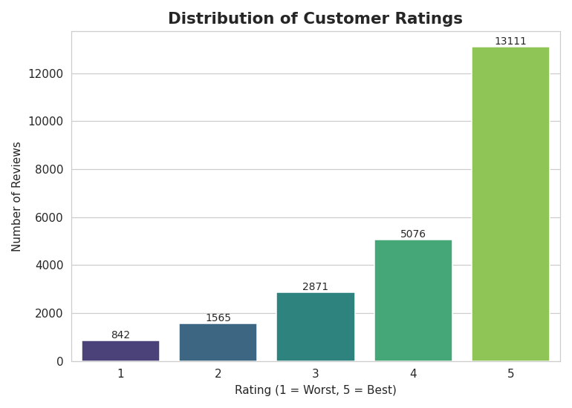
Most customers gave 5-star ratings (55.9%), followed by 4-star (21.6%). Only 10.3% of reviews are 1- or 2-star. This confirms the dataset is heavily imbalanced toward positive reviews.

Customer Age Group Distribution
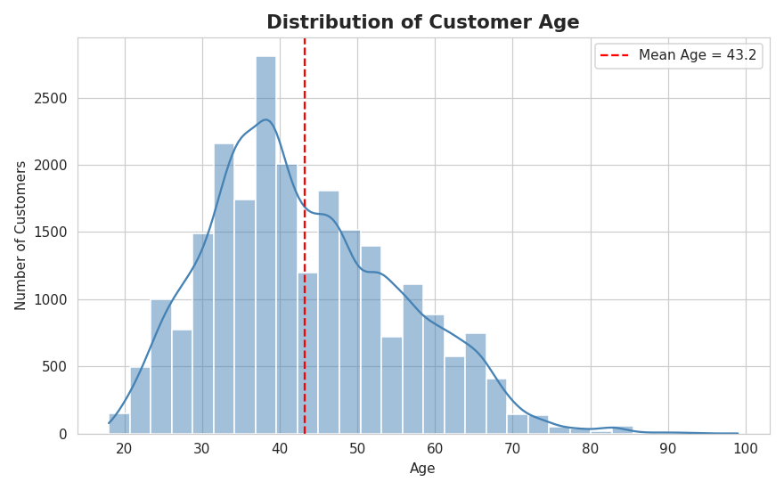
Customer age is centered around 43.2 years (median 41), with most shoppers falling between 34 and 52. The core customer base is middle-aged women, with a slight right skew.

Recommended vs Not Recommended
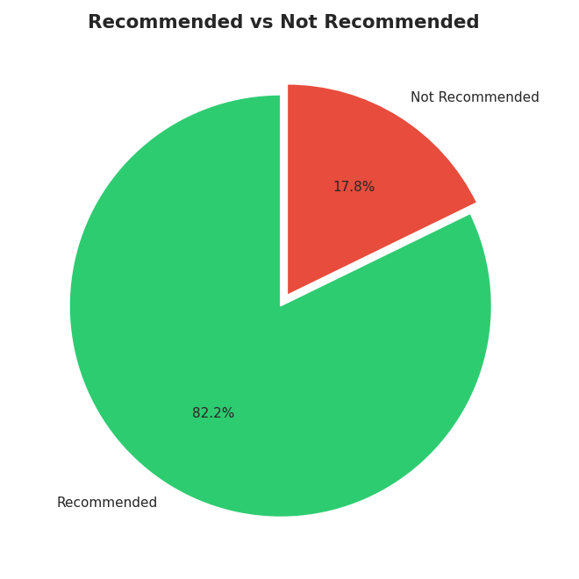
82.2% of customers recommended the product they reviewed, while only 17.8% did not. This mirrors the rating distribution and reinforces the overall positive skew of the dataset.

Word Frequency – Positive Reviews (Rating 4-5)
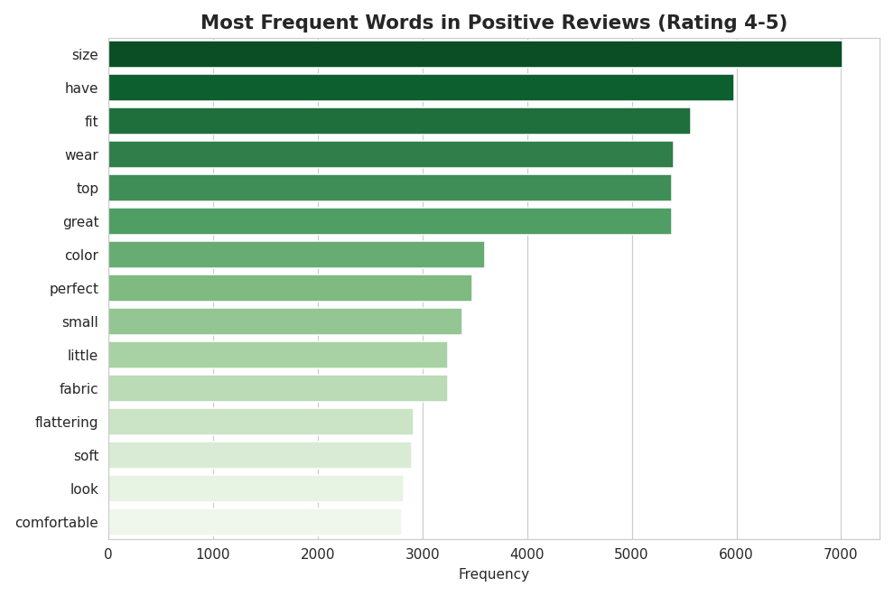
The most common words in positive reviews are 'size', 'have', and 'fit', showing that satisfied customers focus heavily on good fit and comfortable sizing when praising a product.

Average Rating by Department
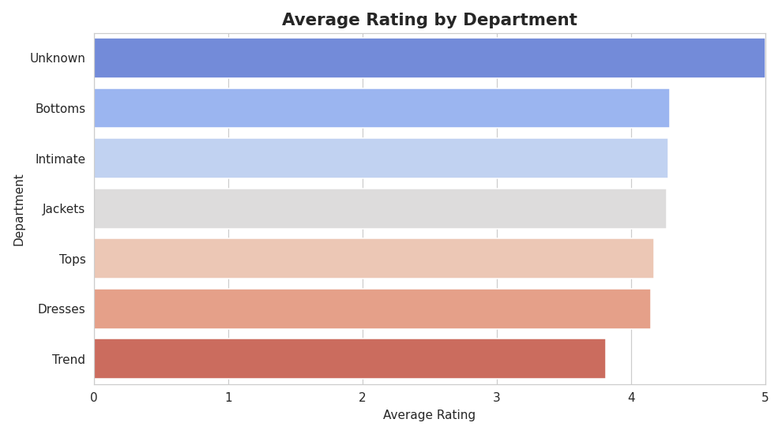
The 'Unknown' department has the highest average rating (5.00, small sample), while 'Trend' has the lowest (3.82). Differences are modest since nearly every department benefits from the overall positive skew.

Correlation Heatmap of Numeric Features
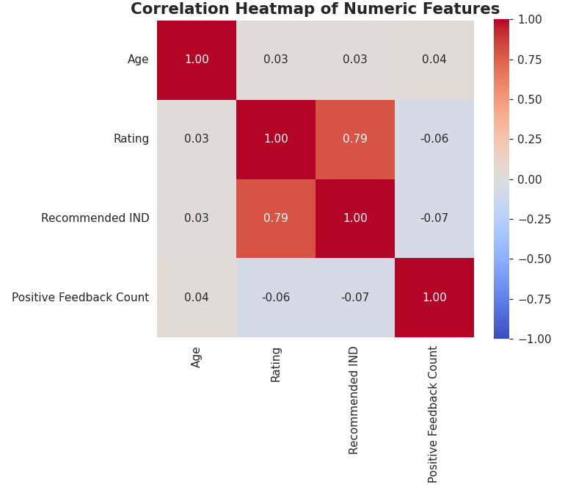
Rating and Recommended IND are strongly correlated (0.79), which makes sense since a high star rating almost always comes with a recommendation. Age shows almost no correlation with Rating or Recommended IND.

Preprocessing Pipeline

Missing Values, Duplicates, Encoding, and Scaling
A five-stage pipeline was used to take the raw 23,486-row CSV to a clean, model-ready dataset:
Stage | Key Actions
1. Data Collection | Loaded Women's Clothing E-Commerce Reviews.csv (23,486 × 11)
2. Data Cleaning | Inspected structure; imputed missing values with constants ("No Title", "No Review", "Unknown"); removed 21 duplicate rows; reset index
3. Data Transformation | Min-Max normalization on Age; Z-Score normalization on Positive Feedback Count (handles outliers); Label Encoding on Division/Department/Class Name; created Sentiment target from Rating
4. Feature Engineering | Custom binning of Age into Young/Middle/Senior (Age_Group); TF-IDF vectorization of review text
5. Data Splitting | Stratified 70/15/15 Train/Validation/Test split, random_state = 42
Constant imputation was chosen over deletion specifically to retain all 23,465 customer records rather than discard rows with only a missing title or review text — every remaining row still carries a valid Rating, which is the source of the prediction target.

NLP Text Preprocessing
Before TF-IDF vectorization, the Review Text column was passed through six sequential NLP preprocessing tasks:
- Lowercase conversion — standardizes casing so "Love" and "love" are treated as one token.
- Regex cleaning — strips URLs and collapses/trims whitespace.
- Special character removal — strips punctuation and non-alphanumeric symbols.
- Tokenization — splits cleaned text into word tokens using NLTK's word_tokenize.
- Stop-word removal — removes common English stop words using NLTK's stop-word list.
- Lemmatization — reduces tokens to their dictionary base form using WordNetLemmatizer.
The output of this pipeline is a new Processed Text column (0 missing values across all 23,465 rows), which feeds directly into TF-IDF vectorization.

Feature Engineering — TF-IDF Vectorization
Scikit-learn's TfidfVectorizer was configured with max_features = 5000 and ngram_range = (1, 2), producing a sparse matrix of shape (23,465, 5,000) consisting of both unigram and bigram features. This matrix is the direct input (X) for all three planned classifiers.

Baseline Model — Multinomial Naive Bayes
The baseline model is a Multinomial Naive Bayes (MNB) classifier, implemented entirely from scratch using NumPy (no scikit-learn classifier). It predicts one of three sentiment classes from the TF-IDF feature vectors, using Bayes' theorem with the conditional-independence assumption between words and Laplace (Add-1) smoothing to avoid zero probabilities for unseen word/class combinations. All computation is done in log-space to avoid numerical underflow.

Metric | Validation Set | Test Set
Sample Count | 3,520 | 3,520
Accuracy | 79.66% | 79.91%
Validation and test accuracy are very close (79.66% vs. 79.91%), indicating the model generalizes consistently and is not overfitting. Because Naive Bayes optimizes overall likelihood, it is naturally biased toward the majority Positive class — this shows up directly in the sample predictions, where a true Negative review was misclassified as Positive and a true Positive review was misclassified as Neutral. Even so, the model clearly exceeds the majority-class baseline of 77.5% (always predicting Positive), confirming it is learning genuine sentiment signal rather than just class frequency.

Additional Model — Logistic Regression with SMOTE
As the second model trained and compared against the baseline, a multiclass Logistic Regression classifier was implemented from scratch, including the sigmoid activation (with input clipping to prevent overflow), a regularized cross-entropy cost function, and regularized batch gradient descent, with the bias term intentionally excluded from the L2 penalty. A One-vs-Rest (OvR) strategy extends the binary logistic model to the three sentiment classes.

Handling Class Imbalance with SMOTE
SMOTE was applied only to the training set and only to the raw TF-IDF features, before the bias column was appended, growing the training set from 16,425 to 38,190 rows with all three classes balanced at 12,730 samples each. Validation and test sets were left untouched, since applying SMOTE there would leak synthetic information into the evaluation metrics.

Hyperparameter Tuning
Hyperparameter | Search Range | Selected Value
Learning Rate (α) | {0.001, 0.01, 0.1, 1, 3, 5, 7, 10} | 7
Regularization (λ) | {0, 0.001, 0.01, 0.1, 1, 10} | 1
Iterations | Tolerance-based convergence check | 1,500 (maximum reached)

Results
Metric | Validation Set | Test Set
Accuracy | 79.49% | 79.60%
Weighted Precision | — | 0.8236
Weighted Recall | — | 0.7960
Weighted F1-Score | — | 0.8079

Classification Report
Class | Precision | Recall | F1-Score | Support
Negative | 0.48 | 0.59 | 0.53 | 361
Neutral | 0.35 | 0.44 | 0.39 | 431
Positive | 0.94 | 0.88 | 0.91 | 2,728

The model performs strongly on the Positive class (F1 ≈ 0.91) but is noticeably weaker on Negative (F1 = 0.53) and Neutral (F1 = 0.39) reviews, even after SMOTE. This suggests Neutral and Negative reviews are genuinely harder to separate — customers often mix mild criticism with positive remarks in the same review — and that SMOTE's TF-IDF-space interpolation improves minority-class recall but cannot fully substitute for linguistically realistic minority examples.

Model Comparison Summary
Model | Type | Test Accuracy | Notes
Multinomial Naive Bayes (Baseline) | Probabilistic, from scratch | 79.91% | Slightly higher raw accuracy; biased toward majority class
Logistic Regression  + SMOTE | Discriminative, from scratch, OvR | 79.60% | Better minority class handling via SMOTE; similar overall accuracy
SVM (planned) | Margin-based | Pending | To be trained and compared in Milestone 2

The two completed models are within 0.31 percentage points of each other on test accuracy, both comfortably above the 77.5% majority-class baseline, and both show the same underlying pattern: strong performance on Positive reviews and weaker performance on the minority Negative/Neutral classes. This consistency across two independently-implemented algorithms suggest the ceiling on minority-class performance is currently driven more by class imbalance and semantic overlap between Neutral and Negative language than by either model's specific architecture.

Challenges Encountered and How They Were Addressed
Challenge | Impact | How It Was Addressed
Severe class imbalance | Models biased toward predicting the majority Positive class | Stratified train/validation/test splitting throughout; SMOTE oversampling applied to the Logistic Regression training set
Missing Review Text / Title | Risk of losing usable rating data if rows were dropped | Constant imputation ("No Title", "No Review") retained all 23,465 rows
Numerical underflow in Naive Bayes | Multiplying many small word  probabilities risked floating-point  underflow | All prior and likelihood computations converted to logspace
Sarcasm and mixed-sentiment reviews | Single words alone can misrepresent true sentiment (e.g. "Oh great, it ripped immediately") | Bigram features (ngram_range = (1,2)) included in TF-IDF to capture short contextual phrases
Numerical overflow in Logistic Regression sigmoid | Very large/small linear scores could overflow the exponential in sigmoid() | Input clipping applied before the sigmoid activation
Choosing a stable learning rate | Too-high a learning rate caused gradient descent to become unstable | Systematic grid search over α, stopping as soon as training cost began increasing

Plan for Milestone 2
- Implement and train the third planned model — Support Vector Machine (SVM) — on the same TF-IDF feature matrix and splits.
- Run a full three-way comparison (Naive Bayes, Logistic Regression, SVM) using accuracy, weighted precision/recall/F1, and confusion matrices.
- Apply macro-averaged F1-score as an additional evaluation metric to better reflect minorityclass (Negative/Neutral) performance.
- Explore class-weighted loss functions as an alternative or complement to SMOTE for handling imbalance.
- Perform detailed error analysis on misclassified Neutral/Negative reviews to identify recurring linguistic patterns (e.g. mixed-sentiment or sarcastic reviews).
- Finalize the technical report and prepare the Milestone 2 submission, including updated visualizations and model selection justification.

Team Role Distribution

Member | Role | Responsibilities
Laiba Haider | Project Manager | Overall coordination, timeline management, compiling the final technical report and milestone documentation; implemented  Logistic Regression model
Hadia Nasir | Modelling Lead | NLP preprocessing pipeline, TF-IDF feature engineering, Multinomial Naive Bayes implementation
Haider Zaman | Data Engineer | Data acquisition, cleaning, missingvalue handling, and Exploratory  Data Analysis with visualizations
Shazil Iqbal | Evaluation & Reporting | Performance metrics, confusion matrices, and detailed error analysis

GitHub Link

https://github.com/Laiba-Haider/ML-Sentiment-Analysis

AI Usage Disclosure
ChatGPT (OpenAI) and Claude (Anthropic) were used only for improving grammar, formatting, report clarity, and as learning references to understand programming errors and machine learning concepts. AI-generated code was not submitted directly. All code implementation, preprocessing, experiments, model training, results, visualizations, and final analysis were completed, verified, and understood by the project team.

References
B. Pang and L. Lee, "Opinion mining and sentiment analysis," Foundations and Trends in Information Retrieval, vol. 2, no. 1–2, pp. 1–135, 2008.
F. Pedregosa et al., "Scikit-learn: Machine Learning in Python," Journal of Machine Learning Research, vol. 12, pp. 2825–2830, 2011.
Kaggle, "Women's E-Commerce Clothing Reviews Dataset." Available: kaggle.com/nicapotato/womensecommerce-clothing-reviews

