National University
of Computer and Emerging Sciences

Fundamentals of Software Engineering
Iteration 0

Fitigue

Group Members:
Name | Roll Number
Ayesha Farooqui | L24-2520
Laiba Shahzad | L24-2600
Waniya Suhail | L24-2552

CS2004 Fundamentals of Software Engineering
Spring 2026
Department of Computer Science
FAST-NU, Lahore, Pakistan

Project Title
Fitigue – Community Clothing Exchange & Marketplace System
Type: Mobile Application

Project Overview
Fitigue is a full-stack clothing exchange and marketplace application. The system focuses on designing and implementing both frontend and backend components using proper software engineering principles.
The frontend will provide an interactive and user-friendly interface where users can register, manage wardrobes, browse clothing listings, and initiate purchase or swap requests. The backend will handle business logic, user authentication, request processing, and communication with the database.
The system will follow a layered architecture approach consisting of:
- Presentation Layer (Frontend UI)
- Business Logic Layer
- Data Access Layer (Database Handling)
The project will emphasize modular design, requirement analysis, iteration-based development, role distribution, and integration between frontend and backend components. The main objective is to demonstrate a working full-stack application developed using structured software engineering practices.

Problem Statement
In modern society, fast fashion has led to excessive clothing consumption, resulting in large amounts of unused garments stored in wardrobes or discarded prematurely. Many people own clothes that are rarely worn but are still in good condition. However, there is no convenient system within local communities that allows individuals to easily exchange or trade such items.
Existing online marketplaces mainly focus on buying and selling products but rarely support clothing swapping, which can promote sustainability and reduce waste. Additionally, informal clothing exchange through social media lacks structured systems for managing requests, tracking transactions, and maintaining trust between users.
Without a proper platform, users may face difficulties in finding specific clothing items, negotiating swaps, or ensuring fair exchanges. There is also limited transparency regarding trade history and user credibility.
Therefore, there is a need for a centralized clothing exchange platform that allows users to buy, sell, and swap clothes efficiently while maintaining records, user ratings, and notifications to ensure smooth and trustworthy interactions.

Problem Solution
Fitigue aims to solve this problem by providing a structured clothing exchange and marketplace management system. The platform enables users to upload clothing items to their personal wardrobe and make them available for either sale or swapping.
Users can browse clothing listings posted by other members and choose to purchase items directly or initiate swap requests. The system also includes a request feature where users can post specific clothing needs if the desired item is not currently available.
To maintain transparency, Fitigue keeps detailed records of all trades, including purchases and swaps (monetary details are out of scope). Notifications inform users about requests, approvals, or completed trades. Additionally, a rating system allows users to provide feedback after trade, helping establish trust within the community.
By combining buying, selling, and swapping features in one platform, Fitigue promotes sustainable fashion practices while offering users a convenient and organized system for clothing exchange.

Scope (Project Boundaries)
The scope of Fitigue includes the complete development of both frontend and backend components of the application. The frontend will focus on designing interactive user interfaces made via Unity, ensuring usability and smooth user experience. The backend will be developed using C# to handle business logic, data processing, authentication, and communication with the database.
The system will implement proper software engineering practices such as modular design, layered architecture (presentation layer, business logic layer, data access layer), and structured API communication between frontend and backend. The project will demonstrate full-stack integration, but it will not include real payment gateways, deployment to cloud, or third-party logistics integration.

Basic Features

1. Sign Up/Log in and User Profile
Users will be asked to sign up/log in when they open the application. Once logged in, the user’s profile will be displayed. This will contain user image, user name, rating, wardrobe, number of posts, number of trades and trade history.

2. Wardrobe Management
Users can upload and manage clothing items in their personal wardrobe. Each item includes details such as description, category, size, price, color, and availability status for selling or swapping.

3. Clothing Marketplace
The platform homepage displays all clothing posts where users can browse available items posted by others and view detailed information before deciding to buy or request a swap.

4. Buy Option
Users can purchase clothing items directly if the seller allows selling. The system records the trade and updates item availability.

5. Swap Request System
Users can send swap requests by offering one of their clothing items in exchange for another user's item. The owner can follow up the request via chat.

6. User Chats
Users will be able to communicate privately with one another via a messaging interface. This can be used for finalizing swap requests, sending addresses and exchanging bank details.

7. Clothing Request Posts
Users can create posts requesting specific clothing items that they want but cannot find in the marketplace.

8. Trade History
All purchases, swaps, and exchanges are recorded in the system so users can review their past activities and track ongoing trades.

9. Notifications System
Users receive notifications for swap requests, approvals, purchase confirmations, and other important updates.

10. Ratings
After completing a transaction, users can rate each other to maintain trust and credibility within the platform.

11. Filter Functionality
Users can filter for clothing items by price, category or size to quickly locate desired products.

Project Plan

a. Modular Breakdown with Iterations
Iteration | Duration | Module | Features Included | Deliverable
1 | Week 1–2 | User Management Module | Sign up, Login, User profile management, Database schema creation | Working system with user accounts and database tables
2 | Week 3–4 | Wardrobe & Marketplace Module | Add wardrobe items, View clothing listings, Filter functionality, Request Posts | Users can upload, browse or request clothing items
3 | Week 5–6 | Transaction & Interaction Module | Buy option, Swap requests, User Chat, Trade history, Ratings | Fully working clothing sale and exchange system

b. Group Roles
Name | Roll Number | Role
Ayesha Farooqui | 24L-2520 | Project Lead & Backend Developer
Laiba Shahzad | 24L-2600 | Database Architect
Waniya Suhail | 24L-2552 | UI/UX and Frontend Developer

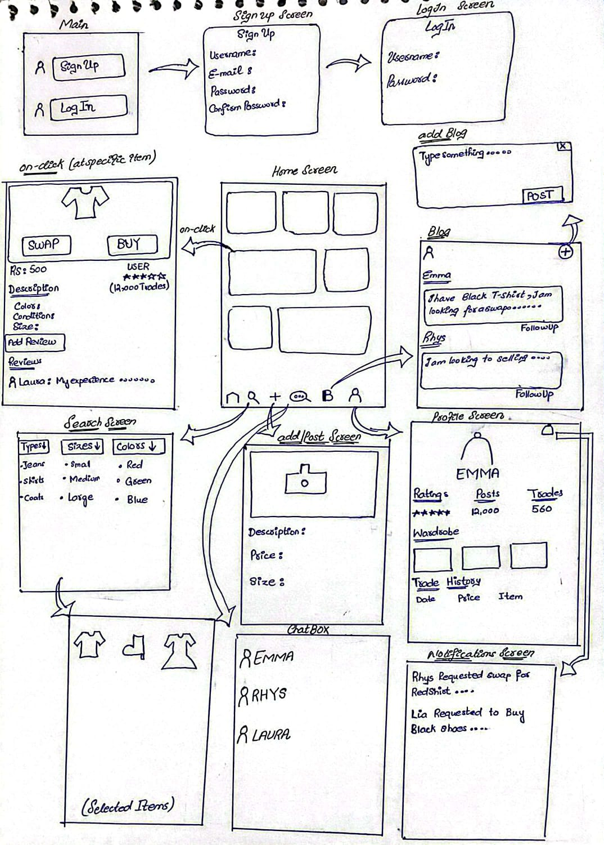
7. Prototype (Main Feature Screens)

