National University of Computer and Emerging Sciences

Fundamentals of Software Engineering
Iteration 0

Fitigue
Sprint 1 Report

Group Members:
Name | Roll Number
Waniya Suhail | L24-2552
Laiba Shahzad | L24-2600
Ayesha Farooqui | L24-2520

CS2004 Fundamentals of Software Engineering Spring 2026
Department of Computer Science
FAST-NU, Lahore, Pakistan

Project Title
Fitigue – Community Clothing Exchange & Marketplace System
Type: Mobile Application

1. Project Introduction
Fitigue is a full-stack clothing exchange and marketplace application. The system focuses on designing and implementing both frontend and backend components using proper software engineering principles.
The frontend will provide an interactive and user-friendly interface where users can register, manage wardrobes, browse clothing listings, and initiate purchase or swap requests. The backend will handle business logic, user authentication, request processing, and communication with the database.
The system will follow a layered architecture approach consisting of:
- Presentation Layer (Frontend UI)
- Business Logic Layer
- Data Access Layer (Database Handling)
Sprint 1 focuses on building the User Management Module, which includes user registration, login, profile creation and database schema development.

2. Sprint Backlog
Sprint Name
Sprint 1 – User Management Module
Sprint Duration
Week 1 – Week 2
Sprint Goal
To implement the basic user management functionality including signup, login and user profile.

Tasks in Sprint
Task Priority Status
Design Database Schema | High | Completed
Create Signup UI | High | Completed
Implement Signup Logic | High | Completed
Implement Login authentication | High | Completed
Create User Profile UI | Medium | In Progress
Connect Profile to Database | Medium | Pending

3. User Stories
User Story 1
Story ID : US-01 Story Title : User Registration  User Story  As a new user,I want to create an account on the application so that I can access the Fitigue platform and use its features.  Description  This story involves implementing a signup system that allows users to create an account by entering their details such as username, email, and password.  Sub User Stories  • As a user, I want to enter my username, email and password.  • As a user, I want the system to validate my input information.  • As a user, I want my account information to be saved in the database.  • As a user, I want confirmation that my account has been created successfully.  Acceptance Criteria  • Signup form should contain username, email and password fields.  • System should validate that all fields are filled.  • System should prevent duplicate email registrations.  • User account should be stored in the database after successful signup. | Priority: High  Estimated Hours: 6
User Story 2

Story ID : US-02 Story Title : User Login  User Story  As a registered user, I want to log in using my credentials so that I can access my account and use the application features.  Description  This story implements the authentication system where users enter their username and password to access their accounts.  Sub User Stories  • As a user, I want to enter my username and password.  • As a user, I want the system to verify my credentials.  • As a user, I want to be redirected to the home screen after successful login.  • As a user, I want an error message if the login credentials are incorrect.  Acceptance Criteria  • Login page should allow users to enter username and password.  • System should verify credentials against the database.  • If credentials are correct, the user should be logged in.  • If credentials are incorrect, an error message should be displayed. | Priority: High  Estimated Hours: 5

User Story 3

Story ID : US-03 Story Title : User Profile  User Story  As a logged-in user, I want to view my profile information so that I can see my wardrobe items, posts, ratings, and trade history.  Description  This story focuses on displaying the user profile page containing user information, clothing items in wardrobe, and statistics related to trades and posts.  Sub User Stories  • As a user, I want to see my profile image and username.  • As a user, I want to view the items in my wardrobe.  • As a user, I want to see my trade history.  • As a user, I want to see the number of posts and ratings.  Acceptance Criteria  • Profile page should display user information.  • Wardrobe items should be visible on the profile page.  • Trade history should be displayed clearly.  • Profile data should be retrieved from the database. | Priority: Medium  Estimated Hours: 7

4. Structured Specifications
Specification 1 – User Registration
Input:
Username, E-mail, Password, Confirm Password

Processing Steps
- User opens signup page.
- User enters required information.
- System validates input fields.
- System checks whether the password and confirm password match.
- If passwords do not match, the system displays an error message.
- System checks if username or email already exists in database
- If username or email does not exist and passwords match, the system creates a new user record.
- System saves the user data in database.

Output
- User account created successfully.
- User is redirected to the Home Screen.

Specification 2 - User Login
Input:
Username and password

Processing Steps
- User enters login credentials.
- System checks credentials with database records.
- If credentials match, user is authenticated.
- If credentials do not match, system displays an error message.

Output
- User is redirected to home screen.

Specification 3 – Profile Data Retrieval
Input:
User ID

Processing steps
- System retrieves user information from database.
- System retrieves wardrobe items belonging to the user.
- System retrieves trade history.
- System loads profile interface with retrieved data.

Output
- User profile page displayed with complete information.

Specification 4 – Database User Creation
Input:
User registration data

Processing Steps
- System validates user data format.
- Unique user ID is generated.
- User record is inserted into the Users Table.
- Confirmation message is generated.

Output
- User stored successfully in database.

- Scrum Board
Three snapshots of the Trello Board were taken during the sprint.

Snapshot 1 – Beginning of Sprint
Tasks added to the Backlog list.
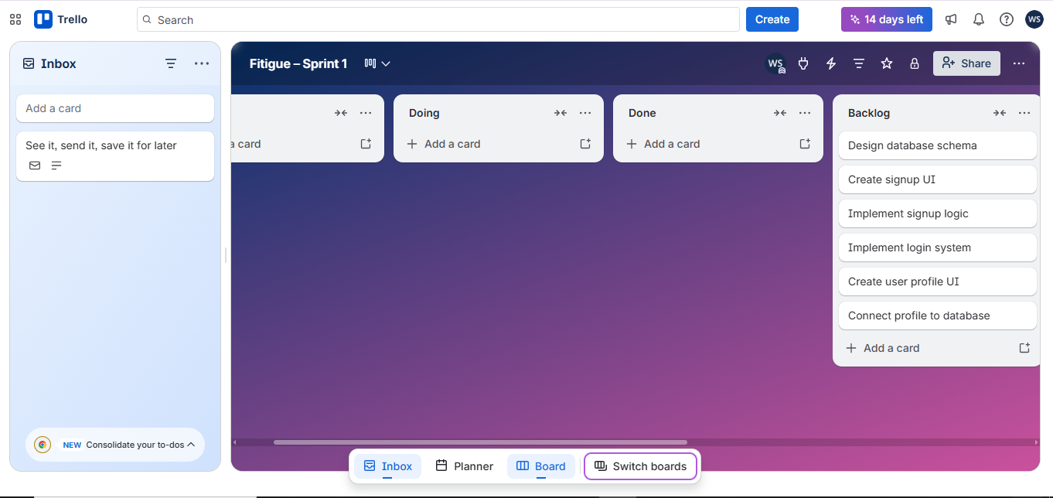

Snapshot 2 – Mid Sprint
Half of the tasks completed and moved to Done column.
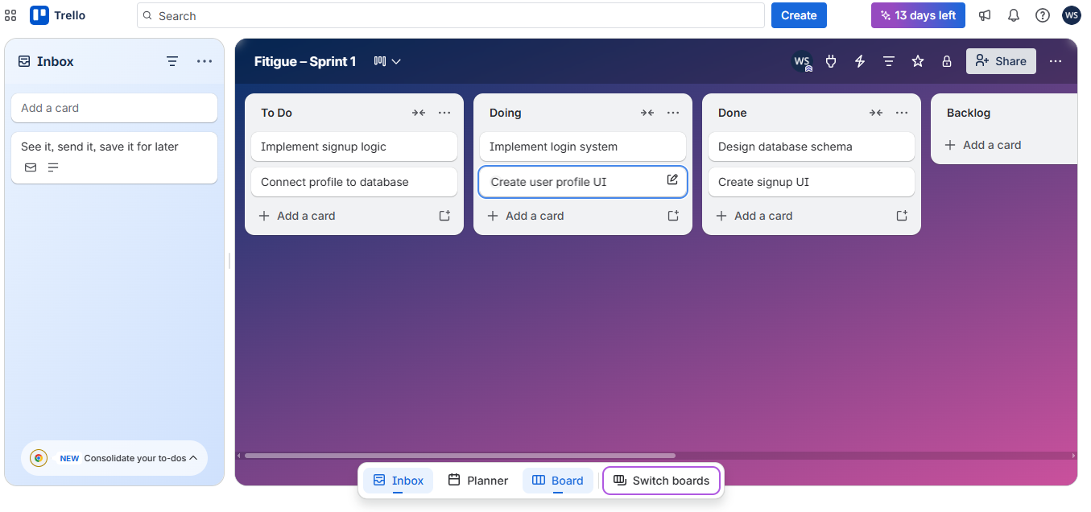

Snapshot 3 – End of Sprint
Most tasks completed. Remaining tasks moved to sprint 2 Backlog.
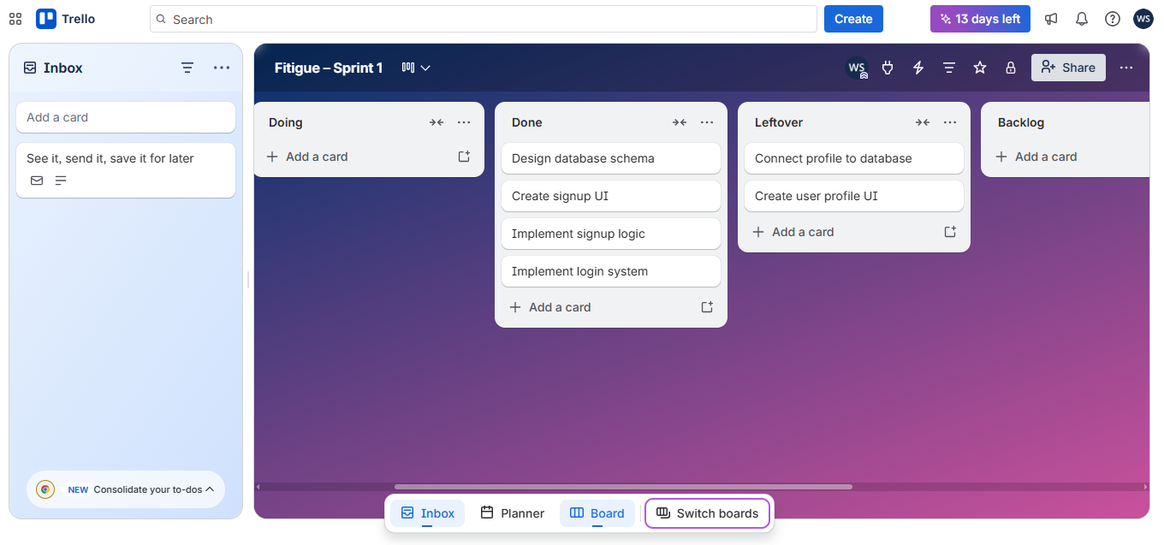

- Product Burn-Down Chart
The burn-down chart tracks planned tasks versus completed tasks during the sprint.
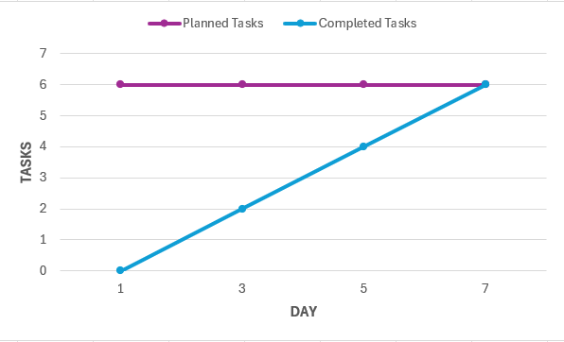

Non-Functional Requirements (NFR)

Performance
The system should allow users to log in within 2 seconds.

Security
User passwords should be stored securely and authentication should prevent unauthorized access.

Usability
The application interface should be simple and intuitive for new users.

Reliability
The system should maintain stable operation without crashes during normal usage

- Iteration 1 Implementation Screenshots
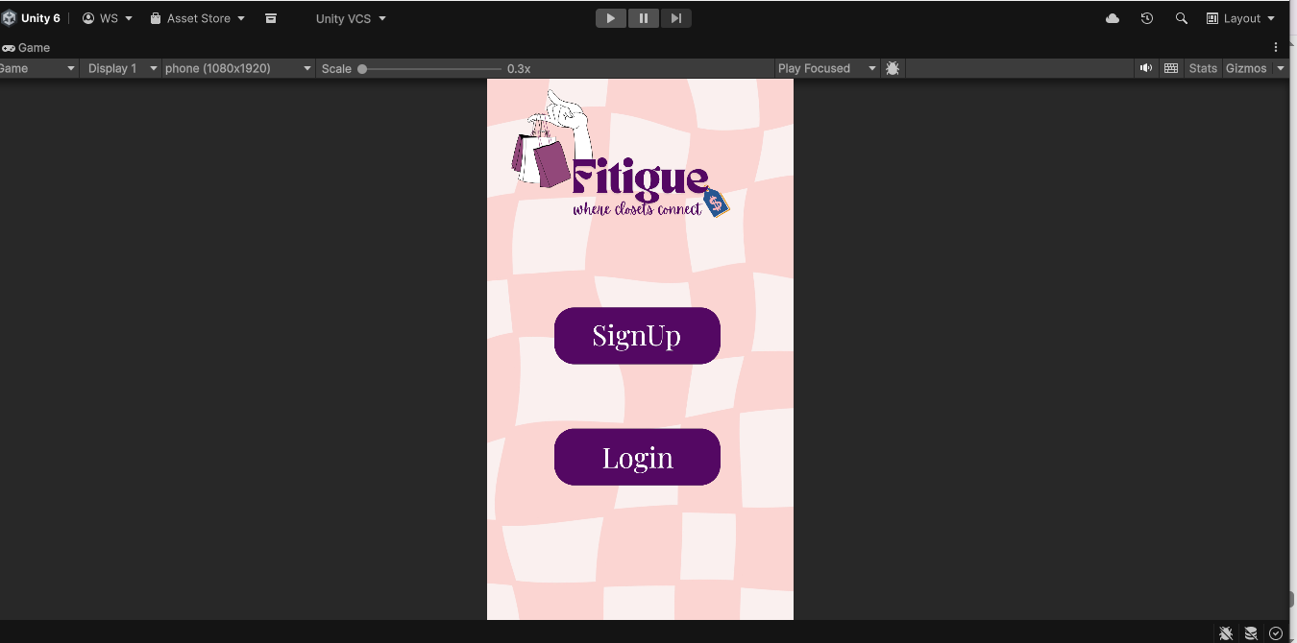
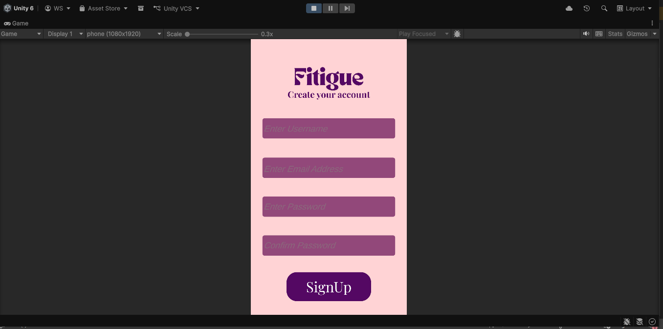
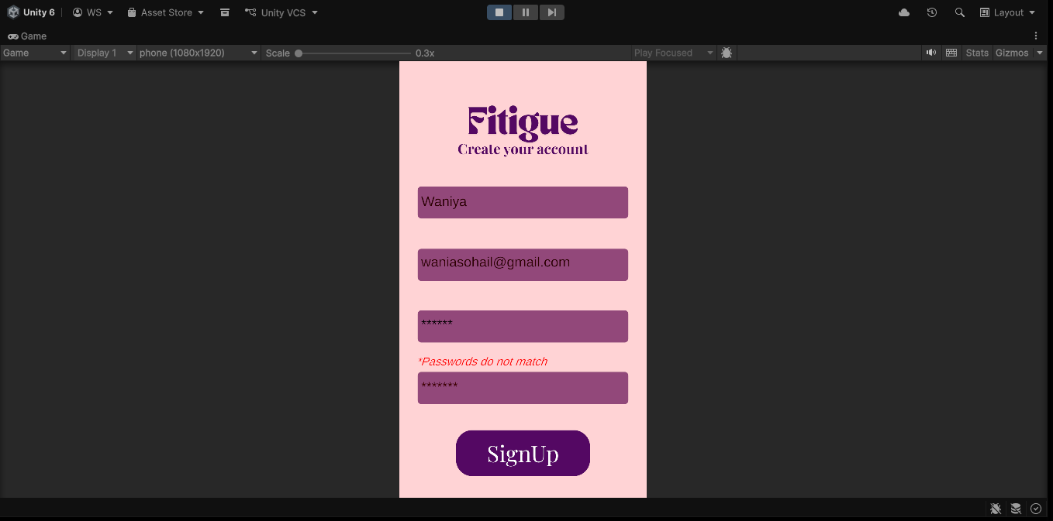
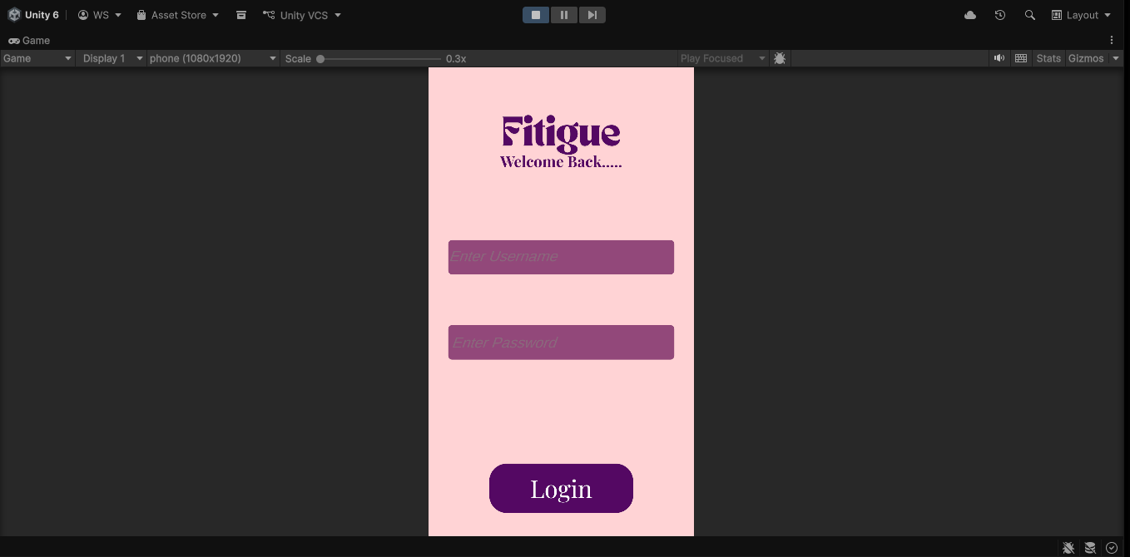
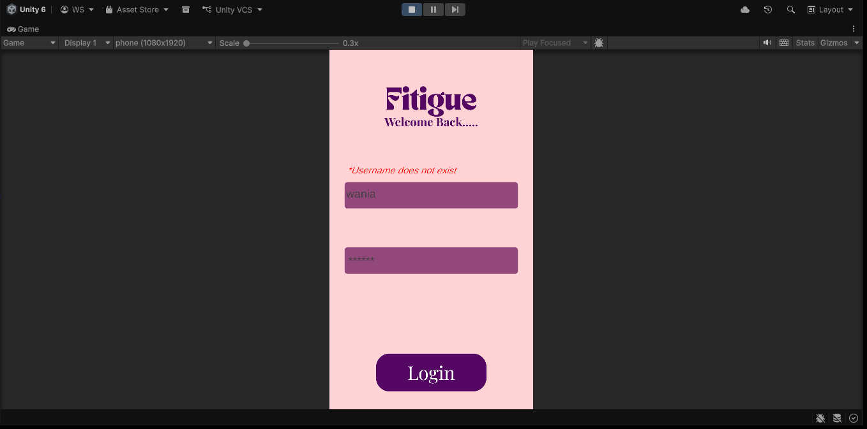

- Work Division
Member | Role | Responsibilities
Waniya Suhail | UI/UX & Frontend Developer | Designed signup UI, login UI, and profile interface; implemented login logic and authentication
Ayesha Farooqui | Backend Developer | Collaborated with database architect on database logic, assisted with login logic
Laiba Shahzad | Database Architect | Designed database schema and tables, assisted with backend integration

10. Schema Diagram
