**LAB 01**

**LAIBA ZAHEER**

**ROLLNO: K180311**

**SECTION: C**

Q1. Command: ipconfig

Ip address:192.168.1.10

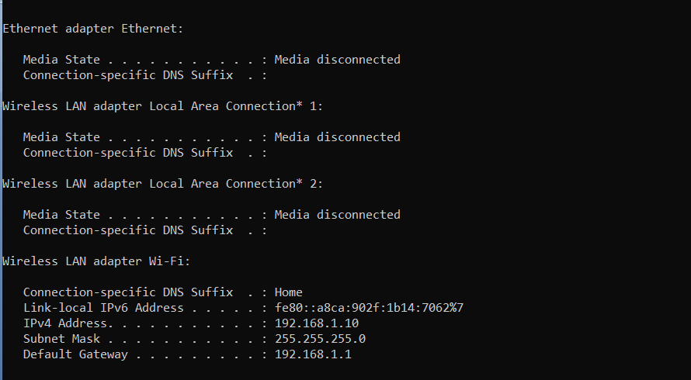

Q2. Command: ipconfig-all

IP address of the computer: 12-5B-AD-BB-C5-69

DHCP is enabled

Mac address: 9C-7B-EF-0C-CC-DA

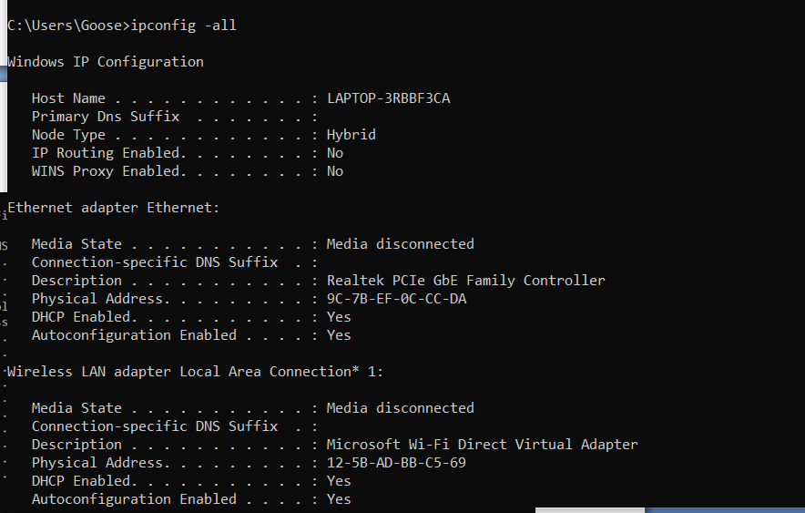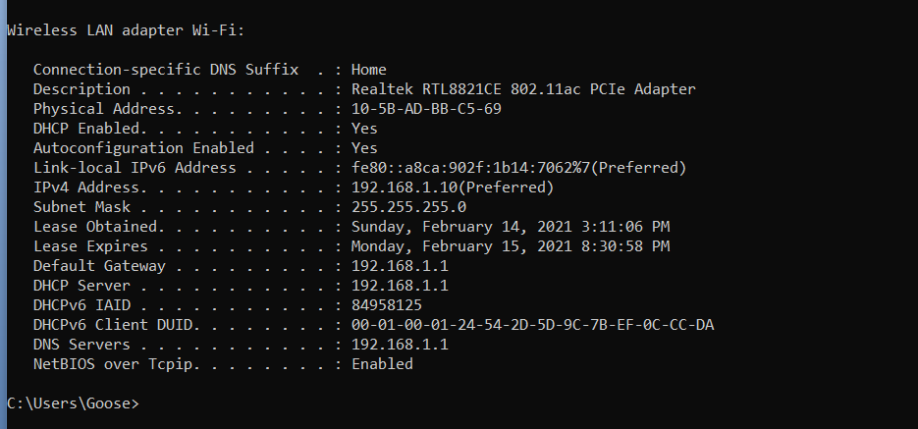

Q3: command: hostname



Q4: command:ping 192.168.1.11

Through ping command Basic Ip connectivity is checked and this is showing that there is no connectivity which means the host is not reachable.

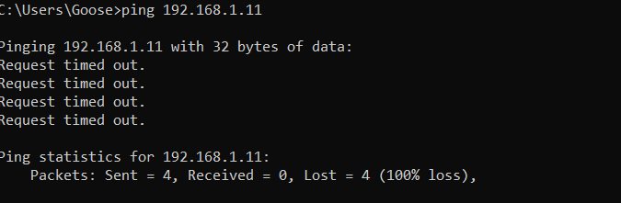

Q5: command: config-all

Mac-address: 9C-7B-EF-0C-CC-DA

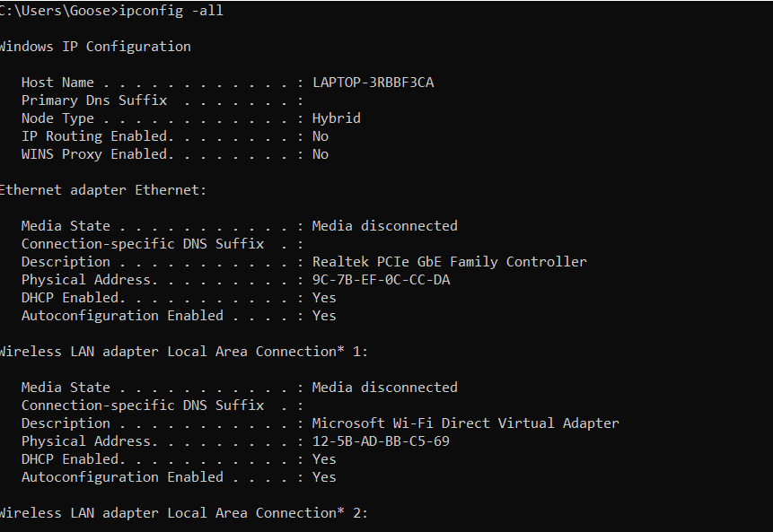

Q6:command: net share

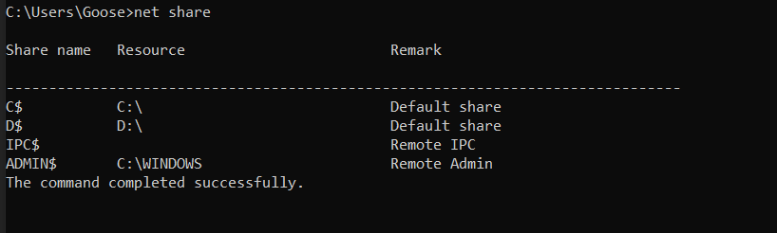

Q7:command: netstat

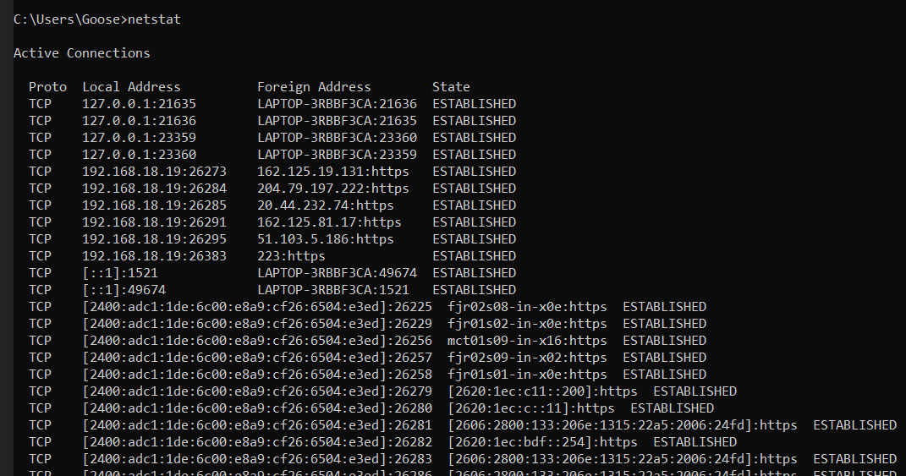

Q8:command:net view

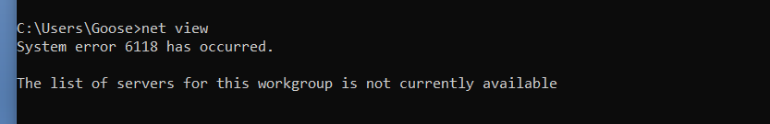

Q9: command:ipconfig

Gateway address:192.168.18.1

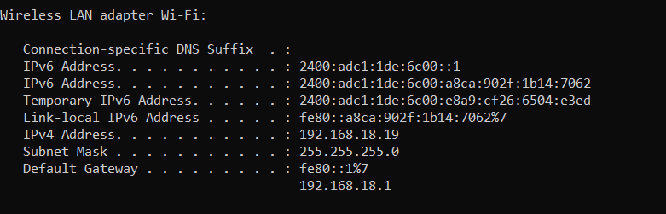

Q10. Command:tracert google.com

Ip address: 2a00:1450:4019:802::200e

Maximum 30 hops are involved in path.

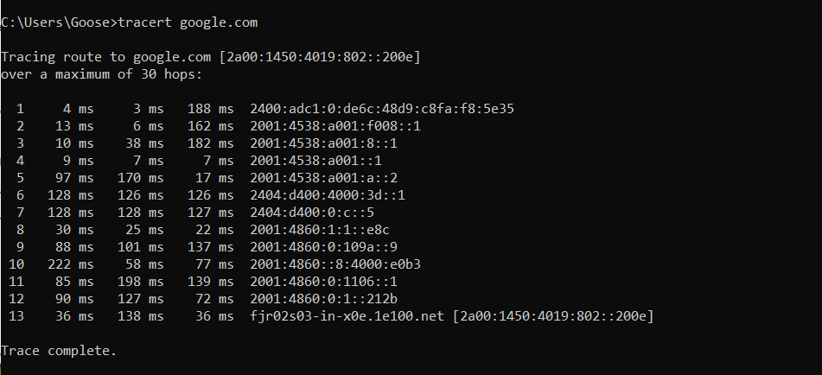

Q11

Domain name(like here blue_machine) is not connect/mapped to ip address that’s why ping will not work