1/1/2026

Software Design Architecture

Carefree Aiding Caretakers

TABLE OF CONTENTS

TABLE OF CONTENTS 2
CHAPTER 1: INTRODUCTION 4
1.1 System Overview 4
1.2 Problem Statement 4
1.3 Scope 4
1.4 Objectives 4
1.5 Users and Stakeholders 5
1.6 System Requirements Summary 5
1.7 Software Process Model 5
CHAPTER 2: SYSTEM ANALYSIS AND MODELING 7
2.1 Use Case Diagram 7
2.1.1 Use Case Description Table 8
2.2 Class Diagram 9
2.2.1 Class Descriptions 10
2.2.2 Key Relationships 11
2.3 Activity Diagrams 12
2.4 Sequence Diagrams 13
2.5 Deployment Diagram 14
2.6 Timing Diagram 15
CHAPTER 3: ARCHITECTURAL VIEW (4+1 MODEL) 16
3.1 Logical View 16
3.2 Process View 16
3.3 Development View 17
3.4 Physical View 17
3.5 +1 Use Case View 18
CHAPTER 4: REFERENCES 19

CHAPTER 1: INTRODUCTION

1.1 System Overview
Carefree — Aiding Caretakers is a mobile application built for Android devices, designed to streamline and automate the complex, time-intensive tasks faced by in-home caregivers. The application serves two primary user roles: Caretakers (the primary users who manage patient care) and Guardians (emergency contacts or family members who monitor patient well-being).

The frontend is developed using the Flutter framework, which connects the user interface to the backend via REST APIs. The backend is built on Java (Spring Boot) for core business logic, with Python handling all Machine Learning and Artificial Intelligence components via FastAPI. A MySQL database stores all patient, caretaker, and operational data.

1.2 Problem Statement
In-home caregivers manage a wide range of responsibilities — from tracking patient vitals and administering medications, to scheduling appointments, maintaining dietary plans, and communicating with guardians. These tasks are typically handled through fragmented tools such as paper notes, spreadsheets, and informal messaging apps, leading to information loss, miscommunication, and potential medical errors.

Carefree addresses this gap by providing a unified, structured digital platform that centralizes all caretaking activities, supports AI-assisted features such as meal flagging and cost prediction, and enables real-time communication between caretakers and guardians.

1.3 Scope
This Software Design Document (SDD) covers the complete design of the Carefree mobile application. It includes:
- System architecture and service decomposition
- UML diagrams: Use Case, Class, Sequence, and State Chart
- Logical, Interface, Interaction, and State Dynamic viewpoints
- System features and functional/non-functional requirements
- Deployment and API integration details

The document excludes implementation code, test plans, and post-deployment operations.

1.4 Objectives
- Provide a comprehensive, implementable design for all development team members
- Ensure alignment with IEEE Std 1016-2009 standards
- Document all system features, flows, and constraints clearly
- Support the use of ML/AI components (Medical Cost Predictor and Meal Flagger)
- Enable secure, role-based access for Caretakers and Guardians

1.5 Users and Stakeholders

Stakeholder | Role | Concerns
Caretaker | Primary user | Ease of use, data accuracy, task management, notifications
Guardian | Secondary user | Patient visibility, communication, report access
Developers | System builders | Clear design specs, modular architecture, testability
Testers/QA | Validation team | Feature completeness, requirement traceability
Patient | Indirect beneficiary | Accurate care delivery, privacy, data security

1.6 System Requirements Summary
The system must support the following high-level capabilities:

Feature | Description
Patient Information Management | CRUD operations on patient profiles with lab reports and visit logs
Vitals & Symptom Tracking | Daily recording of vitals with trend analysis and alerts
Medication & Appointments | Schedule, edit, delete medications and appointments with reminders
Caretaker Task Management | To-do list system with priority, frequency, and progress tracking
Dietary Plan Management | Customized meal plans with nutritional calculations
Expense Tracker | Log, edit, delete expenses and generate financial reports
Guardian Communication | In-app messaging with document attachment support
Custom Notifications | Configurable reminders via push, SMS, or email
Report Generation | Vitals, symptom, and financial reports exportable as PDF/CSV
ML Medical Cost Predictor | Gradient boosting model for yearly cost prediction
AI Meal Flagger | Image-based meal detection with dietary restriction checking

1.7 Software Process Model
Carefree adopts an Iterative and Incremental development model, aligned with principles from the Unified Process (UP).

Rationale:
- The system encompasses distinct, independently deployable features (e.g., vitals tracking, expense management, AI meal flagging), making iterative delivery natural and practical.
- AI/ML components (cost predictor, meal flagger) require prototyping and feedback cycles that benefit from iterative refinement.
- Guardian and Caretaker roles have different access needs, which can be developed and validated in parallel increments.
- The three-tier Service-Oriented Architecture (SOA) supports modular development — each microservice can be built, tested, and integrated independently.

Key phases: Inception (requirements and use cases), Elaboration (architecture and detailed design), Construction (iterative feature implementation), Transition (deployment and testing).

CHAPTER 2: SYSTEM ANALYSIS AND MODELING

2.1 Use Case Diagram
The Carefree system defines two primary actors: the Caretaker and the Guardian. The Caretaker is the primary user with full access to all features, while the Guardian has read-only or limited access to patient data and reports.

Key use case relationships include:
- <<include>>: Mandatory sub-functions automatically triggered (e.g., Login includes Validate Credentials; Add Appointments includes Create Notification Reminders)
- <<extend>>: Optional sub-functions triggered under specific conditions (e.g., Log Symptoms extends to Add Custom Options if customized; AI Meal Flagger extends to Enter Meal if AI cannot detect)

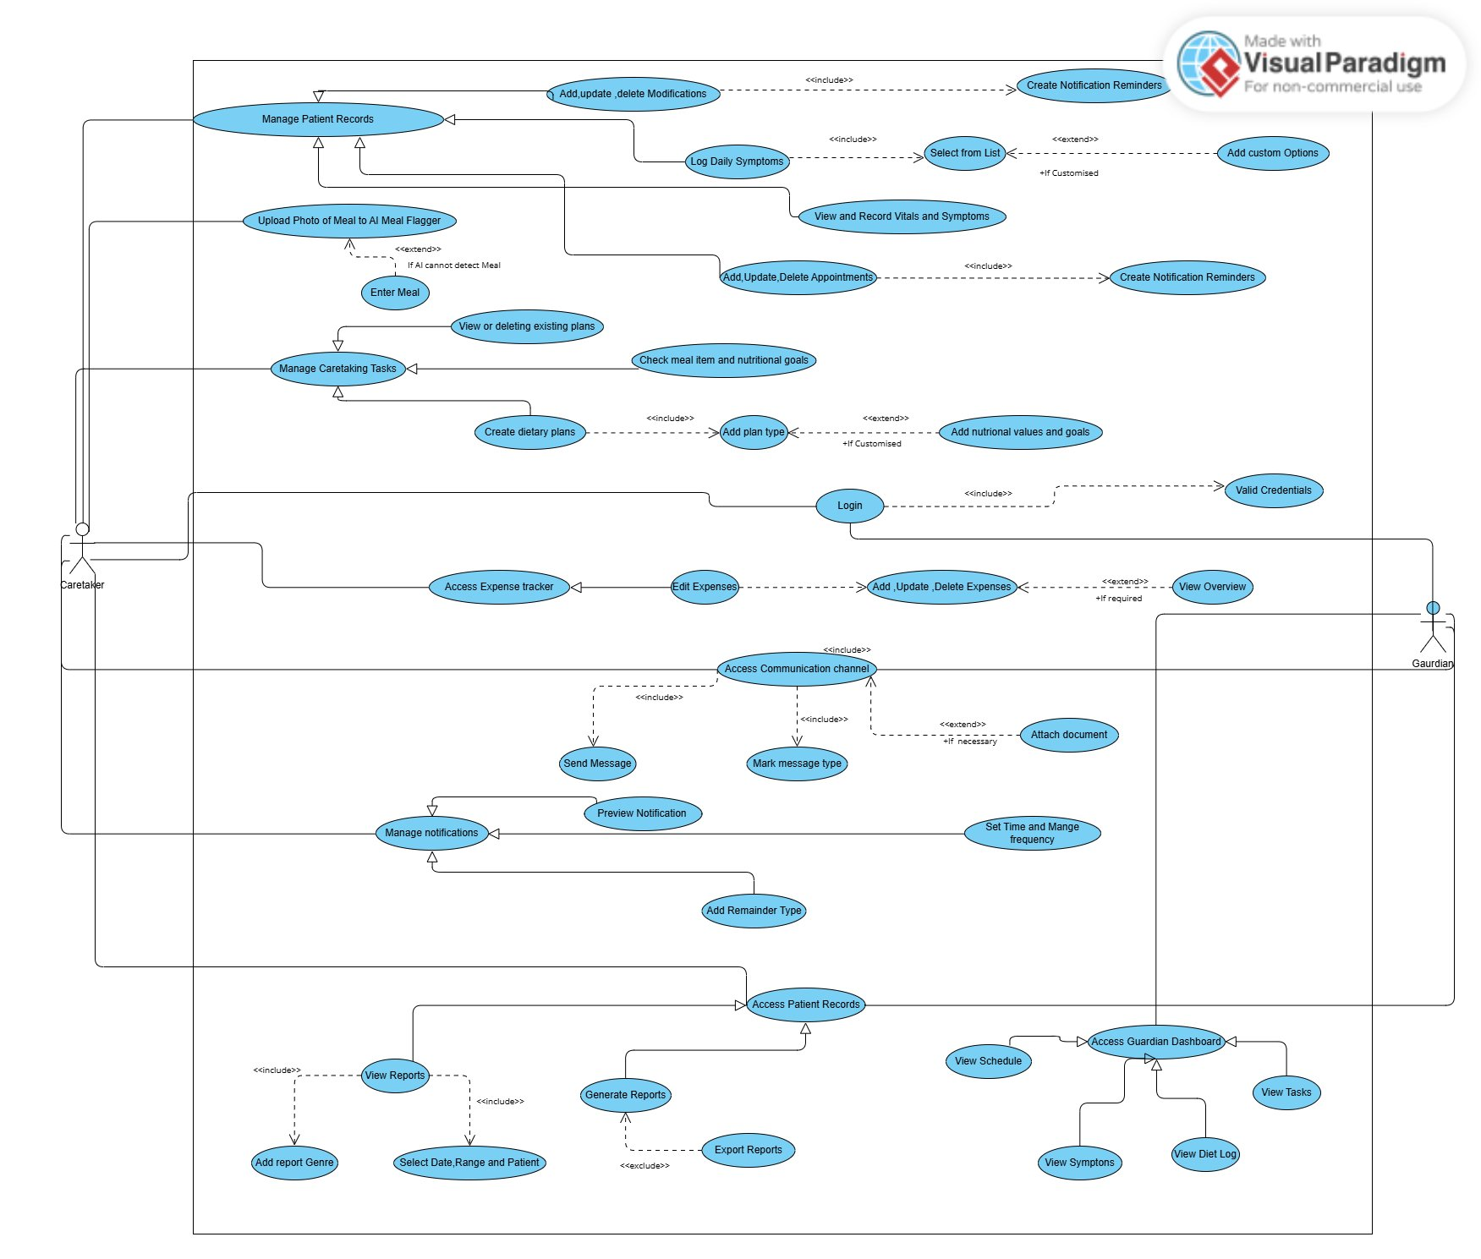
Figure 1. Use Case Diagram — Carefree System

2.1.1 Use Case Description Table

Use Case | Actor(s) | Description | Relationships
Login | Caretaker, Guardian | Authenticate user using credentials stored in the database | <<include>> Validate Credentials
Manage Patient Records | Caretaker | Add, update, delete patient information including vitals, symptoms, medications | <<include>> Add/Update/Delete Modifications
Log Daily Symptoms | Caretaker | Record patient symptoms daily for health trend tracking | <<include>> Select from List; <<extend>> Add Custom Options
Add/Update/Delete Appointments | Caretaker | Manage patient appointment scheduling | <<include>> Create Notification Reminders
View & Record Vitals and Symptoms | Caretaker | Track and review vitals with alert generation | —
Upload Photo to AI Meal Flagger | Caretaker | Use AI to identify meals and check dietary restrictions | <<extend>> Enter Meal (if AI cannot detect)
Manage Caretaking Tasks | Caretaker | Organize daily caregiving duties with priority and frequency | <<include>> Create Dietary Plans, Check Meal Items
Access Expense Tracker | Caretaker | Monitor and manage all patient-related expenses | <<include>> Edit Expenses; <<extend>> View Overview
Access Communication Channel | Caretaker, Guardian | In-app messaging between caretaker and guardian | <<include>> Send Message, Mark Message Type; <<extend>> Attach Document
Manage Notifications | Caretaker, Guardian | Configure and schedule reminders for tasks, appointments, medications | <<include>> Preview Notification, Add Reminder Type, Set Time & Frequency
Access Patient Reports | Caretaker, Guardian | View and generate analytical reports on patient health and finances | <<include>> View Reports, Generate Reports; <<extend>> Export Reports
Access Guardian Dashboard | Guardian | Monitor patient schedule, tasks, symptoms, and diet logs | <<include>> View Schedule, Tasks, Symptoms, Diet Log

2.2 Class Diagram
The class diagram represents the object-oriented data model of Carefree. It shows 16 classes with their attributes, methods, and inter-class relationships including association, aggregation, composition, and inheritance.

The BCE (Boundary-Control-Entity) model is reflected as follows:
- Boundary classes: The Flutter UI components (Login, Dashboard, Vitals Page, etc.) interact with the user
- Control classes: Service layer classes (Patient Management Service, Dietary Management Service, etc.) handle business logic
- Entity classes: Person, Patient, Guardian, Caretaker, Medication, Vitals, Symptoms, Appointment, Task, Notification, DietaryPlan, Meal, Expense, Cardiac, Respiratory, Others

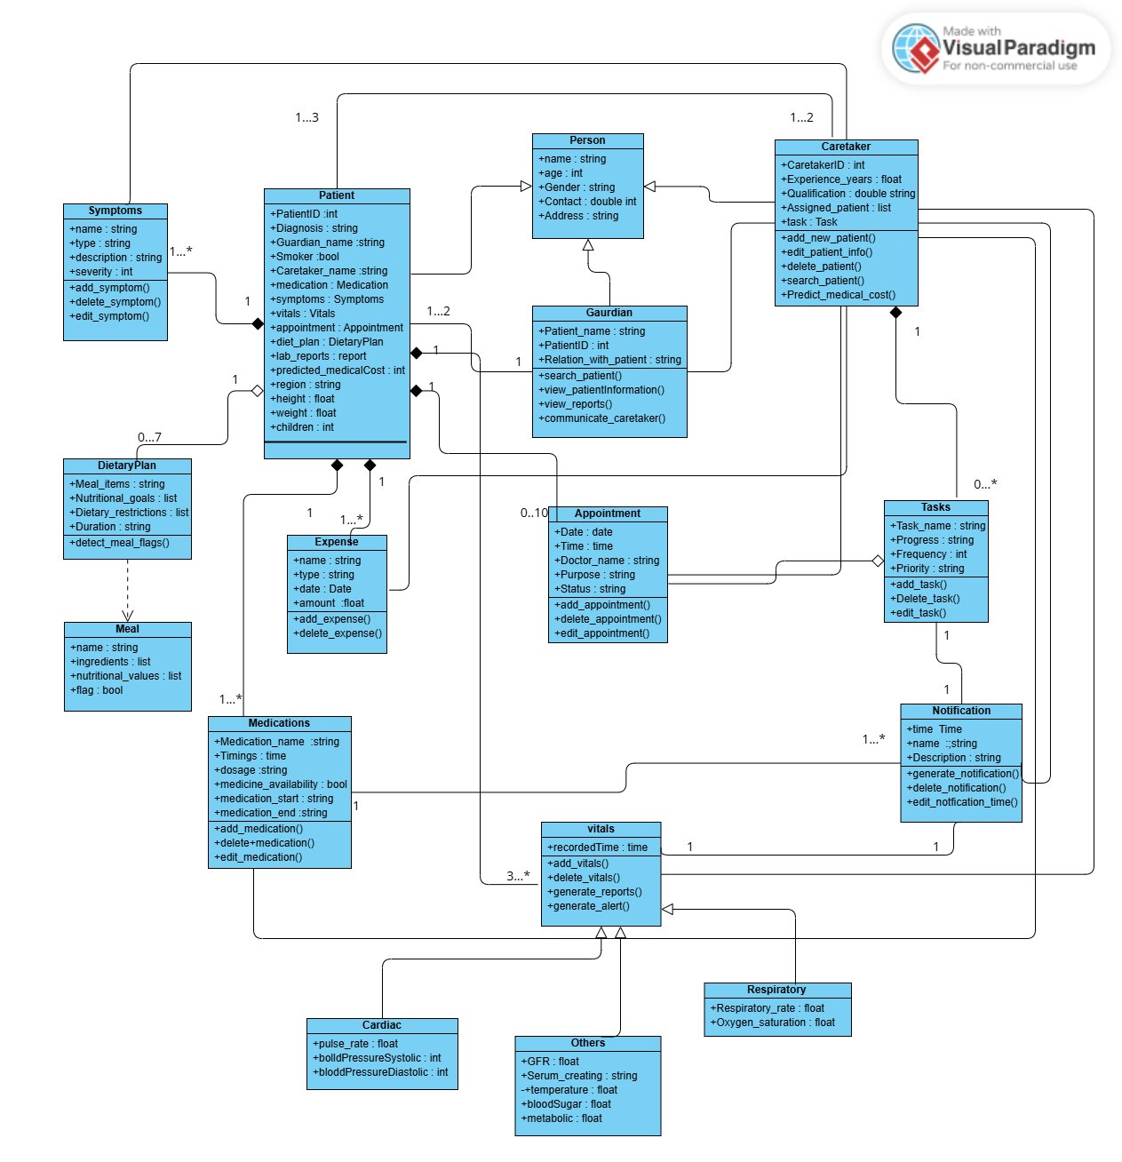
Figure 2. Class Diagram — Carefree System

2.2.1 Class Descriptions

Class | Type | Key Attributes | Key Methods
Person | Entity (Abstract) | name, age, gender, contact, address | —
Patient | Entity | PatientID, diagnosis, guardian_name, medication, vitals, appointment, diet_plan, predicted_medicalCost, smoker, region, height, weight, children | —
Guardian | Entity | Patient_name, PatientID, Relation_with_patient | search_patient(), view_patientInformation(), view_reports(), communicate_caretaker()
Caretaker | Entity | CaretakerID, Experience_years, Qualification, Assigned_patient, task | add_new_patient(), edit_patient_info(), search_patient(), delete_patient(), Predict_medical_cost()
Medication | Entity | Medicine_name, Timings, dosage, medicine_availability, medication_start, medication_end | add_medication(), delete_medication(), edit_medication()
DietaryPlan | Entity | Meal_items, Nutritional_goals, Dietary_restrictions, Duration | detect_meal_flags()
Meal | Entity | name, ingredients, nutritional_values, flag | —
Task | Entity | Task_name, Progress, Frequency, Priority | add_task(), delete_task(), edit_task()
Appointment | Entity | Date, Time, Doctor_name, Purpose, Status | add_appointment(), delete_appointment(), edit_appointment()
Symptoms | Entity | name, type, description, severity | add_symptom(), delete_symptom(), edit_symptom()
Vitals | Entity (Parent) | recordedTime | add_vitals(), delete_vitals(), generate_reports(), generate_alert()
Cardiac | Entity (Child of Vitals) | pulse_rate, bloodPressureSystolic, bloodPressureDiastolic | —
Respiratory | Entity (Child of Vitals) | Respiratory_rate, Oxygen_saturation | —
Others | Entity (Child of Vitals) | GFR, Serum_creatinine, temperature, bloodSugar, metabolic | —
Notification | Entity | time, name, description | generate_notification(), delete_notification(), edit_notification_time()
Expense | Entity | name, type, date, amount | add_expense(), delete_expense()

2.2.2 Key Relationships

Relationship | Classes Involved | Multiplicity | Type
Person generalizes Patient, Guardian, Caretaker | Person → Patient, Guardian, Caretaker | 1 to 1..2 | Inheritance
Patient has Symptoms | Patient → Symptoms | 1 to 1..* | Composition
Patient has Medication | Patient → Medication | 1 to 1..* | Composition
Patient has Appointment | Patient → Appointment | 1 to 0..10 | Aggregation
Patient has DietaryPlan | Patient → DietaryPlan | 1 to 0..7 | Composition
Patient has Expense | Patient → Expense | 1 to 1..* | Aggregation
Caretaker manages Tasks | Caretaker → Tasks | 1 to 0..* | Association
Task has Notification | Task → Notification | 1 to 1..* | Association
Vitals is parent of Cardiac, Respiratory, Others | Vitals → Cardiac, Respiratory, Others | 3..* to 1 | Inheritance
DietaryPlan references Meal | DietaryPlan → Meal | 1 to * | Dependency
Guardian linked to Patient | Guardian → Patient | 1 to 1..2 | Association

2.3 Activity Diagrams

[Space reserved for Activity Diagrams]

Activity diagrams model the major workflows of the system including Sign Up, Sign In, Patient Information Management, Vitals Tracking, Medication Management, Task Management, Dietary Plan Management, Expense Tracking, Guardian Communication, Report Generation, ML Cost Predictor, and AI Meal Flagger. Each diagram includes decision nodes, concurrent flows, and swimlanes separating the Caretaker, System, and Database actors.

2.4 Sequence Diagrams

2.4.1 Login
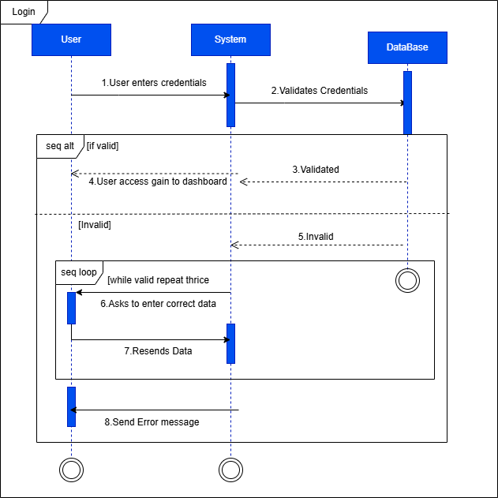

This diagram shows the dynamic flow of logging in. This feature is to be used by both the caretaker and guardian where their credentials will be verified before gaining access.

2.4.2 Manage Patient Records

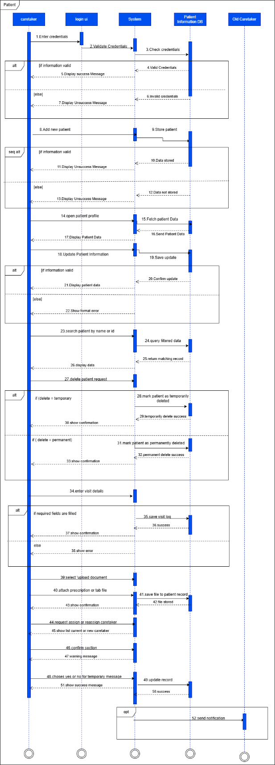
The caretaker logs into the system and accesses their dashboard to manage patient records. They can add a new patient by entering details, after which the system verifies the data and confirms if it’s valid or highlights errors. The caretaker can update existing records, search for patients and choose to delete records temporarily or permanently, each with proper confirmation messages. After each visit, the caretaker logs visit details such as time and tasks completed. They can also upload prescriptions or lab reports, and assign or reassign caretakers, where the system confirms the changes and notifies the old caretaker.

2.4.3 Access Communication

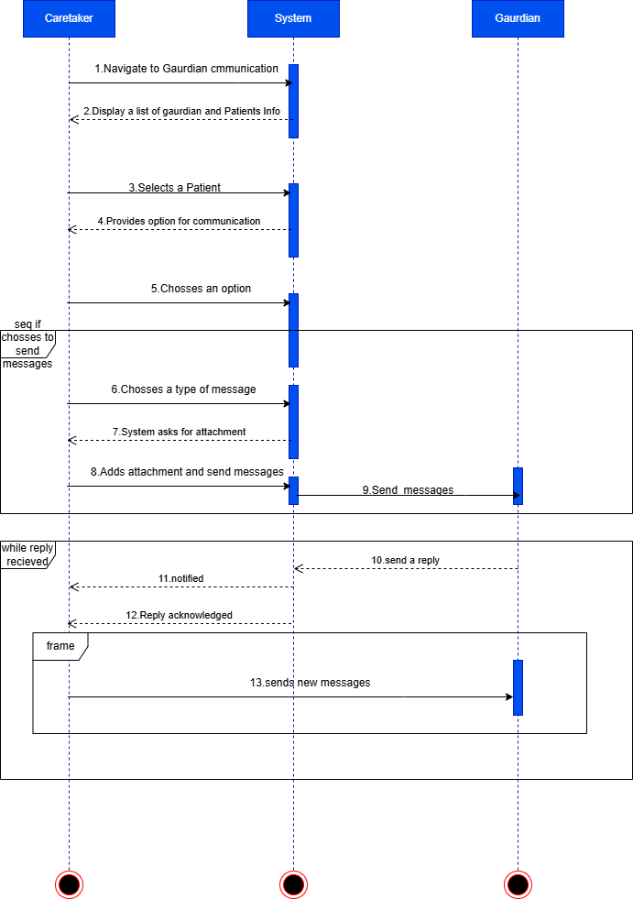

Caretaker logs in and navigates to the Guardian Communication section from the dashboard. The system displays a list of patients along with their associated guardians. The caretaker selects a patient and chooses one of the communication options. If the caretaker chooses to send a new message, they will select the message type (update, alert, query, etc.) so that the guardian will know the importance of that message. Along with the message, the caretaker can also attach relevant documents (such as nutritional or financial reports) and then send the message to the guardian via in-app messaging. The caretaker is notified of any responses and can continue the conversation if needed.

2.4.4 Manage notification

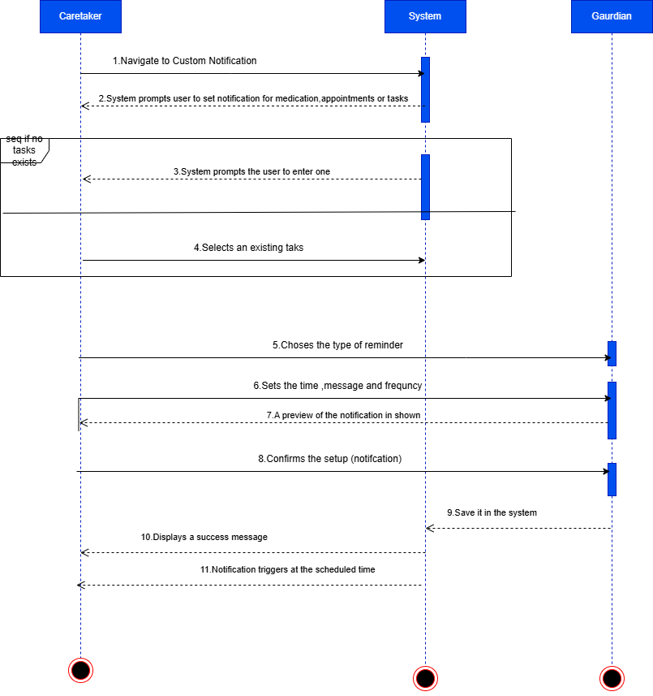

After signing in, the caretaker is given options to manage custom notifications for medications, patient appointments, or caretaker tasks. The caretaker selects an existing task, medication, or appointment to set a notification for. If none exist, the system prompts them to add one first. The caretaker chooses the type of reminder—daily, weekly, specific date/time, or custom interval—and sets the time, message, and frequency. Notifications can be delivered via push notification, SMS, or email. A preview of the notification is shown, and the caretaker reviews and confirms the setup before saving it in the system. A confirmation message appears once the notification is successfully added.

2.4.5 Access Patient Reports

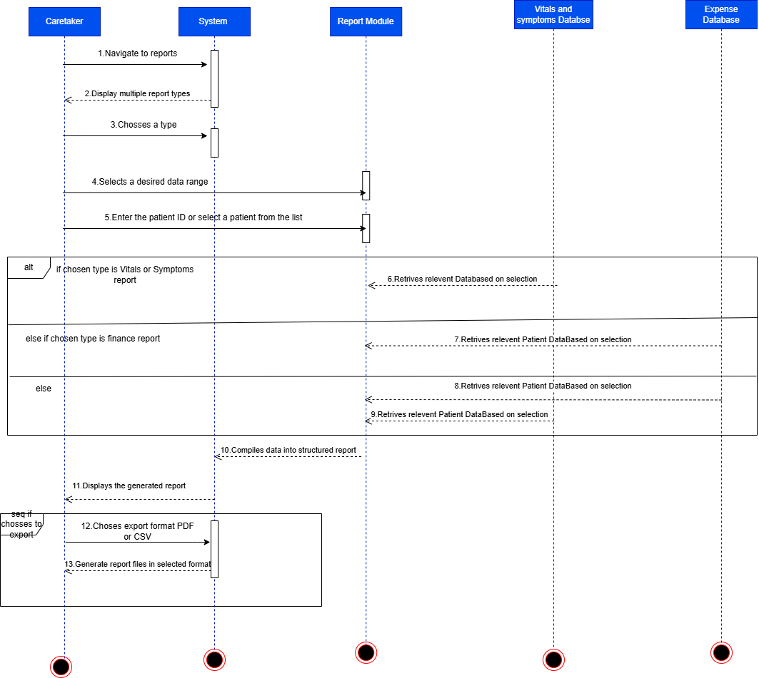

The caretaker or guardian logs into the system and is directed to the dashboard. From the dashboard, the user selects the "Reports" option to proceed. The system displays multiple report types to choose from. The user selects a desired date range for the report. The user enters the Patient ID or selects the patient from a list to specify which report to generate. The system fetches relevant data for the selected patient and time frame. Based on the selection, the system compiles the data into a structured report with summaries and alerts. The report is displayed to the user. The user can export the report as a PDF or CSV file for offline viewing or sharing

2.4.6 Upload Photo to AI Meal Flagger

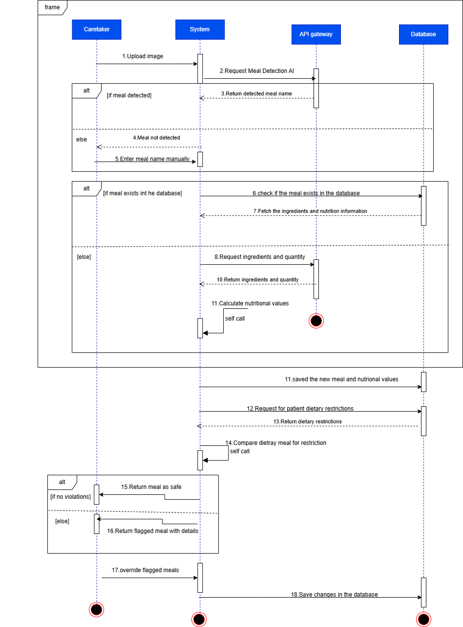

The caretaker initiates the meal detection process. The system uses an AI-based meal detector to identify the meal and its ingredients via web APIs, then cross-checks this information against the patient’s dietary restrictions to determine if the meal should be flagged.

2.5 Component Diagram
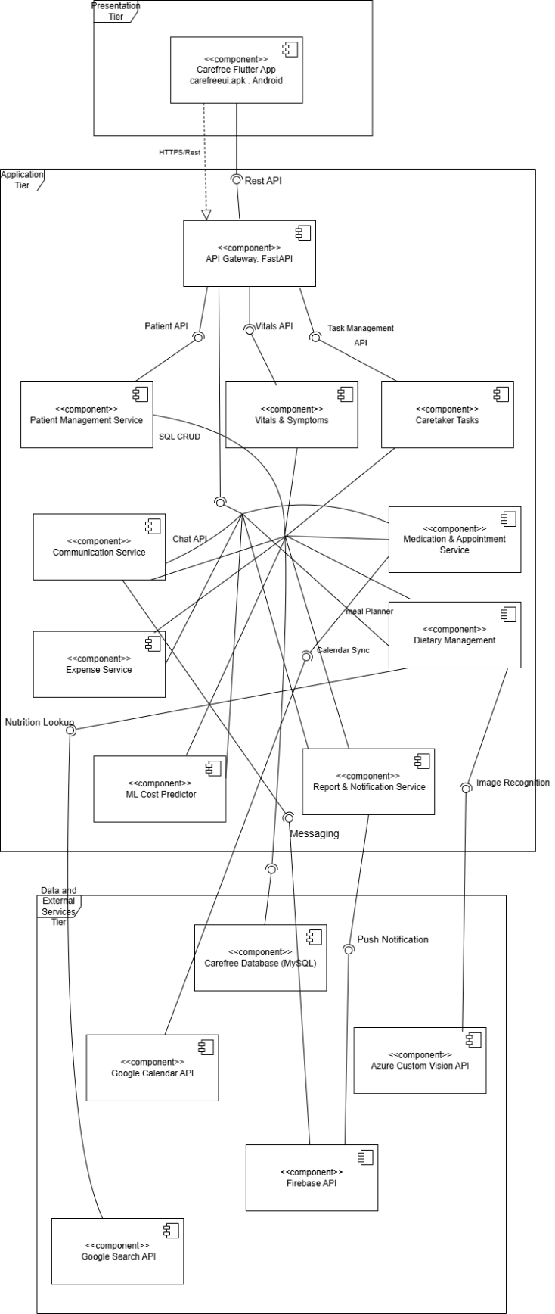

The UML Component Diagram of the Carefree Healthcare Management System shows the overall structure of the system and the interaction between its major components. It includes the Flutter mobile application, API Gateway, backend services, MySQL database, and external APIs such as Firebase and Google Calendar. Components communicate through provided and required interfaces using ports and assembly connectors. The diagram highlights dependencies between modules and demonstrates a modular, scalable, and maintainable system design.

2.6 Deployment Diagram

The deployment diagram maps all software components onto their physical or virtual hardware nodes across the three architectural tiers of the Carefree system. Nodes communicate via internet connections using REST APIs.

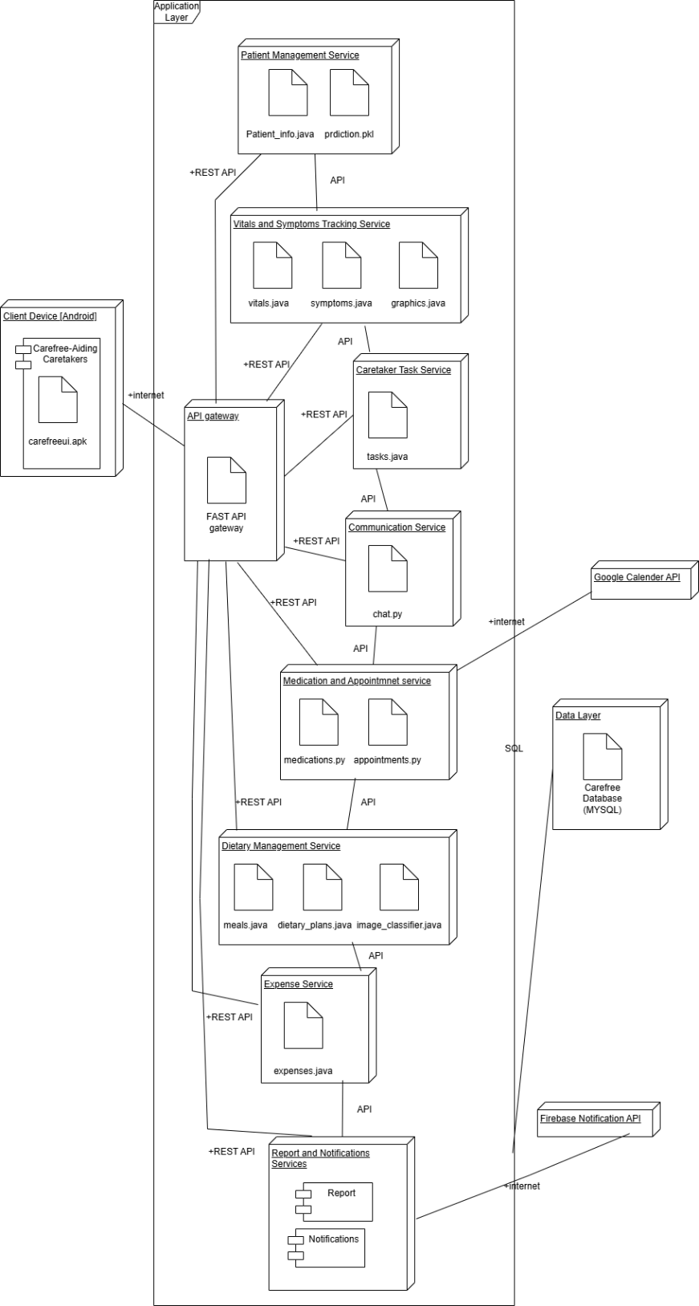
Figure 6 System Deployment Diagram — Carefree

2.5.1 Node Descriptions

Node | Layer | Components | Description
Client Device [Android] | Presentation | Carefree-Aiding Caretakers app, carefreeui.apk | Hardware Android device running the Flutter APK. Connects to the API Gateway via internet with secure encrypted communication.
API Gateway | Application | FAST API gateway | FastAPI-based secure gateway that handles all API requests from the Flutter frontend. Routes traffic to the correct backend microservice, enforces authorisation, and acts as the single entry point for all client requests.
Patient Management Service | Application | Patient_info.java, prdiction.pkl | Manages patient CRUD operations and exposes the ML cost prediction endpoint using the trained gradient boosting model (prediction.pkl).
Vitals and Symptoms Tracking Service | Application | vitals.java, symptoms.java, graphics.java | Records and retrieves patient daily vitals and symptoms. Also handles graphical trend generation for health data visualisation.
Caretaker Task Service | Application | tasks.java | Manages caretaker to-do tasks including creation, editing, deletion, and progress tracking.
Communication Service | Application | chat.py | Handles real-time in-app messaging between caretakers and guardians, including message-type classification and document attachment support.
Medication and Appointment Service | Application | medications.py, appointments.py | Manages medication schedules and patient appointments, including CRUD operations and notification triggers.
Dietary Management Service | Application | meals.java, dietary_plans.java, image_classifier.java | Manages dietary plans and meals. Integrates with the Azure Custom Vision API for AI-based image meal detection and dietary restriction checking.
Expense Service | Application | expenses.java | Handles all patient expense logging, editing, deletion, and financial report generation.
Report and Notifications Services | Application | Report module, Notifications module | Generates structured reports (vitals, symptoms, finances) and dispatches notifications via Firebase to users based on configured triggers.
Data Layer | Data | Carefree Database (MYSQL) | Centralised MySQL relational database accessed by all microservices via SQL queries. Stores all patient, caretaker, appointment, medication, expense, task, and notification data.
Google Calendar API | External | — | Cloud service allowing the Caretaker Task Service and Appointment Service to store and sync appointment and medication schedules.
Azure Custom Vision API | External | — | Cloud AI service enabling the Dietary Management Service to perform image-based meal detection for the AI Meal Flagger feature.
Firebase Notification API | External | — | Cloud messaging service enabling the Report & Notification Service to deliver push notifications and support real-time in-app communication.

2.6 Timing Diagram

[Space reserved for Timing Diagram]

CHAPTER 3: ARCHITECTURAL VIEW (4+1 MODEL)

The 4+1 architectural view model provides a comprehensive multi-perspective description of the Carefree system. Each view addresses different stakeholder concerns and together they form a complete architectural picture.

3.1 Logical View
The Logical View describes the system's object-oriented decomposition, focusing on the key abstractions and their relationships.

The system is organized around the Person base class, from which Patient, Guardian, and Caretaker are derived. The Patient entity is the central data object, aggregating Symptoms, Medication, Vitals, Appointment, DietaryPlan, and Expense objects. The Caretaker manages Tasks and triggers Notifications. The Vitals class uses inheritance to accommodate three sub-types: Cardiac, Respiratory, and Others.

Package / Layer | Key Classes | Responsibility
User Domain | Person, Patient, Guardian, Caretaker | Core user and patient data modeling
Health Tracking | Vitals, Cardiac, Respiratory, Others, Symptoms | Patient health measurements and symptom logging
Care Management | Medication, Appointment, Task, DietaryPlan, Meal | Day-to-day caregiving activities
Financial | Expense | Patient expense tracking and reporting
Communication | Notification | Alerts, reminders, and messaging

3.2 Process View
The Process View addresses concurrency, threading, and control flow across the system. Carefree operates on a three-tier SOA architecture with the following concurrent service threads:

- Patient Management Service — handles patient CRUD operations and ML prediction requests
- Vitals & Symptoms Tracking Service — continuously receives and analyzes patient data; generates alerts asynchronously
- Medication & Appointment Service — manages schedule entries and coordinates with the Notification service
- Dietary Management Service — processes AI meal detection requests via the Azure Custom Vision API asynchronously
- Communication Service — real-time messaging between Caretaker and Guardian via Firebase
- Report & Notification Service — asynchronously compiles report data and dispatches notifications

The API Gateway (FastAPI) routes all incoming requests from the Flutter client to the appropriate microservice, ensuring no single service is a bottleneck. All services communicate with the shared MySQL database via SQL queries, though each service owns a logical partition of the schema.

3.3 Development View
The Development View describes the system's module and package organization for developers.

Module | Technology | Files / Components
Frontend (Presentation) | Flutter (Dart) | carefreeui.apk; screens for Dashboard, Vitals, Meals, Tasks, etc.
API Gateway | FastAPI (Python) | FAST API gateway; routes requests to backend services
Patient Service | Spring Boot (Java) | patient_info.java, prediction.pkl
Vitals Service | Spring Boot + Python | vitals.java, symptoms.java, graphs.py
Caretaker Task Service | Spring Boot (Java) | tasks.java
Communication Service | Python | chat.py
Medication & Appointment | Python | medications.py, appointments.py
Dietary Management | Spring Boot + Python | meals.java, dietary_plans.java, image_classifier.pkl
Expenses Service | Spring Boot (Java) | expenses.java
Report & Notification | Mixed | Report module, Notifications module
Database Layer | MySQL | Carefree Database (single instance)

3.4 Physical View
The Physical View maps software components onto hardware infrastructure.

Node | Layer | Description
Client Device (Android) | Presentation | Android smartphone running the Carefree Flutter APK; connects via internet to the API Gateway
API Gateway Server | Application | FastAPI-based gateway server routing requests to backend microservices; handles authentication and load balancing
Application Server | Application | Hosts all Spring Boot and Python microservices; each service deployed as an independent process
Database Server | Data | MySQL server hosting the Carefree Database; accessed via SQL from all microservices
Google Calendar API | External | Cloud service for appointment scheduling and calendar sync
Azure Custom Vision API | External | Cloud AI service for image-based meal detection
Firebase Notification API | External | Cloud service for push notifications and real-time messaging

3.5 +1 Use Case View
The Use Case View ties together all four architectural views by showing how users interact with the system through its primary use cases. The key scenarios that drive the architecture are:

- Login — triggers the authentication flow across the API Gateway and Database
- Manage Patient Records — exercises the Patient Management Service and MySQL data layer
- Vitals & Symptom Tracking — demonstrates concurrent data recording, analysis, and alert generation
- AI Meal Flagger — illustrates integration of the Flutter client, API Gateway, Azure Custom Vision API, and Dietary Management Service
- ML Medical Cost Predictor — shows the full ML pipeline from data retrieval to model inference and result storage
- Guardian Communication — demonstrates real-time messaging via the Communication Service and Firebase

These scenarios are fully modeled in the Sequence Diagrams (Section 2.4) and State Chart Diagrams (referenced in the full SDD).

CHAPTER 4: REFERENCES

- IEEE Std 1016-2009: IEEE Standard for Information Technology — Systems Design — Software Design Descriptions. IEEE, 2009.
- Unified Modeling Language (UML) Specification, Version 2.5.1. Object Management Group (OMG), 2017.
- Flutter Documentation. Google LLC. https://flutter.dev/docs
- Spring Boot Reference Documentation. VMware, Inc. https://spring.io/projects/spring-boot
- FastAPI Documentation. Sebastián Ramírez. https://fastapi.tiangolo.com
- Azure Custom Vision API Documentation. Microsoft Corporation. https://learn.microsoft.com/en-us/azure/cognitive-services/custom-vision-service/
- Firebase Cloud Messaging Documentation. Google LLC. https://firebase.google.com/docs/cloud-messaging
- Google Calendar API Documentation. Google LLC. https://developers.google.com/calendar/api
- MySQL 8.0 Reference Manual. Oracle Corporation. https://dev.mysql.com/doc/refman/8.0/en/
- HIPAA Privacy Rule Summary. U.S. Department of Health & Human Services. https://www.hhs.gov/hipaa/

