|  |
| --- |
| Name / ID Quiz-2 Date 29-3-2024  SE2A Discrete Structure max time = 30 min |

Counting [2x5=10]

Q1 Solve with justification

1. Suppose that a department committee of FAST –NU contains 10 men and 15 women

How many ways are there to form a committee with six members if it must have more women than men .

1. How many license plates can be made using either three uppercase English letters followed by three digits or four uppercase English letters followed by two digits.
2. There are four blood types, A, B, AB, and O. Blood can also be and Finally, a

blood donor can be classiﬁed as either male or female.

How many different ways can a donor have his or her blood labeled?

1. How many different ID cards can be made if there are 6 digits on a card and no digit can be used more than once.
2. How many bit strings of length 12 contain
3. Exactly three 1s ?
4. At most three 1s ?
5. At least three 1s ?

Number theory [7+3=10]

Q2 a) Use Euclidean algorithm to express as a linear combination.

b) what are Bezout coefficients and what is inverse of 55 modulo 89

c) Solve using modular inverse and write the general solution.

Q3 Determine the check digit for the UPCs that have 11 initial digits

Happy Ramadan

Assistant prof.Jamilusmani

Find a minimum spanning tree using Prim's algorithm. Make sure to keep track of the order in which edges are added to the tree. Then find a minimum spanning tree using Kruskal's algorithm, again keeping track of the order in which edges are added.

**4**

**Chapter 11 Trees**

Introduction, Applications, Tree Traversal (pre order , inorder , postorder), Spanning Trees and Minimum Spanning Trees(Prims and Kuskal’s)

**Chapter 10 Graphs**

Graphs and Terminologies, Types of Graphs, Representing Graphs and Isomorphism, Connectivity, Euler and Hamiltonian Paths, Planar Graphs, and Graph Coloring, shortest path (Dijistra algo), Travelling sales man problem

**Chapter 4 (Number theory and Cryptography)**

Congruence’s and its Applications,chiness and fermat’s theorem ,Cryptography ,RSA cryptosystem

Relations with Properties, Recurrence Relations, Sequences and Series, Mathematical Induction and Recursive Algorithms, Introduction to Proofs and Proof Methods, Equivalences, Predicates and Quantifiers, Nested Quantifiers, Rules of Inference

Chap 1,4,10,11 (complete)

Relations with Properties, one and onto function , Sequences and Series(AP and GP) , Mathematical Induction and Recursion (5.3), Binomial coefficient , solving linear Recurrence Relations (8.2) ,counting techniques ,inclusion –exclusion (8.5)

**KEY TOPICS FOR UPCOMING EXAM**

 **15% 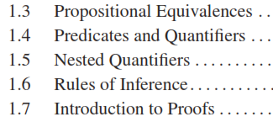  5%**

  **15%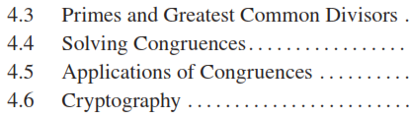  10%**

 

 **5%**

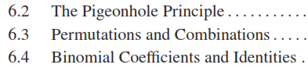  **10%**



 **5%**





 **20%**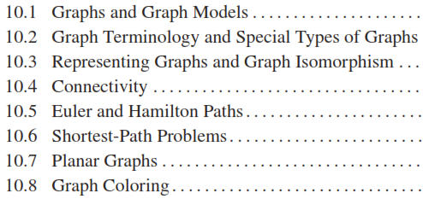

**15%**

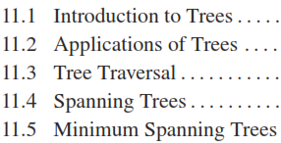

Assistant prof:Jamilusmani