TASK 9
Date set : Student performance.
import pandas as pd

df = pd.read_csv("student_performance_updated_1000.csv")

• pd.read_csv(): This is a Pandas function used to read a CSV file (Comma-Separated Values) and load its data into a Pandas DataFrame. A DataFrame is like a table in Python, with rows and columns.
• "student_performance_updated_1000.csv": This is the name of the CSV file that contains your data. The file should be in the same folder as your Python script or notebook, otherwise you need to give the full path.
• df =: This stores the loaded data into a variable named df (short for DataFrame). You can then use df to explore and manipulate your data.
df.head()

shows the first 5 rows of your DataFrame df by default.
- It’s useful to quickly inspect your data and see what it looks like.
- You can also pass a number to see more or fewer rows, like df.head(10) to see the first 10 rows.
Output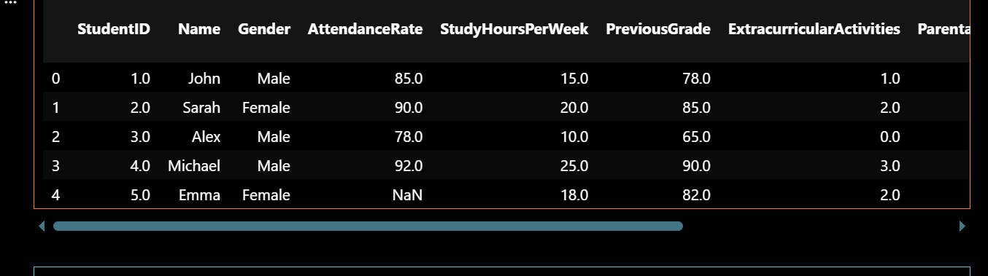
df.tail()
df.tail() shows the last 5 rows of your DataFrame by default.
- Like df.head(), but at the end of the table.
- You can also pass a number, e.g., df.tail(10) to see the last 10 rows.
It’s useful to quickly check the end of your data for completeness or patterns.
Output:-
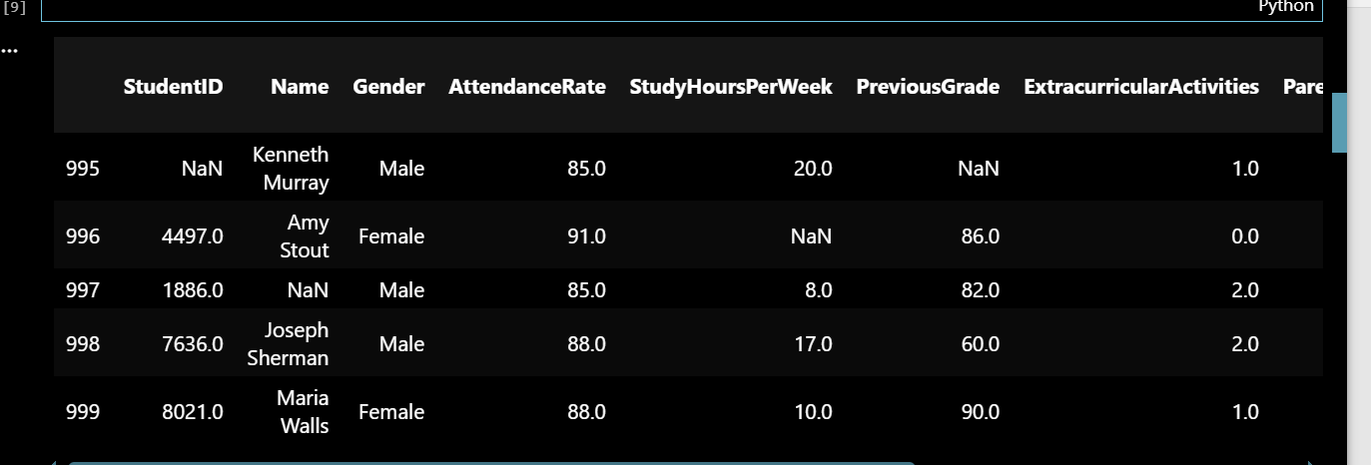

df.shape
df.columns
df.info()

- df.shape → Shows (rows, columns) of your data.
- df.columns → Lists all column names.
- df.info() → Gives a quick summary: column names, data types, and missing values.

Output:-

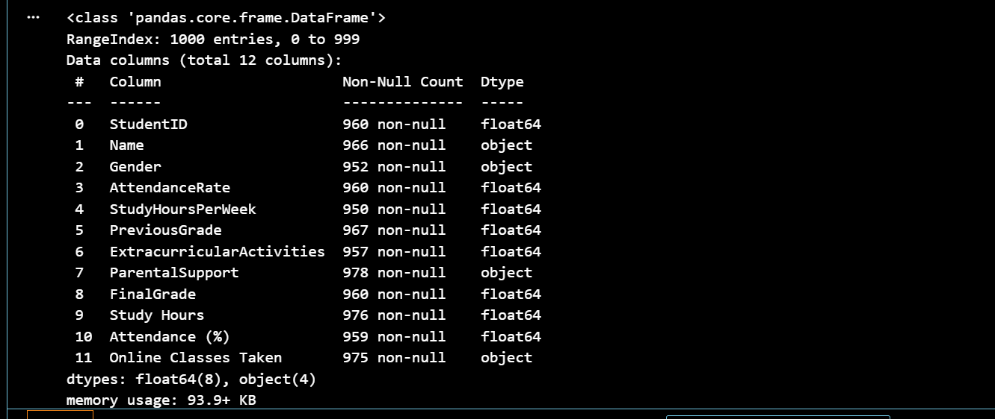
df.describe()
df.describe() gives basic statistics for all numeric columns in your DataFrame, like:
- count → Number of non-missing values
- mean → Average value
- std → Standard deviation (spread of data)
- min → Minimum value
- 25%, 50%, 75% → Percentiles (quartiles)
- max → Maximum value
Output:-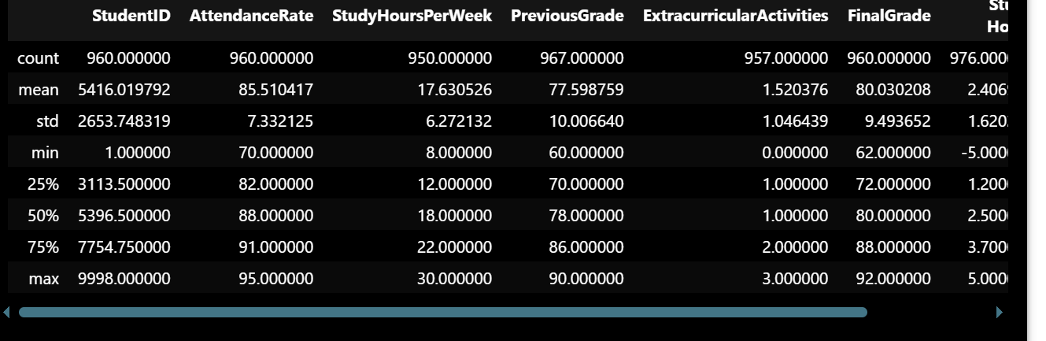
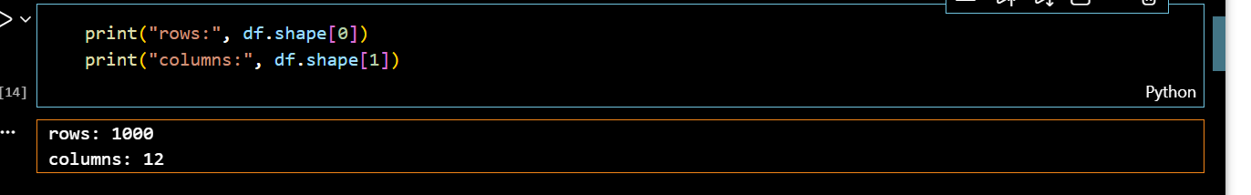• df.shape[0] → Number of rows
• df.shape[1] → Number of columns
df.isnull().sum()
df.isnull().sum() is used to check for missing values in your DataFrame.
- df.isnull() → Returns True for each cell that is missing (NaN) and False otherwise.
- .sum() → Adds up the True values column-wise, giving the total missing values in each column.
Output:-
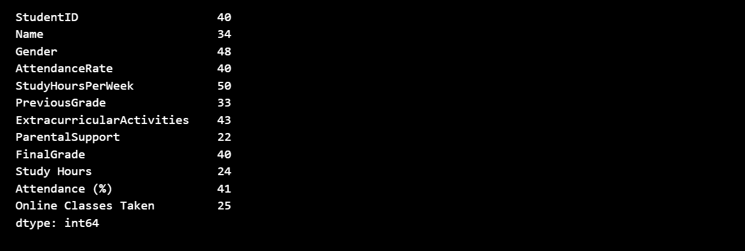
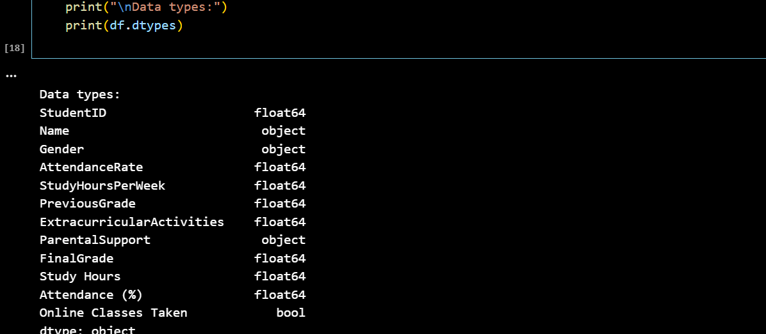

- df.dtypes → Shows the data type of each column (e.g., int, float, object)
- object → Text or string data
- int64 → Integer numbers
- float64 → Decimal numbers
It helps you know what kind of data each column holds.

