**Name: Laiba Adnan**

**Class: Bsds 3A**

**Roll no: 004**

**Task 4**

**Explaination for LUHN Algorithm 2.**

**What the Code Does (Why)**

It checks if a number (like a **credit/debit card**) is **valid using the Luhn algorithm** — a standard checksum method used to detect errors in identification numbers.

**⚙️ How It Works — Step by Step (Short)**

1. **Extract digits** → digits = [int(ch) for ch in number_str if ch.isdigit()]  
   ✅ Removes any non-digits and turns the string into a list of integers.
2. **Pop last digit as check digit** → check = digits.pop()  
   ✅ This is the number used to verify the rest of the digits.
3. **Reverse remaining digits** → digits.reverse()  
   ✅ So the doubling starts from the right side.
4. **Loop through digits**
   * Every **second digit** (i % 2 == 0) is doubled.
   * If doubling > 9, subtract 9 (same as adding digits individually).
   * Add to total.
5. **Add check digit** → total += check
6. **Validate** → return total % 10 == 0  
   ✅ If total ends in 0, the number is valid.

**Output:-**

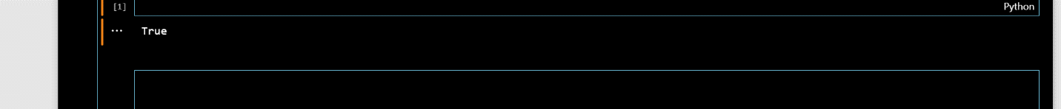

**Write a python program to remove punctuations from the given string?**

🌟

**Why:**

This function removes **punctuation marks** from a string — useful for text processing, cleaning data, or preparing text for analysis.

**⚙️ How:**

1. punctuations → a string of all punctuation symbols to remove.
2. Loops through each character in s.
3. If the character is **not** in punctuations, it’s added to result.
4. Returns the cleaned string.

**Output:-**

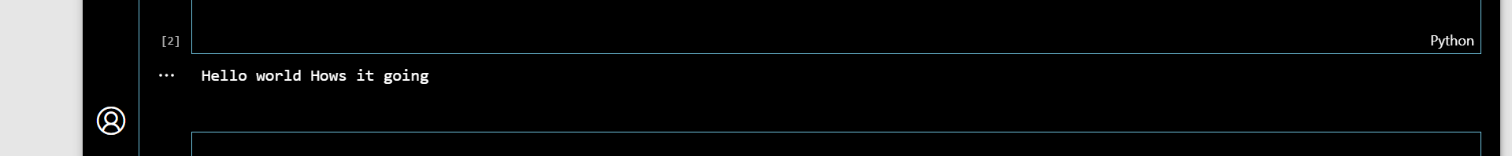

**Write a python program to sort the sentence in alphabetical order?**

**How:**

* The sentence is split into words using split().
* Each word is checked in a loop; if it's **not** in the seen set, it’s added to result and marked in seen.
* Finally, join() combines the unique words back into a sentence.

**Why:**

* The set prevents duplicates.
* Using w.lower() ensures case-insensitive checking.
* This way, the **first occurrence stays**, duplicates are skipped, and the **original order is preserved**.

**Output:-**

