Hospital Management System (HMS) Project Report

Week 1: Planning and Database Design

Lab Tasks
- Project Selection: The project chosen was a Hospital Management System (HMS) to streamline hospital operations, including patient records, appointments, billing, and inventory management.
- Requirements and Features Definition:
  - Objective: Develop a web-based HMS to manage patient records, appointments, consultations, billing, inventory, and staff details.
  - Features:
    - Patient registration and medical history tracking.
    - Appointment scheduling with reminders.
    - Billing and insurance claim processing.
    - Inventory management for medical supplies.
    - Role-based access for admins, doctors, and patients.
    - Data security and compliance with regulations (e.g., HIPAA, GDPR).
  - User Roles:
    - Admins: Manage appointments, registrations, billing, and inventory.
    - Doctors: Access patient records, diagnose, prescribe treatments, and update consultation details.
    - Patients: Book appointments, view medical records, and pay bills.
- Database Schema Design:
  - Tables and Relationships:
    - Tables: patients, doctors, appointments, consultation, billing, inventory, department, admin.
    - Relationships:
      - One-to-Many: A doctor can attend many appointments; a patient can book multiple appointments.
      - One-to-One: Each appointment results in one consultation.
      - Foreign Keys: PatientID in appointments links to patients, DoctorID in appointments links to doctors.
  - Entity-Relationship Diagram (ERD):
    - Created an ERD to visualize relationships between entities like patients, doctors, appointments, and departments.
  - Attributes and Data Types:
    - Example: patients table includes PatientID (int, PK), Name (varchar), Age (int), Gender (enum), Email (varchar), Password (varchar), PhoneNumber (varchar), Address (text), CNIC (varchar).
    - Constraints: Primary keys, foreign keys, NOT NULL for critical fields, UNIQUE for identifiers like Email and CNIC.

Week 1: Front-End Development
- User Interface (UI) Design:
  - Designed using HTML and CSS to create an intuitive and user-friendly interface.
  - Pages included: appointment, billing, consultation, dashboard_admin, dashboard_doctor, dashboard_patient, doctor_profile, inventory_management, login, patient_form, reports.
- Web Pages for Functionalities:
  - Created pages for listing, adding, editing, and deleting records (e.g., patient registration, appointment scheduling).
- Responsive Design:
  - Implemented CSS frameworks (e.g., Bootstrap) to ensure compatibility across mobile and desktop devices.
- JavaScript Implementation:
  - Added client-side validation for forms (e.g., ensuring valid email and phone number formats).
  - Incorporated interactivity for features like dynamic appointment scheduling and real-time form feedback.

Week 2: Back-End Development and Database Integration
- PHP Scripts Development:
  - Developed PHP scripts to handle user input, process requests, and interact with the MySQL database.
  - Implemented CRUD operations:
    - Create: Add new patients, appointments, and inventory items.
    - Read: Retrieve patient records, appointment schedules, and billing details.
    - Update: Modify patient information, consultation details, and inventory quantities.
    - Delete: Remove outdated appointments or inactive patient records.
- Database Connection:
  - Configured database connection settings in PHP to connect to the MySQL database (project.db).
  - Created reusable functions for database interactions (e.g., insertPatient(), retrieveAppointments(), updateBillingStatus(), deleteInventoryItem()).
- Testing:
  - Verified accurate storage and retrieval of data (e.g., patient records, appointment details).
  - Handled errors such as duplicate entries, invalid inputs, and database connection failures.

Week 2: Testing, Debugging, and Refinement
- Thorough Testing:
  - Tested all CRUD operations to ensure functionality (e.g., booking an appointment, generating a bill).
  - Validated data integrity (e.g., no negative inventory quantities, correct appointment-doctor linkage).
- Debugging:
  - Fixed issues like incorrect foreign key references and validation errors in forms.
  - Resolved database query errors (e.g., handling NULL values in appointments table).
- Additional Features:
  - Added search functionality to filter patients, appointments, and inventory items.
  - Implemented user authentication for secure access based on roles (admin, doctor, patient).
- Code Optimization:
  - Optimized database queries for faster retrieval (e.g., indexing frequently accessed columns like PatientID).
  - Refactored PHP code to improve readability and reduce redundancy.

Week 3: Documentation and Presentation
- Documentation:
  - User Manual: Detailed guide for users (admins, doctors, patients) on how to navigate and use the HMS (e.g., booking appointments, viewing medical records).
  - Database Schema Documentation: Included table structures, relationships, constraints, and sample data from project_db.sql.
  - Code Documentation: Commented PHP, HTML, CSS, and JavaScript code to explain functionality and logic.
- Challenges and Solutions:
  - Challenge: Handling NULL values in the appointments table (e.g., PatientID in some records).
    - Solution: Added validation to ensure appointments are linked to valid patients or marked as open slots.
  - Challenge: Ensuring data security for sensitive patient information.
    - Solution: Implemented password hashing (e.g., bcrypt for patient passwords) and role-based access control.
  - Challenge: Synchronizing front-end and back-end validation.
    - Solution: Used JavaScript for client-side validation and PHP for server-side validation to ensure consistency.
  - Challenge: Managing inventory stock levels to prevent negative quantities.
    - Solution: Added validation logic in PHP to check Quantity before updating the inventory table.

Conclusion
The Hospital Management System (HMS) was successfully developed to streamline hospital operations, improve patient care, and enhance efficiency. The system integrates a robust MySQL database with a responsive front-end and secure back-end, supporting various user roles and ensuring data integrity and security. The project addressed challenges through careful planning, testing, and optimization, resulting in a functional and user-friendly application.

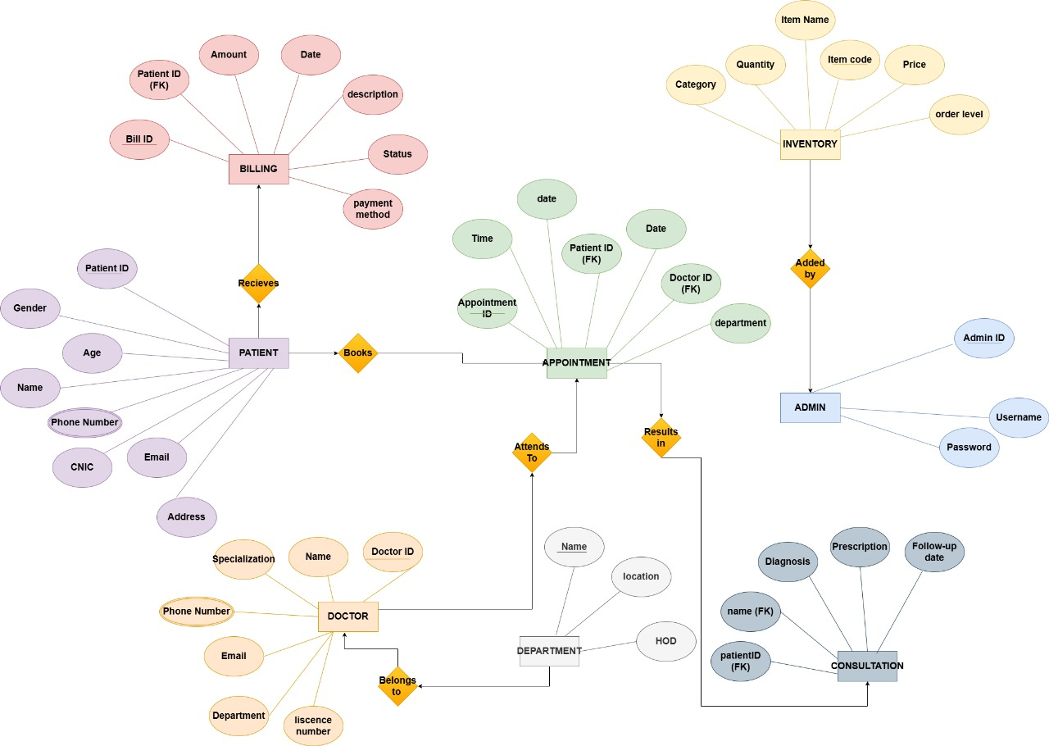
ER DIAGRAM:

