LAIBA BUKHARI

ROLL 124757

BESE-6B

con.setAutoCommit(false);

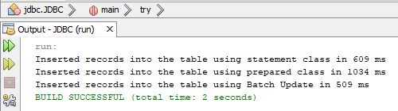

con.setAutoCommit(true);

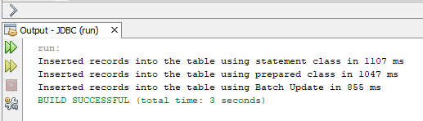

Git link: