**Name:Laiba Gul**

**Sap ID :55740**

**Class:BSCS(7th)**

**Lab #08**

**Question no 01**

.model small

.stack 100h

.data

msg db 'First 5 odd numbers: $'

.code

main:

mov ax, @data

mov ds, ax

; Print message

mov ah, 09h

mov dx, offset msg

int 21h

mov cx, 5

mov bl, 1

print_loop:

mov al, bl

add al, '0'

mov dl, al

mov ah, 02h

int 21h

; Print space

mov dl, ' '

mov ah, 02h

int 21h

add bl, 2

loop print_loop

; Exit

mov ah, 4Ch

int 21h

end main

**Output:**

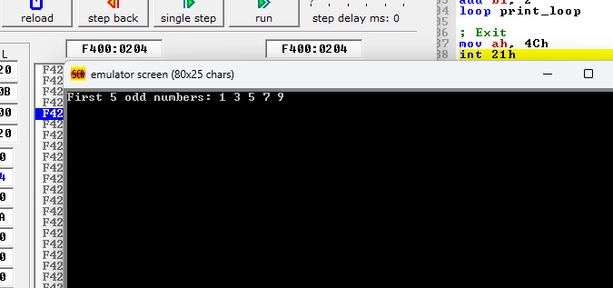

**Question no 02**

.model small

.stack 100h

.data

msg db 'Even numbers (reverse): $'

.code

main:

mov ax, @data

mov ds, ax

; Print message

mov ah, 09h

mov dx, offset msg

int 21h

mov cx, 6

mov bl, 10

print_loop:

mov al, bl

add al, '0'

mov dl, al

mov ah, 02h

int 21h

mov dl, ' '

mov ah, 02h

int 21h

sub bl, 2

loop print_loop

mov ah, 4Ch

int 21h

end main

**Output:**

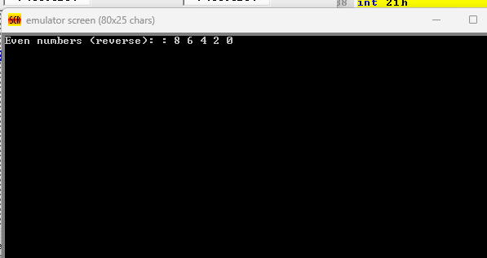

**Question no 03**

.model small

.stack 100h

.data

msg db 'Sum = $'

.code

main:

mov ax, @data

mov ds, ax

; Print message

mov ah, 09h

mov dx, offset msg

int 21h

mov cx, 3

mov ax, 0

mov bl, 1

L1:

add ax, bx

inc bl

loop L1

add al, '0'

mov dl, al

mov ah, 02h

int 21h

; Exit

mov ah, 4Ch

int 21h

end main

**Output:**

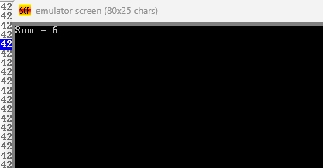

**Question no 04**

.model small

.stack 100h

.data

msg db 'Enter a character please: $'

.code

main:

mov ax, @data

mov ds, ax

; Print message

mov ah, 09h

mov dx, offset msg

int 21h

mov ah, 01h

int 21h

mov bl, al

mov cx, 10

print_10loop:

mov dl, bl

mov ah, 02h

int 21h

mov dl, 13

mov ah, 02h

int 21h

mov dl, 10

mov ah, 02h

int 21h

loop print_10loop

mov ah, 4Ch

int 21h

end main

**Output:**

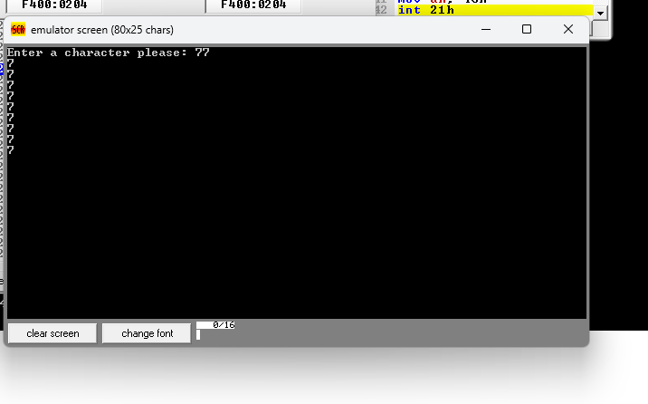

**Question no:05**

.model small

.stack 100h

.data

msg db 'Small letters (a to z): $'

.code

main:

mov ax, @data

mov ds, ax

; Print message

mov ah, 09h

mov dx, offset msg

int 21h

mov cl, 'a'

mov ch, 'z'

print_alphaloop:

mov dl, cl

mov ah, 02h

int 21h

mov dl, ' '

mov ah, 02h

int 21h

inc cl

cmp cl, ch

jg end_program ;

jmp print_alphaloop

end_program:

; Exit

mov ah, 4Ch

int 21h

end main

**Output:**

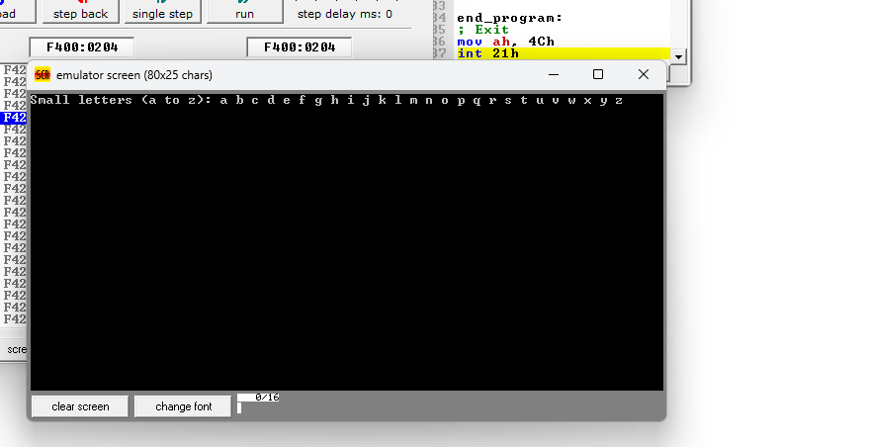

**Question no:06**

.model small

.stack 100h

.data

msg db 'Print by using loop Numbers (9 to 0): $'

.code

main:

mov ax, @data

mov ds, ax

; Print message

mov ah, 09h

mov dx, offset msg

int 21h

mov cl, 9

print_numloop:

mov al, cl

add al, '0'

mov dl, al

mov ah, 02h

int 21h

mov dl, ' '

mov ah, 02h

int 21h

dec cl

cmp cl, -1

jg print_numloop

mov ah, 4Ch

int 21h

end main

**Output:**

