**Software Requirements Specification**

**For**

**Supermarket Management System**

**Version 1.0 approved**

**Prepared by**

**Laiba Idrees**

**Thursday, June 2, 2022**

Table of Contents

1. Project Title 5

2. Introduction 5

2.1 Purpose 5

2.2 Product scope 5

2.2.1 Project Justification 5

2.2.2 Project characteristics and requirements: 6

2.2.3 Project deliverable: 6

2.2.4 Project search criteria: 6

2.3 Definitions, Acronyms, and abbreviations 6

2.4 References 6

3. Project overview statement 7

4. Intended Audience and Reading Suggestions 7

5. Project Goals and objectives 7

5.1 Operating Environment 7

5.2 User Documentation 7

5.3 Market Demography 8

6. Summary of Capabilities 8

7. Functional Requirements 9

7.1 Database 9

7.1.1 Profiling 9

7.2 Data collection 9

7.2.1 Privacy 9

7.2.2 Motion sensing 9

7.3 Anti shop-lift 10

7.3.1 Active credit card 10

7.3.2 Limited entry 10

7.3.3 Automated security system 10

7.4 Data management 11

7.4.1 Recommendations 11

7.4.2 Discounts 11

7.4.3 Informing brands 11

7.5 Environmental services 11

7.6 multi-profiling 11

7.7 Legal repercussions 11

7.7.1 Legal actions 11

7.8 Loss of products 12

7.9 Profiting 12

7.10 Nation-wide connectivity 12

7.11 Offense/Banning 12

8. Tools and technologies used 12

8.1 Motion sensos: 12

8.2 Pressure sensos: 13

8.3 Artificial intelligence: 13

8.4 Accounting Software: 13

8.5 CRM software: 13

8.6 Marketing Automation Software: 13

8.7 Analytics Software: 13

9. Architecture Diagram 13

10. Components Responsibilities 14

11. Use Case Maps 16

11.1 Buying a new Product 16

11.2 Requesting a product 17

12. Requirements Table 17

13- Use Case Models 19

12.1 Profiling of user 19

12.2 Update the product status 20

12.3 Manage product in cart 21

12.4 Validate payment method 21

12.5 Validate customer login 22

12.6 Manage coupon 23

13. Use Case Diagram 23

14. Sequence Diagrams 25

14.1 Profiling of user 25

14.2 Update the product status 26

14.3 Manage product in cart 27

14.4 Validate payment method 28

14.5 Validate customer login 29

14.6 Manage coupon 30

15. System Sequence Diagrams 31

15.1 Profiling of user 31

15.2 Update the product status 32

15.3 Manage product in cart 33

15.4 Validate payment method 34

15.5 Validate customer login 35

15.6 Manage coupon 35

16. Operational Contracts (SSD) 36

16.1 Profiling of user 36

16.2 Update the product status 37

16.3 Manage product in cart 37

16.4 Validate payment method 37

16.5 Validate customer login 37

16.6 Manage coupon 38

17. Activity Diagrams 39

17.1 Validate customer login 39

17.2 Profiling of user 40

17.3 Manage product in cart 41

18. State Machine Diagrams 42

18.1 Validate customer login 42

18.2 Profiling of user 43

18.3 Manage product in cart 43

19. Domain Model 44

20. Component Diagram 44

21. Deployment Diagram 45

# Project Title

**Supermarket Management System**

# Introduction

## Purpose

The purpose is to create the world’s most progressed shopping innovation, so the client never needs to be held up in line. This technology allows the user to shop whatever they want and just walk out without checking in at a cashier. The billing is done via app and a receipt is sent to the user at the end of the purchase. Thus, greatly reducing human efforts and need of human cashier. The main purpose of this management system is to reduce time wastage and use it efficiently. There would be no crowded lines and mingling in stores. To decrease the carrying of cash and to avoid crowded place in situations like pandemic. It has a lot of benefits such as it is Simple & Easy to Use, it Increases reliable engagement, it has Efficient Data Management, it is Highly Secure, Scalable & Reliable, it has Mobile Access, it is error free, innovative, and cost-effective.

## Product scope

### Project Justification

The store management system is a wide ranged system that can be utilized with any store integrated with the sensor technology. It will assist in daily grocery shopping making it compatible and easier.

### Project characteristics and requirements:

The app recognizing the GPS location of the store and checking in automatically at the main door. The mixture of technologies like artificial intelligence, computer vision, and all the data pulled from different sensors to ensure clients are only charged for the stuff they take from the shelves of the store. Moreover the “facial recognition” technology allows it to take information regarding each customer including what they picked and storing the data in its data base further giving recommendation on basis of the stored data. The online transaction of purchased item is done through online billing from an app that is linked with the client’s bank account.

### Project deliverable:

Project plan, project research, design system, design documents, structure, code, hardware.

### Project search criteria:

Delivered in the within time constraints and under the budget with all the requirement fulfilled within the system.

## Definitions, Acronyms, and abbreviations

Some abbreviations or acronyms are as below:

**Customer, Client**: The user who will use the product.

|  |  |
| --- | --- |
| SMS | Supermarket management system |
| SRS | Software Requirement Specification |
| GUI | Graphical User Interface |

## References

TBD

# Project overview statement

Reducing daily hassle of waiting and wasting time at cashier for billing. The simple ‘Walk out technology prevents any extra hassle making shopping everyday grocery a stress free and less time-consuming experience.

# Intended Audience and Reading Suggestions

The intended audience for the given document is:

* Admin of the organization using the software.
* Project managers
* Development team
* Testers

# Project Goals and objectives

The main objective of the project is to provide an experience to the users that will improve the efficiency of the preexisting check-out system, saving time, money, and effort.

Types of users that will use this product:

1. Customers/Clients: They will shop at one of these stores. The store works with an app for iOS or Android: enter, take the products, and then, just leave again. The app is linked to the client bank account for billing.
2. Management staff: Staff hired by the store to manage the app and to solve any upcoming issues regarding the customer and app. Also, to test the durability and compatibility of the sensors with the app from time to time.

## Operating Environment

This product will be able to operate on any operating system normally. It is compatible with IE 6.0 and all the functionality of the management system will be accessible and useable through browser like google chrome, mozzarella Firefox and opera 6.0 and higher versions. The web should have JavaScript on and require an internet connection to work.

## User Documentation

This product will include a manual guide that will hold all the functional and nonfunctional properties of the project and will contain a complete overview of the project including SQL server. Technical details and backup information will also be provided in it including the emails and phone number of required people in case of system crash.

## 5.3 Market Demography

The target market segment includes all income homeowners living in medium and large cities. The users are anticipated to be consumers who already use cell phones on a regular basis for personal and/or business use. Mostly clients who are working and are have the least available time to purchase goods on daily bases.

# Summary of Capabilities

|  |  |
| --- | --- |
| Database | A data manager at the back end to manage and collect all the information received by the system and sorting/distributing them accordingly. |
| Data collection | The data being collected itself by the system of the given profile of the user/customer into its data base and being stored accordingly. |
| Anti-shop-lift | Only one account per user will be activated. The store checkout procedure, only the users which have an active account on their mobile app will be allowed to enter the shop upon presenting a registered bar-code from the app. Including all the billing done through online transactions. Limiting the entry of person inside the store with authorization of app, |
| Data management | All store data will be managed carefully, accordingly recommendation, information of sales for products according to the data stored and managed by the system will be suggested to the user. |
| Recognition/sensors | Devices will be thoroughly linked with the app accordingly managing both the virtual cart and recognizing the customers behavior. A receipt will be sent at the end of a purchase. |

# Functional Requirements

Note: The keyword “Experience” used in the following signifies one full procedure of a customer buying any product and exiting the store without the exceptions of errors and omissions for the sake for understandability.

## Database

A back-ended database will be used to collect and store numerous forms of data which will be sorted according to their respective profiles.

### Profiling

The profiling system will be implemented to make the system responsive enough for the implementation to be near real-time, this way, the accessing and reading/writing of the data can be done with ease and the data will also be reliable, eliminating any chance of misreading.

## Data collection

The data collection will be done according to the profile of the user, and will be stored accordingly

### Privacy

Due to the privacy concerns of some users, the users will be given the option to choose whether they want their data to be collected to provide an enhanced experience. They can configure this setting directly from their app however the data collection will be enabled by default during initial configuration of the app.

### Motion sensing

Multiple motion sensors throughout the store will track and profile each user individually and detect each movement they make with high accuracy.

#### Movement tracking

Movement such as walking patterns, visited aisles, preferred products, preferred brands etc.

#### Body language

Movement such as hesitation while choosing a certain product, being cautious about ingredients, being attracted by an advertisement or a discount offer etc.

#### Billing

Motion sensors and pressure detectors will sense whether the user has picked up a product from a shelf or not, this will automatically add the picked-up item to the user’s cart and other cameras throughout the store can check to see whether the user has changed his/her mind and put the item back or not, the bill will be charged accordingly.

#### Fining system

If a customer picks up an item and then places it in a different shelf, that will be seen as an attempt to confuse the algorithm and will therefore result in a fine. This will motivate customers to be mindful of what they choose, which will prevent any miscalculations that the system may face during an experience.

## Anti shop-lift

For the integrity of the store checkout procedure, only the users which have an active account on their mobile app will be allowed to enter the shop upon presenting a registered bar-code from the app.

### Active credit card

Since the billing is done automatically, the users will require an active credit card to enter the shop, upon entry, a transaction of a minimum of $1 will be made to check the validity of the credit card, this credit will be recorded in the database and compensated later as required.

### Limited entry

The size of the store will define the limit of the number of customers that are allowed inside the store at a time. This is to ensure that each user is tracked as accurately as possible without overloading the system or causing miscalculations.

#### Social analysis

To ensure the integrity of a customer experience and to avoid people waiting in queues outside the store, before a store is constructed in an area, an analysis will be conducted to see the average amount of shoppers per day and what impact will the existence of this store in the region make. This will be an important deciding factor in deciding the size of the store, such that the business can run as smoothly as possible, and the average customer does not have to wait in a queue at all during his/her experience.

### Automated security system

The automated security system can contact authorities in case of breach.

## Data management

All the data done through profiling will be fed to algorithms to improve the experience of the users on an individual level.

### Recommendations

Each user will receive individually unique recommendations which have been tailored specifically for the respective user and is based off their actions inside the store which was recorded. These actions are mentioned above.

### Discounts

Unlike other stores, where discount coupons are based on the popularity of a product, This store will give unique coupons to loyal customers based on what they want, such as something that they’ve wanted to buy but didn’t because of the price. This will greatly impact the user experience for the better.

### Informing brands

The data which is collected by the store can partially be shared by the store’s providers, such as companies or manufacturers, to make them aware of the public trends and popularity of products, this data can be valuable in terms of their marketing, therefore additional data can also be sold to them on demand.

## Environmental services

To reduce the effect on the environment and to gain the edge of morality from the public, the store will not provide any disposable plastic bags and will encourage users to use their own bags to carry whatever they buy, since the billing is done automatically, and the checkout system is non-existent.

## multi-profiling

A user can enable multi-profiling to allow visits with a full family or any number of different people. This way, everything that the people pick, or whatever their behavior is, will be linked to the main user’s profile, as with the bill.

## Legal repercussions

Products such as narcotics and/or alcoholic drinks which are only allowed to adults will only be made accessible by the adults, these items will be stored in a separate section of the store which will only be accessible to the customers who have verified their national identity through the app.

### Legal actions

Any attempt of breach of this restriction will result in immediate reports to the authorities to avid any legal actions against the store and to uphold the integrity of the business.

## Loss of products

Accidental breaking of a product such as: product falling off a shelf, customer mishandling the product, will result in a fine according to the damage. The customer can claim that the mishandling was unintentional, which will drop the fine if the system deems it to be fair. Note: this is only applicable if the damages done is below a certain threshold.

## Profiting

The implementation of this system is expected to increase the profit by a solid 65% as compared to a regular shop, this is due to the lower maintenance costs, lack of staff and security members. Which means that because the whole store is automated, the salaries given to the staff in a traditional store will also be accounted in profit.

## Nation-wide connectivity

The profile made for each user automatically will be unique and can only exist for one user at a time. Which means that only one profile will be made for each user, this way if the user was to use a different outlet of the store, he/she can use the same profile for the store rather than making a completely new one. The layout of each store will also differ so that the algorithm can study the behavior of the user in a much more diverse way.

## Offense/Banning

Going against the terms of agreement of the store can result in a temporary offense ban or even a permanent ban from all stores depending on the severity of the breach. A banned user will not be allowed in the premises of the store during a ban and authorities will be contacted if the user persists even after warnings. Since a user can only make one profile in his/her lifetime, the banning system is fool proof. The ban may be administered for many reasons, such as intentional damage to property, which will all be stated clearly in the terms of agreement.

# Tools and technologies used

## Motion sensos:

The operation of the store heavily relies on the inputs given by motion sensos, as it enables the system to keep track of each individual use as they enter the store.

## Pressure sensos:

Pressure sensos ae used to keep track of what each use picks up from a shelf and minimize errors and accidental additions in the total bill.

## Artificial intelligence:

AI is used which adapts and leans the public tends and manages the advertising accordingly.

## Accounting Software:

[Accounting software](https://www.softwareadvice.com/accounting/) is essentially the technology-laden version of the sales ledger. It helps retailers keep track of incoming and outgoing transactions, as well as generate a cumulative history of finances

## CRM software:

[Customer relationship management (CRM) software](https://www.softwareadvice.com/crm/) is a tool that helps retailers better manage their customer interactions. While traditional retail businesses could keep up with in-person interactions, today’s retailers need to reach customers on multiple platforms such as email, messages, phone calls, messenger services, and social media. CRM tools make this outreach possible and help streamline all incoming communication.

## Marketing Automation Software:

[Marketing automation software](https://www.softwareadvice.com/marketing/automation-comparison/) helps streamline marketing efforts and automate marketing processes such as tracking customers, content publishing, customer segmentation, and marketing analytics.

## Analytics Software:

By integrating analytics software into our system, we can keep a track on who are customers are and what are they buying more or which product they focus more on so that in future we can help them by giving coupons or discounts on that specific product.

# Architecture Diagram

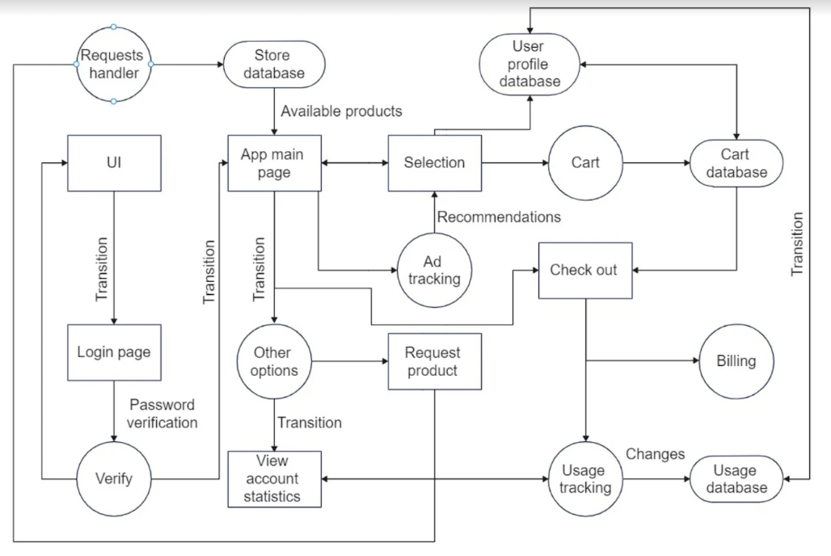

# Components Responsibilities

* **User Profile database**  
  1- Updates the user information

2- Stores the dislikes and like of the user

3- Issue coupons

4- Offer Discounts based on interest

* **Ad tracker**

1. Manage user
2. Uses likes and dislikes of user
3. Share adds according to interest of user
4. Sort adds according to user dislikes and likes

* **Cart**

1. Manages product takes by the user
2. Discard when user puts the product back on shelve
3. Show the current availability of product in cart

# Use Case Maps

## Buying a new Product

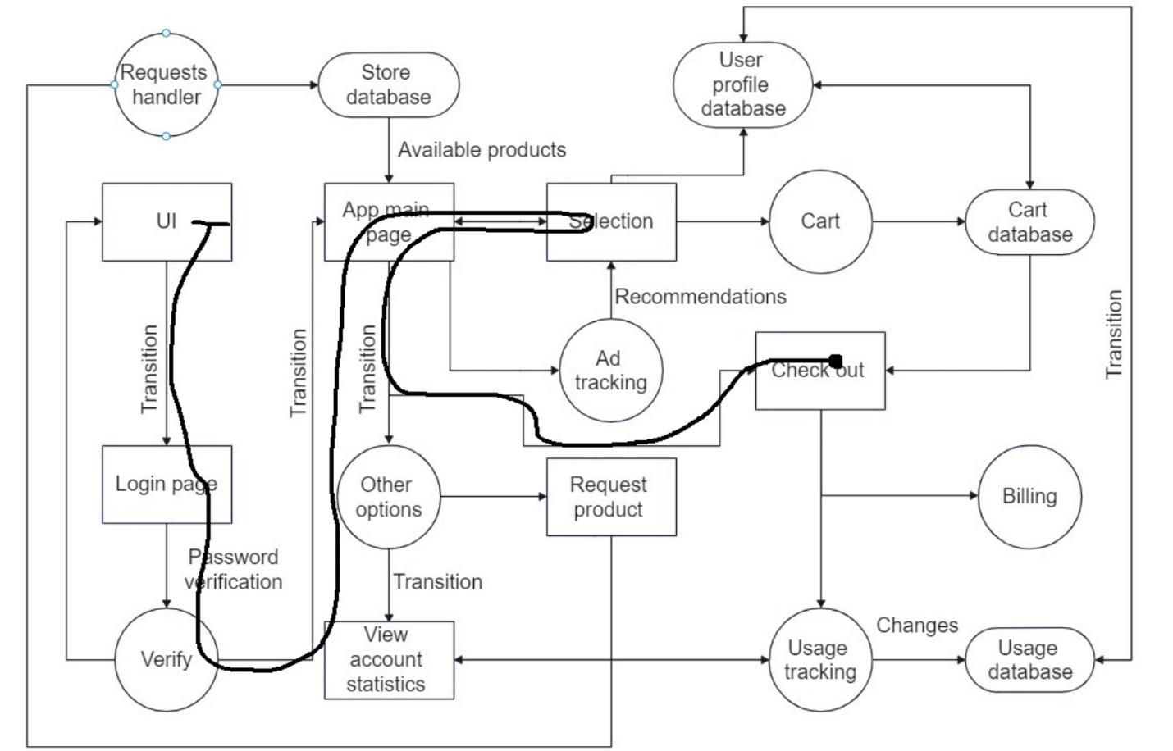

## Requesting a product

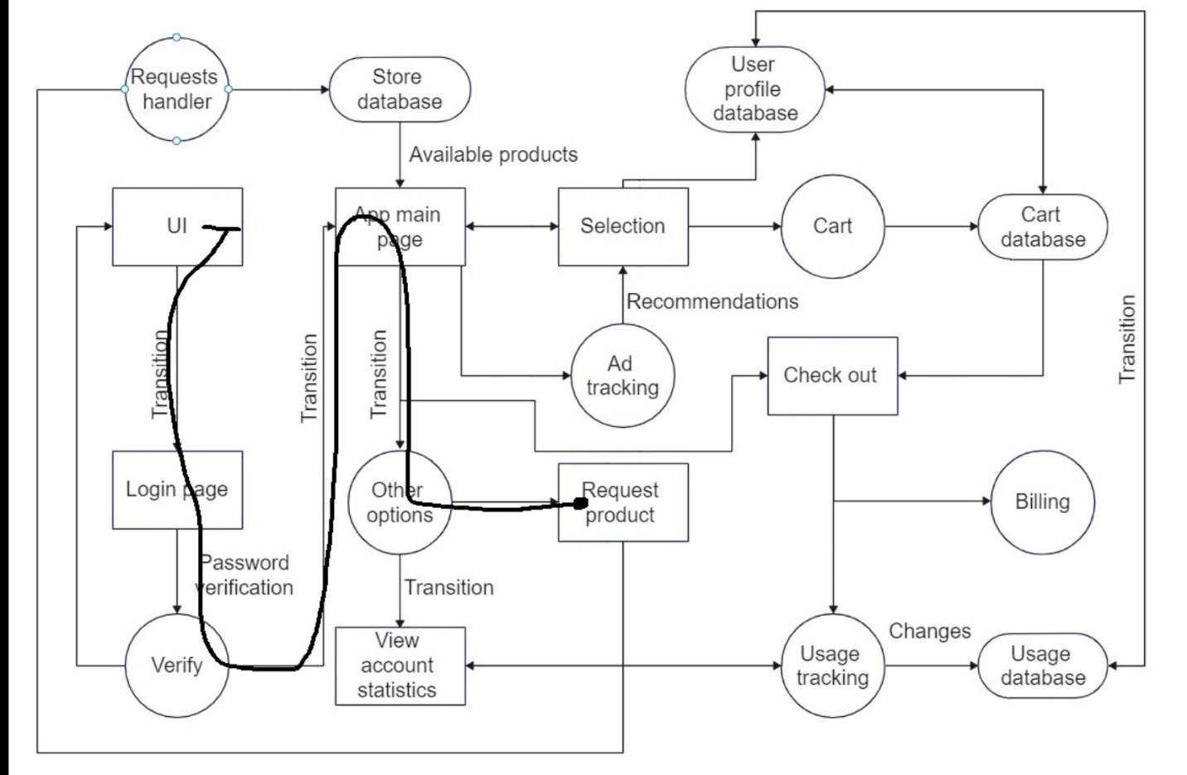

# Requirements Table

|  |  |  |  |
| --- | --- | --- | --- |
|  | Requirements | Use case | Actor |
|  | The System shall ask the user to scan the code in the store’s system and will shut down on its own once the user is away from the store’s vicinity. | Validate customer login |  |
|  | System shall connect the customer with the store system if the user bank account is not active and will automatically take minimal currency from the bank account to check the authenticity of the bank account.. | Validate customer login |  |
|  | System shall decline the entry of the user if the transaction is not successful or not validated from the bank. | Payment verification |  |
|  | System shall not allow entry if the number of people in the store has reached its capacity otherwise it will allow the entry of the user. | Validate customer login |  |
|  | System shall record the data of the user using the sensors and camera placed in the store. | load/update database |  |
|  | System shall track the movement of the user and store it in its database. | load/update database |  |
|  | System shall store the record of the user likes and dislike through sensors. | load/update database |  |
|  | System shall store the information of the user in its database and give recommendation to user based on that data. | load/update database |  |
|  | System shall track the movement of the user in the store. | load/update database |  |
|  | System can sell the collected data to suppliers and manufacturers to let them know about the demands | load/update database |  |
|  | System shall track all the products picked up by the user in the store. | Manage cart |  |
|  | System shall allow the user to view the cart through the app. | Manage Cart |  |
|  | System shall delete and remove all the product from the cart that the user has put back on the shelf. | Manage Cart |  |
|  | System shall update the product status and notify the services provider if there is a need for restocking and refilling of shelves. | Manage product status |  |
|  | System shall provide all the coupons the user has on his/her mobile phone. | Manage coupons |  |
|  | System shall allow the service provider to add all the coupons for the user. | Manage coupons |  |
|  | System shall reward loyal customers with personalized coupons. | Manage coupons |  |
|  | System shall send notification to user if any coupon is nearing its expiring date. | User notification |  |
|  | System shall give recommendation to user history of purchase. | View recommendations |  |
|  | System shall notify the user if there are any sale or offer that the user might like. | View recommendations |  |
|  | The system shall contact authorities if a serious violation of regulatory rules is made | User notification |  |
|  | System shall implement profile-based learning so it can give a unique experience to each user | Manage customer profiles |  |
|  | System shall allow multiple entries on one profile | Manage customer profiles |  |
|  | System can learn the user preferences | Manage customer profiles |  |
|  | System shall bill the products in cart as the user leaves the vicinity of the store. | Billing |  |
|  | System shall provide the user with the option to view their purchase history on the app. | View history |  |
|  | System shall process the cart and validate purchase once the user leaves the vicinity of the store | Make purchase |  |
|  | System shall verify the validity of a coupon once a user tries to redeem it | Coupon verification |  |
|  | System shall update the availability of a product for the user to view, once it runs out of stock | Manage product availability |  |

# Use Case Models

## Profiling of user

|  |  |
| --- | --- |
| Use case name | Profiling of user |
| Primary Actor | Customer |
| Stakeholders & interest | Store Management: Provide new coupons to the user according to their likes and dislike. |
| Precondition | Validation of the user |
| Post condition | Recommendation and coupons of products are created for the user |
| Main success scenario | |  |  | | --- | --- | | Step no. | Action | | 1 | The use case starts after the user is validated and registered into the system. | | 2 | Each time the user adds and discard a product the data of the user is stored into the system. | | 3 | The preference of the user will be tracked through the sensors and updated into the system. | | 4 | The likes and dislikes of the user on basis of which shelves and sections of product they go to are collected of each user individually. | |

## Update the product status

|  |  |
| --- | --- |
| Use case name | Update the product status |
| Primary Actor | Customer |
| Stakeholders & interest | Store Management system: The staff is notified in case of shortage of a product |
| Precondition | The product has either been picked or placed back on the shelf by the user |
| Post condition | The number of products in the database will be updated  Notification will be issued to Store management if there is no specified product left |
| Main success scenario | |  |  | | --- | --- | | Step no. | Action | | 1 | The use case starts after the user is validated and registered into the system. | | 2 | As product is being picked by the user or placed back on the shelve again the number of total products on shelf will increase or decrease accordingly. | |

## Manage product in cart

|  |  |
| --- | --- |
| Use case name | Manage product in cart |
| Primary Actor | Customer |
| Stakeholders & interest | Bill: All the items included into the cart are calculated |
| Precondition | The user is validated at the entrance  The user shall pick items from the shelves |
| Post condition | The bill is calculated on the app  The bill is accessible to the customer through the app |
| Main success scenario | |  |  | | --- | --- | | Step no. | Action | | 1 | The user is validated or registered into the app by the system. | | 2 | Every item is automatically updated into the cart as customer take item off the shelves. | | 3 | Items placed back on the shelves will be removed from the cart | |
| Extensions | The user is not authenticated, the system will notify the store employee and no bill will be calculated |

## Validate payment method

|  |  |
| --- | --- |
| Use case name | Validate payment method |
| Primary Actor | Customer |
| Stakeholders & interest | Bank: The bank will validate the transaction of the customer |
| Precondition | The system will match the use info with the account created for shopping and allow customer to make transaction |
| Post condition | The customer will be able to enter the shop and do shopping |
| Main success scenario | |  |  | | --- | --- | | Step no. | Action | | 1 | The system will transact $1 to check the account’s activity | | 2 | If the account is active and transaction is successful, then the user will be considered as valid | | 3 | Valid customer will be allowed to do shopping | |
| Extensions | If he system is unable to transact money then the customer will be considered invalid and will not be allowed to enter the shop or do shopping |

## Validate customer login

|  |  |
| --- | --- |
| Use case name | Validate customer login |
| Primary Actor | Customer |
| Stakeholders & interest | System |
| Precondition | The system will match the use info with the account created for shopping and count the entered customers |
| Post condition | Only limited number of customers can enter the shop |
| Main success scenario | |  |  | | --- | --- | | Step no. | Action | | 1 | When a person will enter the system will read his information | | 2 | The system will match the customer information with the created account | | 3 | If the information is valid then the customer will be allowed to shopping | | 4 | the system will also count the entered customers | |
| Extensions | If the system does not count the people and people entering the shote rises above the store’s capacity then the system might get overloaded. Thus , then the store  will not allow further entries. |

## Manage coupon

|  |  |
| --- | --- |
| Use case name | Manage coupon |
| Primary Actor | Customer |
| Stakeholders & interest | System: it will validate the coupons for use of the user |
| Precondition | The cart is updated  Product that coupon is valid for is added into the cart |
| Post condition | The coupon is validated for its authenticity |
| Main success scenario | |  |  | | --- | --- | | Step no. | Action | | 1 | The user is validated | | 2 | The user adds product into the cart | | 3 | The user can claim the coupon by going into coupon and vouchers on the app | |
| Extensions | The coupon is expired, in that case the coupon cannot be claimed and used. |

# Use Case Diagram

# Sequence Diagrams

## Profiling of user

## Update the product status

## Manage product in cart

## Validate payment method

## Validate customer login

## Manage coupon

# System Sequence Diagrams

## Profiling of user

## Update the product status

## Manage product in cart

## Validate payment method

## Validate customer login

## Manage coupon

# Operational Contracts (SSD)

## Profiling of user

|  |
| --- |
| System |
| addProduct(Name, Price)  UpdateInformation(Name, Price, Type)  removeProduct(Name, Price)  updateInformation(Name, Price, Type) |

## Update the product status

|  |
| --- |
| System |
| Enter_Information(password,username/id)  Add_to_Cart(product)  Remove_from_Cart(product) |

## Manage product in cart

|  |
| --- |
| System |
| validateUser(name, ID)  RegisterUser(name, Password)  AlertEmployee()  addProduct(Name, Price)  removeProduct(Name, Price)  AlertEmployee(Name, Price) |

## Validate payment method

## Validate customer login

|  |
| --- |
| System |
| Enter_Information(password,username/id)  Add_Customer(count) |

## Manage coupon

# Activity Diagrams

## Validate customer login

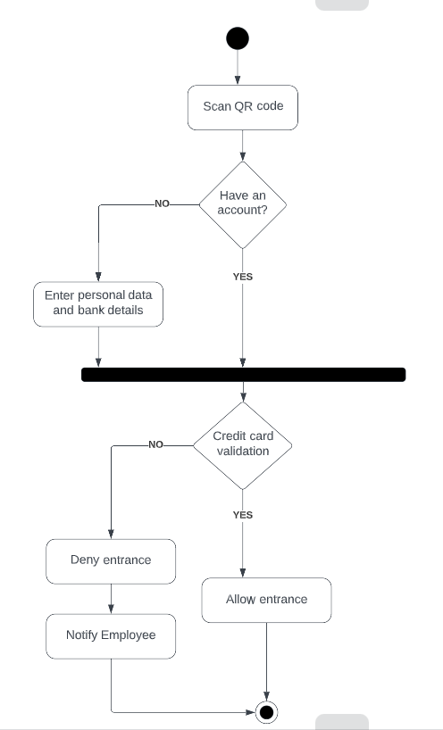

## Profiling of user

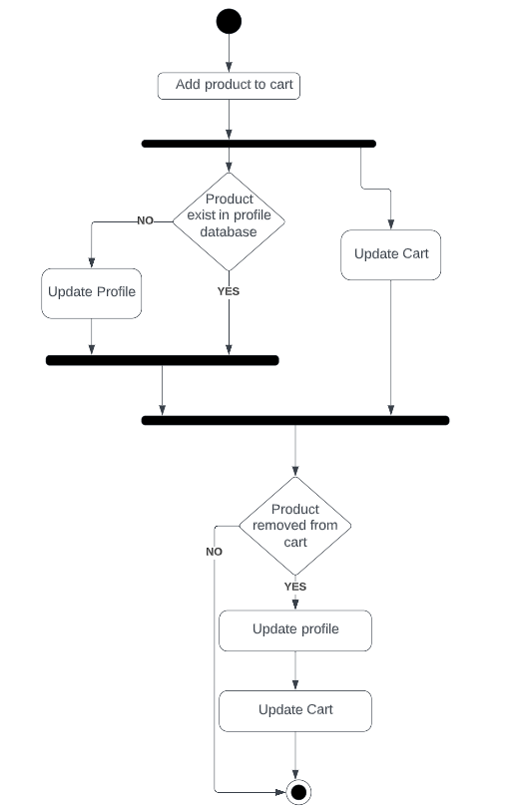

## Manage product in cart

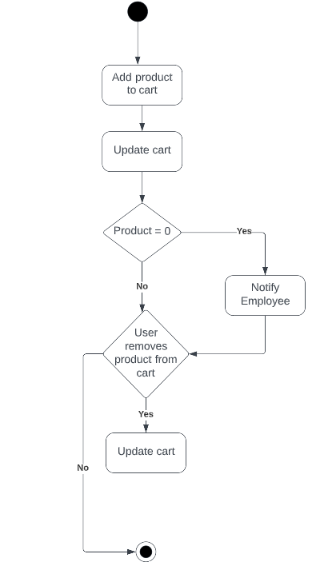

# State Machine Diagrams

## Validate customer login

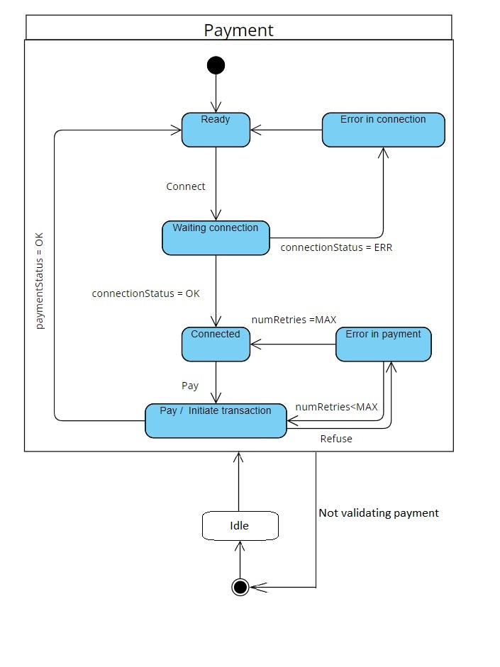

## Profiling of user

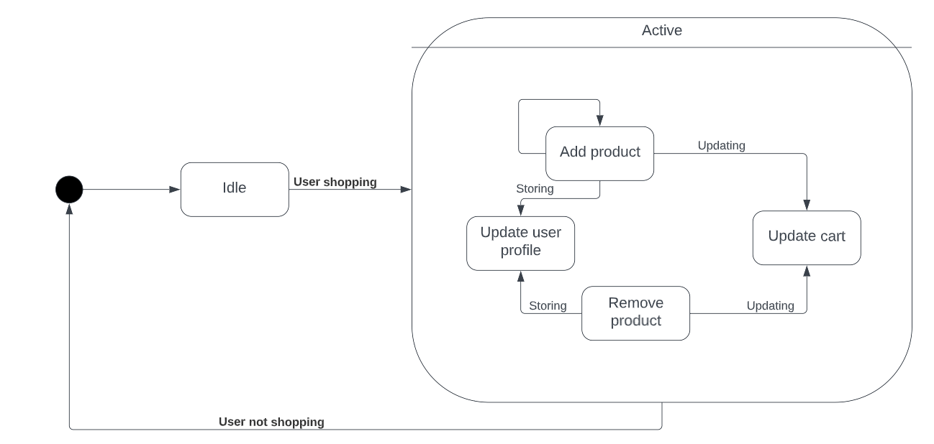

## Manage product in cart

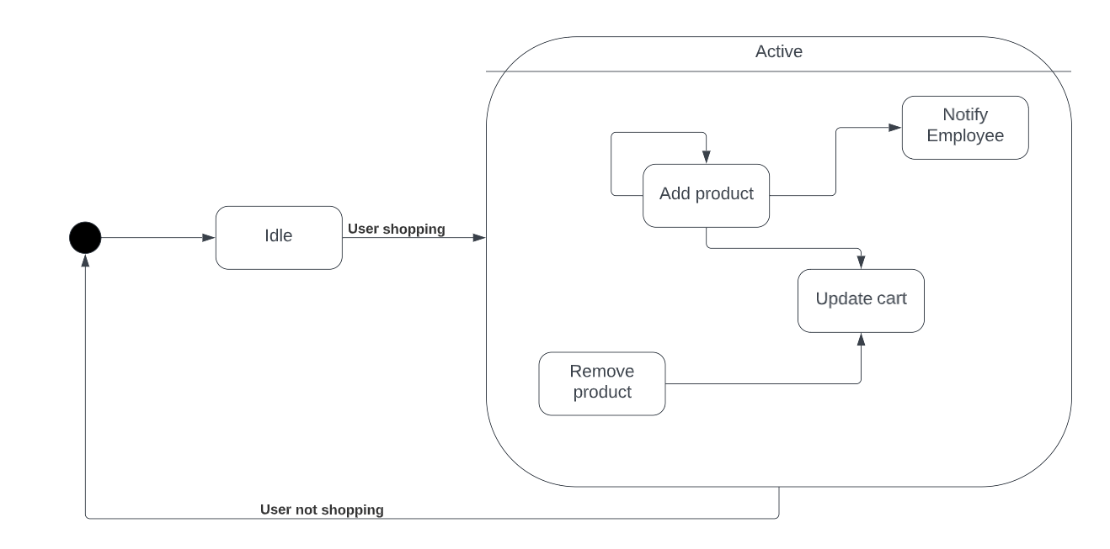

# Domain Model

# Component Diagram

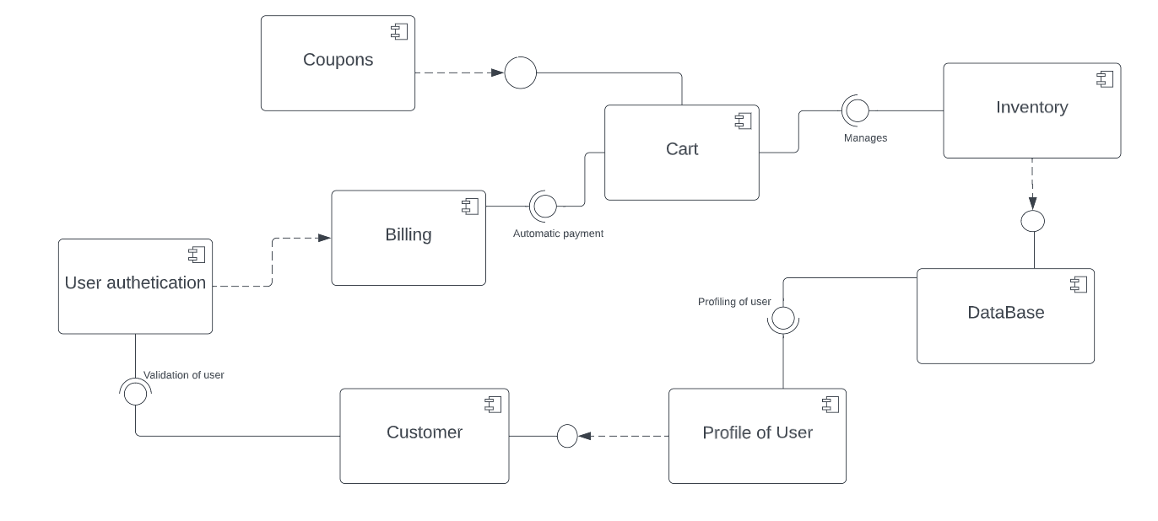

# Deployment Diagram

