Laiba Khan

DHC-81

Security Assessment Report - Week 1

1. Application Tested
Application Name: OWASP Juice Shop
URL: http://localhost:3000

2. Tools Used
- OWASP ZAP
- Browser Developer Tools (F12)
- Manual testing (XSS & SQL Injection)

3. Testing Performed

3.1 Cross-Site Scripting (XSS)
Payload used: <script>alert('XSS')</script>
Result: Popup didn’t appear
Payload used: <img src=x onerror=alert(1)>
Result: Popup appeared
Conclusion: XSS vulnerability is present

3.2 SQL Injection
Payload used: admin' OR '1'='1
Result: Login success
Conclusion: SQL Injection vulnerability is present

3.3 Security Misconfigurations
Findings:
- Missing security headers detected in OWASP ZAP scan.
- Application may expose sensitive information through error messages.
- Input validation appears weak in some fields.
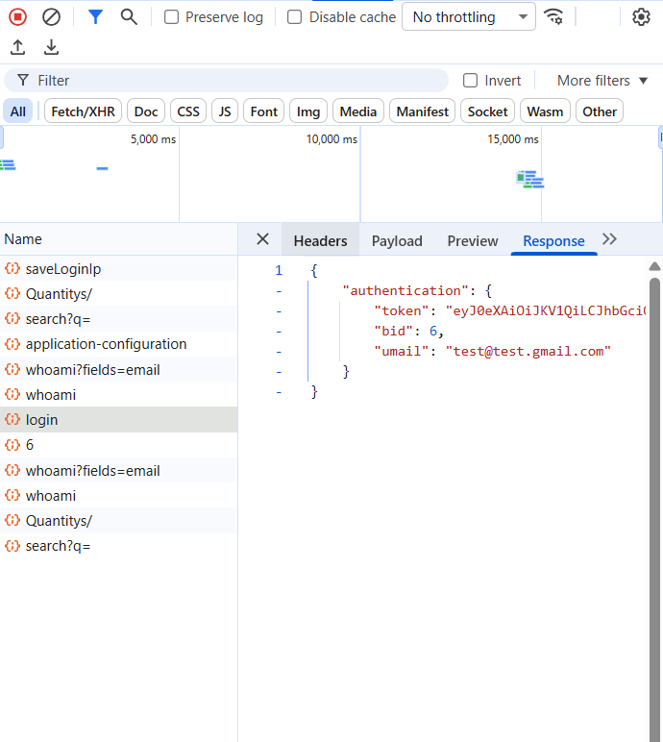
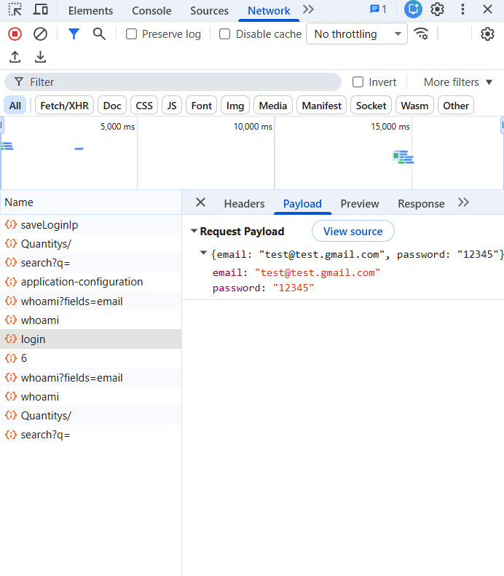

4. OWASP ZAP Findings
Summary of automated scan results:
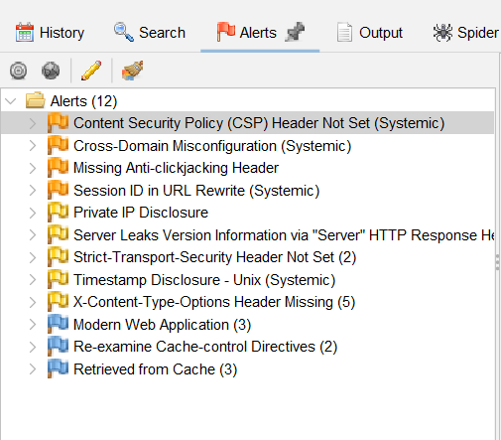

5. Areas of Improvement
- Sanitize all user inputs
- Use prepared statements for SQL queries
- Encode output to prevent XSS
- Implement security headers (CSP, HSTS)
- Hash passwords using bcrypt

6. Conclusion
Overall Security Level is low.
Main vulnerabilities found: XSS, SQL Injection, Misconfigurations

