
NAME: | LAIBA MALIK
SECTION: | BSSE-VB
ROLL NO: | FA24B1-SE-076
TITLE: | ASSIGNMENT#1
INSTRUCTOR: | SIR WAQAS SALEEM

TASK#1:
Install Gitea and Push a Repository from the Ubuntu Server:

SCREENSHOT#1: Install and Run Gitea on the Ubuntu Server
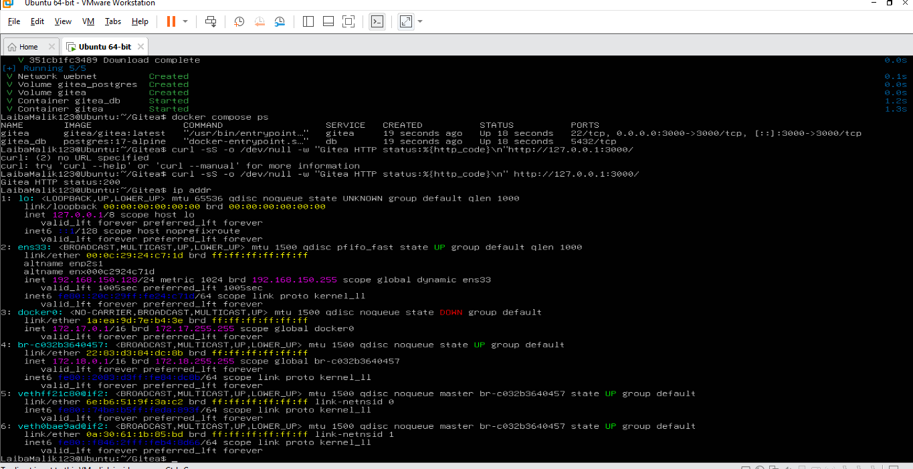

SCREENSHOT#2 Create and Push the Initial Repository
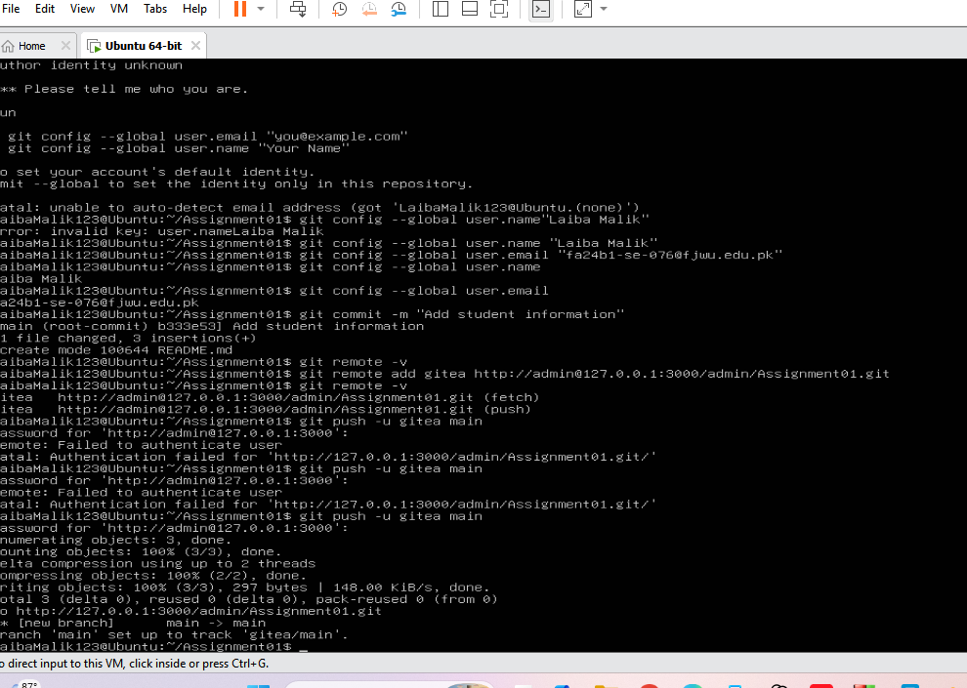

SCREENSHOT#3 Verify the Gitea Repository
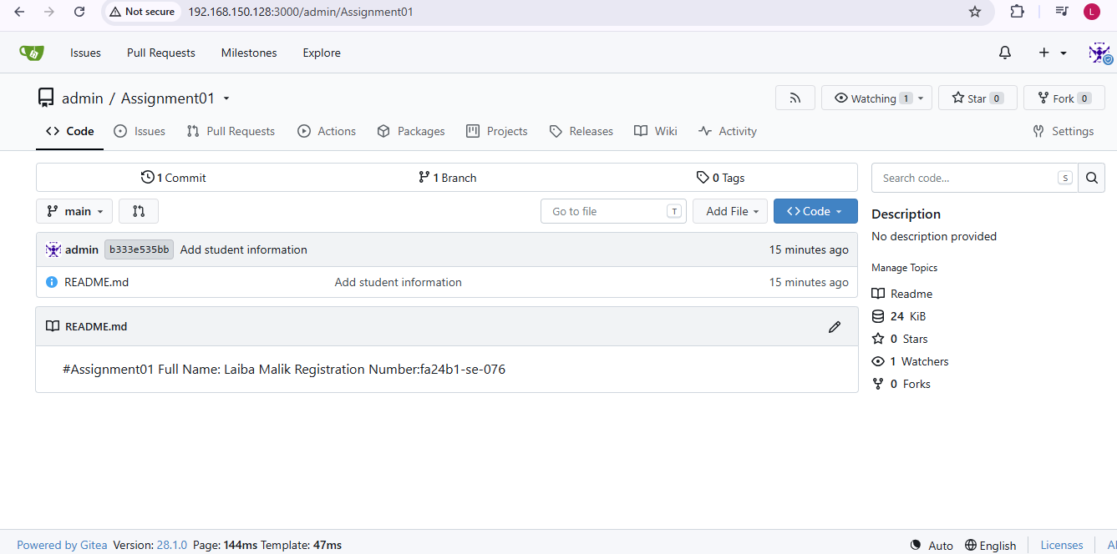

TASK#2:
Push the Same Repository to GitHub

SCREENSHOT#1 Create the GitHub Repository and Verify Both Remotes
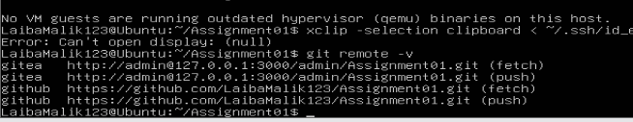

SCREENSHOT#2 Push to GitHub
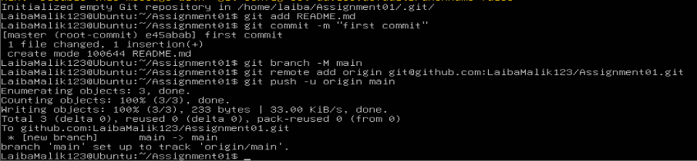

SCREENSHOT#3 Verify the GitHub Repository
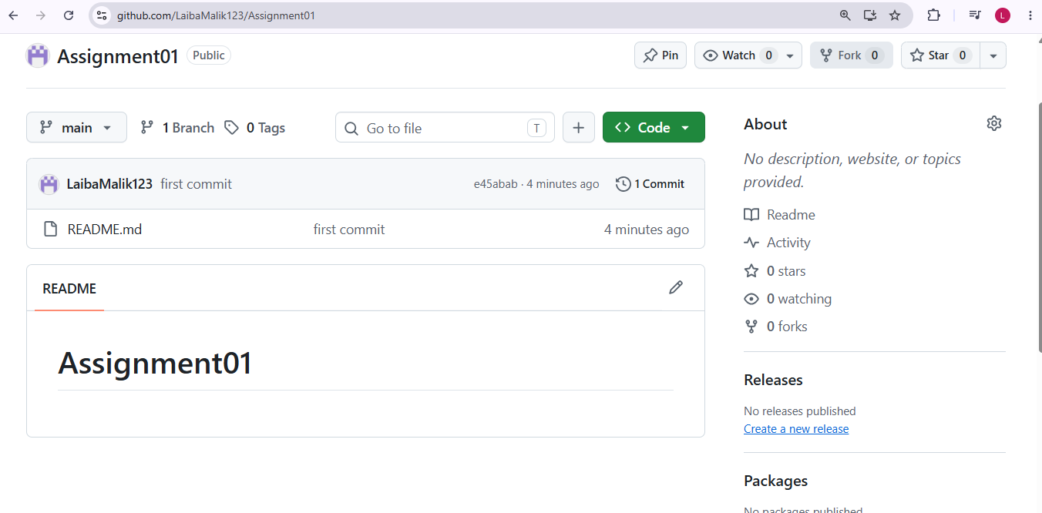

TASK#3:
Track Three Large Files with Git LFS

SCREENSHOT#1 Configure Git LFS
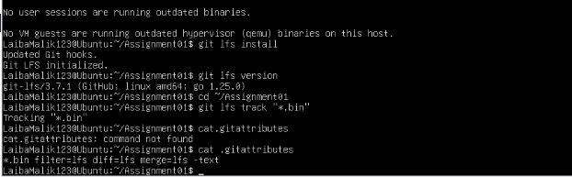

SCREENSHOT#2 Create and Verify Three LFS Files
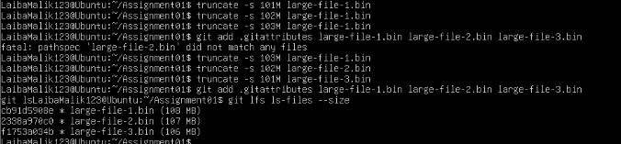

TASK#4:
Create a Portfolio or CV with GitHub Pages

SCREENSHOT#1 Create and Push the Portfolio Repository
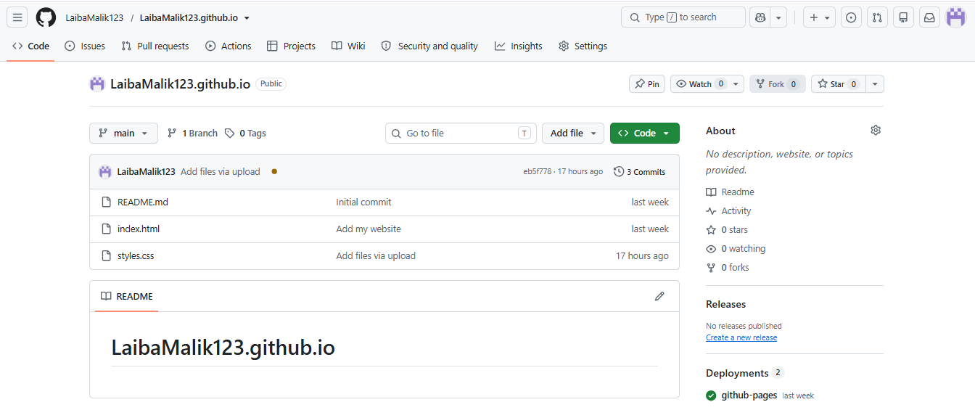

SCREENSHOT#2 Publish with GitHub Pages
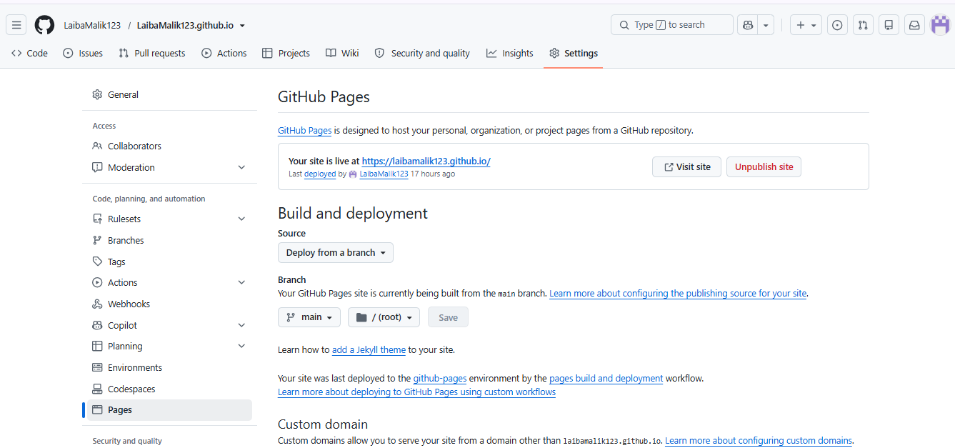

SCREENSHOT#3 Verify the Live Portfolio
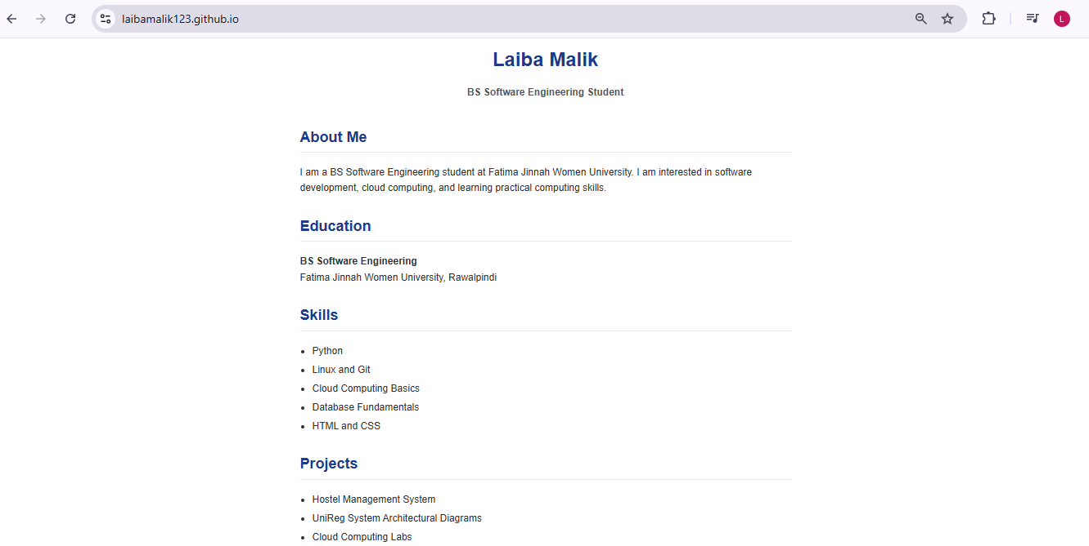

Conclusion
In summary, this lab offered comprehensive practical training on version control workflows and cloud deployment methods. By configuring Gitea and GitHub simultaneously, tracking large assets via Git LFS, and launching a personal portfolio website through GitHub Pages using HTML and CSS, all technical objectives of the assignment were successfully accomplished.

