

Configuration Manual: Human Activity Recognition using Deep Learning Approach

MSc Research Project Data Analytics

Laiba Rehman

Student ID: x20144032

School of Computing

National College of Ireland

Supervisor: Mohammed Hasanuzzaman

**National College of Ireland MSc Project Submission Sheet School of Computing**

|  |  |  |  |
| --- | --- | --- | --- |
| **Student Name:** | Laiba Rehman……………………………………………………………………… | | |
| **Student ID:** | X20144032………………………………………………………………………………..…… | | |
| **Programme:** | Data Analytics…………… | **Year:** | 2021-2022.. |
| **Module:** | M.Sc. Research Project…………………………………………………….……… | | |
| **Lecturer:** | ………………………………………………………………………………………………………….……… | | |
| **Submission Due Date:** | 31/01/2022…………………………………………………………………….……… | | |
| **Project Title:** | Human Activity Recognition using Deep Learning Approach….……… | | |
| **Word Count:** | 1057… **Page Count:** 19…………………….…….……… | |  |

I hereby certify that the information contained in this (my submission) is information pertaining to research I conducted for this project. All information other than my own contribution will be fully referenced and listed in the relevant bibliography section at the rear of the project.

ALL internet material must be referenced in the bibliography section. Students are required to use the Referencing Standard specified in the report template. To use other author's written or electronic work is illegal (plagiarism) and may result in disciplinary action.

|  |  |
| --- | --- |
| **Signature:** | Laiba……………………………………………………………………………… |
| **Date:** | 31/01/2022………………………………………………………………………………………… |

**PLEASE READ THE FOLLOWING INSTRUCTIONS AND CHECKLIST**

|  |  |
| --- | --- |
| Attach a completed copy of this sheet to each project (including multiple copies) | □ |
| **Attach a Moodle submission receipt of the online project**  **submission,** to each project (including multiple copies). | □ |
| **You must ensure that you retain a HARD COPY of the project**, both for your own reference and in case a project is lost or mislaid. It is not  sufficient to keep a copy on computer. | □ |

Assignments that are submitted to the Programme Coordinator Office must be placed into the assignment box located outside the office.

|  |  |
| --- | --- |
| **Office Use Only** | |
| Signature: |  |
| Date: |  |
| Penalty Applied (if applicable): |  |

Configuration Manual: Human Activity Recognition using a Deep Learning Approach

Laiba Rehman x20144032

# Introduction

The configuration manual provides an overview of the hardware, software, and programming required to complete the MSc Research Project "Human Activity Recognition Using a Deep Learning Approach." Additionally, it discusses the specifics of the needed libraries. The last portion of this document contains code and major output for all execution, results, and assessment procedures.

# Hardware Requirement

For environmental setup, an HP laptop with a 64-bit OS system is utilized.

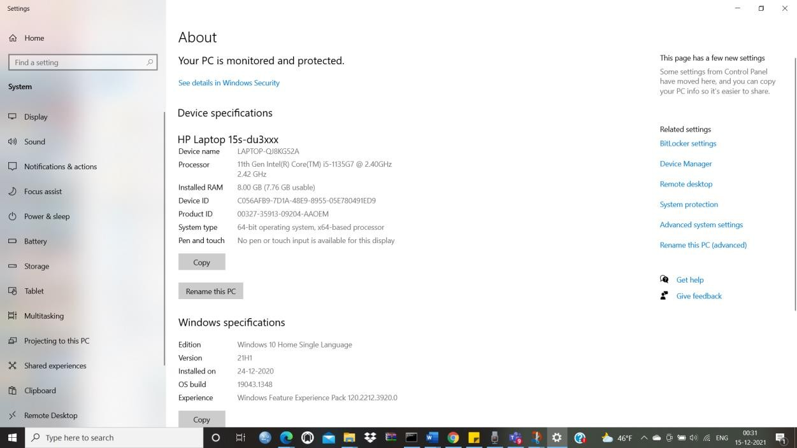

Fig 1 Device and Windows Specifications

The above-mentioned configuration is the one on which the scripts were executed, but the requirements were more than these. There were certain limitations that were observed during executing the models in the project. The limitations include high amount of time taken during training each model and different errors that are encountered during executing the hyper parameter tuning of the projects with the help of hyperas libraries.

This indicated us that the code should be updated in different period of time in order to support updated libraries and methods that reduce the issues that are encountered now. The training time can be reduced by executing all the models in a better hardware system that has at least 16 GB of RAM with high end processor and graphics.

# Software Requirements

Jupyter Notebook was used to write and run these scripts. Jupyter Notebook is an Integrated Development Environment (IDE) for writing Python scripts. Because the data was captured in a.csv file, we kept it on the system, as the jupyter notebook can access files and run applications directly on the system. To execute jupyter notebook, we must first open a command prompt in the same directory and then pre-install all the Python libraries and additional deep learning frameworks such as TensorFlow and Keras, as well as sklearn.

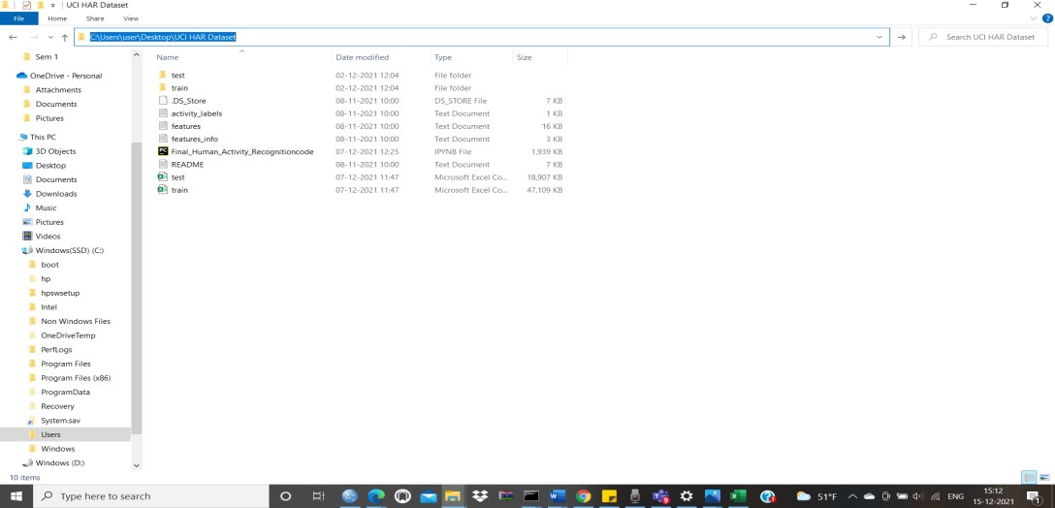

**Fig: Directory path**

The Figure below shows all the libraries imported in our code.

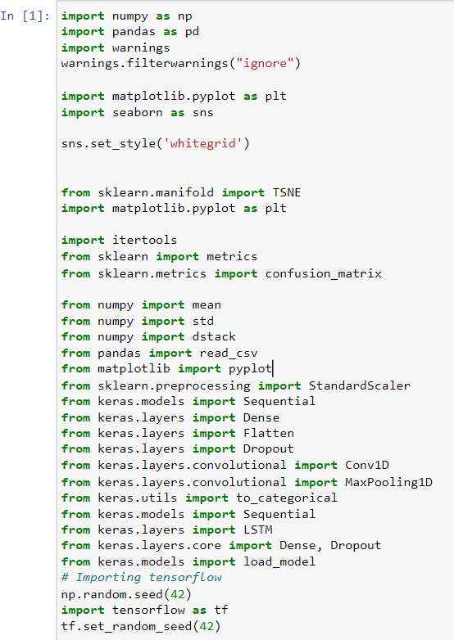

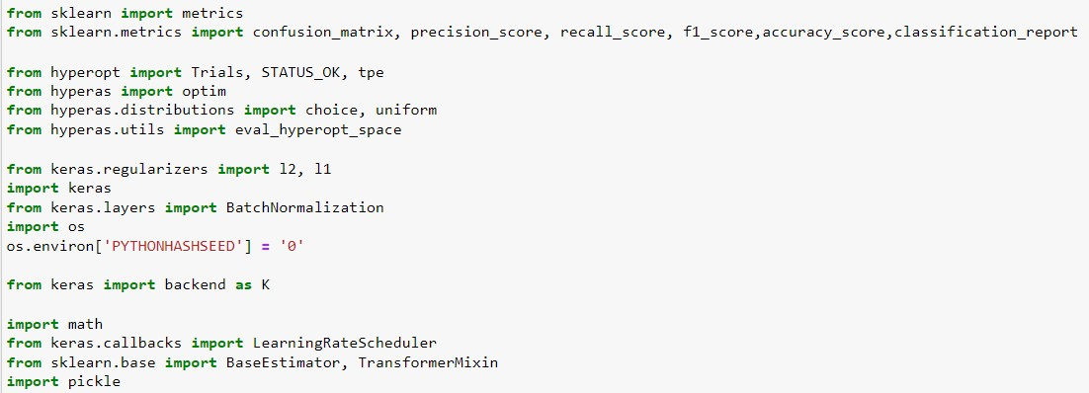



**Fig 2: Obtain the train data from the text files to pandas dataframe**



**Fig 3: Obtain the test data from the text files to pandas dataframe**

## Data Preprocessing

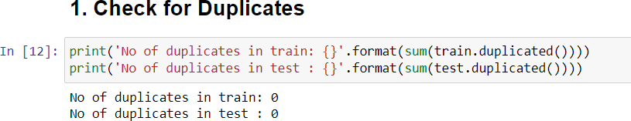

**Fig 4**

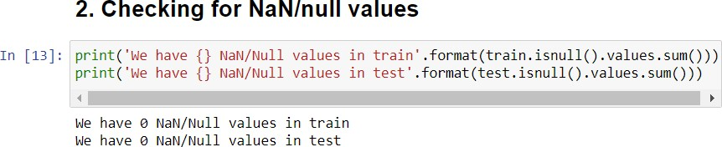

**Fig 5**

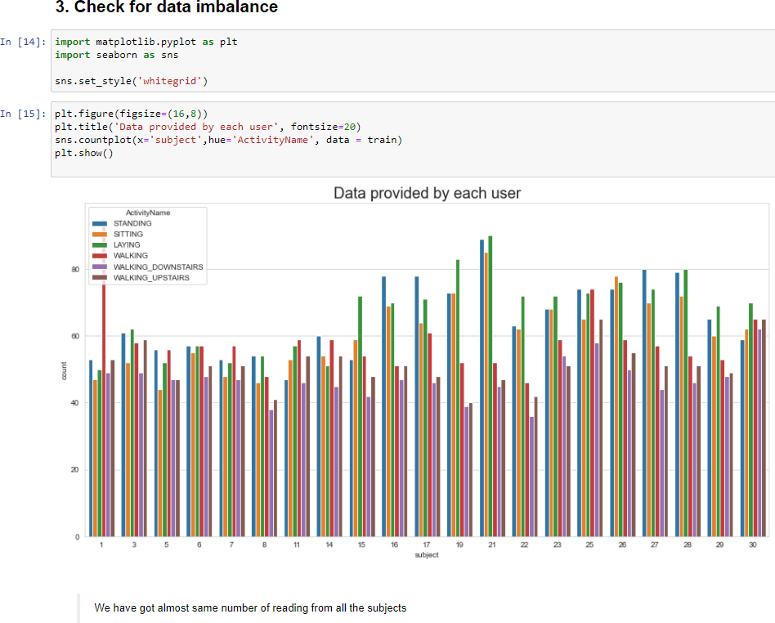

**Fig 6**

### Observation

The data was nearly balanced.

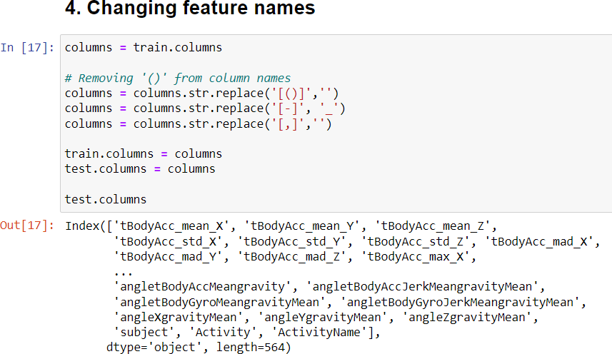

**Fig 7**

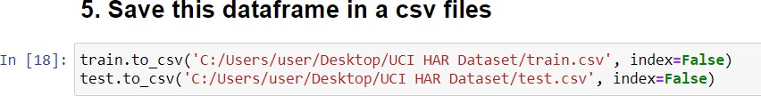

**Fig 8**

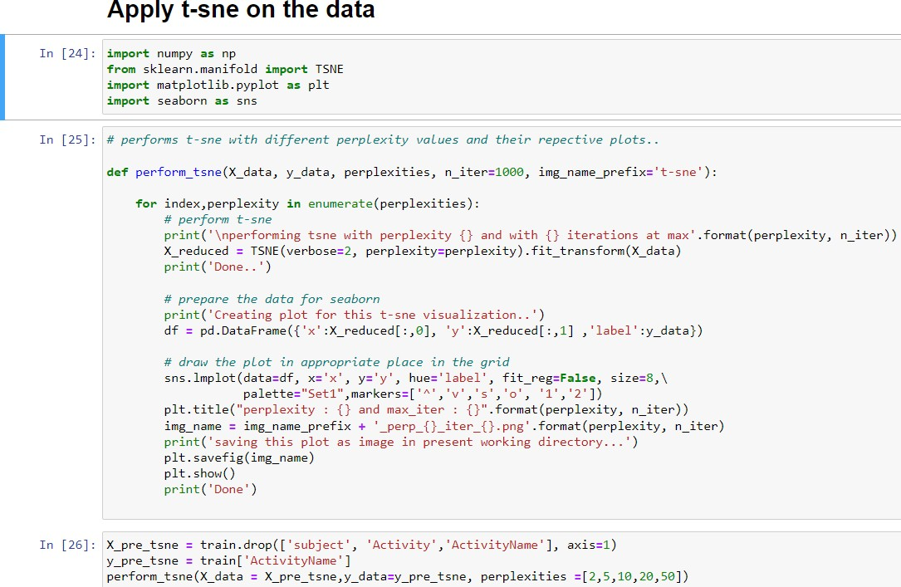

**Fig 9**

We have visualized all the activities with the help of the t-Distributed Stochastic Neighbour Embedding that will convert all the data from high dimensional to 2-dimensional space. We will use different perplexity values in order to separate the data in order to understand how distinct the classes are from each other. The results are shown in the report.

## Building Models

### LSTM

In LSTM model, we will build a single layer and multilayer LSTM model and also a model with regularization technique in order to see if there is an improvement in accuracy compared to the baseline model.

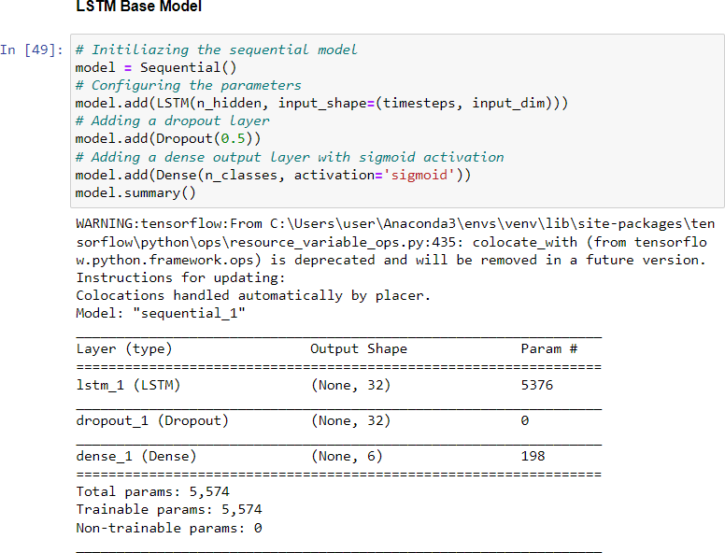

**Fig 10**

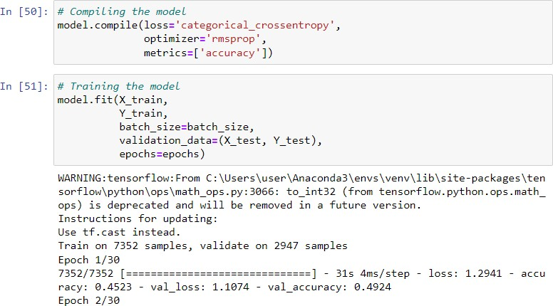

**Fig 11 Compiling and Training the model**

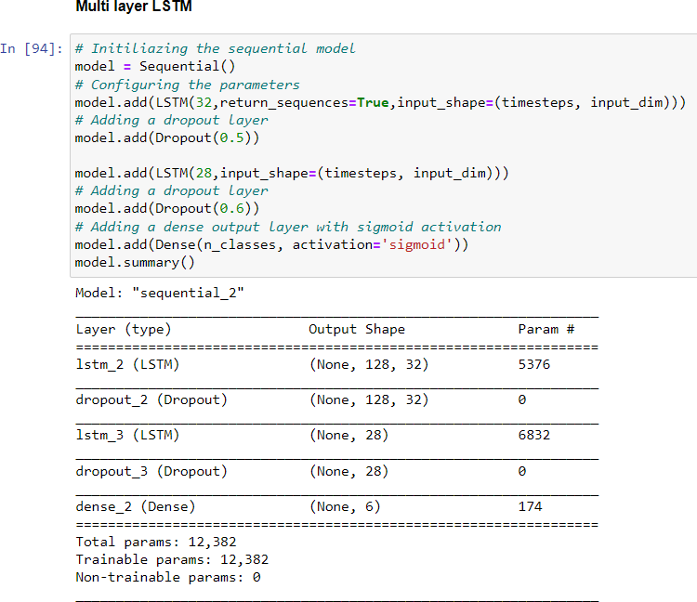

**Fig 12**

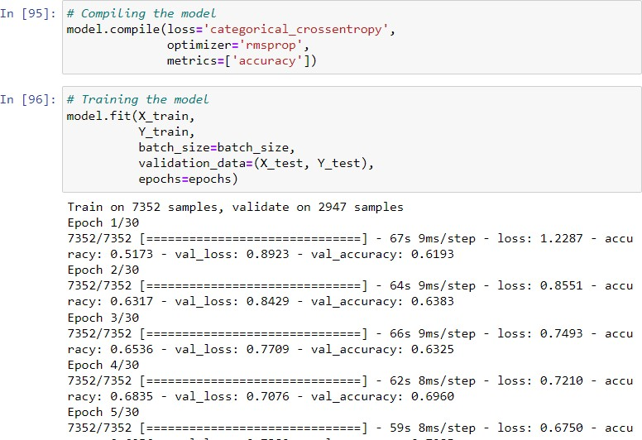

**Fig 13: Compiling and Training the model**

By making a comparison of above shown, 2 layer LSTM model is giving similar score as 1 layer LSTM model which we trained.

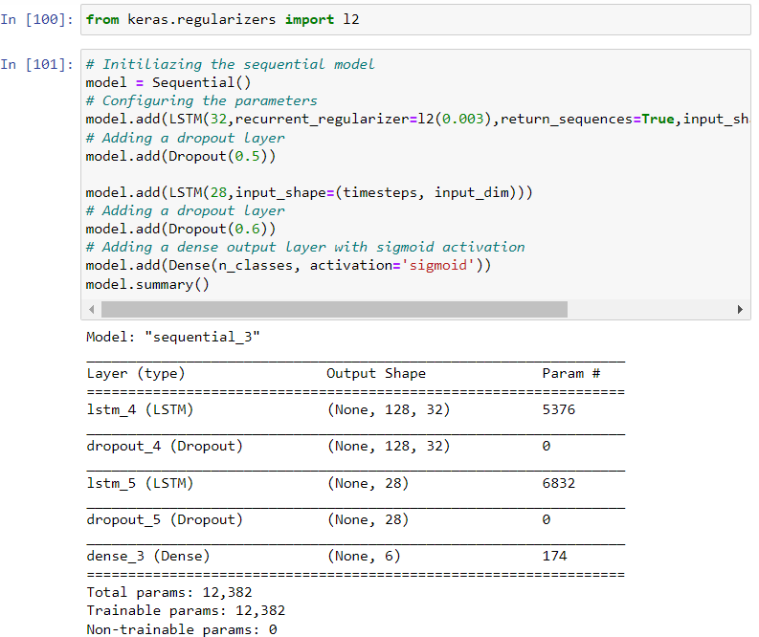

**Fig 14: LSTM model with regularization technique**

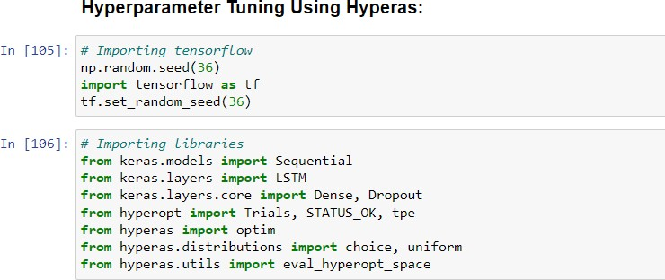

**Fig 15: Importing libraries of hyperas**

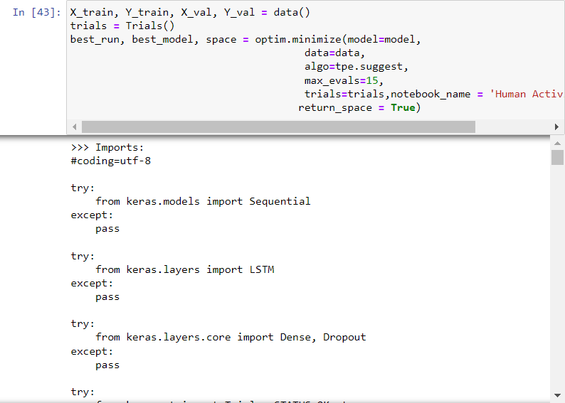

### Convolution Neural Network

**Fig 16**

In CNN model, we will build a baseline model and a model using L2 regularized parameter and compare the accuracy of the model.

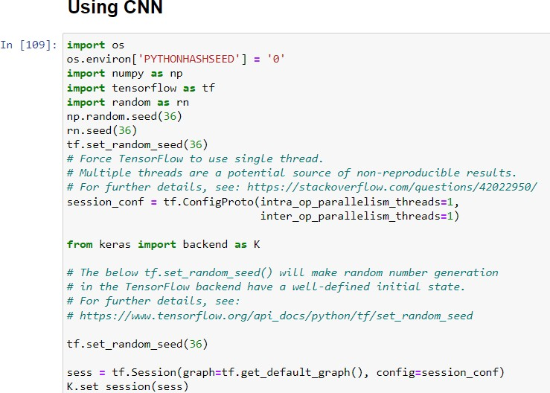

**Fig 17**

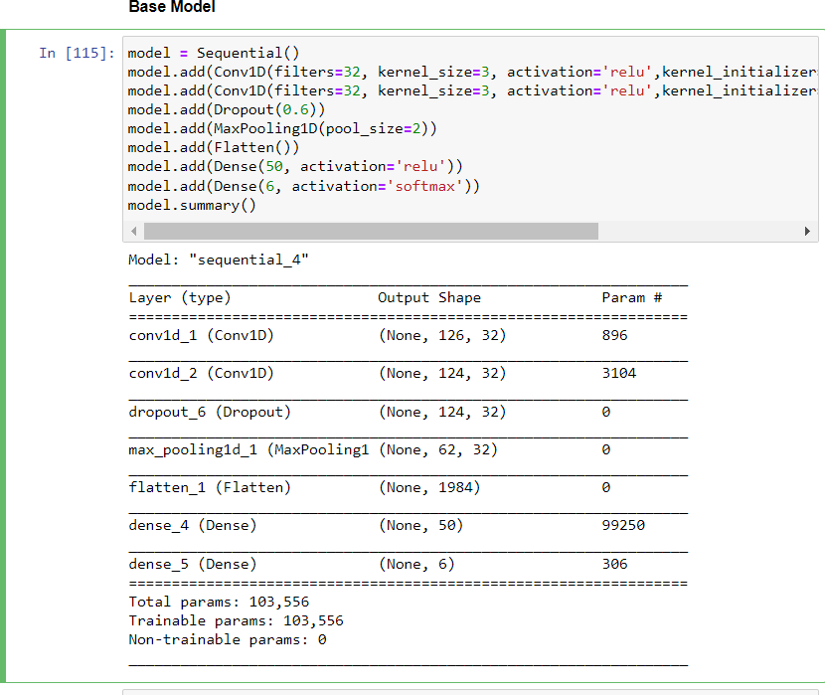

**Fig 18 CNN Base Model**

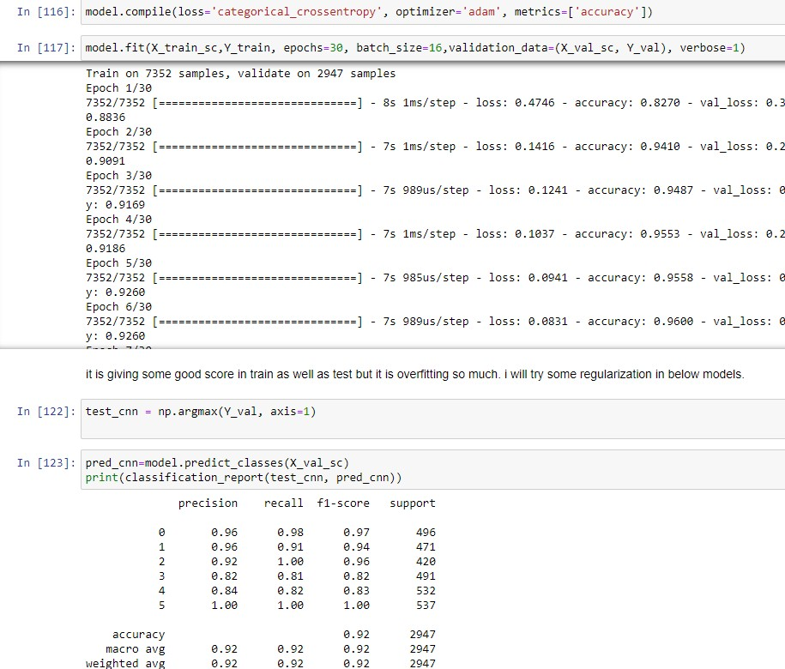

**Fig 19 Compiling and Training the model**

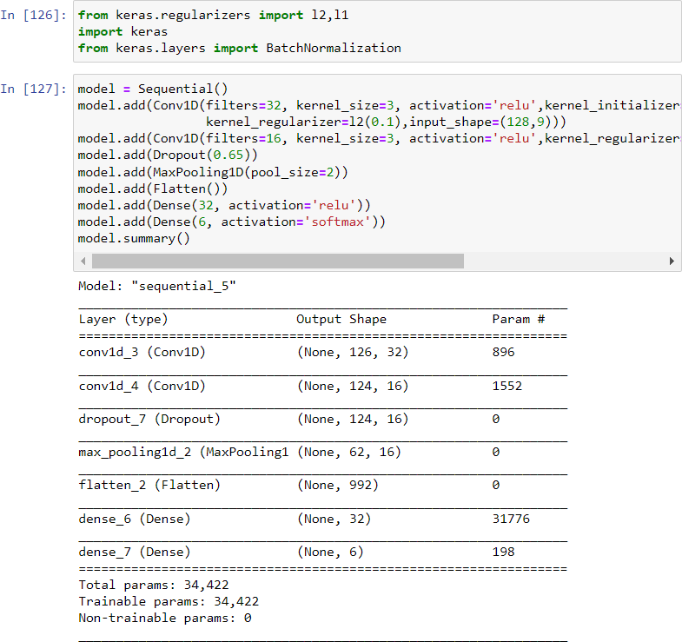

**Fig 20 CNN model with regularization technique**

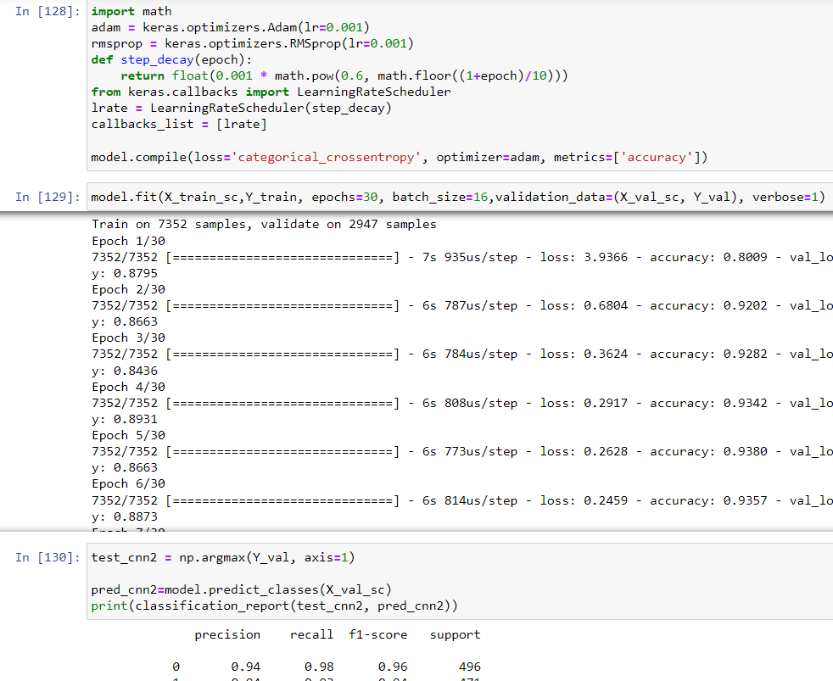

**Fig 21 Compiling and Training the model**

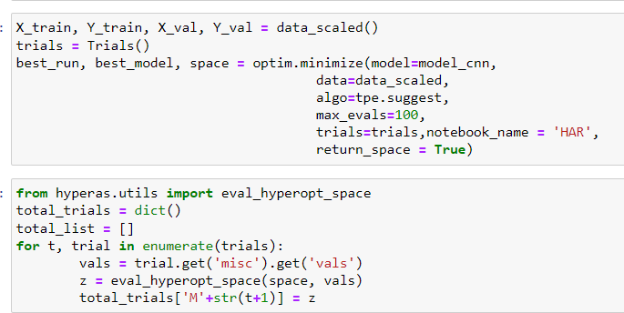

Fig 22 **Hyperparameter tuning using Hyperas on CNN model**

### Divide-And-Conquer based CNN model

In divide and conquer based approach we will build two models using three classes which will divide the model into Static and dynamic activities and build CNN model on each of them. We will also perform both base line and model with regularized parameter to see if there is an improving accuracy in both the models.

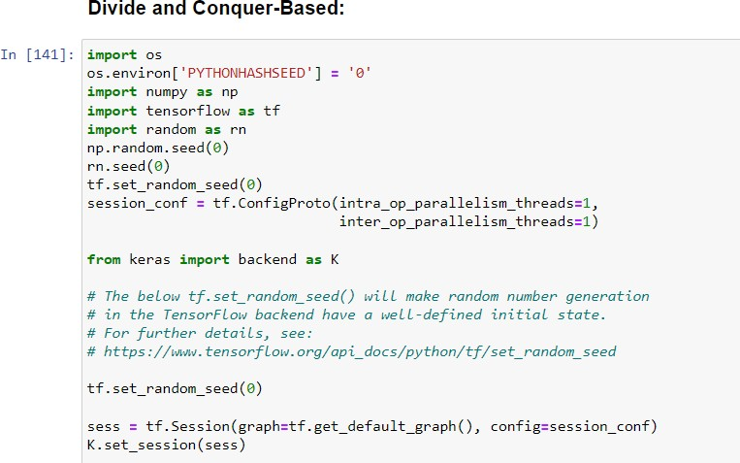

**Fig 23**

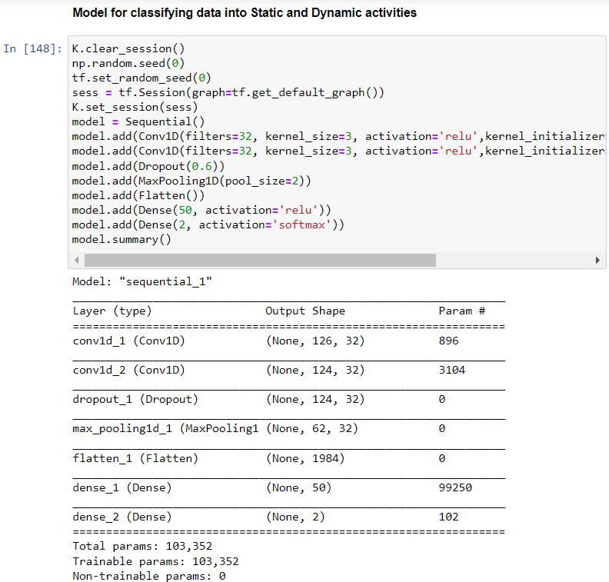

**Fig 24**

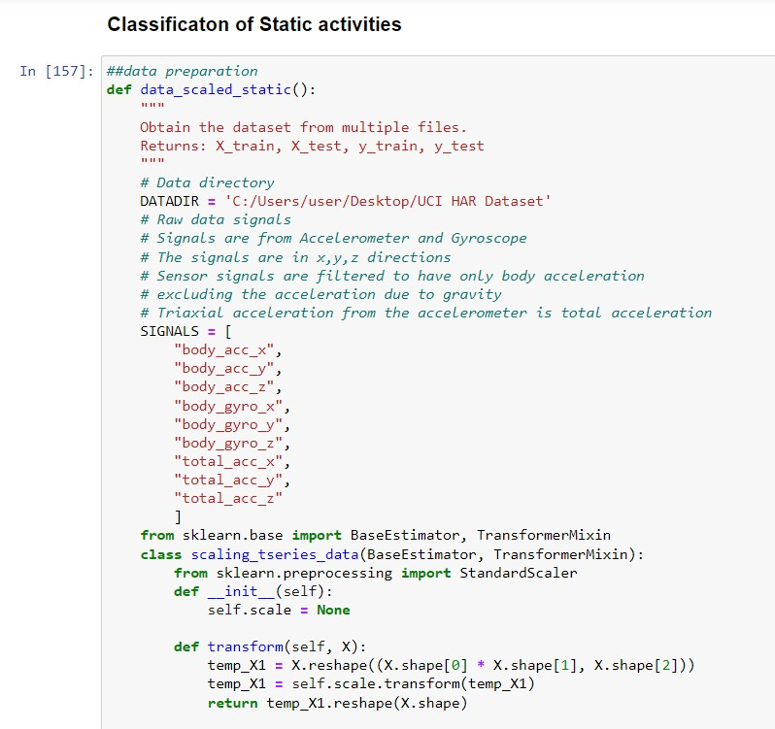

**Fig 25**

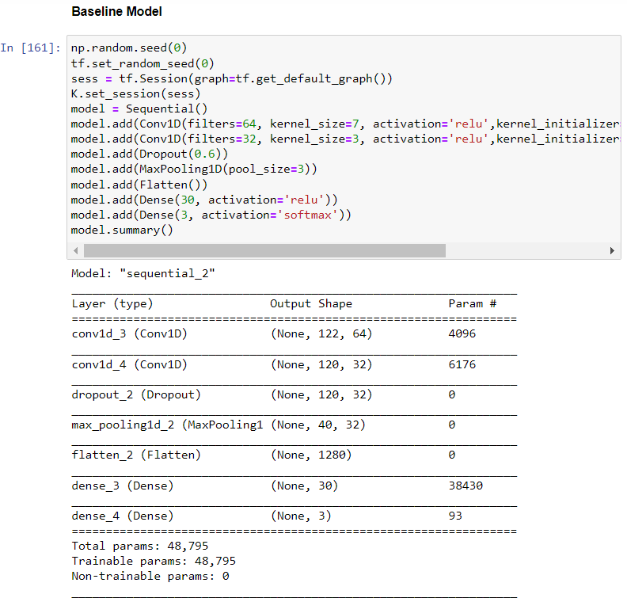

**Fig 26: Applying CNN model on Static Activities**

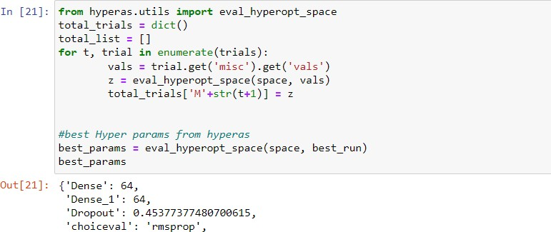

**Fig 27: Hyperparameter Tuning using Hyperas**

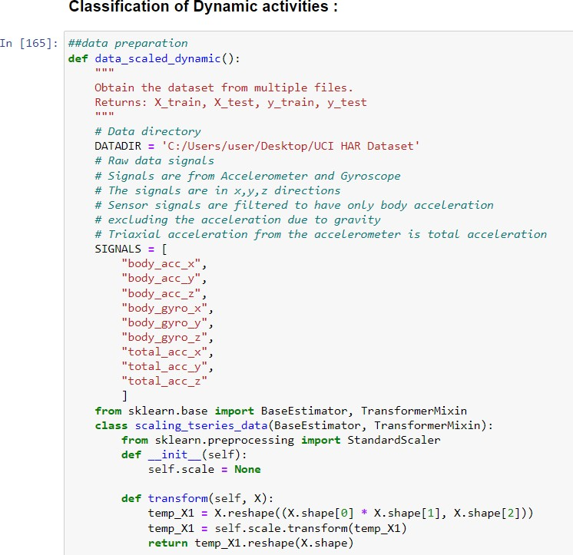

**Fig 28**

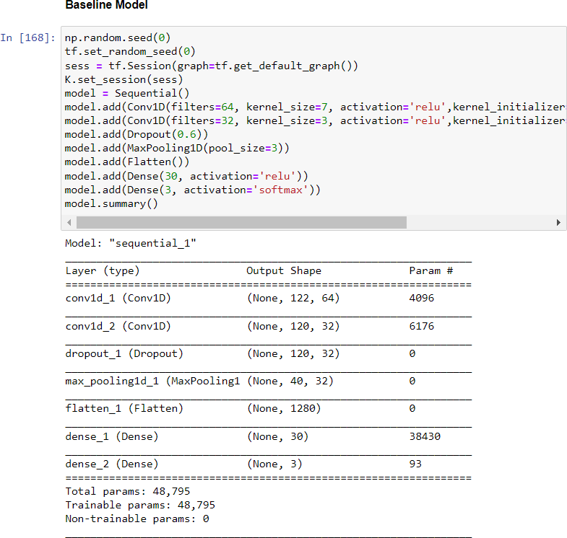

Fig 29 **Applying CNN model on Dynamic Activities**

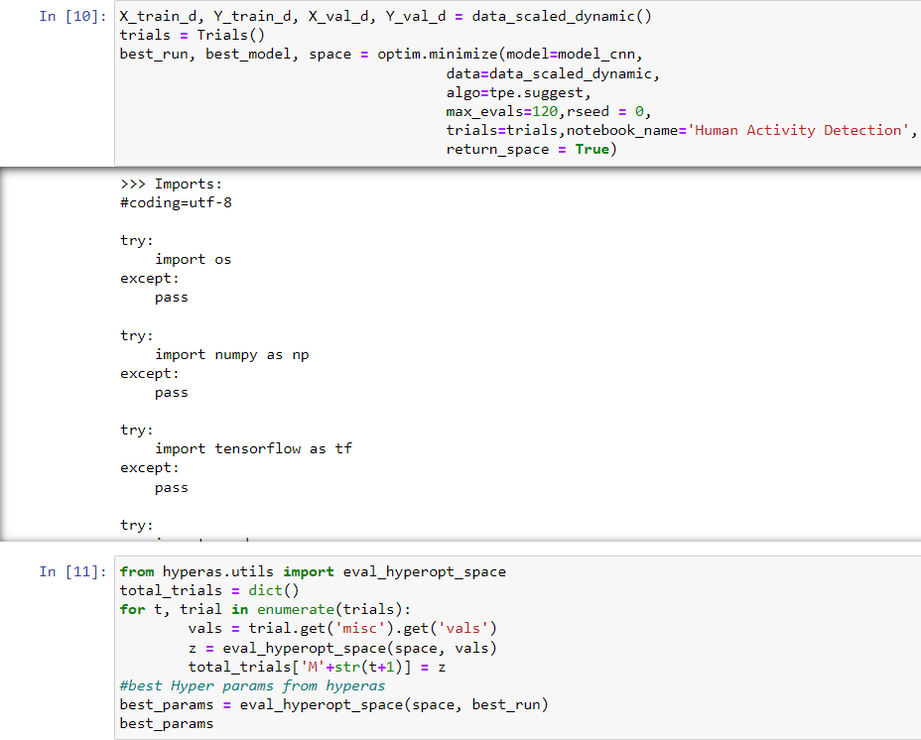

**Fig 30 Hyperparameter Tuning using Hyperas**

### Final Prediction

**Fig 31:**

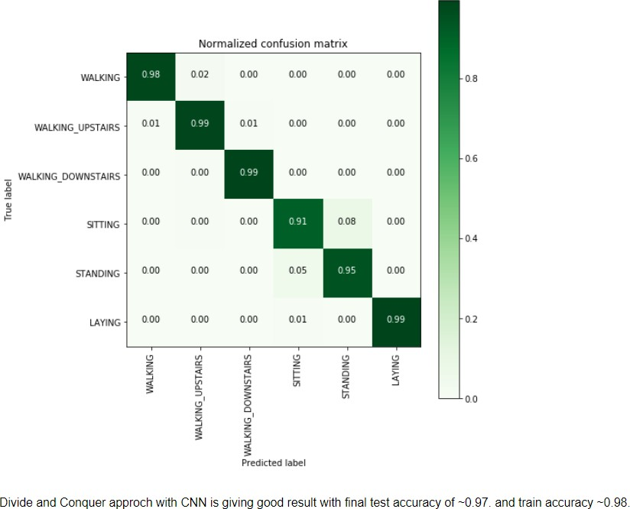

**Fig 32**

The Classification accuracies given by the CNN model on classifying both Static and dynamic activities are fitted into a final pipeline in order to give the combined accuracy in classifying all the 6 human activities. The combined CNN model after building different CNN models based on divide and conquer based approach are evaluated based on confusion Matrix where the final pipeline model is classified as both Static and dynamic activities in a single model.