

Assignment Title
Assignment 01: Git, Gitea, GitHub, Git LFS, and GitHub Pages
Student Name: Laiba Tariq
Registration No: 2024-BSE-85
Semester: Fifth
Subject: Cloud Computing (BSE-410)

DEPARTMENT OF SOFTWARE ENGINEERING
SESSION: 2024-2028

Task 1

Install Gitea and Push Repository from Ubuntu Server
1.1: Gitea Running Status:

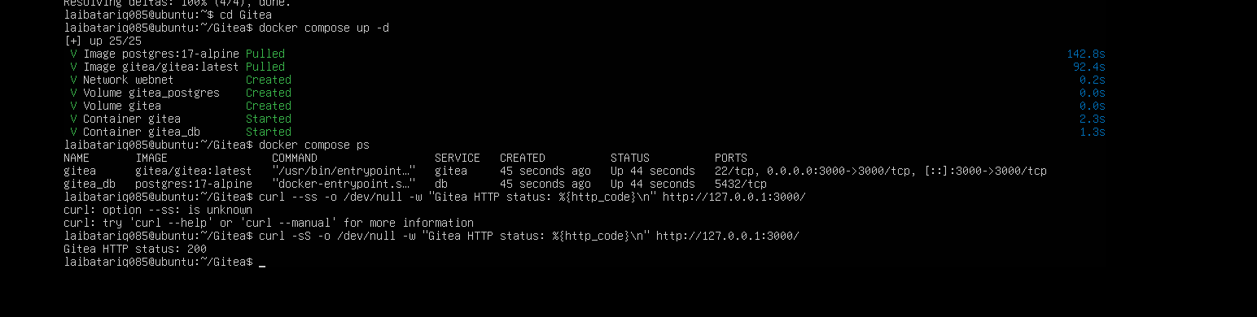
task1_gitea_running.png

1.2: Terminal Push to Gitea:

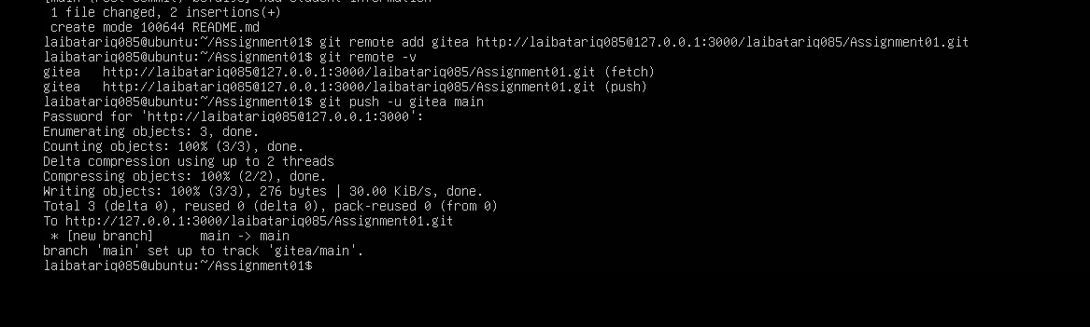
task1_gitea_push.png

1.3: Gitea Web Repository:
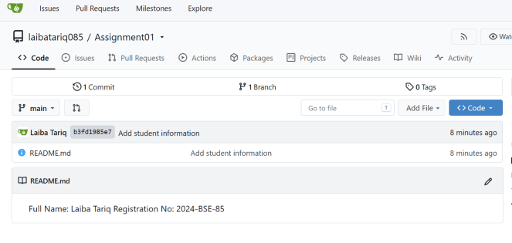
task1_gitea_repository.png
Task 2

GitHub Remote Configuration:
2.1: Verify Remotes:

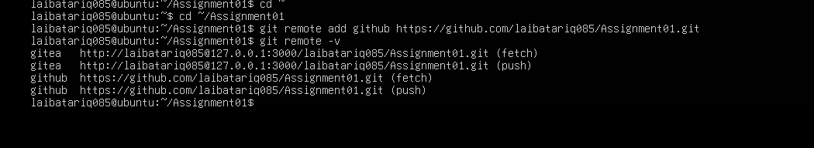
task2_remotes.png

2.2: Terminal Push to GitHub:

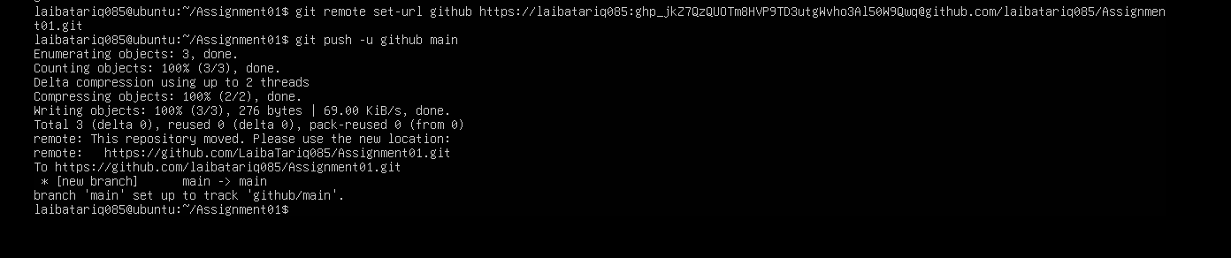

task2_github_push.png

2.3: GitHub Web Repository:

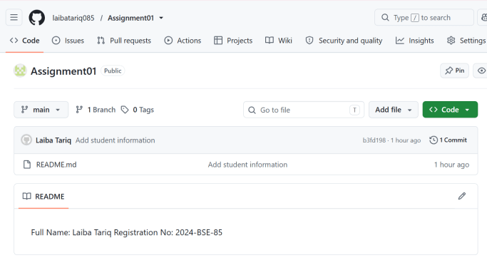
task2_github_repository.png

Task 3

Track Three Large Files with Git LFS
3.1: Git LFS Setup:

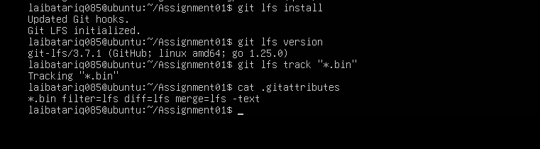
task3_lfs_setup.png

3.2: LFS Files Listing:

task3_lfs_files.png

3.3: Push LFS Files:
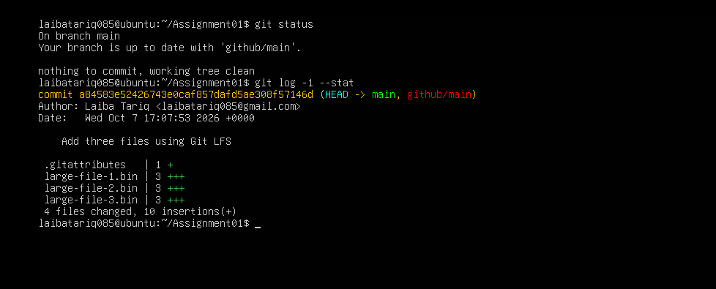

task3_lfs_push.png

Task 4

GitHub Pages Portfolio Setup
4.1: Portfolio Repository:

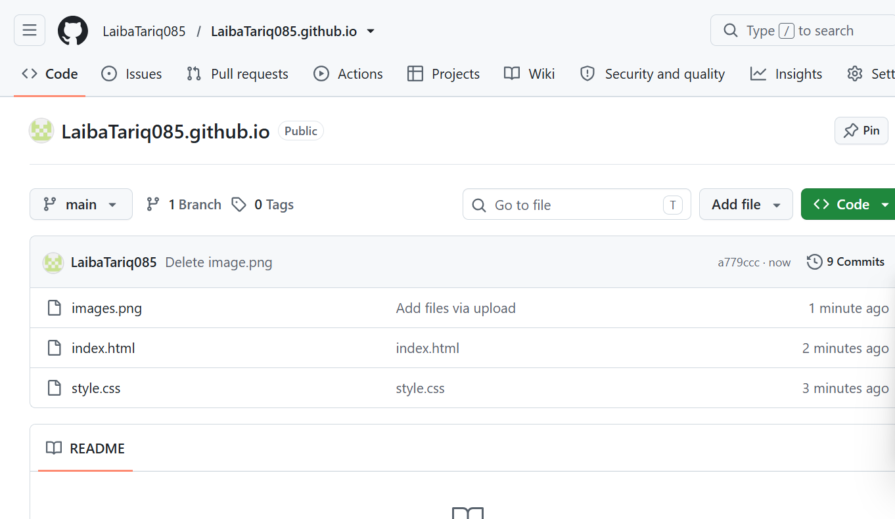
task4_pages_repository.png

4.2: GitHub Pages Settings:

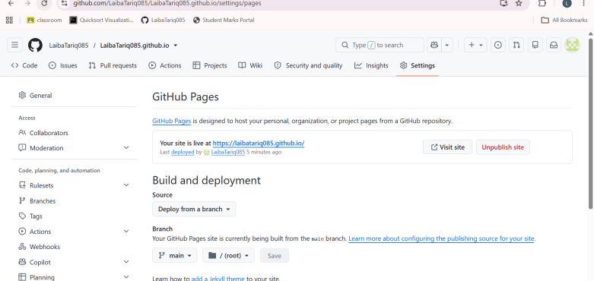
task4_pages_deployment.png

4.3: Live Portfolio Site:
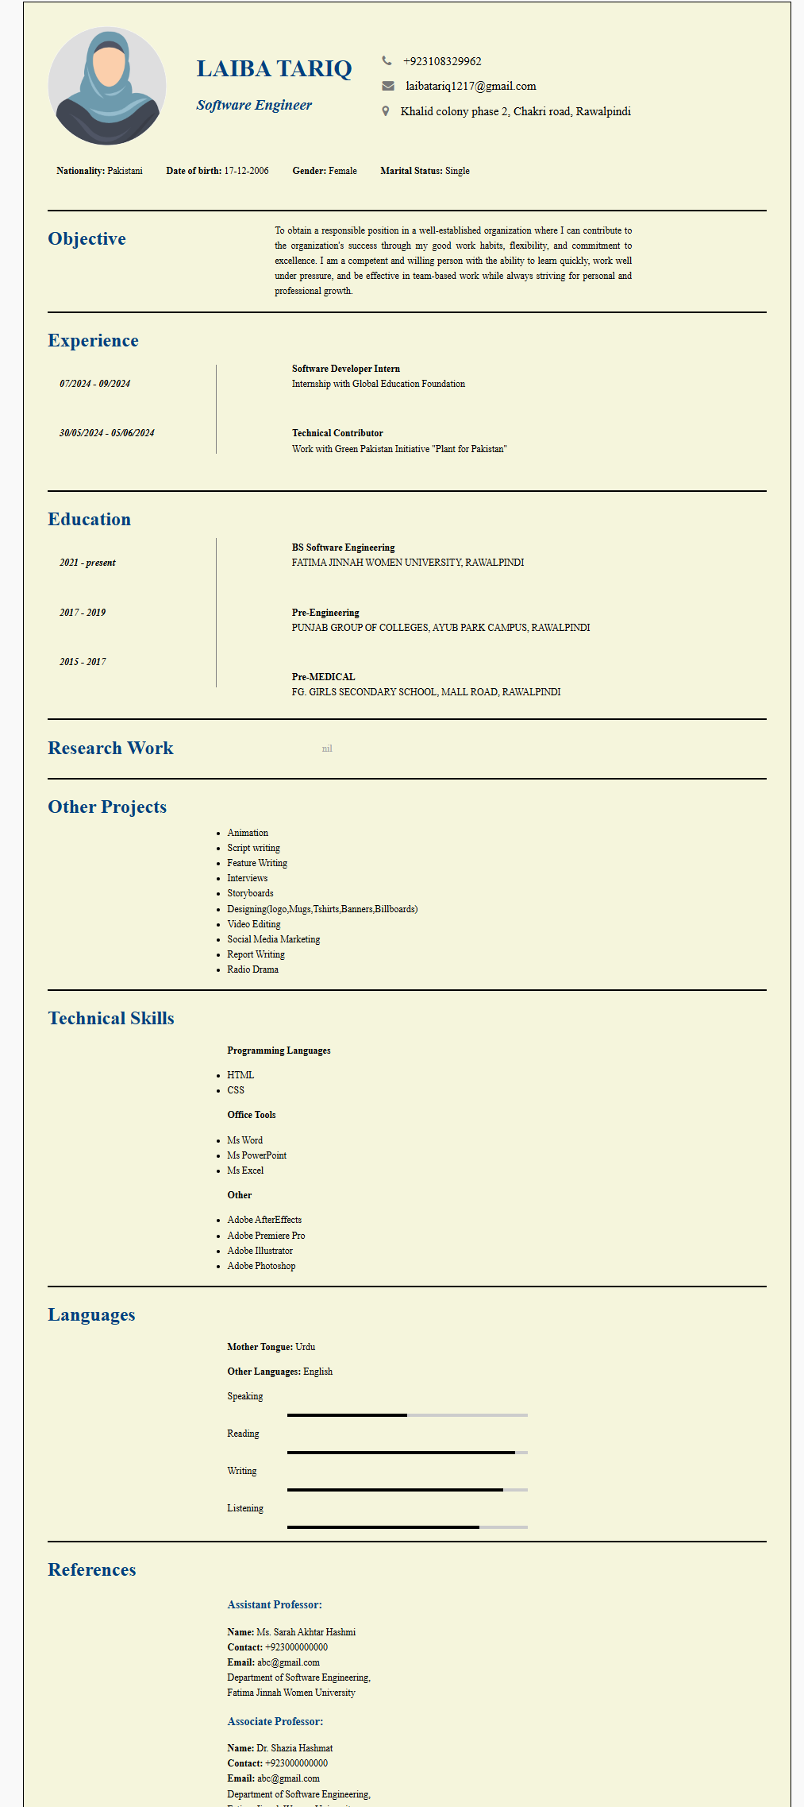
task4_portfolio_live.png

