Title:
MQTT Data Subscription and Debug Display using Node-RED
Objective:
To subscribe DHT22 temperature data published by ESP32 using MQTT and display it in Node-RED Debug window.

Tools / Software Used:
- ESP32 (Simulator in Wokwi / VS Code)
- DHT22 sensor
- Mosquitto MQTT Broker (running on port 1883)
- Node-RED (http://localhost:1880)
Procedure (Step-by-Step):
- Start Mosquitto Broker:
Open terminal / command prompt and run:
- mosquitto -v
Output should confirm:
mosquitto running
- Run ESP32 Code (Publisher):
  - Make sure ESP32 code has correct broker IP:
  - const char* mqtt_server = "";
  - ESP32 publishes temperature to topic:
  - home/lab1/temp
  - Serial monitor shows:
  - MQTT connected
  - Publishing temperature: 26.5
- Start Node-RED:
- node-red
Open browser: http://localhost:1880
- Add MQTT-in Node:
  - Drag MQTT-in node
  - Configure:
    - Server: localhost
    - Port: 1883
    - Topic: home/lab1/temp
    - QoS: 0
    - Action: Subscribe to single topic
  - Click Done
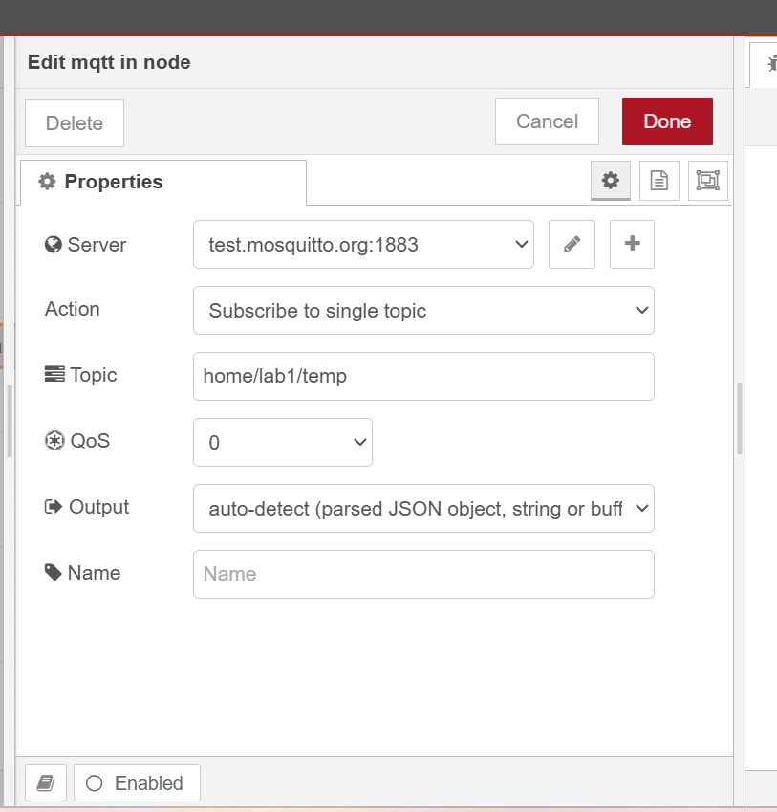
- Add Debug Node:
  - Drag Debug node
  - Output: msg.payload
  - Connect: MQTT-in → Debug
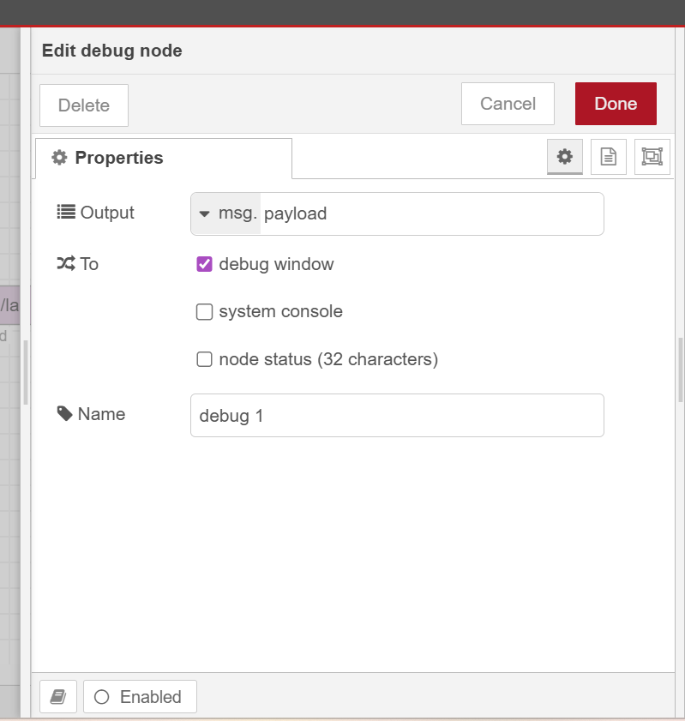
- Deploy Flow:
  - Click Deploy
  - Open Debug tab (right panel)
  - You should see temperature values like:
  - 26.4
  - 27.0
- Screenshots:
  - Mosquitto running terminal
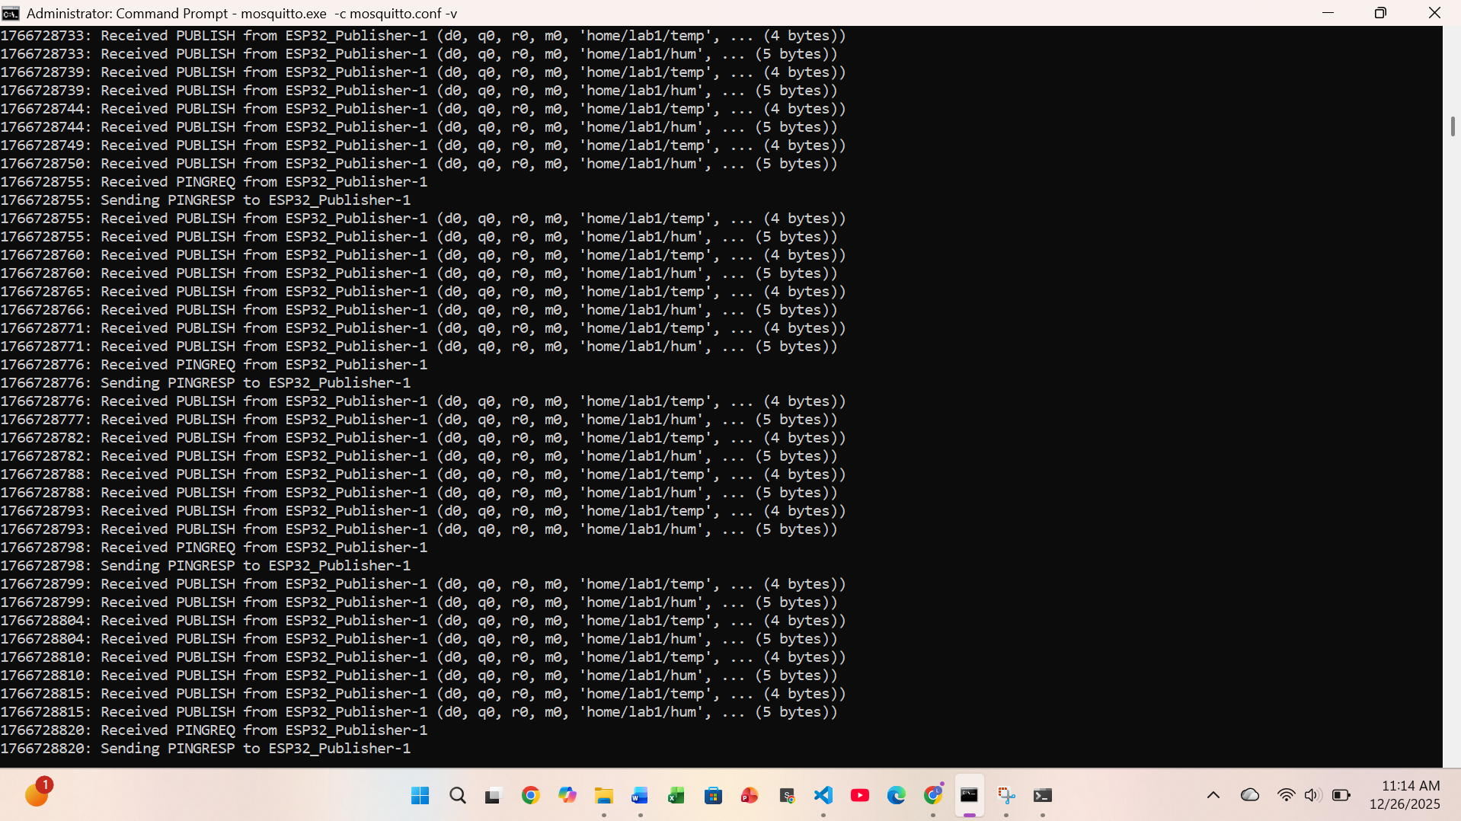
  - ESP32 serial output (Wokwi)
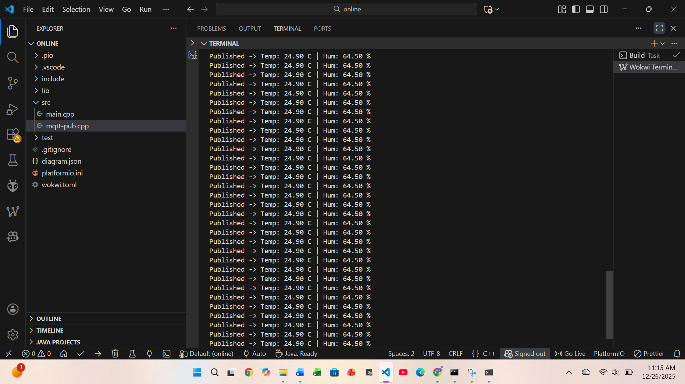
  - Node-RED flow (MQTT-in → Debug)
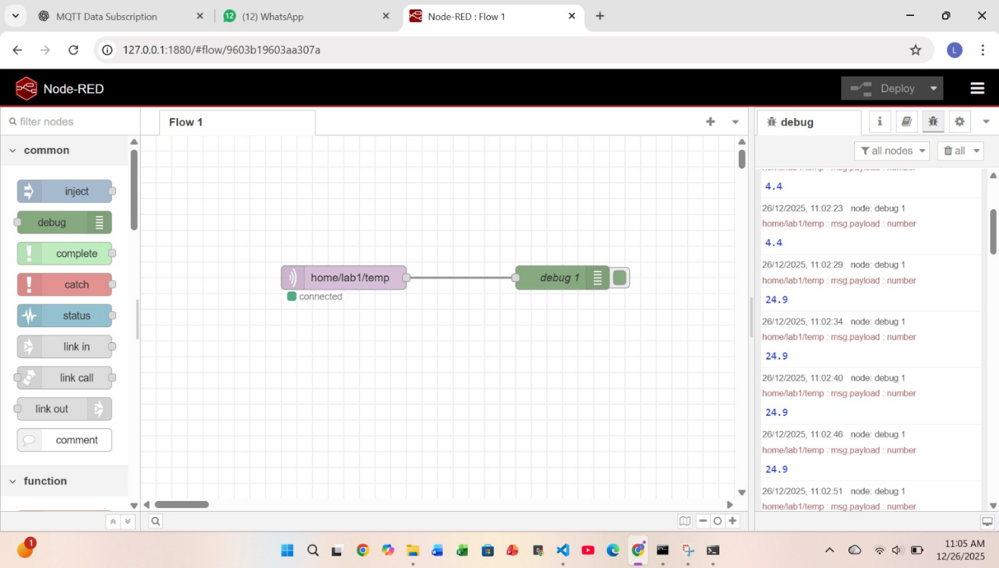
Conclusion:
ESP32 successfully published DHT22 temperature data using MQTT protocol. Node-RED subscribed to the topic home/lab1/temp through a local Mosquitto broker. The received data was displayed in the Debug window, demonstrating successful IoT data monitoring.

