

Project: Smart Medicine Box
Submitted To: Sir Nasir Mehmood
Laiba Taseen 23-NTU-CS-1258
Rabia Naseer 23-NTU-CS-1275
Malaika 23-NTU-CS-1291

Submitted By:

Course Title: Embedded IOT Systems
Corse Code: CSE-3079

National Textile University Faisalabad
Problem Statement
Medication problems are common, especially for older people and patients with long-term diseases. People often forget to take their pills, take the wrong ones, or store them in bad conditions like heat or moisture. This can harm their health. Caregivers also cannot always check if medicines are taken on time.
Objectives
- Automated Scheduling: To design a system that automatically unlocks specific medicine compartments at pre-set times.
- Multi-Modal Alerting: To provide audible (Buzzer), visual (LED/OLED), and digital (Mobile App) reminders.
- Verified Compliance: To use IR sensors to detect if the patient has actually reached into the box to take the medicine.
- Remote Monitoring: To enable caregivers to track pill intake and environmental storage conditions via the Blynk IoT platform.
- Missed Dose Notifications: To log and alert the caregiver if a dose is not taken within a specific timeframe.
System Architecture
The system follows a three-layer architecture:
- Input Layer: DHT11 (Climate), IR Sensors (Medicine detection), and Blynk App (Control).
- Processing Layer: ESP32 Microcontroller (Processes logic and schedules).
- Output Layer: Servos (Lid opening), Buzzer/LEDs (Alerts), OLED Display (Status), and Blynk Dashboard (Remote monitoring).
Block Diagram
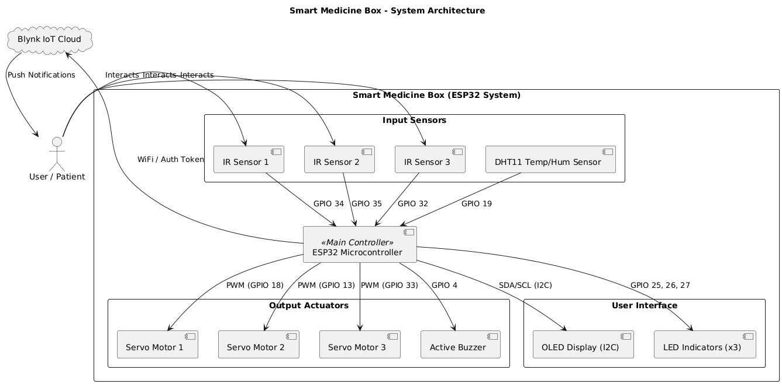

Hardware and Software Description
Hardware:
- ESP32: The brain with built-in Wi-Fi.
- Servos (x3): Opens specific compartments for different doses.
- IR Sensors (x3): Detects if the patient has physically taken the medicine.
- DHT11 Sensor: Measures storage temperature and humidity.
- OLED Display: Shows local status and sensor readings.
- Buzzer & LEDs: Visual and audible alarms.
Software:
- Blynk IoT: Mobile app interface for remote alerts and monitoring.
- Arduino IDE: Used for writing and uploading the C++ code.
- Libraries: BlynkSimpleEsp32, ESP32Servo, DHT, and Adafruit_SSD1306.
Methodology
- Initialization: ESP32 connects to Wi-Fi and Blynk.
- Scheduling: The code checks the internal timer (millis) against pre-set medicine times.
- Alerting: When time matches, a Servo opens the lid, the Buzzer sounds, and an LED lights up.
- Verification: The system waits for the IR sensor to detect a hand/object.
- Logging: If taken, it resets; if not taken within 60 seconds, it logs a Missed Dose event to Blynk.
Flow chart
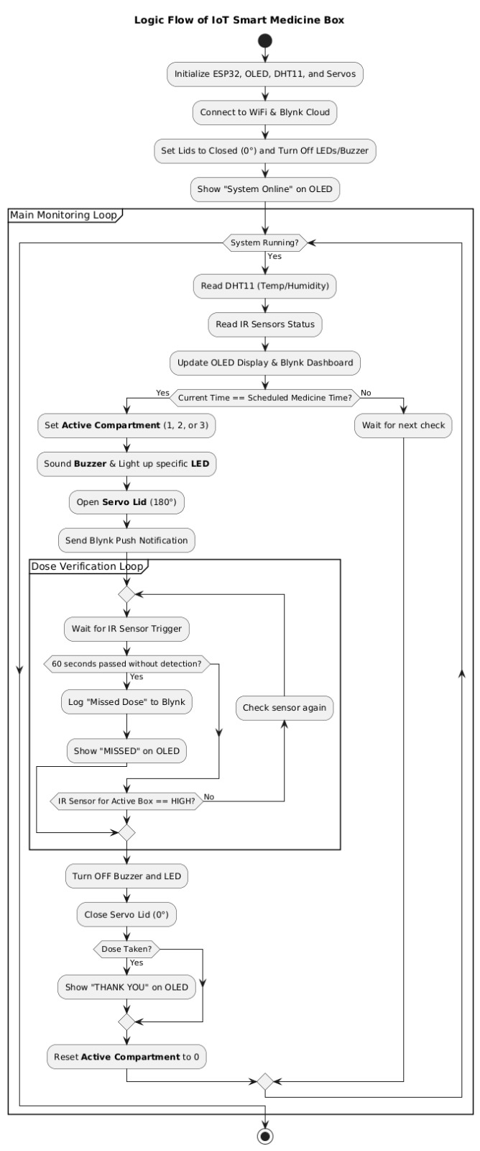

Screenshots of Output and Dashboards
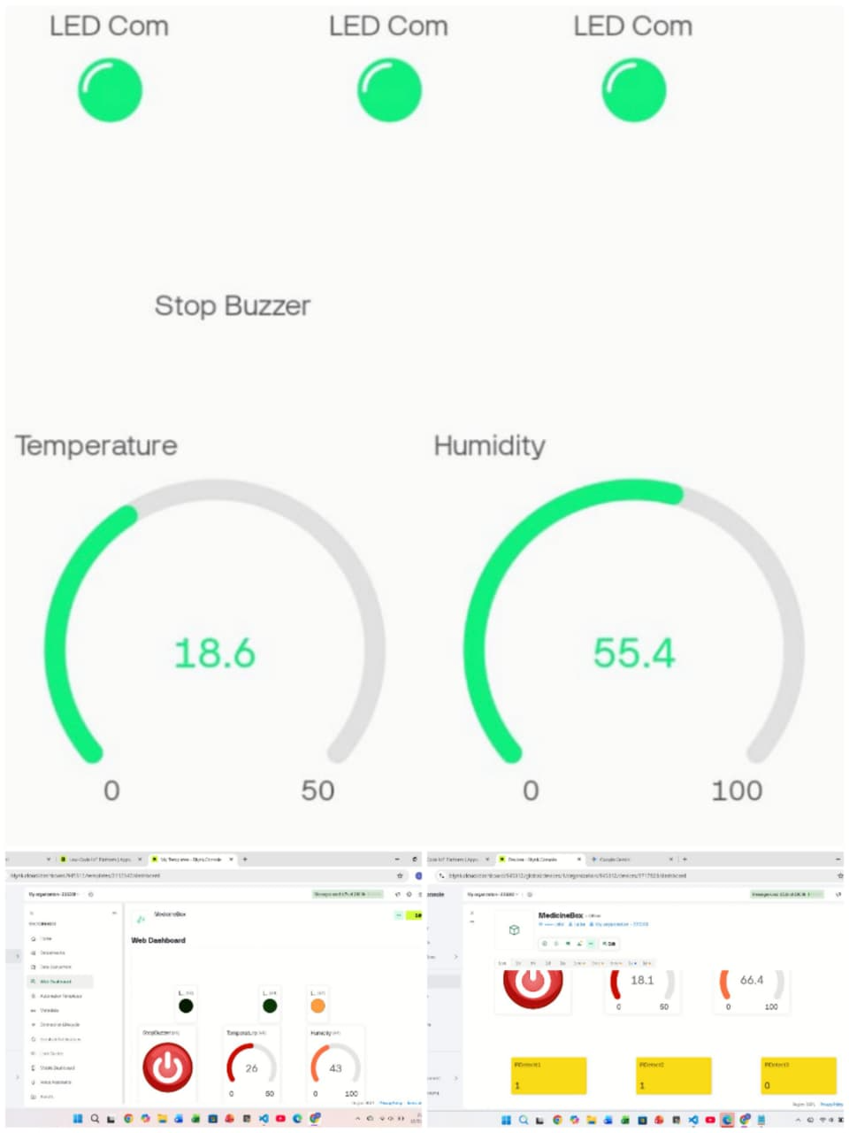
- OLED Screen: Displays "ALARM!" or "T:25C H:50%".
- Blynk App: Show the Gauges for Temp/Humidity and the Virtual LEDs for IR status.
- Serial Monitor: Show the Wi-Fi connection logs and "Box Open" messages.
Results, Conclusion, and Future Scope
Results:
The project successfully dispenses medicine at three different intervals. The Wi-Fi integration allows for real-time monitoring, and the IR sensors provide a reliable way to track patient compliance.
Conclusion:
This IoT device reduces the risk of missed medications. It provides peace of mind for caregivers through automated logs and remote notifications.
Future Scope:
- Cloud Scheduling: Allow users to change medicine times via the app (currently hardcoded).
- Voice Integration: Add Alexa or Google Assistant reminders.
- Pill Counting: Add load cells to weigh the medicine and ensure the correct number of pills are taken.

