Project Title :
ESP32 Dual Switch - Dual LED using External Interrupts and Timer Debounce

Code:
/*
Project Title : ESP32 Dual Switch - Dual LED using External Interrupts and Timer Debounce
Author : Laiba Taseen
Reg No : 23-NTU-CS-1258
*/

#include <Arduino.h>

#define LED1_PIN 2
#define LED2_PIN 4
#define SW1_PIN 32
#define SW2_PIN 14

// Debounce time (milliseconds)
#define DEBOUNCE_MS 50

hw_timer_t *debounceTimer1 = NULL;
hw_timer_t *debounceTimer2 = NULL;

volatile bool sw1_pending = false;
volatile bool sw2_pending = false;

// Function declarations
void IRAM_ATTR sw1_isr();
void IRAM_ATTR sw2_isr();
void IRAM_ATTR debounceTimer1ISR();
void IRAM_ATTR debounceTimer2ISR();

void setup() {
Serial.begin(115200);
delay(100);
Serial.println("ESP32 Dual Switch Dual LED Project - Core v3.x Compatible");

pinMode(LED1_PIN, OUTPUT);
pinMode(LED2_PIN, OUTPUT);
digitalWrite(LED1_PIN, LOW);
digitalWrite(LED2_PIN, LOW);

pinMode(SW1_PIN, INPUT_PULLUP);
pinMode(SW2_PIN, INPUT_PULLUP);

debounceTimer1 = timerBegin(20000);
debounceTimer2 = timerBegin(20000);

// Attach ISRs
timerAttachInterrupt(debounceTimer1, debounceTimer1ISR);
timerAttachInterrupt(debounceTimer2, debounceTimer2ISR);

attachInterrupt(digitalPinToInterrupt(SW1_PIN), sw1_isr, FALLING);
attachInterrupt(digitalPinToInterrupt(SW2_PIN), sw2_isr, FALLING);
}

void loop() {

static unsigned long lastPrint = 0;
if (millis() - lastPrint > 2000) {
lastPrint = millis();
Serial.printf("LED1: %d | LED2: %d\n", digitalRead(LED1_PIN), digitalRead(LED2_PIN));
}
}

void IRAM_ATTR sw1_isr() {
detachInterrupt(digitalPinToInterrupt(SW1_PIN));
sw1_pending = true;

timerAlarm(debounceTimer1, DEBOUNCE_MS * 1000, false, 0);
}

void IRAM_ATTR sw2_isr() {
detachInterrupt(digitalPinToInterrupt(SW2_PIN));
sw2_pending = true;
timerAlarm(debounceTimer2, DEBOUNCE_MS * 1000, false, 0);
}

// Timer ISR for Switch 1
void IRAM_ATTR debounceTimer1ISR() {
if (sw1_pending && digitalRead(SW1_PIN) == LOW) {
digitalWrite(LED1_PIN, !digitalRead(LED1_PIN));
}
sw1_pending = false;
attachInterrupt(digitalPinToInterrupt(SW1_PIN), sw1_isr, FALLING);
}

// Timer ISR for Switch 2
void IRAM_ATTR debounceTimer2ISR() {
if (sw2_pending && digitalRead(SW2_PIN) == LOW) {
digitalWrite(LED2_PIN, !digitalRead(LED2_PIN));
}
sw2_pending = false;
attachInterrupt(digitalPinToInterrupt(SW2_PIN), sw2_isr, FALLING);
}

Output Screenshot:
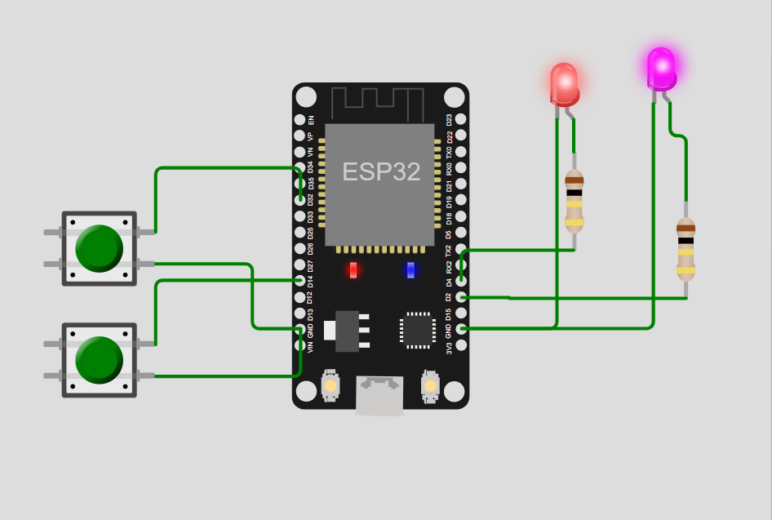

Wokwi Project Link:
https://wokwi.com/projects/443984382660231169

