Name:

Laiba Faisal

Roll Number:

213002

Subject:

Visual Programming

Assignment:

03

**Screenshot 1: VIEW**

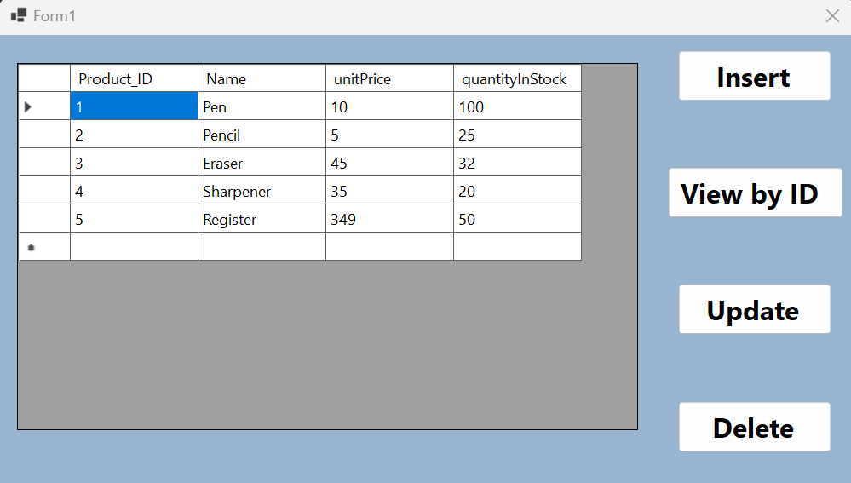

**Screenshot 2: INSERT**

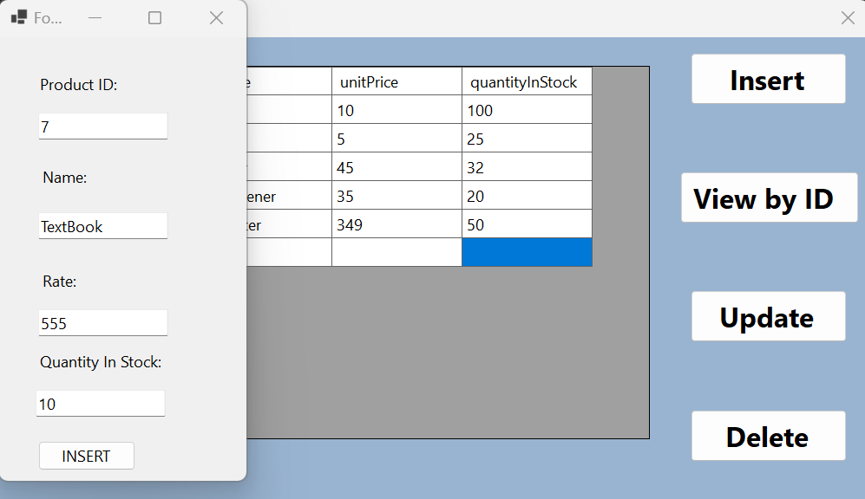

**Screenshot 3: View By ID**

**Screenshot 4: UPDATE**

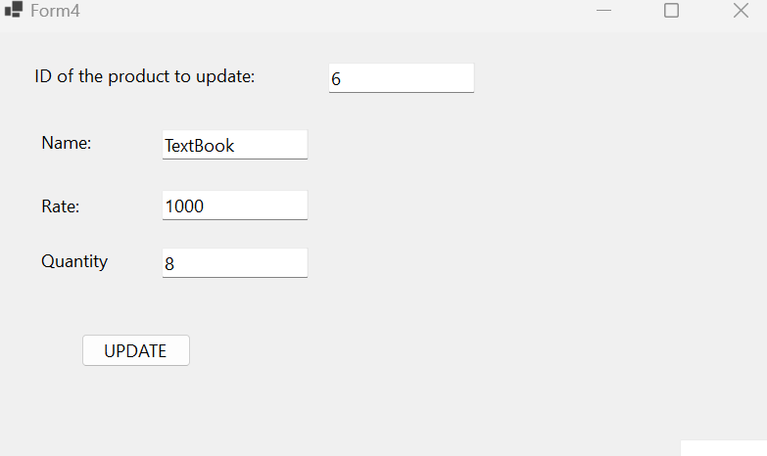

**Press ok in the message box to view the entire table again:**

**Screenshot 4: DELETE**

