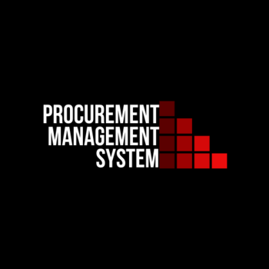

**Procurement Management System**

**Object Oriented Analysis and Design**

**Object Modeling:**

Class: Employee

|  |  |  |
| --- | --- | --- |
| **Objects** | **Type** | **Methods** |
| Name | String | Getter + setter |
| CNIC | String | Getter+Setter |
| E-mail | String | Getter+setter |

Class: Accessories

|  |  |  |
| --- | --- | --- |
| **Objects** | **Type** | **Methods** |
| Name | String | Getter+setter |
| Count | Integer | Getter+Setter |
| Date Added | String | Getter |

Class: Manager

|  |  |  |
| --- | --- | --- |
| **Objects** | **Type** | **Methods** |
| E-mail | String | Getter+setter |
| Password | String | Getter+setter |
|  |  |  |

Class: System

|  |  |  |
| --- | --- | --- |
| **Objects** | **Type** | **Methods** |
| Employees | List | 1. addEmployee(boolean) 2. remEmployee(boolean) 3. updateEmployee(name,cnic) 4. showEmployee() |
| Accessories | List | 1. addAccessory(boolean) 2. remAccessory(boolean) 3. upateAccessory() |
|  |  |  |

**Object Relations:**

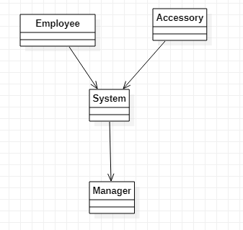

**Dynamic Modelling**

* Employee non-static
* Accessory non-static
* Manager static
* System static

Login

Checks Login

Input

Member

Driver

If login is successful access given to system

System

**System**

Employee

Accessory

remAccessory

updateAccessory

addAccessory

Exit

Driver

Driver

updateEmployee

remEmployee

showEmployee

addEmployee

**Domain Model**

