

Lahore Garrison University

Data Transmission in Activities

using Java (Android Studio)

Laiba Riaz

Mobile Application Development

Sir. Wahid Qayyum



Assignment Due Date

May 20, 2024

**Activity Layouts**

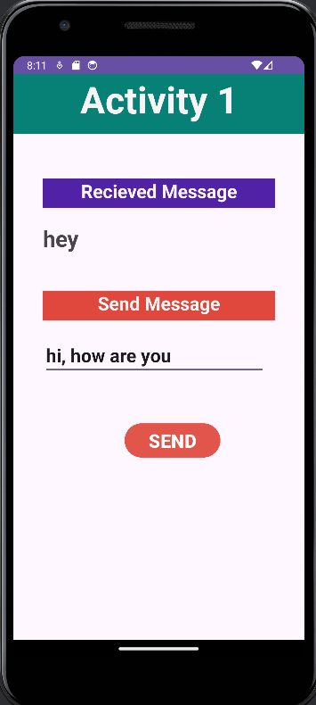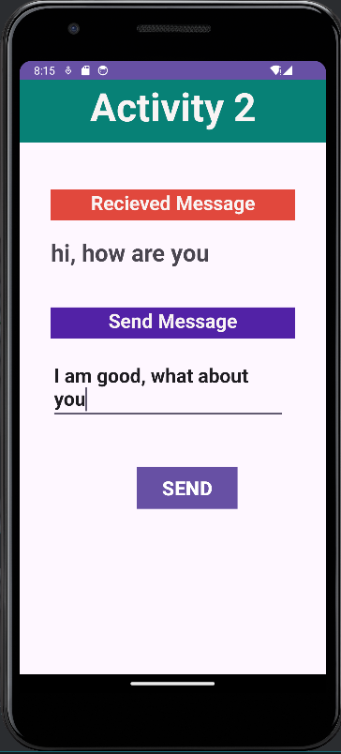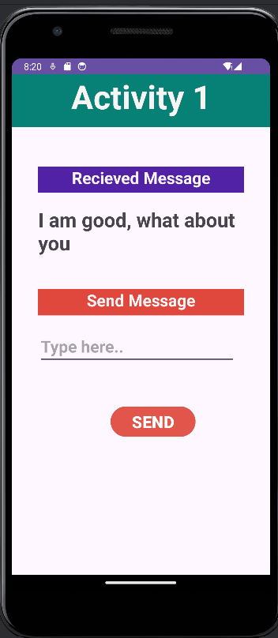

**(MainActivity.java)**

package com.example.datatransfer;  
import android.content.Intent;  
import android.os.Bundle;  
import android.view.View;  
import android.widget.Button;  
import android.widget.EditText;  
import android.widget.TextView;  
import androidx.activity.EdgeToEdge;  
import androidx.appcompat.app.AppCompatActivity;  
import androidx.core.graphics.Insets;  
import androidx.core.view.ViewCompat;  
import androidx.core.view.WindowInsetsCompat;  
  
public class MainActivity extends AppCompatActivity {  
 // define the variable  
 Button send_button;  
 EditText send_text;  
 TextView showMsg_activity1;  
 @Override  
 protected void onCreate(Bundle savedInstanceState) {  
 super.onCreate(savedInstanceState);  
 setContentView(R.layout.*activity_main*);  
  
 send_button = findViewById(R.id.*send_button_id_activity1*);  
 send_text = findViewById(R.id.*send_text_id_activity1*);  
 showMsg_activity1 = findViewById(R.id.*show_msg_activity1*);  
  
  
 // create the get Intent object  
 Intent showMsg_intent_activity1 = getIntent();  
 // receive the value by getStringExtra() method and  
 // key must be same which is send by first activity  
 String received_msg_from_activity2 = showMsg_intent_activity1.getStringExtra("message_key_activity2");  
 // display the string into textView  
 showMsg_activity1.setText(received_msg_from_activity2);  
  
  
 // add the OnClickListener in sender button after clicked this button following Instruction will run  
 send_button.setOnClickListener(new View.OnClickListener() {  
 public void onClick(View v) {  
 // get the value which input by user in EditText and convert it to string  
 String message = send_text.getText().toString();  
 // Create the Intent object of this class Context() to Second_activity class  
 Intent sendMsg_intent_activity1 = new Intent(MainActivity.this,Activity2.class);  
 // now by putExtra method put the value in key, value pair key is  
 // message_key by this key we will receive the value, and put the string  
 sendMsg_intent_activity1.putExtra("message_key_activity1", message);  
 startActivity(sendMsg_intent_activity1);  
 }  
 });  
  
 }  
  
}

**(Activity2.java)**

package com.example.datatransfer;

import android.content.Intent;

import android.os.Bundle;

import android.view.View;

import android.widget.Button;

import android.widget.EditText;

import android.widget.TextView;

import androidx.activity.EdgeToEdge;

import androidx.appcompat.app.AppCompatActivity;

import androidx.core.graphics.Insets;

import androidx.core.view.ViewCompat;

import androidx.core.view.WindowInsetsCompat;

public class Activity2 extends AppCompatActivity {

Button send_button_activity2;

EditText send_text_activity2;

TextView showMsg;

@Override

protected void onCreate(Bundle savedInstanceState) {

super.onCreate(savedInstanceState);

setContentView(R.layout.activity_2);

send_button_activity2 = findViewById(R.id.send_button_id_activity2);

send_text_activity2 = findViewById(R.id.send_text_id_activity2);

showMsg = findViewById(R.id.show_msg_activity2);

// create the get Intent object

Intent showMsg_intent_activity2 = getIntent();

// receive the value by getStringExtra() method and

// key must be same which is send by first activity

String received_msg_from_activity1 = showMsg_intent_activity2.getStringExtra("message_key_activity1");

// display the string into textView

showMsg.setText(received_msg_from_activity1);

// send data to activity 1

send_button_activity2.setOnClickListener(new View.OnClickListener() {

public void onClick(View v) {

// get the value which input by user in EditText and convert it to string

String Activity2_Message = send_text_activity2.getText().toString();

// Create the Intent object of this class Context() to Second_activity class

Intent sendMsg_intent_activity2 = new Intent(Activity2.this,MainActivity.class);

// now by putExtra method put the value in key, value pair key is

// message_key by this key we will receive the value, and put the string

sendMsg_intent_activity2.putExtra("message_key_activity2", Activity2_Message);

startActivity(sendMsg_intent_activity2);

}

});

} }