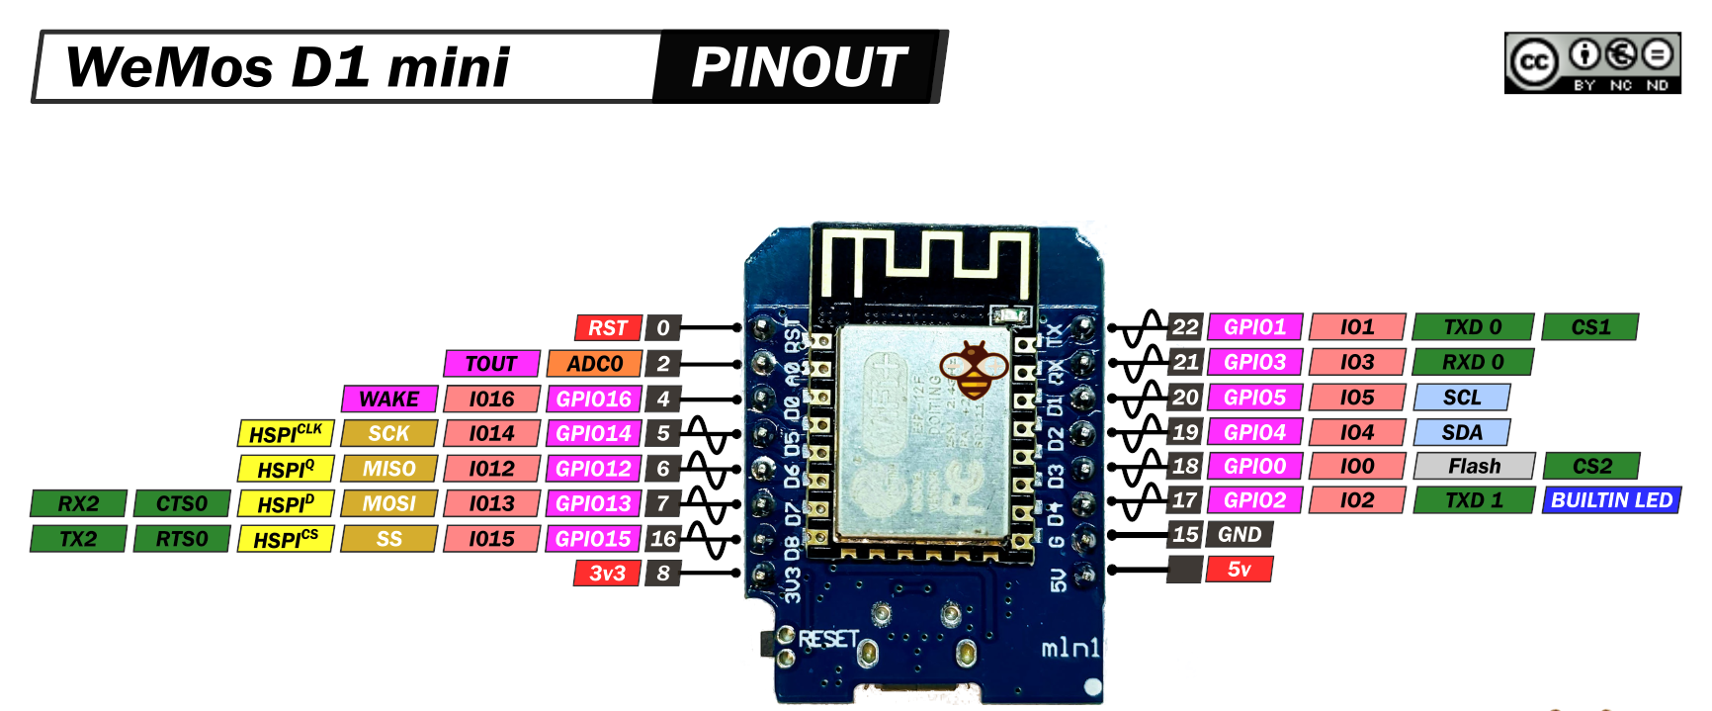


 | BMP180 | SD | AM2302 | MPU9250 | BN-880 | Pin wemos | Pin wemos | BN-880 | MPU9250 | AM2302 | SD | BMP180
 | Presión | SD | Hum/Temp | IMU | GPS | Micro. | Micro. | GPS | IMU | Hum/Temp | SD | Presión
 |  |  |  |  |  | RST | TX | RX
 |  |  |  |  |  | A0 | RX | TX
 |  |  |  |  |  | D0 | D1 |  | SCL |  |  | SCL
 |  | SCK |  |  |  | D5 | D2 |  | SDA |  |  | SDA
 |  | MISO |  |  |  | D6 | D3
 |  | MOSI |  |  |  | D7 | D4 |  |  | DATA
 |  | SS |  |  |  | D8 | GND | GND | GND | GND | GND | GND
 | VCC | VCC | VCC | VCC | VCC | 3.3V | 5V

