**Task1**

**Bug report**

1. Division by zero:

When we open the calculator application and enter 10 / 0 it will not show an error message it just have incorrect value “infinity”.

* Expected output: error message that we cannot divide by zero.
* Actual output: no error message, it shows incorrect value.
* Severity: critical.

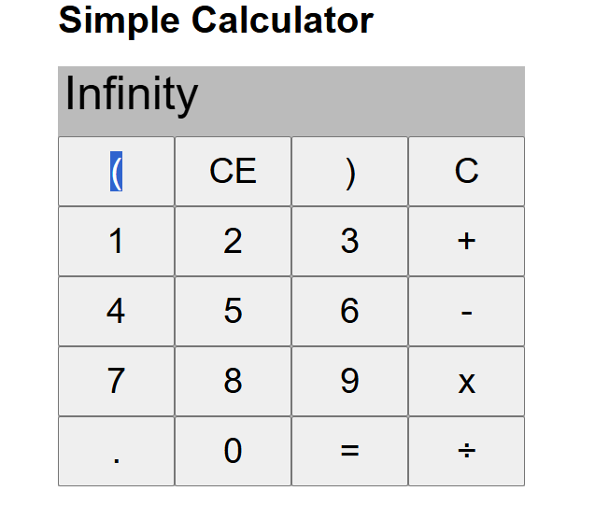

1. Incorrect for large numbers:

When we sum 999999991 + 9 the output is equal to 18.9999999 and this is false.

Expected output: 1000000000.

Actual output: Incorrect result displayed.

Severity: Major.

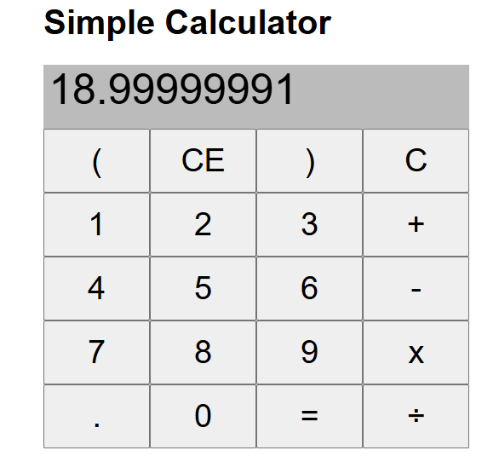

1. Calculator give incorrect result for rapid sequential

As example for 5*2 – 7/-2 it show an incorrect result equal to 17 instead of 13.5.

Expected output: 13.5.

Actual output: Incorrect result displayed.

Severity: Major.

