|  |  |
| --- | --- |
| AIN SHAMS UNIVERSITYFACULTY OF ENGINEERINGi-CREDIT HOURS ENGINEERING PROGRAMS *Computer Engineering and Software Systems Program* |  |

|  |  |
| --- | --- |
| ***Spring 2021*** | **Course Code: *CSE 472*** |
| **Artificial Intelligence** | |

**Course Project**

Submitted by

|  |  |  |
| --- | --- | --- |
|  | **Name** | **ID** |
| **1** | **Omar Mohamed Lotfy** | **18P5606** |
| **2** | **Laila Mohamed Aborizka** | **18P9654** |
| **3** | **Hana Yasser Amgad** | **18P5007** |
| **4** | **Ilaria Refaat Ghobrial** | **18P3050** |

**Add briefly a manual (supported by screenshots ) that describes the steps to run the project. show a demo example step by step, starting from creating the problem until finishing the search algorthim**

This program allows user to draw a graph and apply different search algorithm techniques on it (BFS, DFS,UCS, Greedy and A*).

This demo will help user to run the project by following the following steps:

1. By running the code a window will representing GUI will appear.

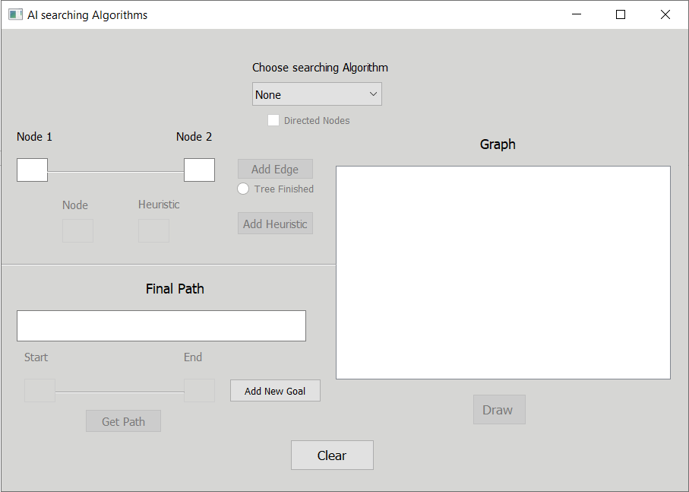

1. User has to choose a search algorithm from the combo box.

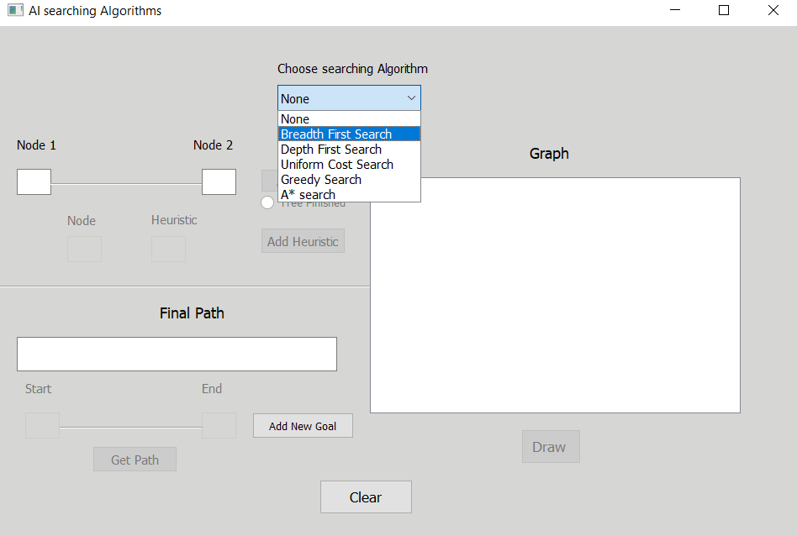

1. After choosing the search algorithm, program allows user to choose either working on directed or undirected graph.

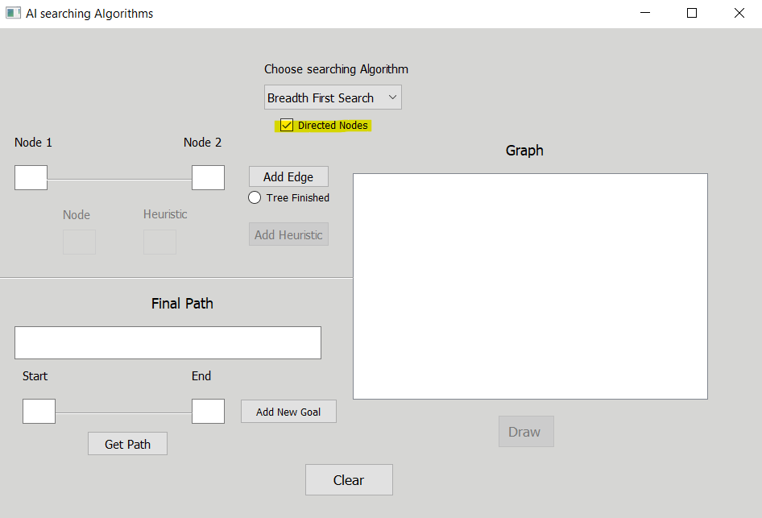

1. In case of choosing BFS or DFS: program will allow user to:
   1. Insert nodes.

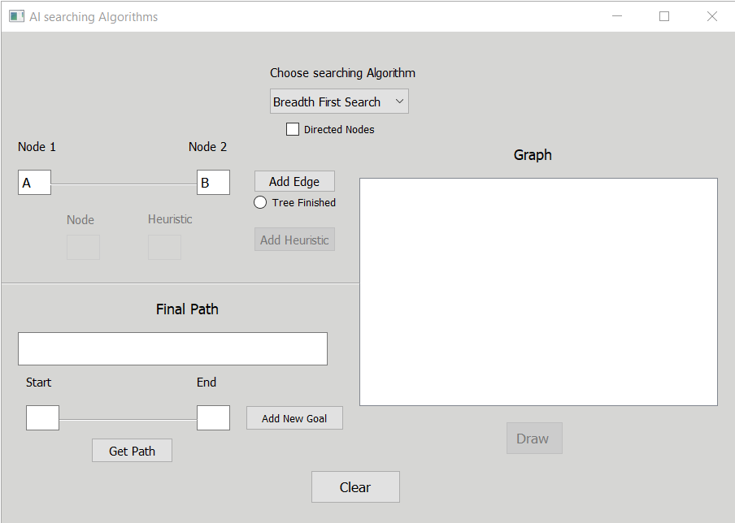

* 1. Click **ADD Edge**.

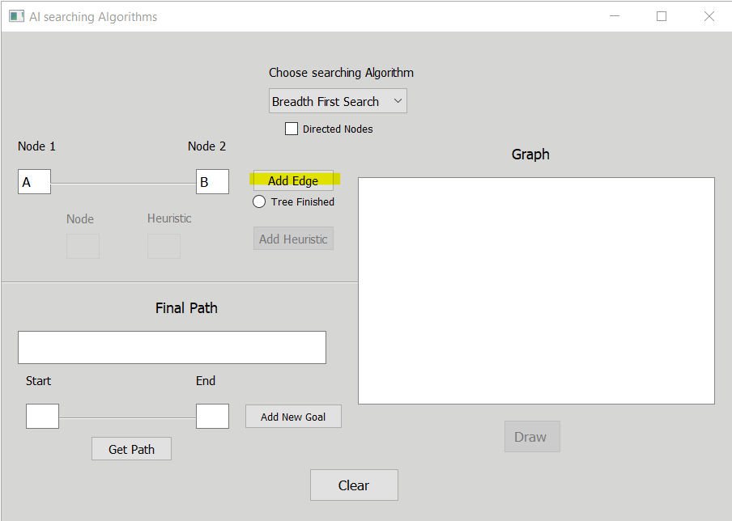

* 1. After inserting all nodes, click **on Tree Finished** that indicates that graph is complete and is ready to be drawn.

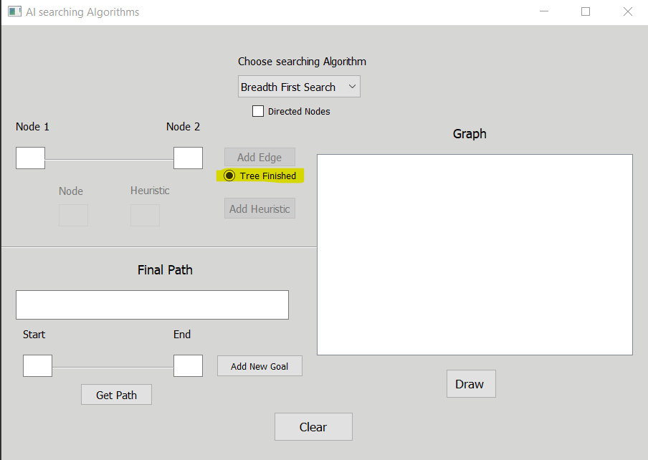

* 1. Click on **Draw** to show graph**.**

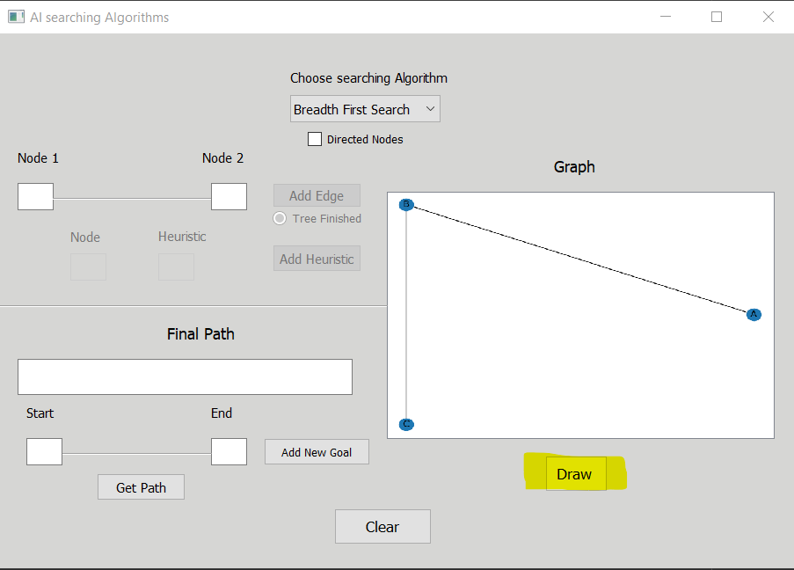

* 1. User has to insert start node and goal node, program allow user to enter multiple goals by clicking on **ADD New Goal**.

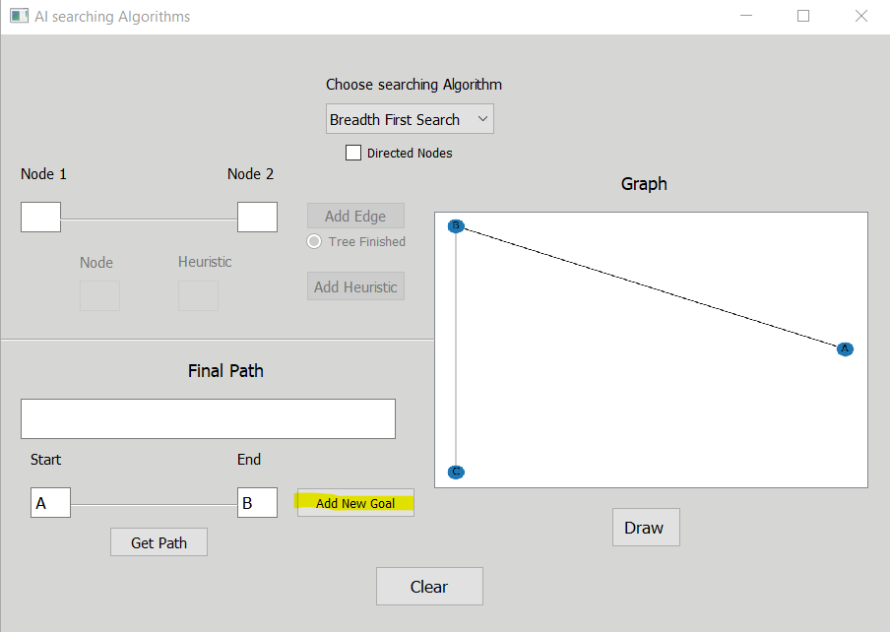

* 1. Click on **Get Path** to show path.

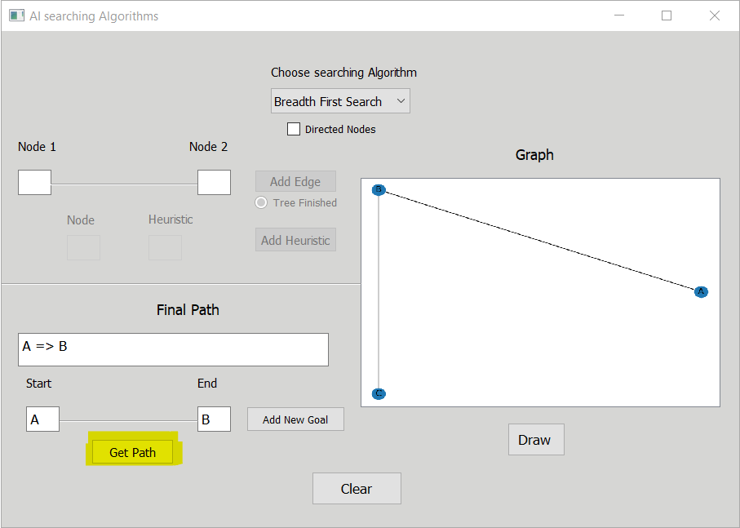

1. In case of choosing UCS, program allows user to add weight to edges.

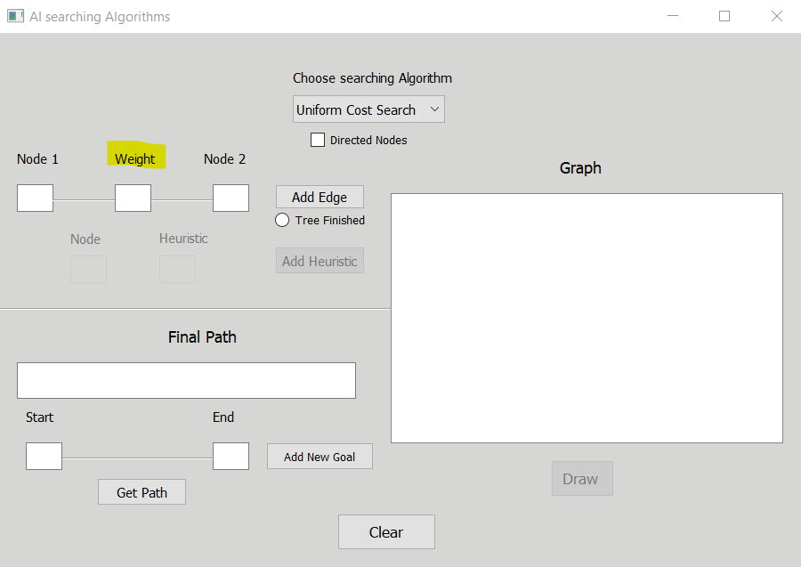

1. In case of choosing Greedy :
   1. Click ADD Heuristic, to add heuristic value to each node.

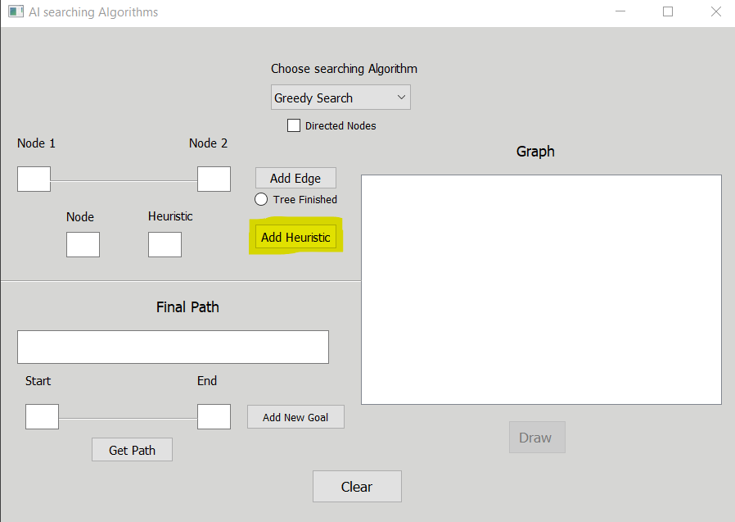

1. In case of choosing A* search, system allows user to add weight to edges and add heuristic value to each node.

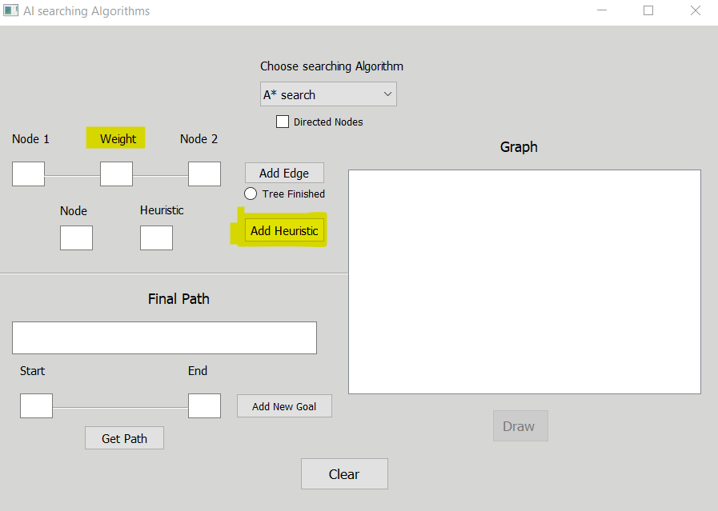

1. **Clear** button to reset the program, so user can choose another search algorithm, draw its graph and apply this search algorithm on it.

