

## 18P9654 G2s2

## Laila Mohamed Aborizka

Hospital management system

Major Task

Agile software engineering report

This project is a web based hospital management system consisting of Registration portal for assigning patients, consultation, Medical matter management , Check out, Report generation, and a database that holds all the important info for the hospital.The software product is the Hospital Management System web based. The intentions of the system are to reduce over-time pay and increase the number of patients that can be treated accurately.As well as offer users a handy and user friendly tool so that they can achieve best performance in the hospital.

**Part ONE**

The team consists of 10 people divided into 4 teams ( front-end developers, backend developers, testing team, UI designers ).

|  |  |  |
| --- | --- | --- |
| **Name** | **Role** | **Expertise** |
| Laila Mohamed | Front-end developer | HTML, CSS, Javascript, Experience with CSS Preprocessors, problem solving skills. |
| Farida Abdelfattah | Front-end developer | HTML, CSS, Javascript, Git and Version Control Systems. |
| Nada Fawzy | Tester | Testing and debugging, Problem solving, Creating documentation, Automation testing. |
| Hana Abo el Ezz | Tester | Testing and debugging, Problem solving, Creating documentation, Agile testing. |
| Noor Ashraf | Back-end developer | Python, Java, PHP, SQL, Cross-Browser Development. |
| Ashraf ahmed | Designer | Invision studio, research, prototyping and wireframing, typography. |
| Mohamed Soliman | Designer | Branding, Visual design, Interactivity and animation |
| Alaa mohamed | Back-end developer | Databases and Cache, Data structures and algorithms , python, Git, Java, HTML, CSS. |
| Doaa Gameel | Back-end developer | Python, Java, PHP, SQL, HTML, CSS , Javascript. |
| Yassin Shalaby | Front-end developer | HTML, CSS, Javascript, Git and Version Control Systems, Content Management Systems and E-commerce Platforms |

* The possible stakeholders are

External: Hospital management (customers), doctors and hospital workers (users), Funding Partner (An organization that provides financial support for the company and its projects), product owner.

Internal: Account and Sales Manager.

|  |  |  |  |  |
| --- | --- | --- | --- | --- |
| **Name** | **Role** | **Availability** | **Influence** | **Engagement** |
| Product manager | External stakeholder | high | high | Actively engaged |
| Account and sales manager | Internal stakeholder | high | High | Keep informed |
| Hospital management | External stakeholder | low | high | Keep informed |
| Doctors and workers | External stakeholder | Low | Low | Keep satisfied |
| Funding partner | External stakeholder | low | High | keep informed |

* The complete vision of this project is to deliver the hospital management system fully functional without bugs and to integrate it within the hospital system. This is going to be done over the course of several months. So to begin the **near vision** for the 2 upcoming sprints will be :

Note that a sprint is two weeks which is 12 available days/sprint. Assuming each day has 5-7 hours/day (all team members work in the same range) so the sprint is around 60-84 working hours

**Sprint 1** : homepage and portals are ready and part of the registration and consultation : receptionist should be able to

Add patients.

Manage waiting list

**Sprint 2** : The rest of the registration functions and part of the medical matter management ; a user should be able to :

Receptionist able to Assign patients to their ward in the correct hospital section.

Receptionist able to Check patients out.

Doctor and nurse able to view their surgery and emergency tasks from a task viewer.

Doctors and nurses should be able to record procedures.

**Story point convention:**

We assume that 1 story point takes 1 hour

Story points are estimated following fibonacci series

Small size story : 1,2,3 points

Medium size story: 5,8,13 points these are stories no:8,4,6,9,10,12,11,14,15,16

Large size story : >13 these are stories no: 13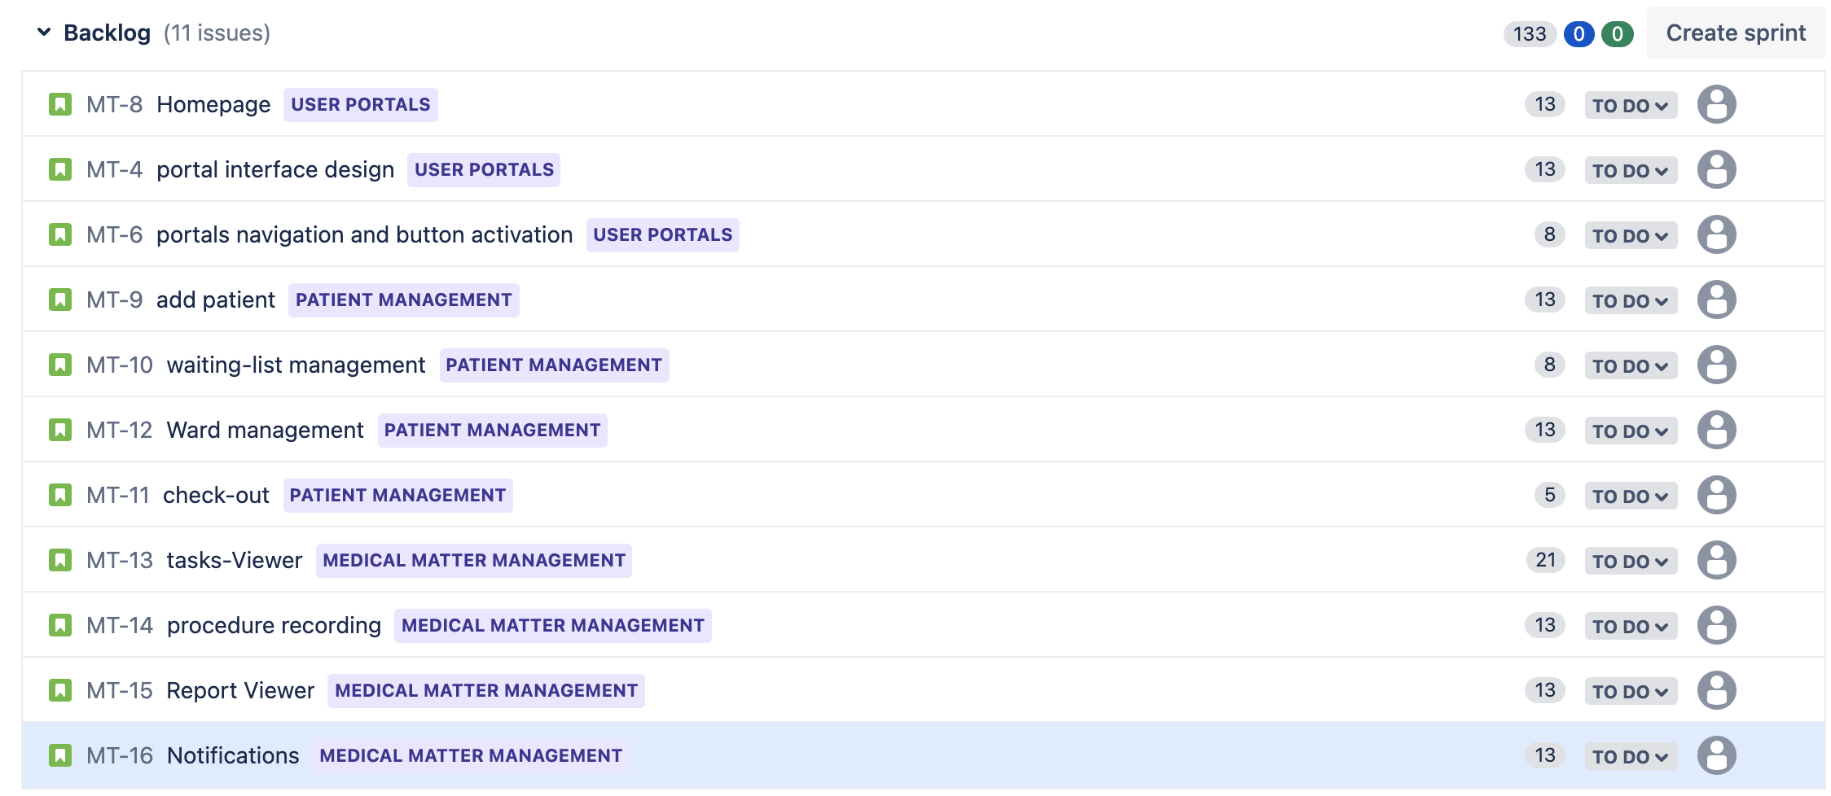

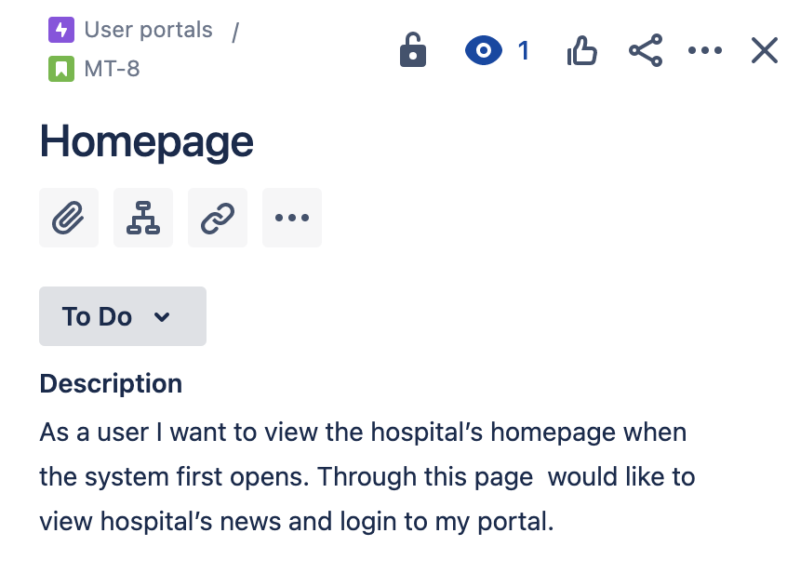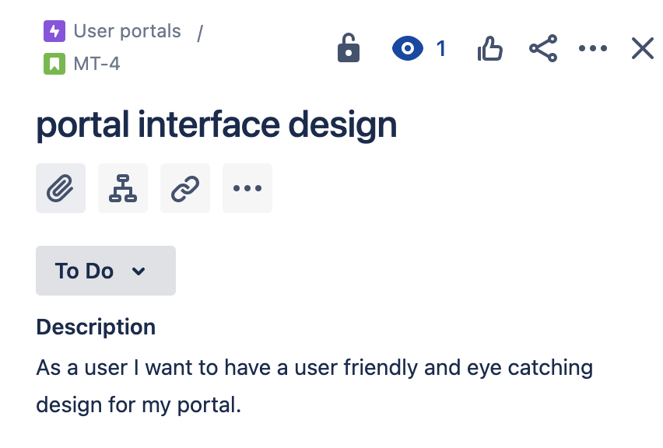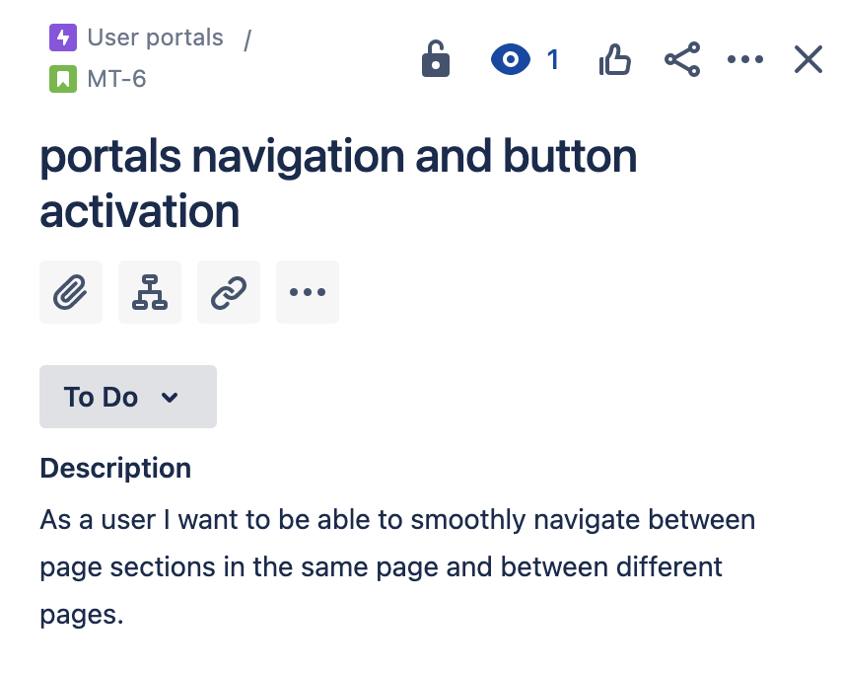

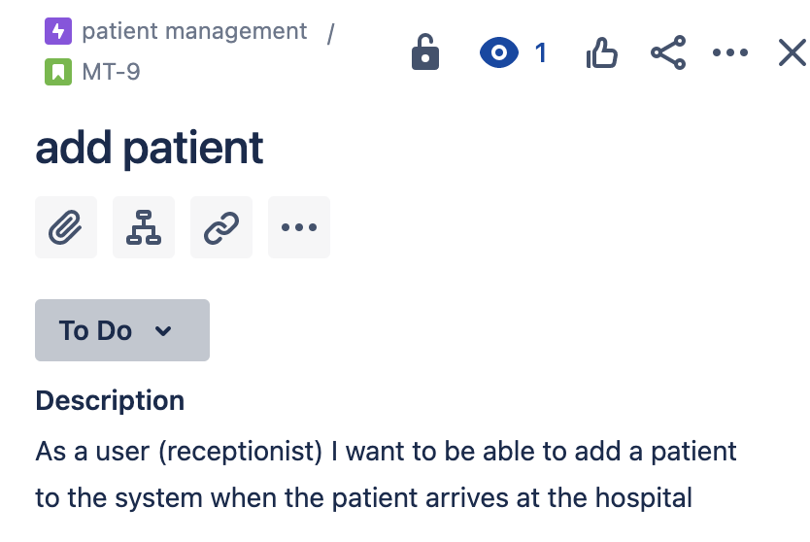

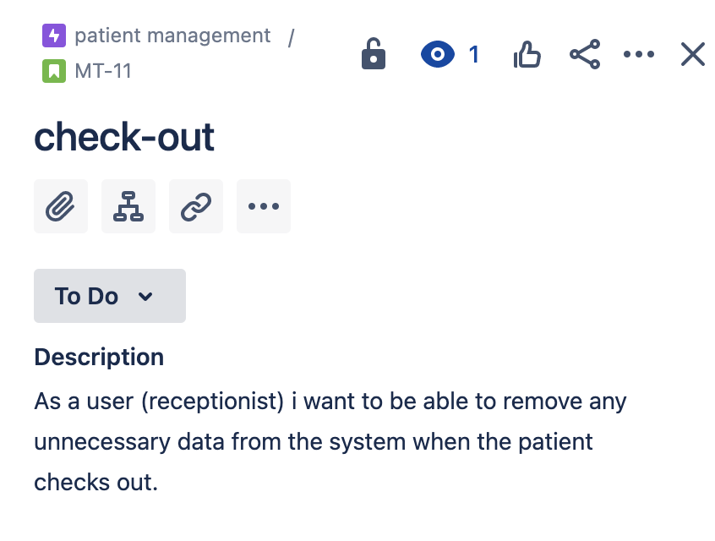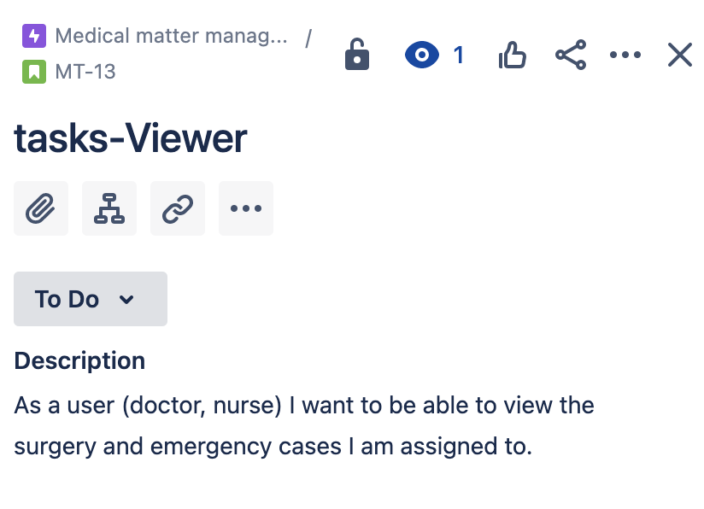

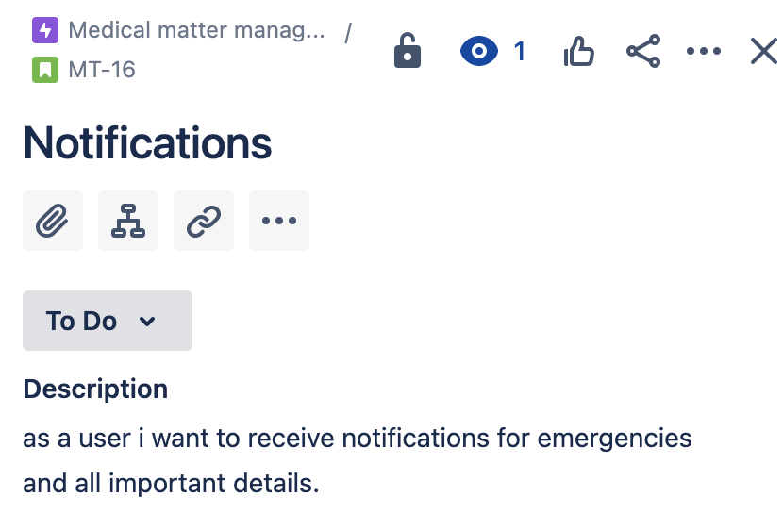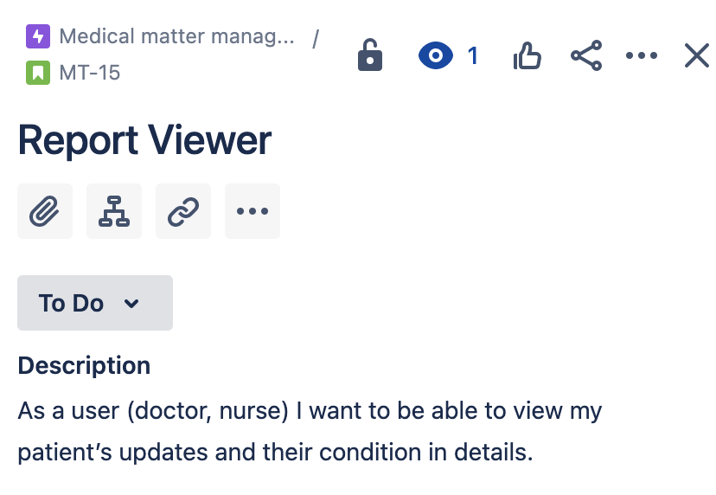

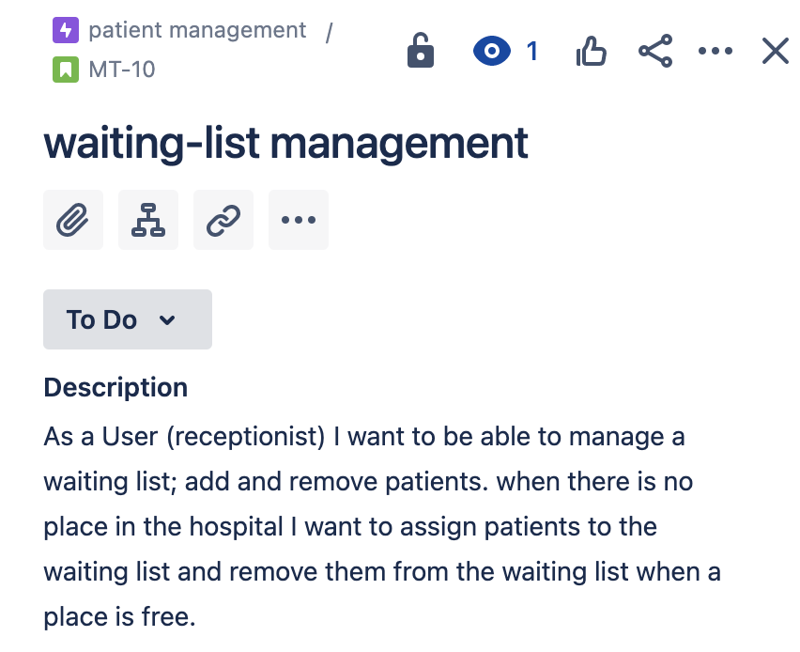

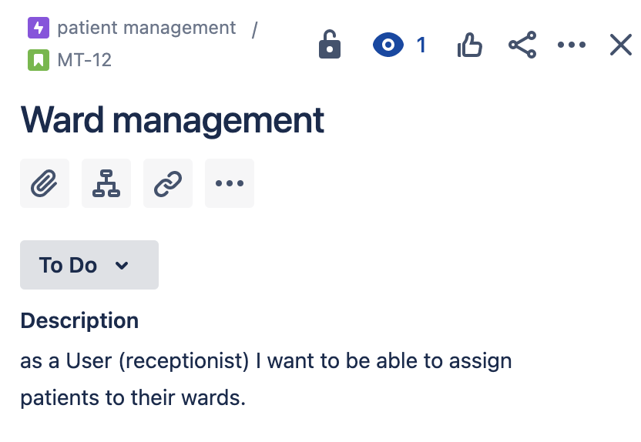

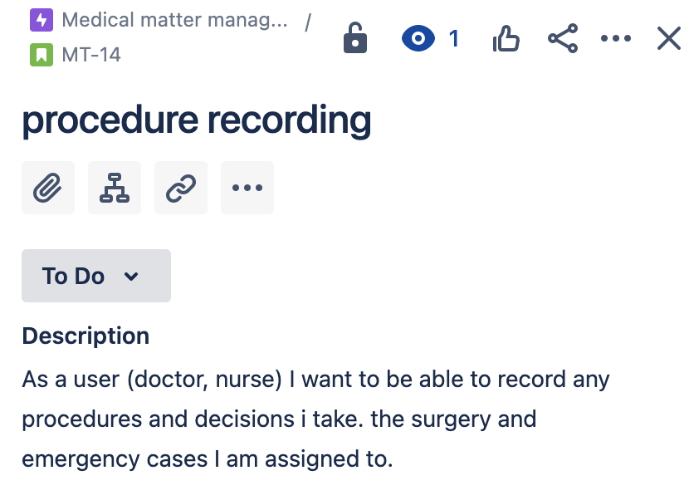

The order is according to the priority and what’s important so first of all

1- There is no system without a homepage that lets users view news and login from it

2- Secondly portals have to be finished before the functionalities are implemented because each user will communicate with the system through their own interface

3-the interface has to be designed first

4-then there has to be smooth navigation between pages and buttons so that the user can move from one page or function to the other and interact with the system

5- then receptionists functionalities(patient management) have to be covered first because they are the most needed in the hospital to handle the amount of patients coming in and out of the hospital and keep track of them

6- after that Medical matter issues are handled the most important one is viewing tasks because it is needed to keep orders and nurses on track properly

7- followed by procedure recording report viewing and notifications as they are of lower importance to the hospital in the time being

**Part 2:**

**Note that a sprint is two weeks which is 12 available days/sprint. Assuming each day has 4-6 hours/day (all team members work in the same range) so the sprint is around 48-72 working hours**

**We assume that 1 story point takes 1.5 hours and since our sprint is 60-84 hours so the team covers 40-56 story points**

**Daily scrum document**

|  |  |  |  |  |  |
| --- | --- | --- | --- | --- | --- |
| Team member | Questions | Mon | Tues | Wed | Thurs |
| Laila Mohamed | What did you do yesterday? | Coded the front -end for doctor portal | Coded front end for the nurse portal |  |  |
| What’re you doing today? | Code front end for the nurse portal | Work on navigation |  |  |
| Is there something blocking you? |  |  |  |  |
| Farida Abdelfattah | What did you do yesterday? | Coded the front -end for receptionist portal | Coded the front -end for manager portal |  |  |
| What’re you doing today? | Code front end for the manager portal | Work on navigation |  |  |
| Is there something blocking you? |  |  |  |  |

|  |  |  |  |  |  |
| --- | --- | --- | --- | --- | --- |
| Team member | Questions | Mon | Tues | Wed | Thurs |
| Nada Fawzy | What did you do yesterday? | Tested homepage | Tested the front -end for doctor portal |  |  |
| What’re you doing today? | Test the front -end for doctor portal | Test front end for the nurse portal |  |  |
| Is there something blocking you? |  |  |  |  |
| Hana aboelEzz | What did you do yesterday? | Tested homepage nav | Tested front end for the receptionist portal |  |  |
| What’re you doing today? | Tested front end for the receptionist portal | Test front end for the manager portal |  |  |
| Is there something blocking you? |  |  |  |  |

**Sprint document 1:**

**Goal**: homepage and portals are ready and part of the registration and consultation related to assigning patients .

**Progress**: done

**Next sprint**: finish rest of the registration functions and part of the medical matter management related to viewing tasks.

**Sprint document 2:**

**Goal**: finish rest of the registration functions and part of the medical matter management related to viewing tasks.

**Progress**: done

**Next sprint**: complete medical matter management functionalities

Workflow: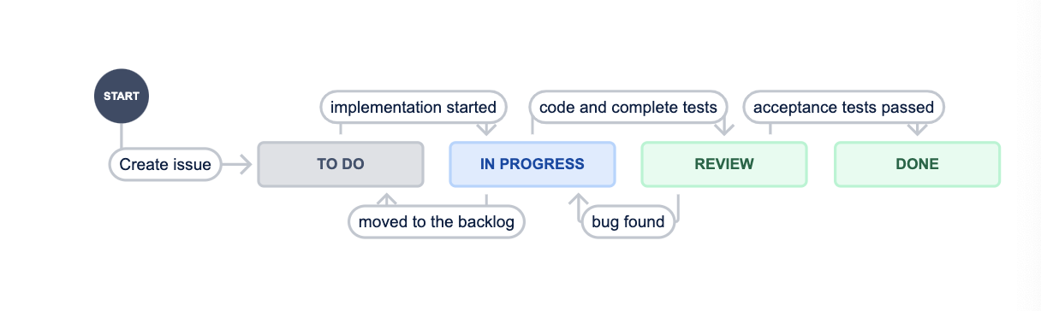

- Workflow starts by creating issues and prioritizing them

- Start sprint with implementing till we have a part that is ready ready to review.

- If a work in progress faces a problem or still needs other things it could be moved to the backlog

- We review this part if it passes then it is done if the tests fail then it is till in progress.

- Anything that is done is not edited again it is ready to deliver .

Sprint1: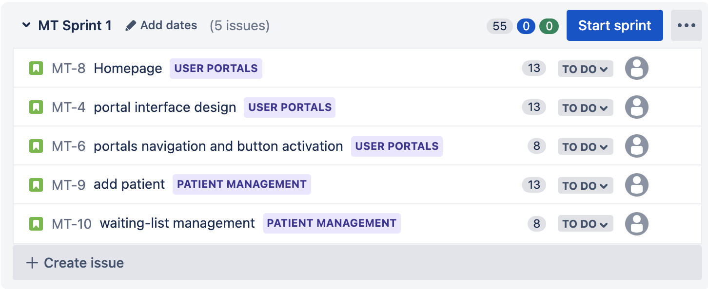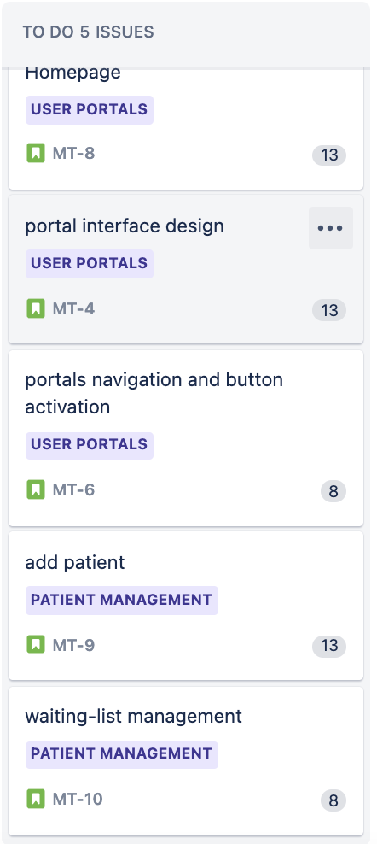

Day 3:

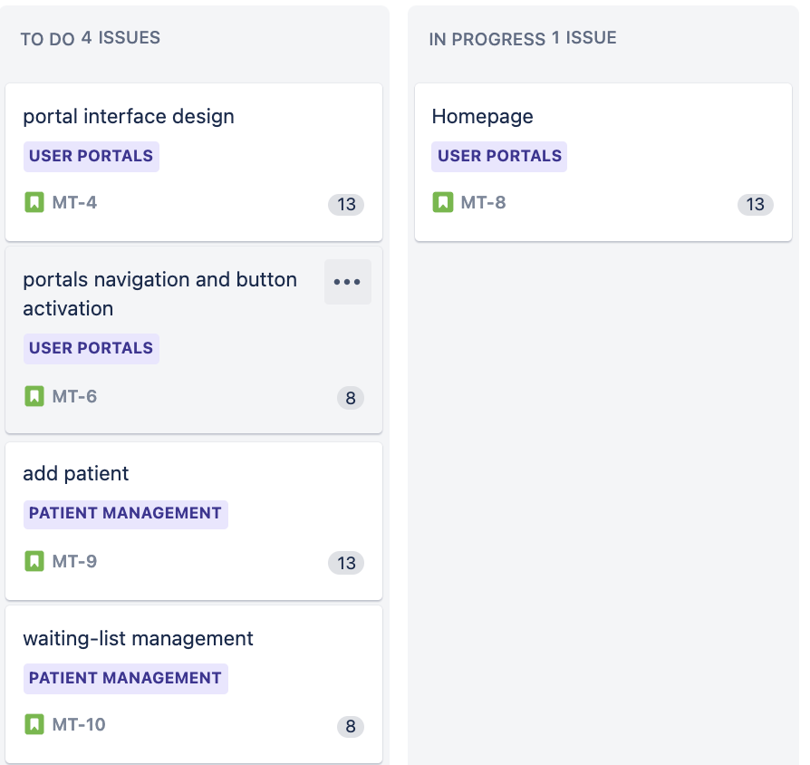

Day 5: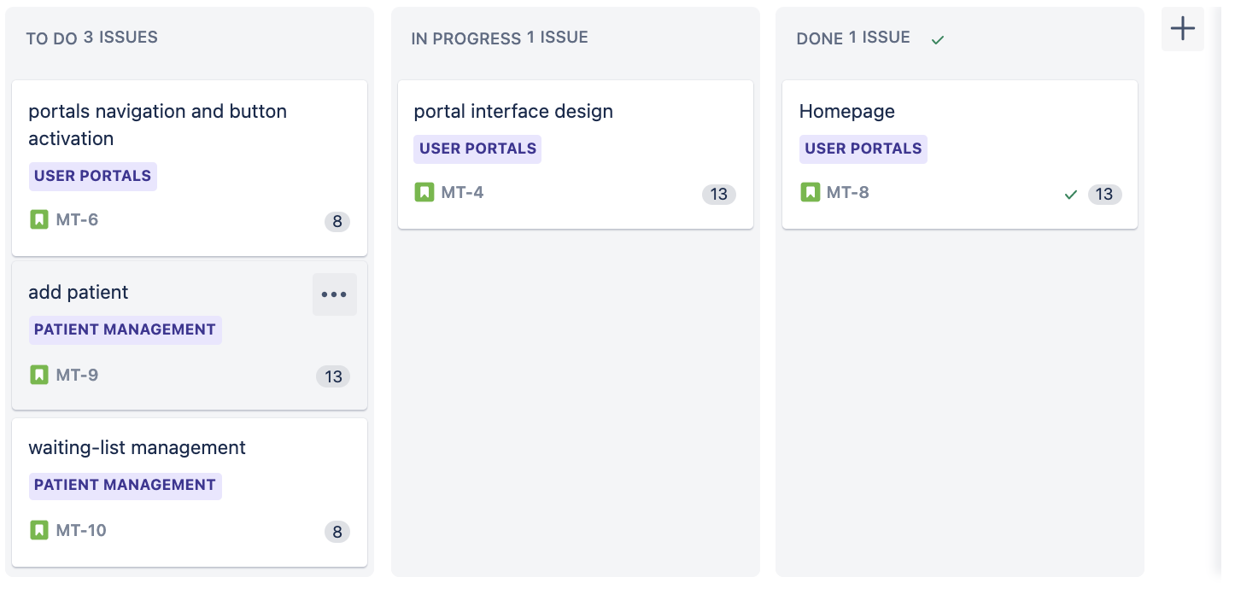

Day 8: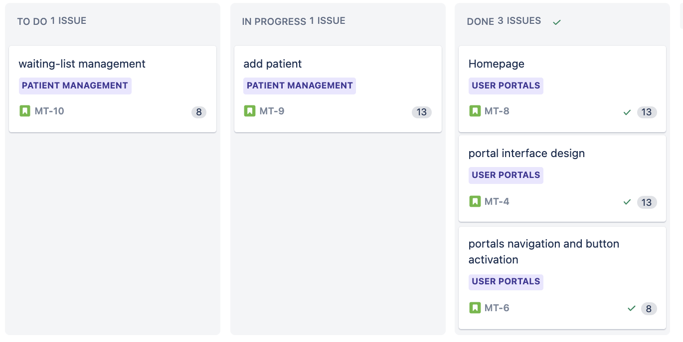

Day 12: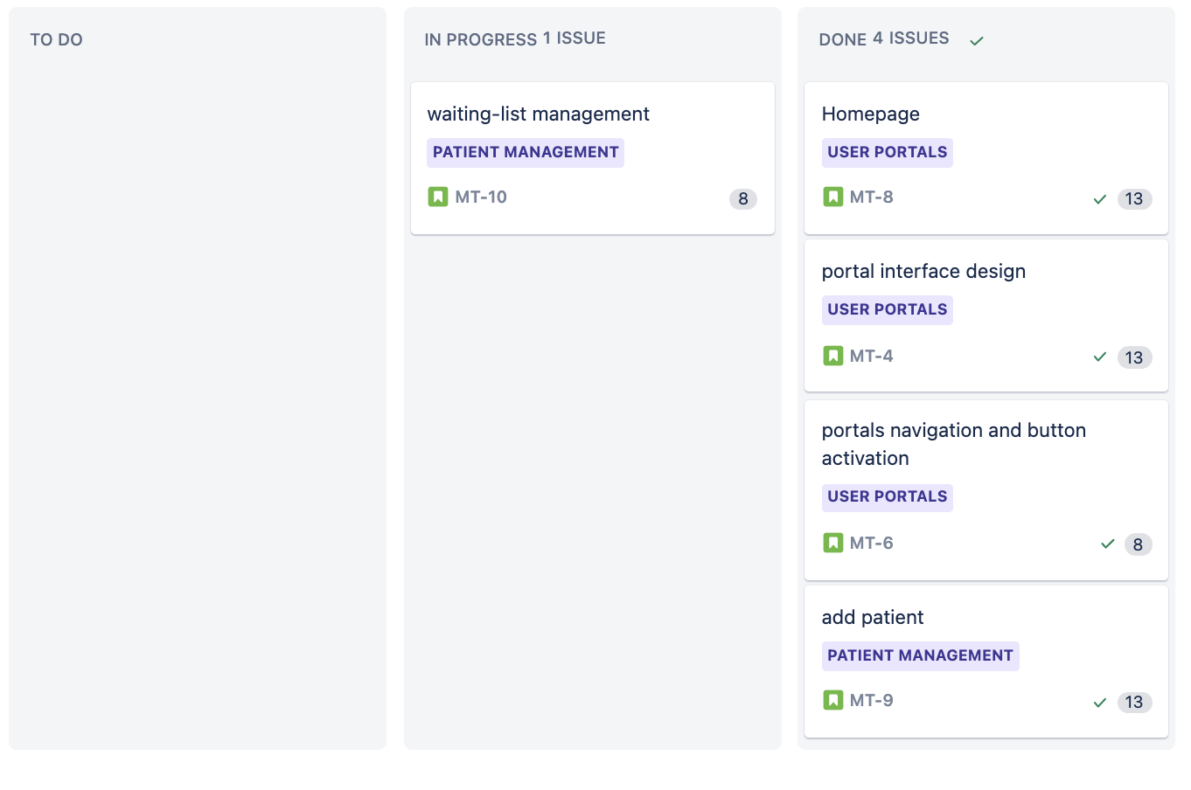

Sprint 2:

Day 3:

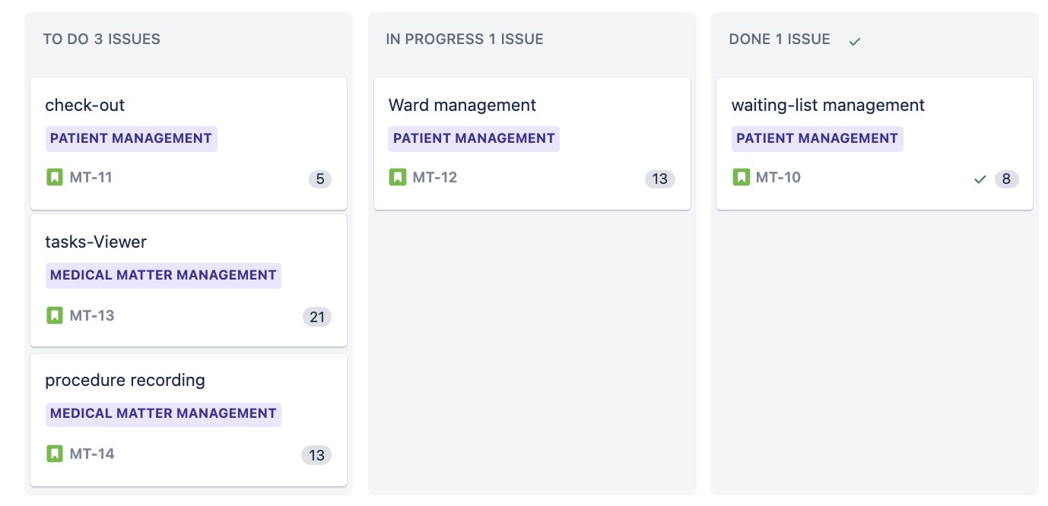

Day 5: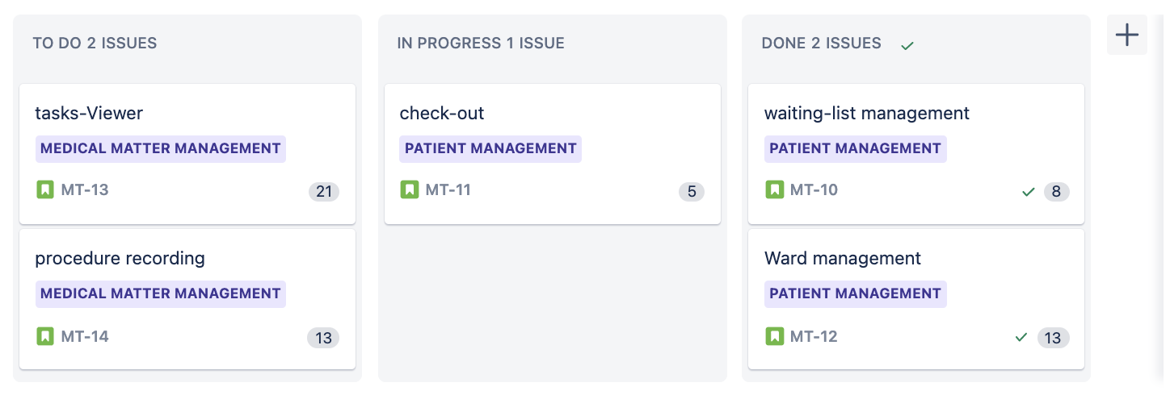

Day 8: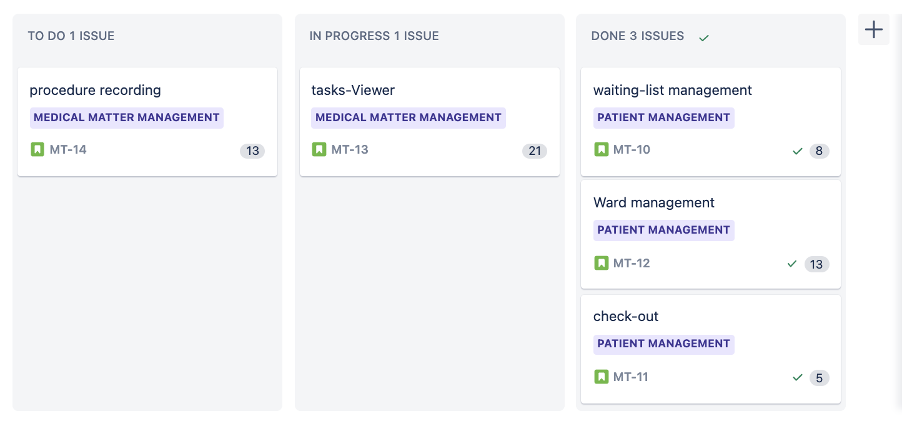

Day 12: