**Name:** Laila Shafei

**Date:** 25th of November 2024

**Course name:** IT FDN 110 A

**Assignment 06 – using set of data classes**

**Introduction**

Assignment 7 involved creating a Python program that simulates a student registration system for a Python course. This project built upon the foundation laid in Assignment 6 by introducing data classes and refining the program to include object-oriented design principles. While Assignment 6 focused on using constants, variables, and print statements to convey simple information about course registration, Assignment 7 took a significant leap forward. It incorporated data modelling through classes, added validation logic, and employed JSON files for data persistence. This enhancement made the program more robust, dynamic, and practical, but it also brought its share of challenges and learning moments.

**Body**

Throughout this assignment, I implemented a system that manages student enrolments in courses. The design involved creating reusable classes such as Person and Student using inheritance and property decorators for validation. Additionally, I introduced file handling methods to persist student data in a JSON format, a skill critical for real-world applications. Below are some of the challenges that I have faced:

1. Early in the process, I encountered indentation errors that disrupted the execution of the program. Debugging these errors required revisiting Python’s strict indentation rules and closely analysing the code structure to identify inconsistencies.
2. A significant issue arose when attempting to read data from a JSON file. A KeyError occurred because the JSON file lacked the expected keys (first_name, last_name, course_name). This mistake highlighted the necessity of robust error handling.
3. During testing, I encountered a FileNotFoundError when the Enrollments.json file was absent.

**Repository link:**

**Summary**

This assignment was a valuable learning experience that strengthened my problem-solving skills and deepened my understanding of Python programming. The challenges I faced, such as managing JSON data, resolving syntax errors, and implementing robust error handling, provided essential lessons in debugging and code design. Moving forward, I will adopt a more systematic approach to testing, and I will plan to enhance my skills in designing clear and user-friendly error messages to improve program usability.

**Appendix for snips of my code and errors**

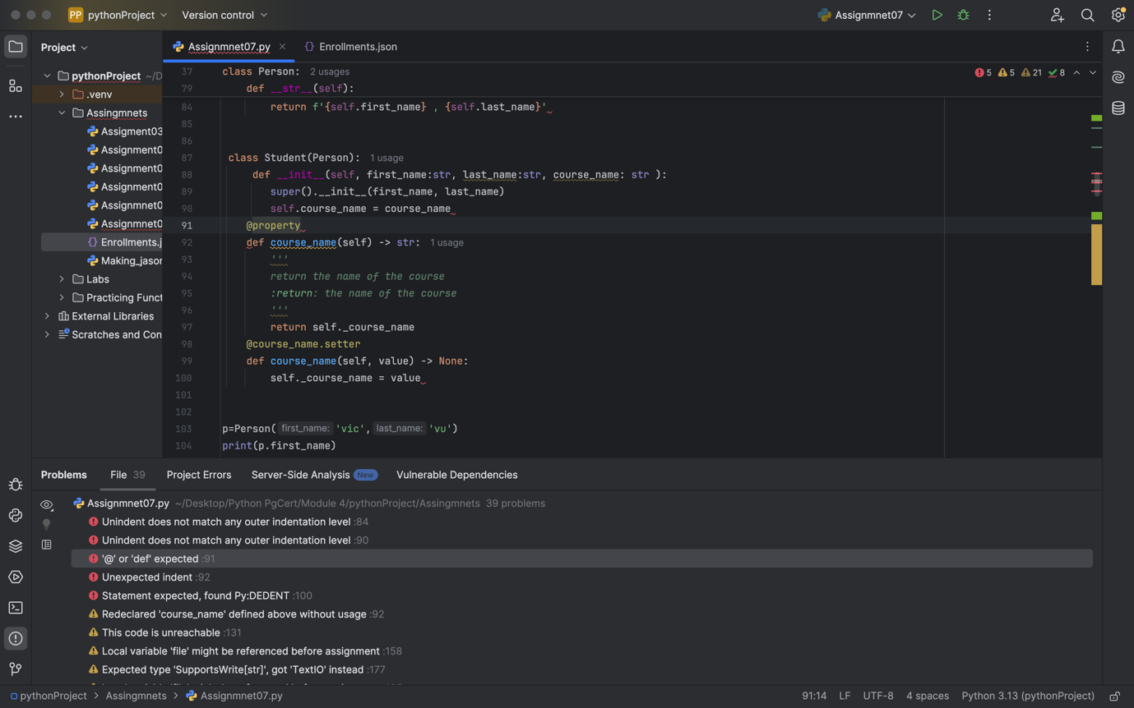

**Figure 1. Errors encountered**

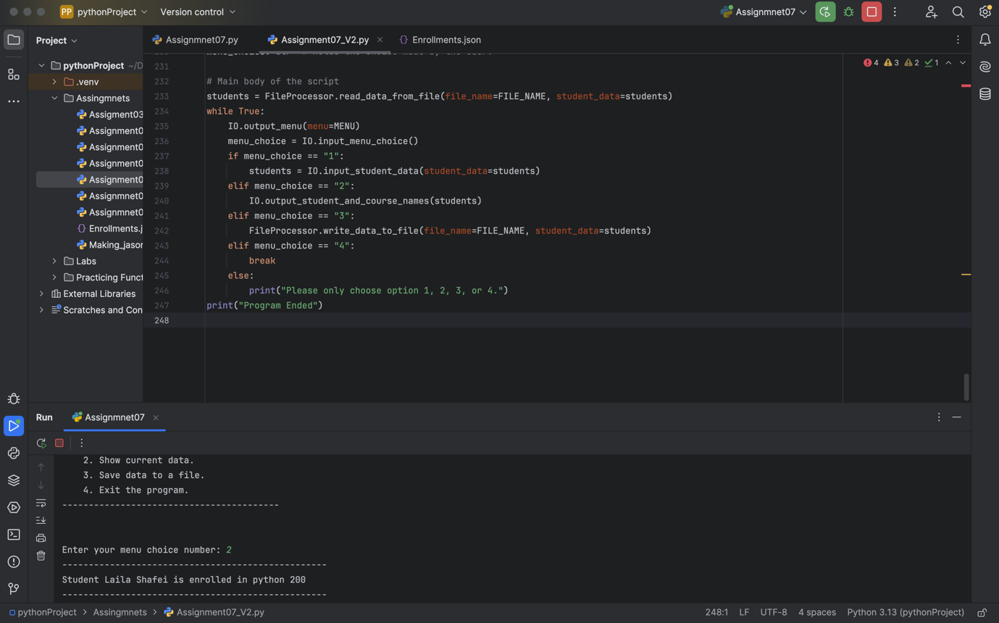**Figure 2. Code working successfully**