UI Testing

1. Filters are not working correctly. When size S is being selected and it always shows size X in the view cart page.
2. Whatever color is being selected it always shows color black in the view cart page for size S. On the other hand if size X is being selected then the colors filter works properly.

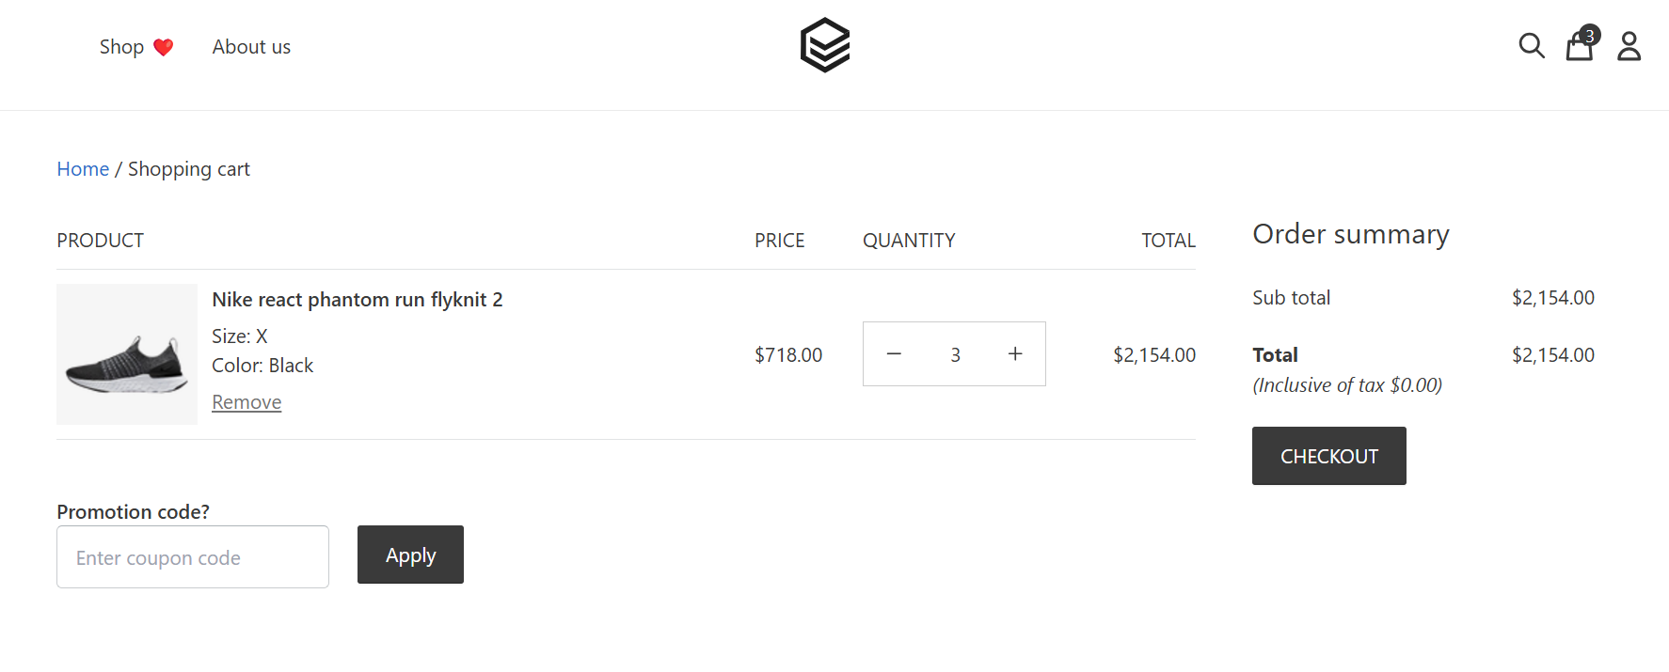

3.The color field is not changed when the color filter is clicked for size S .

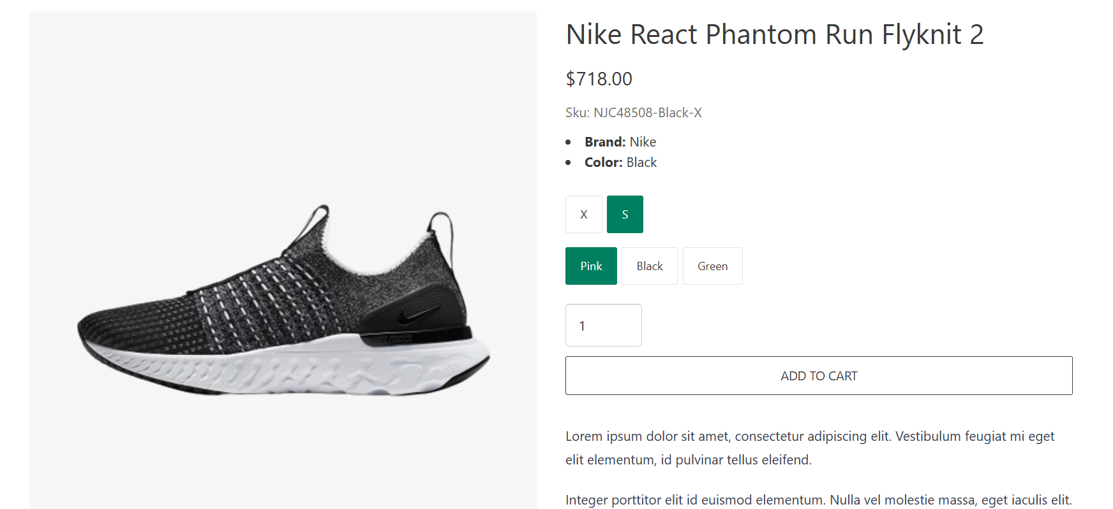

Test API : [POSTMAN_COLLECTION](https://drive.google.com/file/d/10wvqrXwKApFTiXx_ALXj6mYyL51HX2A0/view?usp=sharing)

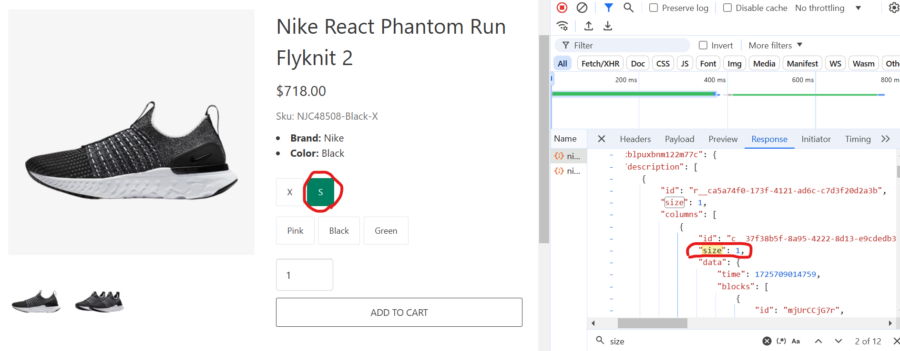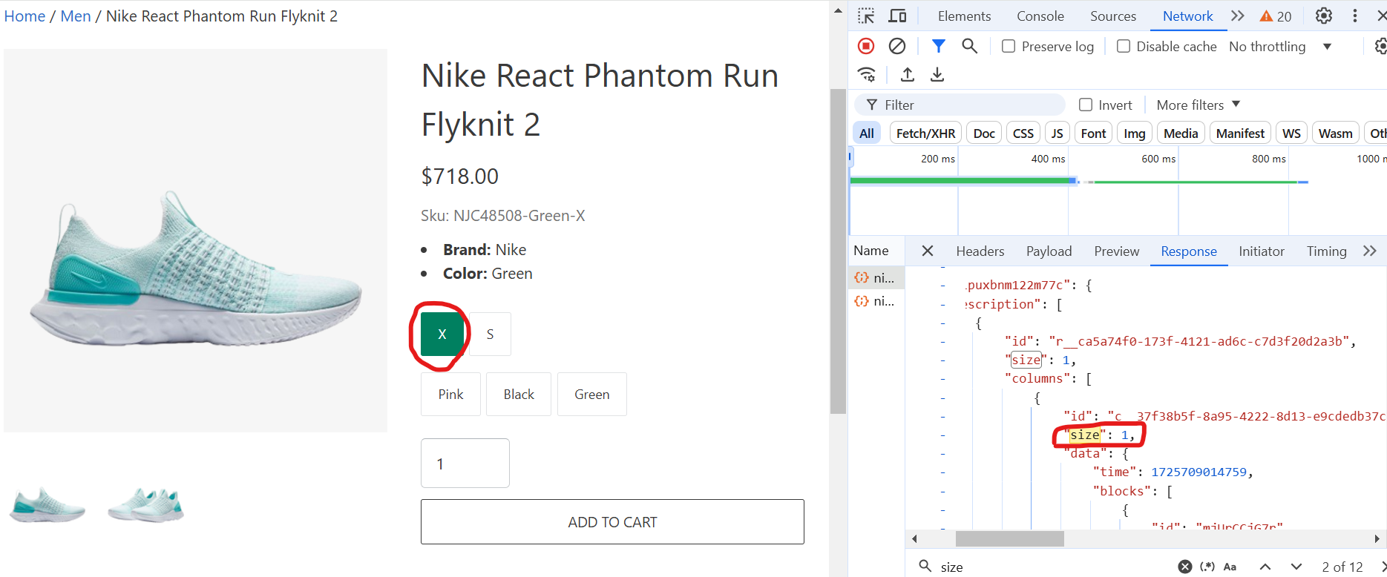

In API requests the size parameters are different for size S and X but in API response size values are the same.

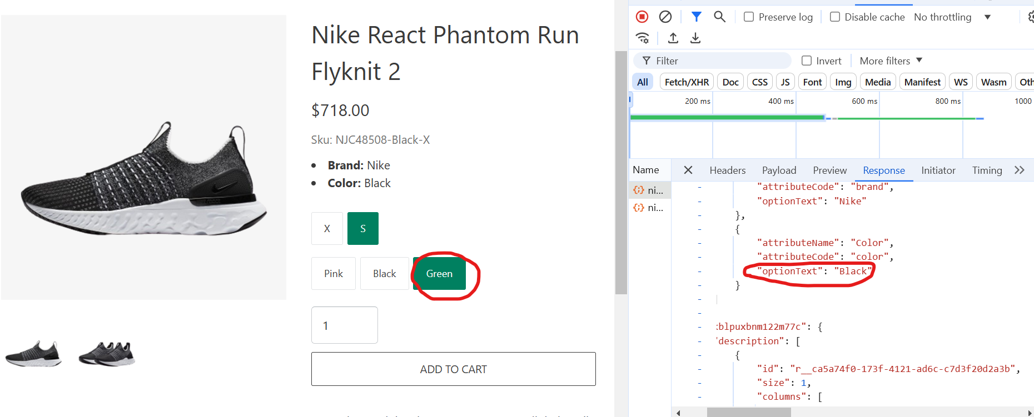

For size X color filters are working but for size S In API response **optionText** value is always black . so it is not working. It is showing the same result repeatedly.