# Figures (ONLY non-managed species)

**Figure 1.** Estimated number of species in each protected area (region) with savanna type on the left and no savanna on the right. Points and error bars indicate the posterior summaries (mean and 95% Bayesian Credible Intervals, respectively). Grey triangles are the number of species observed. The horizontal dashed line indicates the total number of species observed (73)



**Figure 2.** Estimated effect (slopes) of the different variables on mammal species richness across protected areas in South Africa. The plot shows the posterior summaries of the logit-linear model for the data augmentation parameter Ω. Points represent the mean, lines the 95% Bayesian Credible Intervals (BCI) and boxes 50% BCI (Effects were considered substantial if the 95% BCI did not overlap zero (vertical black dashed line). Numbers over the boxes indicate the probability of the parameters to be either greater or lower than zero.

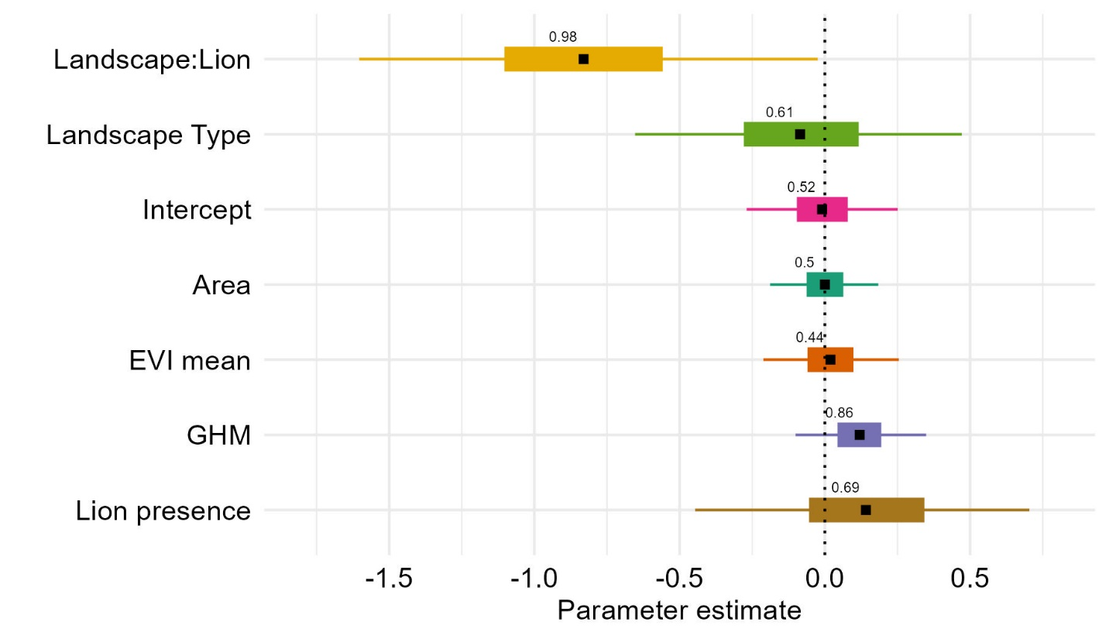

**Figure 3.** Interaction effects between landscape type (savanna vs no savanna) and lion presence on mammal species richness across 19 protected areas in South Africa.

