The website should have a log-in page. Something like this:
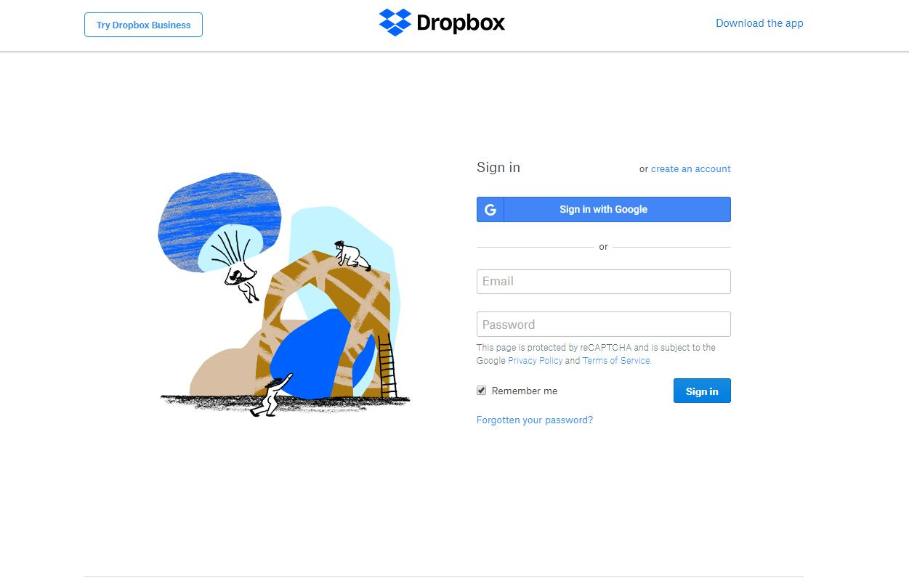
Signin with google should not be possible. They need a username and password, remeber me and signin. Also a forgot password.

