BARC: Brain Atlas Regional Counter
George Taylor¹, Brenton T. Laing¹
¹Department of BioMolecular Sciences, University of Mississippi, Oxford, MS 38673, U.S.A.
Correspondence should be addressed to Brenton Laing (btlaing@olemiss.edu)

Summary
Histological analysis of cells is a critical end-point for many experiment types, particularly in neuroscience. One bottleneck in histological analysis that consumes substantial experimenter effort, is vulnerable to subjective decision-making, or unable to deal with the heterogenous background signal present in brain tissue. Here we present BARC, a semi-automated cell counting software specifically designed for the use in brain tissue. The program is easy to install and launch as a graphic user interface. Once launched, the user can follow intuitive steps to paint regions of interest that correspond to the brain regions they are want to generate counts for. With the press of a button, users can analyze cell counts of any histological marker on their 2-dimensional image. The user has the ability to modify their settings according to the signal to noise ratio in their acquisition, delete erroneous identifications, and manually add cells that are undetected. Once they are satisfied with the counts on an image, they can save flattened image and generate spreadsheets corresponding to the regions analyzed.
1. Statement of Need
Cell counting as part of the histological analysis of brain slices is a valuable measure in neuroscience studies. This can be useful in immunostaining¹, tracing studies³, in-situ hybridization⁴. This can be particularly useful for particularly for markers like c-FOS² that have utility in assessing changes in neuronal activity patterns following environmental stimuli, pharmacological treatment, or circuit modulation. Together, these strategies are useful for localizing transcripts or proteins on in-tact brain tissue as a measurement for gene expression.
Cell counting is a critical bottleneck in the histological analysis pipeline for many laboratories. This is particularly true of neuroscience studies that often involve microscopy images of brain that do not have uniform background level. Many software solutions have been developed to address this analysis. For example, ImageJ⁵ is the most used manual cell counting tool that is freely available. Macros have been developed that semi-automate ImageJ analysis⁶. These macros have gained popularity and coincidentally, multiple groups have developed ImageJ tools named Autocount have been developed that attempt to automate cell counting of fluorescent images^{7,8}. These tools require installation of macros and user modification to code proper thresholding of signal for cell identification. These limitations hinder use uptake and . Other groups have utilized machine learning based algorithms for fungal cell counting under a complicated background⁹ for that research field, but even the most complex images are still far more simpler than neural tissue. Other tools such as Wholebrain¹⁰ and Belljar¹¹ have been developed for slice alignment and semi-automated cell detection, but these require the user to take images of numerous sections that contain the entire section. For many users, this requires tiling of many images together, creates a huge acquisition time cost, and results in the counting of many regions that are not experimentally needed. Thus, many software solutions have been produced by none meet
Here, we present Brain Atlas Regional Counter (BARC), a stand-alone semi-automated brain region histological analysis graphical user interface (GUI). This software is packaged as an executable file for simple implementation. It is open-source and released for any users to make updates as they appropriate for their use case. The wide range of settings available enable users to process images from any brain region and type of cell-based histological analysis they need.
2. Brief Description of Program Use and Features
BARC is a software written in Python 3.14. It is available both as a compiled EXE and as source code on the GitHub repository. The compiled EXE allows for the program to be run without installing a python environment or the required dependencies. Using the source code, the program is tested to run on Windows and Linux, with plans to support OS X. The dependencies utilized in this project include: Skimage and Scipy for image analysis. Pillow is used for other image manipulation tasks such as saving, resizing, and cropping. Numpy is used for mask manipulation and assists in image processing. Tkinter is used as the GUI framework. Fitz is used to handle the PDF format. Additional packages are used, but the listed packages utilize the majority of processing time.
The pipeline process is described by the workflow from data import, to region setting, to cell detection and counting, and a save (Figure 1).
Once started, the program shows a blank screen with a menu bar. The user is then able to import a .TIF image of the cells they would like to count. The user is then able to adjust the brightness of the image to improve visibility of the cells. This brightness feature was designed so as not impact image processing.
Once the image is imported, the user is then able to isolate cell regions either through a standardized PDF format digital atlas (e.g. Paxinos and Franklin) or with manual painting and boundary drawing. The user is then able to label each region of interest (ROI) that corresponds to the structure. This structure identification function allows users to conduct analysis of numerous brain regions within a single image simultaneously, but does not require acquisition of the entire brain slice.
The user is then able to visualize the cell mask to ensure that the software settings are aligned with the expected cell count outputs. These settings were designed to provide the user flexibility in setting parameters for cell identification that are optimized for their imaging configuration, signal to noise ratio, and staining techniques.. The software features a robust image processing settings menu to allow the user to tune their image processing setup to best fit their needs. The software also features an external settings configuration file, allowing for the saving and sharing of settings. The processing settings include options for background correction, noise reduction, contrast enhancement, signal enhancement, and threshold method. The available background correction methods are Tophat and Gaussian. The available noise reduction methods are Gaussian, Median, and Bilateral. The available contrast enhancement methods are Stretch, Clahe, and Gamma. The available signal enhancement method is an Unsharpen mask. The available thresholding methods are Otsu, Adaptive, Local, and Manual. Other settings include Circularity, Sell Size, and Watershed segmentation for overlapping cells.
Once the ROIs are set and the cell mask has been verified, the cell counter can be started. It will automatically apply the cell mask and count the total number of cells in each ROI. Users have the ability to add cells that are missed by the mask using a manual counting step, or to subtract from the mask that has counted portions of the image which are not cells. This strategy provides the user with a way to substantially reduce the total number of label clicks that they must apply, but still gives them ultimate decision making ability for what is a cell and not a cell. The software can automatically export the cell counts and a copy of the flattened .TIF image with the ROIs and the tick marks over the counted cells. The whole process only requires the user to use drop-down menus, text-boxes, radio-buttons, and clicks to conduct their analysis. This strategy provides a simple process for transparent evaluation of counts that is useful for evaluating and reporting results with record keeping for painted regions of interest and the cells identified as counted (Figure 2).
The GitHub code repository contains detailed information about the software not included here (https://github.com/LaingLab/BARC).
Figures
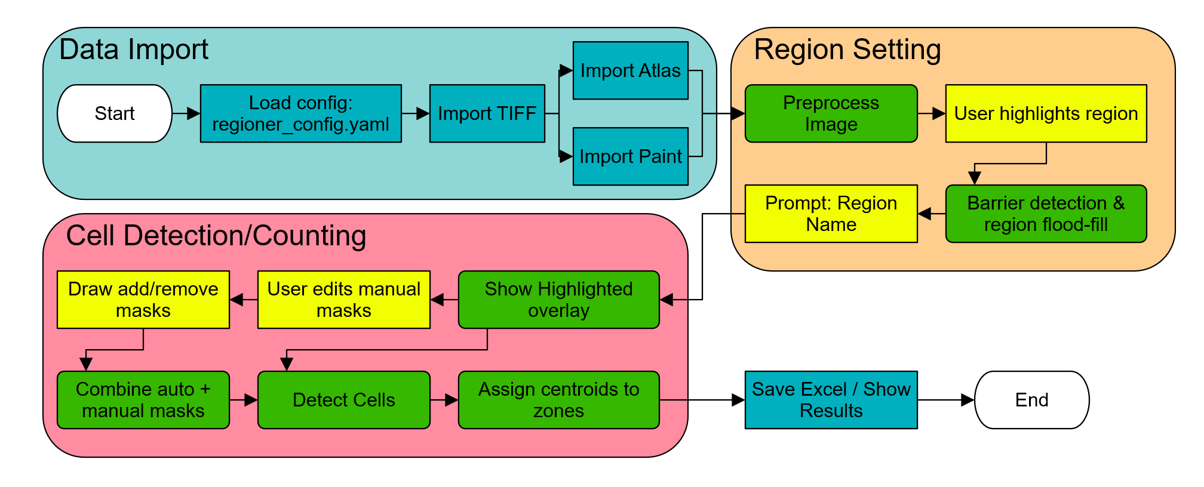
Figure 1. Workflow Diagram. This figure depicts data import steps with a configuration load step, followed by import of the TIFF, and then a choice between importing an atlas or

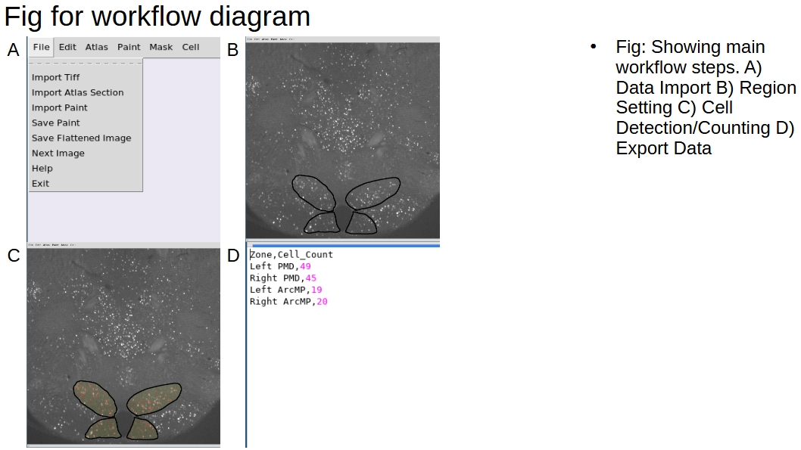
Fig 2. Showing main workflow steps. A) Data Import B) Region Setting C) Cell Detection/Counting D) Export Data

References
1 Tu, L. et al. Free-floating immunostaining of mouse brains. Journal of visualized experiments: JoVE, 10-3791 (2021).
2 Krukoff, T. L. in Cell neurobiology techniques 213-230 (Springer, 1999).
3 Wickersham, I. R., Finke, S., Conzelmann, K.-K. & Callaway, E. M. Retrograde neuronal tracing with a deletion-mutant rabies virus. Nature methods 4, 47-49 (2007).
4 Palop, J. J., Roberson, E. D. & Cobos, I. in Alzheimer's Disease and Frontotemporal Dementia: Methods and Protocols 207-230 (Springer, 2010).
5 Sheffield, J. B. ImageJ, a useful tool for biological image processing and analysis. Microscopy and Microanalysis 13, 200-201 (2007).
6 Grishagin, I. V. Automatic cell counting with ImageJ. Analytical biochemistry 473, 63-65 (2015).
7 Laing, B. T. et al. Regulation of body weight and food intake by AGRP neurons during opioid dependence and abstinence in mice. Frontiers in Neural Circuits 16, 977642 (2022).
8 Sharara, A., Kraft, C., Shameem, M. & Singh, B. N. AutoCount: An ImageJ Macro for Automatic Cell Counting of Fluorescent Images. DNA and Cell Biology Reports 6, 52-63 (2025).
9 Li, C. et al. Machine learning‐based automated fungal cell counting under a complicated background with ilastik and ImageJ. Engineering in Life Sciences 21, 769-777 (2021).
10 Fürth, D. et al. An interactive framework for whole-brain maps at cellular resolution. Nature neuroscience 21, 139-149 (2018).
11 Soronow, A. L. R., Jacobs, M. W., Dickson, R. G. & Kim, E. J. Bell Jar: A Semiautomated Registration and Cell Counting Tool for Mouse Neurohistology Analysis. eneuro 12 (2025).

