FULL-STACK APPLICATION
FurShield
Software Requirements Completion Report
Purpose | Implementation traceability, architecture, data design, verification, and handoff
Source | PetCare Full-Stack App SRS (final)
Stack | Next.js 16, React 19, MongoDB Atlas, Cloudinary, signed cookie sessions
Prepared | 26 August 2026
Release status | Local release candidate; deployment and MP4 are external release artifacts

Completion statement All mandatory application workflows in the SRS have an implemented local path. Optional family sharing and chatbot features remain intentionally excluded. Payment, delivery, and vet credential authentication are explicitly outside scope. Hosting and recording cannot be certified by a local build.

1. Problem and proposed solution
Pet-care information is often split across paper files, clinics, calendars, shelters, shops, and informal messages. That fragmentation makes reminders easier to miss and forces veterinarians and shelters to reconstruct context. FurShield centralizes these workflows around the animal while preserving role boundaries.
- Owners maintain multiple pets, rich health timelines, documents, appointments, adoption requests, cart activity, notifications, and reviews.
- Veterinarians publish availability, manage bookings, access only booked-pet histories, and record structured clinical observations and treatment.
- Shelters publish image-based profiles, maintain care logs, review adopter forms, reply, and finalize decisions.
- Visitors search care content, products, veterinarians, adoption listings, and public feedback without signing in.

2. Scope, assumptions, and constraints
Class | Decision | Treatment
Mandatory application scope | Owner, veterinarian, shelter, and public workflows | Implemented in the local application
Optional | Family sharing; AI chatbot | Not enabled; not required for acceptance
Excluded by SRS | Payments, physical delivery, vet credential authentication | Deliberately absent
External configuration | Email provider, deployment target | Environment-driven; in-app alerts work locally
Submission artifact | MP4 walkthrough | Script supplied; recording requires an interactive release environment

3. Architecture and system flow
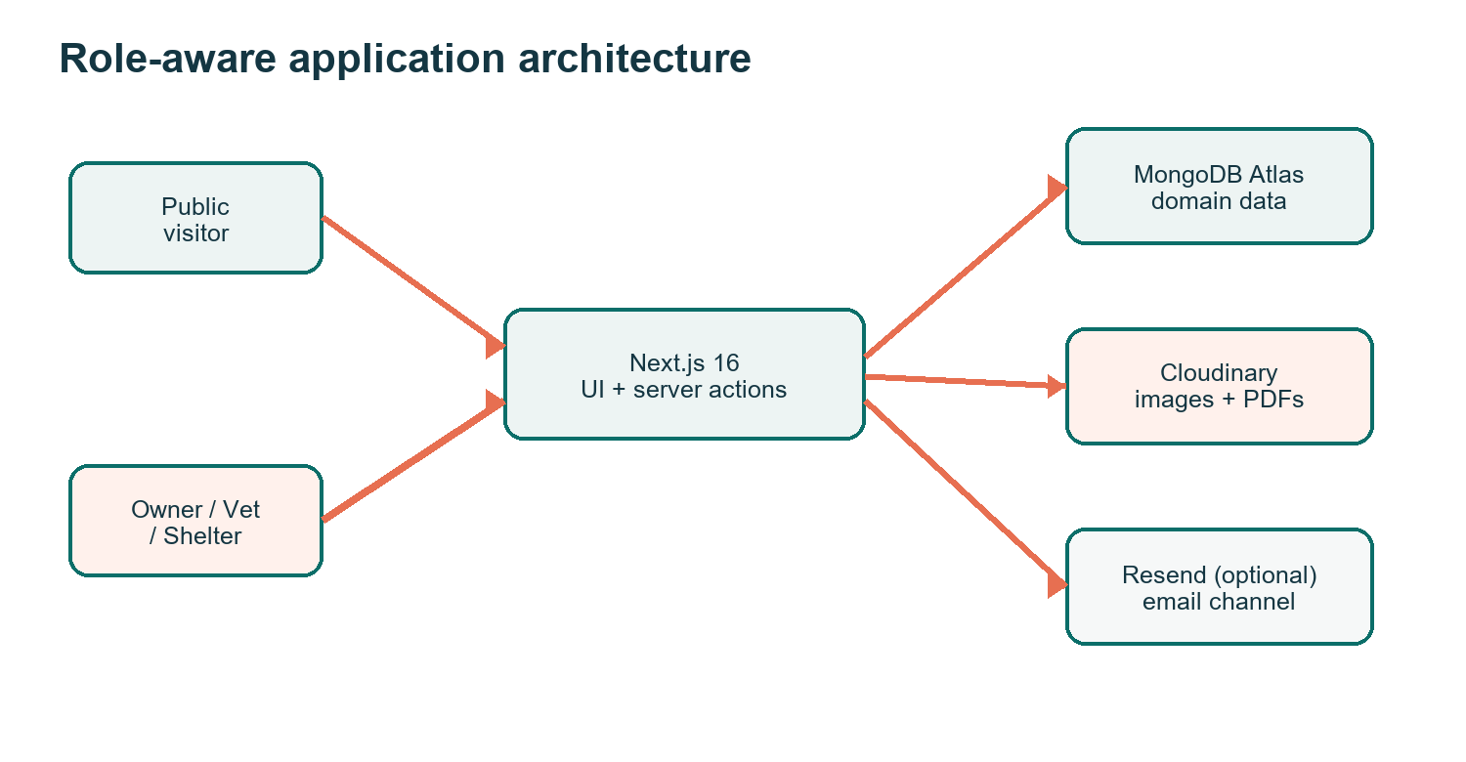
Figure 1. Browser, application, data, media, and optional email boundaries.
The Next.js application uses server-rendered routes for data-aware screens, server actions for form mutations, and route handlers for signed uploads. Every protected route and mutation repeats session, role, and ownership checks; navigation visibility is not treated as authorization.
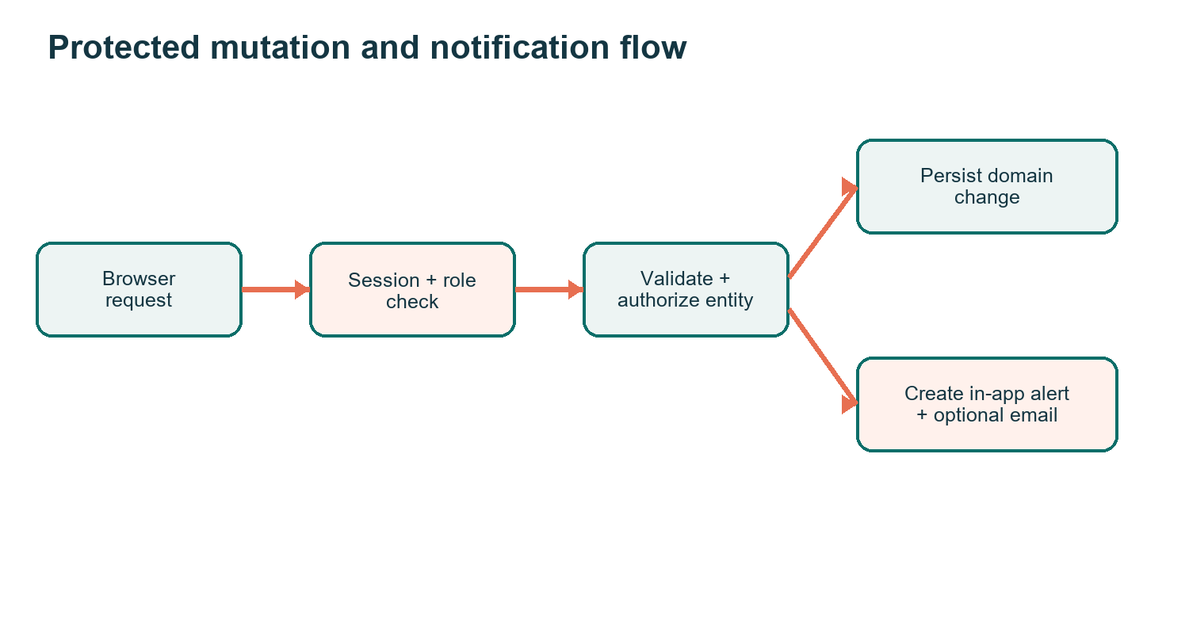
Figure 2. Authorization precedes persistence and user notification.

4. Database design
Collection | Key relationships | Purpose
users | role; owned pets/listings; reviews | Identity, contact data, vet profile/availability, shelter profile
pets | ownerId | Identity, gallery, allergies, ongoing conditions, microchip and weight
healthrecords | petId, ownerId, optional vetId | Vaccines, allergies, illness, treatment, labs, documents, insurance
appointments | ownerId, petId, vetId | Requested/rescheduled time, condition, reason, status
products | review target | Category, pet type, price, stock, details
carearticles | public content | Article, video, and FAQ metadata/content
adoptionlistings | shelterId | Animal profile, images, health/status, care logs
adoptioninterests | listingId, shelterId, adopterId | Form, reply, and decision lifecycle
reviews | authorId, targetType, targetId | One-to-five rating and public comment
notifications | userId | Appointment, vaccine, adoption, product, and system alerts
contactmessages | public submission | Persisted support/contact inquiries

Database choice The SRS explicitly permits MongoDB. Consequently, the seed script and Mongoose schemas are the database deliverables; a relational SQL script would not describe the implemented persistence layer accurately.

5. Functional requirement traceability
ID | Requirement | Status | Evidence
FR-01 | Owner account and contact details | Complete | Role-aware register/login/profile
FR-02 | Multiple pet CRUD and tabbed navigation | Complete | Owner pet workspace
FR-03 | Gallery, PDFs, X-rays, labs, insurance | Complete | Signed Cloudinary upload/view/delete
FR-04 | Health CRUD and chronological timeline | Complete | Structured records and due dates
FR-05 | Products, filters, details, cart quantities | Complete | No checkout by SRS exclusion
FR-06 | Articles, video, FAQs | Complete | Searchable public care library
FR-07 | Appointment booking and vet suggestions | Complete | Condition/location ranking
FR-08 | Vet profile, experience, slots | Complete | Registration and profile workspace
FR-09 | Booked-pet-only clinical access | Complete | Server-side appointment authorization
FR-10 | Treatment, labs, prescriptions, follow-up | Complete | Structured clinical form
FR-11 | Approve, reschedule actual time, complete | Complete | Vet schedule controls
FR-12 | Shelter listings with images and status | Complete | Public catalog + shelter management
FR-13 | Feeding, grooming, medical care logs | Complete | Per-listing care ledger
FR-14 | Adopter form, shelter reply, finalize | Complete | Decision lifecycle + alerts
FR-15 | Search/sort/filter across discovery | Complete | Pets/products/care/vets/adoption
FR-16 | Ratings/comments | Complete | Owner submission + public feedback
FR-17 | About, Contact, map | Complete | Dedicated pages + persisted form
FR-18 | Role-based access and notifications | Complete | Signed sessions + in-app alerts

6. Security and quality design
- Passwords are bcrypt-hashed at cost 12; signed session cookies are HTTP-only and SameSite=Lax, with Secure enabled in production.
- Database and media credentials remain in ignored environment files and are never returned to the browser.
- Upload signatures require authentication; media is restricted to expected formats and 10 MB client limits, and stored URLs must use the configured Cloudinary host.
- Veterinarian access to health history requires a matching, non-cancelled appointment for the veterinarian and pet.
- Responsive layouts, visible labels, focus indicators, reduced-motion support, semantic headings, native controls, empty states, loading states, and error boundaries support usability and accessibility.
- The application uses indexed identifiers, server rendering, reusable domain models, and stateless signed sessions to support scaling and compatibility across current browsers.

7. Test data and acceptance verification
Check | Result | Evidence
ESLint | Pass | npm run lint
TypeScript | Pass | Production build type-check
Next.js production build | Pass | 26 routes; static and dynamic generation
MongoDB seed | Pass | Idempotent demo dataset executed successfully
Authorization | Implemented | Role and ownership gates in pages/actions/routes
Secret isolation | Pass | .env.local excluded; .env.example contains names only
DOCX structural QA | Pass | Styles, headings, tables, relationships, and accessibility audited

The seed creates two owner pets, health events, appointments, products, an adoptable animal and care log, adopter interest/reply, reviews, and notifications. Re-running the seed updates known records instead of multiplying them.

8. Installation and role credentials
- Install Node.js 20 or newer and run npm install in the project directory.
- Copy .env.example to .env.local and fill MongoDB, Cloudinary, and SESSION_SECRET values. Resend variables are optional.
- Run npm run seed to create deterministic demonstration data.
- Run npm run dev for local use, or npm run build followed by npm start for a production-mode check.
Role | Email | Password
Owner | owner@furshield.test | FurShield123!
Veterinarian | vet@furshield.test | FurShield123!
Shelter | shelter@furshield.test | FurShield123!

Credential hygiene These accounts are demonstration-only. Replace the password and rotate all credentials before any public deployment.

9. Release checklist and residual external work
Item | Local state | Release action
Application features | Complete and build-verified | Run role walkthrough in target environment
DOCX visual render | Blocked: LibreOffice unavailable | Open once in Word/LibreOffice and visually inspect before submission
Email delivery | Adapter implemented; optional | Add verified sender and Resend API key if email is required
Hosted URL | Not created locally | Select host, configure secrets, deploy, and smoke-test
Mandatory MP4 | Demo script supplied | Record 7-10 minute walkthrough at 1080p
Credential exposure | User supplied credentials in chat | Rotate MongoDB and Cloudinary secrets before deployment

This report distinguishes application completion from external operational evidence. A passing local build cannot prove 24/7 availability, a deployed URL, email deliverability, or the existence of a recorded video.

