Dell OSD Customizer Tool

Dell OSD Customizer tool Version 6.1

Updated on January 2017 (AM)

First release: November 22, 2013

Amar Maouche

Dell EMEA IMS

# Overview

The OSD Customizer tool is designed to run from a SCCM /MDT Task Sequence or can be integrated into a WIM syspreped image such as Dell ImageAssist image (DIA).

The OSD Customizer tool is a set of scripts and configuration files that help to do following tasks:

* + For Dell ImageAssist:
    - The tool will just update the existing Unattend,xml with selected values for regional settings, computername, join domain details if required.
    - Install Applications at logon after sysprep if **OSDSettings**.ini and **Apps**.XML are configured with required applications installation.

**The Unattend.xml in DIA image has to be configured with User Account Control disabled, Administrator account enabled and Autologon enabled**.

* + For SCCM Image:
    - If Tool integrated at WinPE phase of TS, It assigns just the value to the right SCCM OSD TS variables (This is a NON BIF scenario)
    - If Tool integrated at Post-Delivery Group of TS running at Full Windows OS Phase, the tool will apply the regional settings using a custom xml file and / or rename the computername using wmi queries.
  + For MDT Image:
    - If Tool integrated at Post-Delivery Group of TS running at Full Windows OS Phase, the tool will apply the regional settings using a custom xml file and / or rename the computername using wmi queries. When using the switch /MDTForms the tool will display some Built in MDT Forms instead of the OSDFrontEnd.hta form.

Note: Applications installation is not supported for MDT or SCCM Images.

The tool retrieves values from the configuration file OSDSettings.ini and /or prompts the user for input via a custom HTA form. All values retrieved are stored in an output file OSDProfile.ini.

**Optional Scenario:**

OSDCustomizer can also be executed silently if the output file OSDProfile.ini is prepared previously and added to the location where the tool is located. To prepare an output profile you will need to run the OSDCustomizer.vbs /createProfile:<full_path>\OSDProfile.ini.

This created profile can be loaded by another run of one of OSDCustomizer with /AppplyProfile: <full_path>\OSDProfile.ini or using the option /AppplyProfile:AssetTag.

The /AppplyProfile:AssetTag can be useful during CFI image load in factory where we can inject the right name of profile to use based on content of Asset Tag value.

# How it works

#### For an SCCM Image:

1. As a first step, you will need to prepare and configure the file OSDSettings.ini located in CFG folder. See next sections for different settings that can be applied to the configuration file.
2. Create a SCCM package without a program to host only the OSD Customizer files.
3. For CFI SCCM boot in factory scenario, amend your task sequence and add 2 steps in “Post-Delivery Configuration” group:
   1. Add a new “run command line” task to execute the command: Cscript.exe OSDCustomizer.vbs as shown below:

Note that the package option is enabled and select the SCCM package you created in point 2. above.

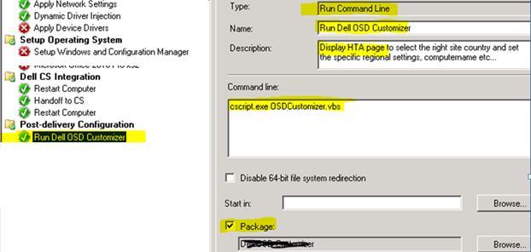

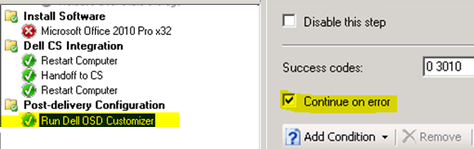

* 1. add a “Restart Computer” after “Run Dell OSD Customizer” step with options as highlighted below:

**Note:** The restart is required here only if you have entered a new computername within the HTA page of OSDCustomizer tool.

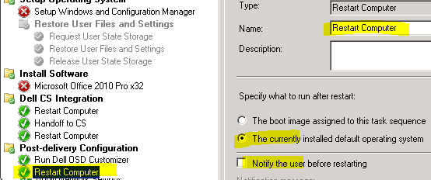

When running at Post Delivery group, the tool will assign TS variables and apply regional settings and /or rename hostname.

1. Optionally, OSDCustomizer can be set to run at WinPE phase of task sequence for customer onsite deployment if requested. At WinPE phase of TS, the tool will only assign TS variables. **This step not applicable for Dell CS SCCM boot in factory scenario.**

Notes:

* Running the tool from a TS will do the following:
  + Read OSDSettings.ini sections
  + Depending on settings in [General] section, it can display OSDFrontEnd.HTA form if “DefaultGateway” property is not set to “YES”.
  + Create OSDProfile.ini under _SMSTSLogPath folder as a result of the selected settings
  + Assign TS variables using the value of selected properties in OSDProfile.ini file
  + If Task Sequence variable CFI=True then the selected settings will be applied: such as regional settings, Time Zone, and /or rename Hostname with a new computername
  + Create OSDCustomizer.log under _SMSTSLogPath folder

#### For an MDT Image:

For MDT images, we have 2 options:

1. Running the tool by calling the MDT forms
2. Or Running the tool based on the OSDSettings.ini where you get a normal HTA page with fields based on the configuration of OSDSettings.ini

Only one of the options above has to be used and not both. More details on each options as described below:

1. **Running the tool by calling the MDT forms : the tool is designed to manage the 3 Forms below :**

* DeployWiz_LanguageUI.xml: for Regional settings
* DeployWiz_ComputerName.xml: for computername and or Domain and OU
* NICSettings_Definition_ENU.xml: for NIC configuration such static IP address etc…
  1. Copy the **OSDCustomizer** folder including all source files and scripts to your **Deployment share\Scripts** folder:

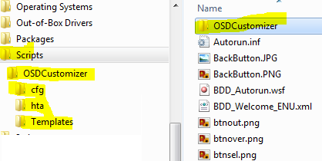

* 1. Add a run command line to execute the osdcustomizer with the /MDTForms switch as in in below commands:

To display only Computername /Domain form, use this command line:

**cscript.exe "%SCRIPTROOT%\OSDCustomizer\OSDCustomizer.vbs" /MDTForms:DeployWiz_ComputerName.xml**

To display only Regional settings form, use this command line:

**cscript.exe "%SCRIPTROOT%\OSDCustomizer\OSDCustomizer.vbs" /MDTForms:DeployWiz_LanguageUI.xml**

To display only NIC configuration settings form, use this command line:

**cscript.exe "%SCRIPTROOT%\OSDCustomizer\OSDCustomizer.vbs" /MDTForms:NICSettings_Definition_ENU.xml**

To display all 3 forms, use this command line:

**cscript.exe "%SCRIPTROOT%\OSDCustomizer\OSDCustomizer.vbs" /MDTForms:DeployWiz_LanguageUI.xml,DeployWiz_ComputerName.xml,NICSettings_Definition_ENU.xml**

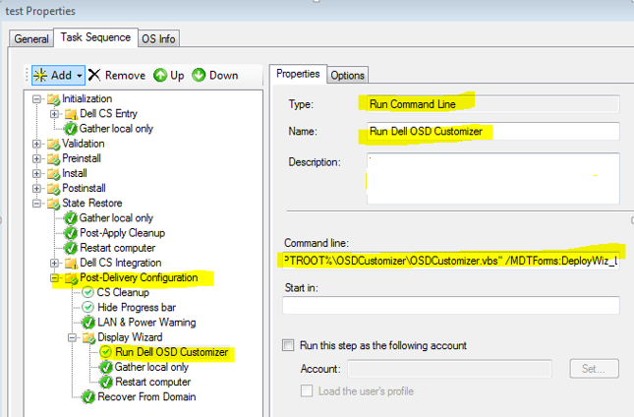

* 1. add a “Gather local only” MDT step as seen below:

**Note:** This is required in order to update the MDT OSDvariables before the Join domain step which is detailed in next step..

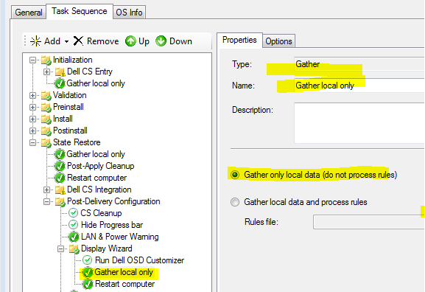

* 1. If a new computername is entered in the MDT Form then add a “Restart Computer” after “Run Dell OSD Customizer” step with options as highlighted below:

**Note:** The restart is required here only if you have entered a new computername within the MDT form.

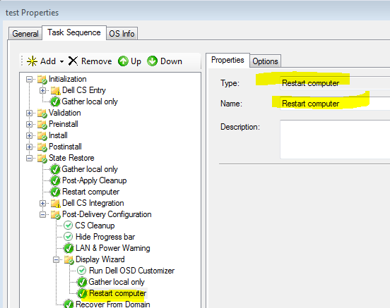

* 1. add a “Recover from Domain” only if the join domain is required and set is as seen below:

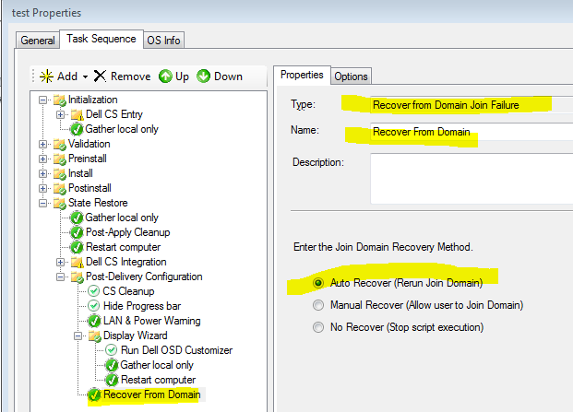

1. **Running the tool based on the OSDSettings.ini where you get a normal HTA page with fields based on the configuration of OSDSettings.ini:**
   1. Copy the **OSDCustomizer** folder including all source files and scripts to your **Deployment share\Scripts** folder:



* 1. Prepare and **configure** the file OSDSettings.ini located in CFG folder. See next sections for different settings that can be applied to the configuration file. You can edit the files using Notepad.exe.

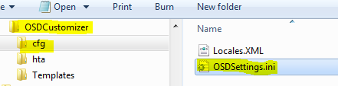

* 1. Amend your task sequence by adding some steps in “Post-Delivery Configuration” group as shown below:
  2. Add a new “run command line” task to execute the command: Cscript.exe OSDCustomizer.vbs as shown below:

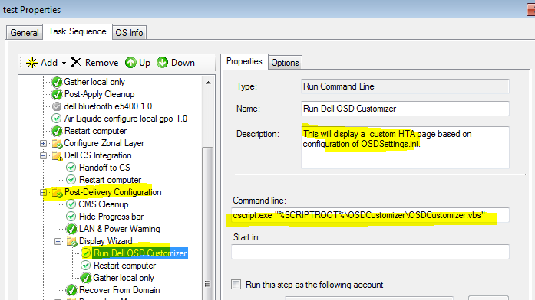

* 1. add a “Gather local only” MDT step as seen below:

**Note:** This is required in order to update the MDT OSDvariables before the Join domain step which is detailed in next step..



* 1. If a new computername is entered in the HTA page then add a “Restart Computer” after “Run Dell OSD Customizer” step with options as highlighted below:

**Note:** The restart is required here only if you have entered a new computername within the HTA page of OSDCustomizer tool.



* 1. add a “Recover from Domain” only if the join domain is required and set is as seen below:



#### For a Syspreped Image captured with Dell ImageAssit:

1. As a first step, you will need to prepare the source files using some structure like below:

For the example below, the DellOSDcustomizer contains the folder “OSDCustomizer” which is the tool itself and the “Applications” folder that contains the source packages for applications installation.

“Applications” folder is required only if applications installation is enabled in OSDSettings.ini otherwise you can remove it.

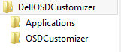

1. Configure the following files:
   1. OSDSettings.ini located in CFG folder.

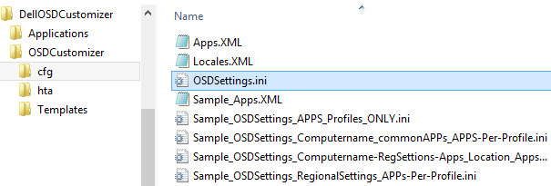

* 1. Configure APPS.XML this is required only if applications installation is enabled in OSDSettings.ini

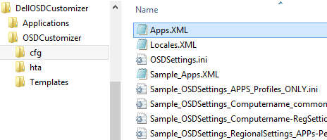

* 1. Remove all Sample files as they are only provided as examples.

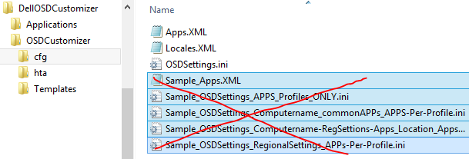

See next sections for different settings that can be applied to the configuration files.

1. Mount your WIM image using DSIM.

Example: DISM.exe /Mount-Image /ImageFile:C:\test\images\myimage.wim /Index:2 /MountDir:C:\test\offline

Where myimage.wim with index 2 is the OS image partition and index 1 is for system reserved partition.

1. Copy the whole DellOSDCustomizer folder and folders to the root of your mounted wim

Example:

XCopy C:\MyDATA\ DellOSDCustomizer \*.* /cherky C:\test\offline\DellOSDCustomizer\

1. Using regedit, load the SYSTEM hive from your mounted wim image and name it SYSTEM2 and modify the HKEY_LOCAL_MACHINE\System2\Setup\CmdLine value as:

"CmdLine"=Wscript.exe C:\DellOSDCustomizer\OSDCustomizer\OSDCustomizer.vbs

Or

"CmdLine"="Wscript.exe C:\DellOSDCustomizer\OSDCustomizer\OSDCustomizer.vbs /ApplyProfile:AssetTag"

The option /ApplyProfile:AssetTag will require the creation of all profiles to apply and prepare the asset tag value to match one of the created profile.

Below a screenshot showing how to modify the loaded system hive (named here as System2):

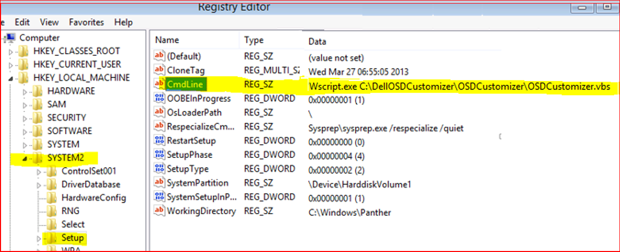

1. Unload the SYSTEM2 hive (SYSTEM2 is the SYSTEM file located on the mounted Image\Windows\System32\Config folder)
2. Unmount the image and save changes using DSIM such as example below:

DISM.exe /Unmount-Wim /MountDir:C:\test\offline /commit

# Files and Folders

The OSDCustomizer tool is structured as shown in figure 1 below.

**OSDCustomizer.vbs:**  this is the main script to call in your Task sequence step (SCCM/MDT) or in CommandLine of registry file if DIA image. Depending on configuration files, a HTA frontend form may be displayed or not.

**CFG** folder: contains all configuration files like locales.xml and OSDSettings.ini

**HTA** folder: contains the HTA pages and other files used by HTA pages.

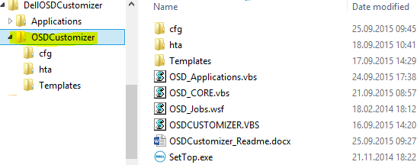

*Figure 1: OSDCustomizer files & folders.*

CFG folder: The CFG folder (as shown figure 2) contains 3 input files:

* **OSDSettings.ini**: This is the configuration file you will need to adapt to your customer requirements. This is the only configuration file needed to be set up before starting using the tool.
* **APPS.XML**: This is the configuration file you will need to prepare for applications installations. This is required only for ImageAssist images if you have applications to install at logon after sysprep.
* **Locales.xml**: contains the list of all Windows user locales with default keyboard layouts and country ID per

user locale.

Note: Please remove all Files starting with “Sample-“: they are provided here only as examples.

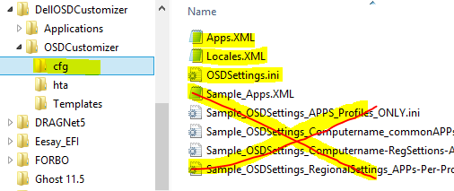

*Figure 2: CFG subfolder.*

HTA folder: The HTA folder (as shown in figure 4) contains 3 HTA pages that can be displayed during the execution of the tool and this is depending on OSDSettings.ini configuration.

**OSDFrontEnd.hta**: main form to select the different settings for localization, computername and Join domain details.

**AppForm.hta**: form to display the full list of applications to install if not configured to be installed per location and/or profile in OSDSettings.ini.

**KeybLayout.hta**: can be displayed to set the correct keyboard before getting the OSDFrontEnd.hta to fix any issue when typing a password in the hidden field password and confirm password of OSDFrontEnd.hta.

Splash.hta and SplashErr.hta are used during Applications installation only.

**Rest of the files**: shared files used by the HTA pages.

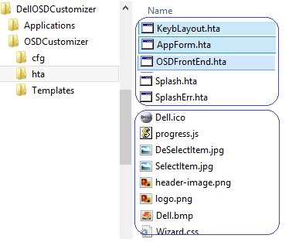

*Figure 4: HTA folder.*

Templates folder: The Template folder (as shown in figure 5) contains the templates of Unattend.xml files that can be merged during the execution of the tool and this is depending on OSDSettings.ini configuration. Please do not update those files and leave as is.

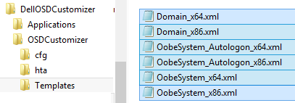

*Figure 5: Templates folder.*

# TS Variables assigned by OSDCustomizer (default SCCM OSD variables)

Running OSDCustomizer tool from a task sequence will assign the OSD variables as specified in the table below.

Mapping table between OSDCustomizer properties and SCCM OSD TS variables:

|  |  |
| --- | --- |
| **OSDCustomizer Property** | **TS variable** |
| UserLocale | OSDUserLocale |
| SystemLocale | OSDSystemLocale |
| InputLocale | OSDInputLocale |
| UILanguage | OSDUILanguage |
| TimeZone | OSDTimeZone |
| ComputerName | OSDComputerName |
| Domain | OSDDomainName |
| DomainOU or OUx where x=1…99 | OSDDomainOUName |
| DomainUser | OSDJoinAccount |
| DomainUserPassword | OSDJoinPassword |

The tool will assign a value for a TS variable only if the corresponding OSDCustomizer Property is defined or configured to be prompted by the tool and this based on OSDSettings.ini file.

Note:

To not define a TS variable, we just need to add a SKIP*<property_name>*=YES and not assign a value to the specific *<property_name>* within OSDSettings.ini.

Please read the next section to understand how to define and configure each OSDCustomizer Property using the OSDSettings.ini file.

# OSDSettings.ini File Configuration

Before running the OSDCustomizer tool, you have to customize the OSDSetting.ini file to match your customer’s requirements (See the section named “OSDSettings.ini Sample Configuration” that covers some scenarios).

OSDSettings.ini is using sections and properties. Depending on which deployment type you have chosen then some sections have to be completed.

Here are the list of sections and properties used per section:

**[General] section:**

This is the main section where we have to define which type of deployment is selected within your environment.

The table below lists all properties in [General] section and their associated range of values.

[General] section Details

| Property | Value |
| --- | --- |
| DefaultGateway | YES / NO  If settings are based on IP Default Gateway address then set DefaultGateway=YES  When enabling DefaultGateway property, OSDCustomizer will run in silent mode and not displaying any HTA page. |
| MUI | YES / NO  Set **MUI=YES** to select and set the UILanguage.  Note: OSDCustomizer is not installing language packs but just assign TS variable OSDUILanguage and apply selected display language in regional settings. |
| SkipLocationName | YES / NO  the SkipLocationName property can be set to one of the following value:   * YES : set this value if you need to skip the prompt a location name. * NO : default value and this will prompt for location name to select. |
| MultiInputLocalePerLocation | YES / NO   * Is set to YES when it is required to have multiple input locale per location. This property is working only when Location section is defined. |
|  |  |
| **SkipRegionalSettings** | YES / NO  the SkipRegionalSettings property can be set to one of the following value:   * YES : set this value if you need to skip the prompt for the regional parameters and will not display the regional form hta page. * NO : default value and this will display the regional hta page. |
| **SkipSystemLocale** | YES / NO   * YES: set this value if you need to skip the prompt for the System Locale. |
| **SkipUserLocale** | YES / NO   * YES: set this value if you need to skip the prompt for the User Locale. |
| **SkipInputLocale** | YES / NO   * YES: set this value if you need to skip the prompt for the Input Locale. |
| **SkipUILanguage** | YES / NO   * YES: set this value if you need to skip the prompt for the UI Language. |
| **SkipCountry** | YES / NO   * YES: set this value if you need to skip the prompt for the Country. |
| **SkipTimeZone** | YES / NO   * YES: set this value if you need to skip the prompt for the Time Zone. |
| **SkipDomainJoin** | YES / NO   * YES: set this value if you need to skip the prompt for the Domain Join Properties. |
| **SkipDomainName** | YES / NO   * YES: set this value if you need to skip the prompt for the Domain name. |
| **SkipDomainOU** | YES / NO   * YES: set this value if you need to skip the prompt for the Domain OU name. |
| **SkipDomainUser** | YES / NO   * YES: set this value if you need to skip the prompt for the Domain User name. |
| **SkipDomainUserPassword** | YES / NO   * YES: set this value if you need to skip the prompt for the Domain User Password. |
| **SkipComputerName** | YES / NO   * YES: set this value if you need to skip the prompt for the ComputerName. |
| **SkipKeyboardForm=YES** | YES / NO  the **SkipKeyboardForm** property can be set to one of the following value:   * YES : set this value if you need to skip the run of KeyboardLayout form hta page.   This form is used to prepare the next frontend hta page to get the right keyboard in case we have to enter or type in some fields like UserPassword. |

**[ComputerNaming] section:**

This section is used to define a certain convention naming for Computer name to differentiate Desktops from Laptops systems.

The computer name will be set by default to “Construct”.

The table below lists all properties in [ComputerNaming] section and their associated range of values.

[ComputerNaming] section Details

| Property | Value |
| --- | --- |
| Desktop | <**value**>  The <**value**> could be something like D, DT, WS or any custom abbreviation to distinct desktops from laptops or leave it blank if not needed.  Note: it is recommended that the value size to be no more than 2 characters. |
| Laptop | <value>  The <value> could be something like L, LP, NB or any custom abbreviation to distinct desktops from laptops or leave it blank if not needed.  Note: it is recommended that the value size to be no more than 2 characters. |
| Server | <value>  The <value> could be something like SRV, S or any custom abbreviation to distinct Servers from Laptop /Desktop or leave it blank if not needed.  Note: it is recommended that the value size to be no more than 2 characters. |
| Construct | Can be set to use a combination of variables <Prefix>, <Desktop_Laptop_Server>, <Service_Tag> or <Suffix> and separated with “+”.  Examples:  Construct =<Prefix>+<Desktop_Laptop_Server>+<Service_Tag>+<Suffix>  Or  Construct =<Prefix>+<Desktop_Laptop_Server>+<Service_Tag>  Or  Construct =< Prefix >+<Desktop_Laptop_Server>+<Suffix>  <Prefix> and <Suffix> can are used only when working with Locations. |

**[MUIList] section:**

This section is used to define the list of language packs to manage.

The table below lists all properties in [MUIList] section and their associated range of values.

MUIList section Details

| Property | Value |
| --- | --- |
| <Language name> | **<culture_language_name>**  Where **<culture_language_name>** can be one of the culture language name for the language pack to integrate.  For example, to add French language pack, just add a line like:  **French =fr-FR**  Here below a list of all LP (full LP or Partial LP) with their culture names:  English=en-US  Dutch =nl-NL  French =fr-FR  German =de-DE  Italian =it-IT  Japanese =ja-JP  Spanish =es-ES  Arabic =ar-SA  Chinese - PRC=zh-CN  Chinese - HK=zh-HK  Chinese - TW=zh-TW  Czech =cs-CZ  Danish =da-DK  Finnish =fi-FI  Greek =el-GR  Hebrew =he-IL  Hungarian =hu-HU  Korean =ko-KR  Norwegian=nb-NO  Polish =pl-PL  Portuguese - BR=pt-BR  Portuguese - PT=pt-PT  Russian =ru-RU  Swedish =sv-SE  Turkish =tr-TR  Bulgarian =bg-BG  Croatian =hr-HR  Estonian =et-EE  Latvian =lv-LV  Lithuanian =lt-LT  Romanian =ro-RO  Serbian =sr-Latn-CS  Slovak =sk-SK  Slovenian =sl-SI  Thai =th-TH  Ukrainian =uk-UA  Note: The full list above can be added to the OSDSettings.ini but just add a semi colon (;) at front of each NOT needed Language pack.  Use this link for a supported MS language packs:  <http://technet.microsoft.com/en-us/library/dd744369(WS.10).aspx> |

**[Applications] section:**

This section is used to define how to install applications. We can define different options in this section like installing Common Applications, Applications per location, Applications per profile or skip/display a general Applications form.

The table below lists all properties and their associated range of values.

[Applications] section Details

| Property | Value |
| --- | --- |
| AppsInstall | YES / NO   * YES: set this value if you need to install applications   Note: This is only available for DIA Images. |
| SkipAppsForm | YES / NO   * YES: set this value if you need to skip the display of AppForm.hta. means you have to define applications to install per location, profile or common applications. * NO: This will display the APPForm.hta to select which applications to be installed. |
| CommonApplicationXXX=APPID  Where XXX=001 to 999  And APPID is the ID value you defined in your APPS.XML file. | **list all common applications to be installed for all systems and/or locations**  Example: in example below, I defined 2 common applications App2 and App4 as common applications for all systems and/or for all locations.  CommonApplication001=App2  CommonApplication002=App4 |
| AppsPerLocation | YES / NO   * YES: set this value if you need to install applications per location. * NO: no applications per location |
| AppsPerProfile | YES / NO   * YES: set this value if you need to install applications per profile/department. * NO: no applications per profile. |
| AutologonSetInUnattendXML | YES / NO   * YES: set this value if “autologon with admin user“ set in your unattend.xml * NO: set this value if “autologon” not set in your unattend.xml.   Note: if value is “NO” then you have to provide the username and password as detailed in next properties |
| AutologonUser | **<enter the administrator username>** |
| AutologonUserPassword | **<enter the password of the administrator username>** |
| EncryptedAutologonUserPassword | **True/False**   * False: set this value if the value of “AutologonUserPassword” is in clear text * True: set this value if the password is encrypted using “**Windows System Image Manager**” tool. Only WSIM is supported for encryption of password, |

**[Location] section:**

This section is used to define the list of Locations or sites.

This section should be defined when DefaultGateway=Yes and SkipLocationName=NO.

The table below lists all properties and their associated range of values.

[Location] section Details

| Property | Value |
| --- | --- |
| List | **<Location name 1>,< Location name 2>,< Location name 3>,….< Location name n>**  Where < **Location** name x>is a short **Location** name.  Example: here below an example of **Location** list:  **[Location]**  **List=Belgium;France;Netherlands;Italy;United Kingdom;Germany;Spain;United States;Brazil;Argentina**  **Note:** *a comma* ***“,****” or “;” should be specified to separate two Locations.* |

**[<Location Name>] section:**

This section is used to define all the properties for a specific location <Location Name>.

This section should be defined when DefaultGateway=Yes and/or SkipLocationName=NO.

The table below lists all properties and their associated range of values.

[<Location Name>] section Details

| Property | Value |
| --- | --- |
| SystemLocale | **<*locale_name*>**  Sets the language for non-Unicode programs (also called system locale) and font settings in Windows.  <locale_name> specifies the name of the language and locale to set as the default language for non-Unicode; for example, en-US, fr-FR...  Note: You cannot set Unicode-only languages as the system locale. |
| UserLocale | **<*locale_name*>**  Specifies the per-user settings used for formatting dates, times, currency, and numbers.  For example, en-US, fr-FR, or es-ES. |
| InputLocale | **<language_id1:keyboard_layout1>;<language_id2:keyboard_layout2>;….;<language_idn:keyboard_layoutn>**  Sets the input locales and keyboard layouts to use.  The value of the <language_ID>:<keyboard_layout> pair can be for example: 0409:00000409  Use this link for more details on input locales:  <http://technet.microsoft.com/en-us/library/dd744319(WS.10).aspx> |
| UILanguage | **<*language_name*>**  <language_name> specifies the name of the language pack to set as the default; for example, ja-JP.  Note: Testing is only made on Language packs (Full LP or Partial LP) and not on language Interface Packs (LIP). So if using LIP then think to install the parent language also otherwise the apply setting may fail.  Use this link for more details on FLP, PLP, LIP: <http://technet.microsoft.com/en-us/library/dd744369(WS.10).aspx> |
| Country | **<Country_ID>**  Where <Country_ID> is the geo location ID for the selected country.  For example, for Switzerland the Country ID is 223.  For a table of supported locations in Windows 7 click here. |
| Prefix | **<Prefix>**  The value could be set to the site code of the selected location and used in combination with “Suffix” for the computer name.  For example, a site named Geneva may have Prefix=GVA. |
| Suffix | **<Suffix>**  Where <Suffix> **can** be: an empty value or set to **Service_Tag.**  When the value of Suffix is set to Service_Tag then the Service tag of the target system will be extracted and used in combination with site code for the computer name. |
| TimeZone | **<*timezone_name*>**  <timezone_name> specifies the name of the time zone to use; for example, TimeZone = **Pacific Standard Time.** |
| Domain | **<domain_name>**  Where **<domain_name>** can be : set to **a domain name** or leave it **blank** if joining the system to a **workgroup.** |
| DomainOU | **<Machine_Object_OU_LDAP_Path>**  Where **<Machine_Object_OU_LDAP_Path>** can be : set **the full LDAP of the Organization Unit** that the system will joinor leave it **blank** if no specific OU is needed.  For example,  **DomainOU=OU=WOrkstations,OU=Amsterdam,DC=EMEA,DC=XYZCORP,DC=com** |
| DomainUser | **<username>**  Where **<username**> is a domain user account to be used for joining the system to the domain. |
| UserPassword | **<Password>**  Where **< Password** > is the password for the domain user account used for joining the system to the domain.  For security reason, you can set the **< Password** > value to blank and then it will asked to enter the password during the deployment process but only when using Location. |
| ApplicationXXX  Where XXX=001 to 999 | **<Enter APP ID of the application>**  **Example: below defined 2 applications for a specific location:**  **Application001=App3 Application002=App2**  **Note: set** SkipAppsForm=YES when defining Applications to install per location. |

**[Profile] section:**

This section is used to define the list of Profiles/Departments.

This section should be defined when **AppsPerProfile=YES and SkipAppsForm=YES**.

The table below lists all properties and their associated range of values.

[Profile] section Details

| Property | Value |
| --- | --- |
| **ProfileList** | **<Profile name 1>,< Profile name 2>,< Profile name 3>,….< Profile name n>**  Where < **Profile** name x>is a short **Profile** name.  Example: here below an example of **Profile** list:  **[Profile]**  **ProfileList=Accounting;Finance;IT;HR;Marketing;Sales**  **Note:** *a comma* ***“,****” or “;” should be specified to separate two Locations.* |

**[<Profile Name>] section:**

This section is used to define all the properties for a specific Profile **< Profile Name>.**

The table below lists all properties and their associated range of values.

[<Profile Name>] section Details

| Property | Value |
| --- | --- |
| ApplicationXXX  Where XXX=001 to 999 | **<Enter APP ID of the application>**  **Example: below defined 2 profiles with specific applications:**  **[Accounting]**  **Application001=App3**  **Application002=App4**  **[Marketing]**  **Application001=App5**  **Application002=App6**  **Application003=App7  Where App3, App4,…,App7 correspond to the application ID defined in Apps.xml.** |

**[DefaultGateway] section:**

This section is used to define the list of default DefaultGateway mapped to specific sites.

This section should be defined when the property in [general] section named DefaultGateway is set to Yes.

The table below lists all properties and their associated range of values.

[DefaultGateway] section Details

| Property | Value |
| --- | --- |
| <IP default gateway>  Where <IP default gateway> is a default gateway IP address. | **<Site_name>**  Where <Site name x>is a short site name as defined in the list of the sites for a specific location.  Example: here below an example of sites within EMEA location:  **[DefaultGateway]**  192.168.1.1=**Geneva**  192.168.2.10=Paris  192.168.3.1=Bracknell  192.168.3.2=Bracknell  **Note:** as you can see it in the example above one site could be mapped to many defaults DefaultGateway*.*  Below an example of a defined site : (similar to a location section)  **[Geneva]**  SystemLocale=en-US  UserLocale=fr-CH  InputLocale=100c:0000100c  UILanguage=fr-FR  Country=223  Prefix=CH  Suffix=Service_Tag  TimeZone=W. Europe Standard Time  Domain=EMEA.XYZCorp.com  DomainOU=OU=WOrkstations,OU=Geneva,DC=XYZ,DC=com  ;DomainUser=  ;DomainUserPassword= |

**Note: DefaultGateway** deployment option is not supported for DIA images

**[Domain] section:**

This section is used to define the list of domains.

This section should be defined when DefaultGateway=NO and/or SkipLocationName=YES.

The table below lists all properties in [Domains] section and their associated range of values .

Domains section Details

| Property | Value |
| --- | --- |
| List | **<Domain name 1>,< Domain name 2>,< Domain name 3>,….< Domain name n>**  Where < **Domain** name x> is the name of a domain.  Example: for XYZCorp company here is the list of domains used in 3 regions EMEA, Americas and Japan:  [Domain]  List=EMEA.XYZCorp.com,AMER.XYZCorp.com,JAPN.XYZCorp.com  **Note:** *a comma* ***“,****” should be specified to separate two domain names.* |

**[<Domain Name>] section:**

This section is used to define the list of OUs per <Domain Name>.

This section should be defined when DefaultGateway=NO and/or SkipLocationName=YES.

The table below lists all properties and their associated range of values.

[<Domain Name>] section Details

| Property | Value |
| --- | --- |
| OU<x>  Where <x> is a number from 0 to 99 | **<Machine_Object_OU_LDAP_Path>**  Where **<Machine_Object_OU_LDAP_Path>**  is the **full LDAP of an Organization Unit**.  Example: here below an example of OU names in EMEA.XYZCorp.com domain:  [EMEA.XYZCorp.com]  OU1=OU=WOrkstations,OU=Amsterdam,DC=EMEA,DC=XYZCORP,DC=com  OU2=OU=Portables,OU=Amsterdam,DC=EMEA,DC=XYZCORP,DC=com  OU3=OU=WOrkstations,OU=Bracknell,DC=EMEA,DC=XYZCORP,DC=com  OU4=OU=Portables,OU=Bracknell,DC=EMEA,DC=XYZCORP,DC=com  OU5=OU=WOrkstations,OU=Geneva,DC=EMEA,DC=XYZCORP,DC=com |

# APPS.XML File Configuration

The file setup/configuration of the APPS.XML is required only if we need to install applications after Sysprep for an ImageAssist image only.

You need to create your own APPS.xml based on the sample file named Sample_APPS.xml file.

Note: in order to install applications you have to enable in the Unattend,xml the following items:

1. Enable Administrator account
2. Disable User account Control (UAC)
3. Enable Autologon with a user, password and logoncount

See the sample Unattend.xml at the end of this document.

Here is the list of properties used for each application node:

**<Application> </Application> Node:**

You need to create one Application Node for each application to install.

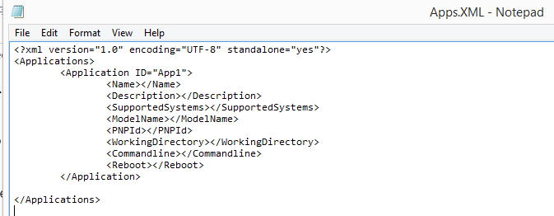

The table below lists all properties in Application node and their associated range of values.

| Property | Value |
| --- | --- |
| ID= | “APPxxx”  This has to be a unique ID for each application.  Where xxx is a number starting from 1 to 999.  Example: ID=”App1” |
| <Name></Name> | Enter a name of the application to install.  Example: <Name>Adobe Reader EN</Name> |
| <Description></Description> | Enter a Description of the application to install.  Example: <Description>Adobe Reader English version 11</Description> |
| <SupportedSystems></SupportedSystems> | Set one of the following values:  */Desktops/Notebooks   * * : all Systems * Desktops : desktops only * Notebooks : notebooks only   Below 3 examples:  <SupportedSystems>*</SupportedSystems>  <SupportedSystems>Notebooks</SupportedSystems>  <SupportedSystems>Desktops</SupportedSystems> |
|  |  |
| **<ModelName></ModelName>** | Enter the right BIOS name  Example: <ModelName>Latitude E7440</ModelName>  <ModelName>Latitude E7240</ModelName> |
| **<PNPId></PNPId>** | Enter the PNPId of the device.  Note: please add amp; after the symbol & of the PNPid as shown in example below.  Example: you can as many <PNDId> entries as you need:  <PNPId>USB\VID_8087&amp;PID_07DC</PNPId>  <PNPId>PCI\VEN_8086&amp;DEV_08B1</PNPId> |
| **<WorkingDirectory>**  **</WorkingDirectory>** | Enter the full path where application source is located.  Note: no need to add \ at the end of the path. See example below:  Example:  <WorkingDirectory>C:\DellOSDCustomizer\Applications\Intel Proset</WorkingDirectory> |
| **<Commandline></Commandline>** | Enter the name of the command line for the application to install.  Note: Just enter name of command without full path as the command line /Batch file or executable is located at the same location as Working directory path defined above. See example below:  Example:  <Commandline>Install.cmd</Commandline> |
| **<Reboot></Reboot>** | true / false  Note: if an application installation requires a reboot after the install then set it to “true”. The tool is managing the reboot and continues installation of other applications is required. See example below:  Example:  <Reboot>true</Reboot> |

**Below an example of Apps.xml:**

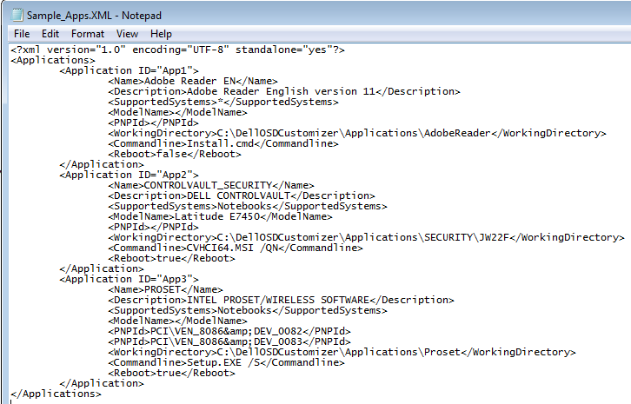

**Below an example of Unattend.xml used in a DIA image with the required settings for applications installation as highlighted below:**

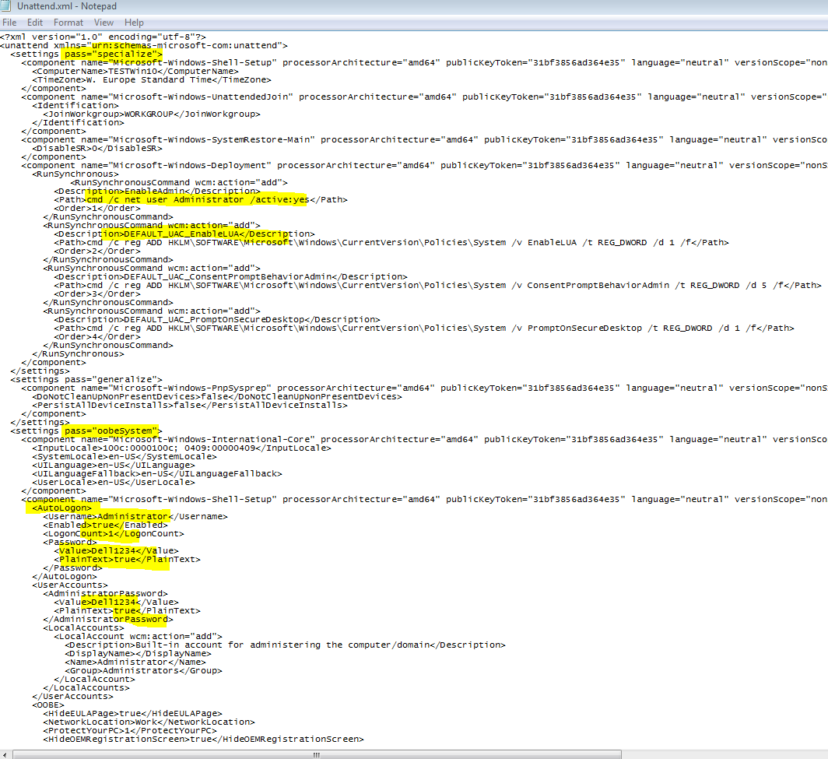

# Sample Files:

Please check some sample files added to the **CFG** folder to get an idea on how to setup the OSDSettings.ini and/or Apps.xml.

# Appendix

## Country List:

This the country list used with this tool.

|  |  |  |  |  |  |  |  |  |  |  |
| --- | --- | --- | --- | --- | --- | --- | --- | --- | --- | --- |
| **Country name** | **Country ID** |  | **Country name** | **Country ID** |  | **Country name** | **Country ID** |  | **Country name** | **Country ID** |
| Afghanistan | 3 |  | Brunei | 37 |  | Egypt | 67 |  | Howland Island | 326 |
| Albania | 6 |  | Bulgaria | 35 |  | El Salvador | 72 |  | Hungary | 109 |
| Algeria | 4 |  | Burkina Faso | 245 |  | Equatorial Guinea | 69 |  | Iceland | 110 |
| American Samoa | 10 |  | Burundi | 38 |  | Eritrea | 71 |  | India | 113 |
| Andorra | 8 |  | Cambodia | 40 |  | Estonia | 70 |  | Indonesia | 111 |
| Angola | 9 |  | Cameroon | 49 |  | Ethiopia | 73 |  | Iran | 116 |
| Anguilla | 300 |  | Canada | 39 |  | Falkland Islands (Islas Malvinas) | 315 |  | Iraq | 121 |
| Antarctica | 301 |  | Cape Verde | 57 |  | Faroe Islands | 81 |  | Ireland | 68 |
| Antigua and Barbuda | 2 |  | Cayman Islands | 307 |  | Fiji Islands | 78 |  | Isle of Man | 15126 |
| Argentina | 11 |  | Central African Republic | 55 |  | Finland | 77 |  | Israel | 117 |
| Armenia | 7 |  | Chad | 41 |  | France | 84 |  | Italy | 118 |
| Aruba | 302 |  | Channel Islands | 308 |  | French Guiana | 317 |  | Jamaica | 124 |
| Ascension Island | 303 |  | Chile | 46 |  | French Polynesia | 318 |  | Jan Mayen | 125 |
| Ashmore and Cartier Islands | 304 |  | China | 45 |  | French Southern and Antarctic Lands | 319 |  | Japan | 122 |
| Australia | 12 |  | Christmas Island | 309 |  | Gabon | 87 |  | Jarvis Island | 327 |
| Austria | 14 |  | Clipperton Island | 310 |  | Gambia, The | 86 |  | Jersey | 328 |
| Azerbaijan | 5 |  | Cocos (Keeling) Islands | 311 |  | Georgia | 88 |  | Johnston Atoll | 127 |
| Bahamas, The | 22 |  | Colombia | 51 |  | Germany | 94 |  | Jordan | 126 |
| Bahrain | 17 |  | Comoros | 50 |  | Ghana | 89 |  | Kazakhstan | 137 |
| Baker Island | 305 |  | Congo | 43 |  | Gibraltar | 90 |  | Kenya | 129 |
| Bangladesh | 23 |  | Congo (DRC) | 44 |  | Greece | 98 |  | Kingman Reef | 329 |
| Barbados | 18 |  | Cook Islands | 312 |  | Greenland | 93 |  | Kiribati | 133 |
| Belarus | 29 |  | Coral Sea Islands | 313 |  | Grenada | 91 |  | Korea | 134 |
| Belgium | 21 |  | Costa Rica | 54 |  | Guadeloupe | 321 |  | Kuwait | 136 |
| Belize | 24 |  | Côte d'Ivoire | 119 |  | Guam | 322 |  | Kyrgyzstan | 130 |
| Benin | 28 |  | Croatia | 108 |  | Guantanamo Bay | 323 |  | Laos | 138 |
| Bermuda | 20 |  | Cuba | 56 |  | Guatemala | 99 |  | Latvia | 140 |
| Bhutan | 34 |  | Cyprus | 59 |  | Guernsey | 324 |  | Lebanon | 139 |
| Bolivia | 26 |  | Czech Republic | 75 |  | Guinea | 100 |  | Lesotho | 146 |
| Bosnia and Herzegovina | 25 |  | Denmark | 61 |  | Guinea-Bissau | 196 |  | Liberia | 142 |
| Botswana | 19 |  | Diego Garcia | 314 |  | Guyana | 101 |  | Libya | 148 |
| Bouvet Island | 306 |  | Djibouti | 62 |  | Haiti | 103 |  | Liechtenstein | 145 |
| Brazil | 32 |  | Dominica | 63 |  | Heard Island and McDonald Islands | 325 |  | Lithuania | 141 |
| British Indian Ocean Territory | 114 |  | Dominican Republic | 65 |  | Honduras | 106 |  | Luxembourg | 147 |
|  |  |  | Ecuador | 66 |  | Hong Kong SAR | 104 |  | Macao SAR | 151 |

|  |  |  |  |  |  |  |  |  |  |  |
| --- | --- | --- | --- | --- | --- | --- | --- | --- | --- | --- |
| **Country name** | **Country ID** |  | **Country name** | **Country ID** |  | **Country name** | **Country ID** |  | **Country name** | **Country ID** |
| Macedonia, FYROM | 19618 |  | Northern Mariana Islands | 337 |  | Somalia | 216 |  | United Arab Emirates | 224 |
| Madagascar | 149 |  | Norway | 177 |  | South Africa | 209 |  | United Kingdom | 242 |
| Malawi | 156 |  | Oman | 164 |  | South Georgia and the South Sandwich Islands | 342 |  | United States | 244 |
| Malaysia | 167 |  | Pakistan | 190 |  | Spain | 217 |  | Uruguay | 246 |
| Maldives | 165 |  | Palau | 195 |  | Sri Lanka | 42 |  | Uzbekistan | 247 |
| Mali | 157 |  | Palestinian Authority | 184 |  | St. Helena | 343 |  | Vanuatu | 174 |
| Malta | 163 |  | Palmyra Atoll | 338 |  | St. Kitts and Nevis | 207 |  | Vatican City | 253 |
| Marshall Islands | 199 |  | Panama | 192 |  | St. Lucia | 218 |  | Venezuela | 249 |
| Martinique | 330 |  | Papua New Guinea | 194 |  | St. Pierre and Miquelon | 206 |  | Vietnam | 251 |
| Mauritania | 162 |  | Paraguay | 185 |  | St. Vincent and the Grenadines | 248 |  | Virgin Islands | 252 |
| Mauritius | 160 |  | Peru | 187 |  | Sudan | 219 |  | Virgin Islands, British | 351 |
| Mayotte | 331 |  | Philippines | 201 |  | Suriname | 181 |  | Wake Island | 258 |
| Mexico | 166 |  | Pitcairn Islands | 339 |  | Svalbard | 220 |  | Wallis and Futuna | 352 |
| Micronesia | 80 |  | Poland | 191 |  | Swaziland | 260 |  | Yemen | 261 |
| Midway Islands | 21242 |  | Portugal | 193 |  | Sweden | 221 |  | Zambia | 263 |
| Moldova | 152 |  | Puerto Rico | 202 |  | Switzerland | 223 |  | Zimbabwe | 264 |
| Monaco | 158 |  | Qatar | 197 |  | Syria | 222 |  |  |  |
| Mongolia | 154 |  | Reunion | 198 |  | Taiwan | 237 |  |  |  |
| Montserrat | 332 |  | Romania | 200 |  | Tajikistan | 228 |  |  |  |
| Morocco | 159 |  | Rota Island | 340 |  | Tanzania | 239 |  |  |  |
| Mozambique | 168 |  | Russia | 203 |  | Thailand | 227 |  |  |  |
| Myanmar | 27 |  | Rwanda | 204 |  | Timor-Leste | 7299303 |  |  |  |
| Namibia | 254 |  | Saipan | 341 |  | Tinian Island | 346 |  |  |  |
| Nauru | 180 |  | Samoa | 259 |  | Togo | 232 |  |  |  |
| Nepal | 178 |  | San Marino | 214 |  | Tokelau | 347 |  |  |  |
| Netherlands | 176 |  | São Tomé and Príncipe | 233 |  | Tonga | 231 |  |  |  |
| Netherlands Antilles | 333 |  | Saudi Arabia | 205 |  | Trinidad and Tobago | 225 |  |  |  |
| New Caledonia | 334 |  | Senegal | 210 |  | Tristan da Cunha | 348 |  |  |  |
| New Zealand | 183 |  | Serbia | 269 |  | Tunisia | 234 |  |  |  |
| Nicaragua | 182 |  | Seychelles | 208 |  | Turkey | 235 |  |  |  |
| Niger | 173 |  | Sierra Leone | 213 |  | Turkmenistan | 238 |  |  |  |
| Nigeria | 175 |  | Singapore | 215 |  | Turks and Caicos Islands | 349 |  |  |  |
| Niue | 335 |  | Slovakia | 143 |  | Tuvalu | 236 |  |  |  |
| Norfolk Island | 336 |  | Slovenia | 212 |  | Uganda | 240 |  |  |  |
| North Korea | 131 |  | Solomon Islands | 30 |  | Ukraine | 241 |  |  |  |

## Time Zone list:

This the Time Zone list used with this tool.

|  |  |  |  |  |
| --- | --- | --- | --- | --- |
| **Time Zone** | **Display** |  | **Time Zone** | **Display** |
| Dateline Standard Time | (GMT-12:00) International Date Line West |  | E. South America Standard Time | (GMT-03:00) Brasilia |
| Samoa Standard Time | (GMT-11:00) Midway Island, Samoa |  | Mid-Atlantic Standard Time | (GMT-02:00) Mid-Atlantic |
| Hawaiian Standard Time | (GMT-10:00) Hawaii |  | Cape Verde Standard Time | (GMT-01:00) Cape Verde Islands |
| Alaskan Standard Time | (GMT-09:00) Alaska |  | Azores Standard Time | (GMT-01:00) Azores |
| Pacific Standard Time | (GMT-08:00) Pacific Time (US and Canada); Tijuana |  | Greenwich Standard Time | (GMT) Casablanca, Monrovia |
| Mountain Standard Time | (GMT-07:00) Mountain Time (US and Canada) |  | GMT Standard Time | (GMT) Greenwich Mean Time : Dublin, Edinburgh, Lisbon, London |
| Mexico Standard Time | (GMT-07:00) Chihuahua, La Paz, Mazatlan |  | W. Europe Standard Time | (GMT+01:00) Amsterdam, Berlin, Bern, Rome, Stockholm, Vienna |
| US Mountain Standard Time | (GMT-07:00) Arizona |  | Central Europe Standard Time | (GMT+01:00) Belgrade, Bratislava, Budapest, Ljubljana, Prague |
| Canada Central Standard Time | (GMT-06:00) Saskatchewan |  | Romance Standard Time | (GMT+01:00) Brussels, Copenhagen, Madrid, Paris |
| Mexico Standard Time | (GMT-06:00) Guadalajara, Mexico City, Monterrey |  | Central European Standard Time | (GMT+01:00) Sarajevo, Skopje, Warsaw, Zagreb |
| Central Standard Time | (GMT-06:00) Central Time (US and Canada) |  | W. Central Africa Standard Time | (GMT+01:00) West Central Africa |
| Central America Standard Time | (GMT-06:00) Central America |  | GTB Standard Time | (GMT+02:00) Athens, Istanbul, Minsk |
| US Eastern Standard Time | (GMT-05:00) Indiana (East) |  | E. Europe Standard Time | (GMT+02:00) Bucharest |
| Eastern Standard Time | (GMT-05:00) Eastern Time (US and Canada) |  | Egypt Standard Time | (GMT+02:00) Cairo |
| SA Pacific Standard Time | (GMT-05:00) Bogota, Lima, Quito |  | South Africa Standard Time | (GMT+02:00) Harare, Pretoria |
| Pacific SA Standard Time | (GMT-04:00) Santiago |  | FLE Standard Time | (GMT+02:00) Helsinki, Kiev, Riga, Sofia, Tallinn, Vilnius |
| SA Western Standard Time | (GMT-04:00) Caracas, La Paz |  | Israel Standard Time | (GMT+02:00) Jerusalem |
| Atlantic Standard Time | (GMT-04:00) Atlantic Time (Canada) |  | Arabic Standard Time | (GMT+03:00) Baghdad |
| Newfoundland Standard Time | (GMT-03:30) Newfoundland and Labrador |  | Arab Standard Time | (GMT+03:00) Kuwait, Riyadh |
| Greenland Standard Time | (GMT-03:00) Greenland |  | Russian Standard Time | (GMT+03:00) Moscow, St. Petersburg, Volgograd |
| SA Eastern Standard Time | (GMT-03:00) Buenos Aires, Georgetown |  | E. Africa Standard Time | (GMT+03:00) Nairobi |

|  |  |  |  |  |
| --- | --- | --- | --- | --- |
| **Time Zone** | **Display** |  | **Time Zone** | **Display** |
| Iran Standard Time | (GMT+03:30) Tehran |  | Yakutsk Standard Time | (GMT+09:00) Yakutsk |
| Arabian Standard Time | (GMT+04:00) Abu Dhabi, Muscat |  | Cen. Australia Standard Time | (GMT+09:30) Adelaide |
| Caucasus Standard Time | (GMT+04:00) Baku, Tbilisi, Yerevan |  | AUS Central Standard Time | (GMT+09:30) Darwin |
| Afghanistan Standard Time | (GMT+04:30) Kabul |  | E. Australia Standard Time | (GMT+10:00) Brisbane |
| Ekaterinburg Standard Time | (GMT+05:00) Ekaterinburg |  | AUS Eastern Standard Time | (GMT+10:00) Canberra, Melbourne, Sydney |
| West Asia Standard Time | (GMT+05:00) Islamabad, Karachi, Tashkent |  | West Pacific Standard Time | (GMT+10:00) Guam, Port Moresby |
| India Standard Time | (GMT+05:30) Chennai, Kolkata, Mumbai, New Delhi |  | Tasmania Standard Time | (GMT+10:00) Hobart |
| Nepal Standard Time | (GMT+05:45) Kathmandu |  | Vladivostok Standard Time | (GMT+10:00) Vladivostok |
| N. Central Asia Standard Time | (GMT+06:00) Almaty, Novosibirsk |  | Central Pacific Standard Time | (GMT+11:00) Magadan, Solomon Islands, New Caledonia |
| Central Asia Standard Time | (GMT+06:00) Astana, Dhaka |  | New Zealand Standard Time | (GMT+12:00) Auckland, Wellington |
| Sri Lanka Standard Time | (GMT+06:00) Sri Jayawardenepura |  | Fiji Standard Time | (GMT+12:00) Fiji Islands, Kamchatka, Marshall Islands |
| Myanmar Standard Time | (GMT+06:30) Yangon (Rangoon) |  | Tonga Standard Time | (GMT+13:00) Nuku'alofa |
| SE Asia Standard Time | (GMT+07:00) Bangkok, Hanoi, Jakarta |  |  |  |
| North Asia Standard Time | (GMT+07:00) Krasnoyarsk |  |  |  |
| China Standard Time | (GMT+08:00) Beijing, Chongqing, Hong Kong SAR, Urumqi |  |  |  |
| North Asia East Standard Time | (GMT+08:00) Irkutsk, Ulaanbaatar |  |  |  |
| Singapore Standard Time | (GMT+08:00) Kuala Lumpur, Singapore |  |  |  |
| W. Australia Standard Time | (GMT+08:00) Perth |  |  |  |
| Taipei Standard Time | (GMT+08:00) Taipei |  |  |  |
| Tokyo Standard Time | (GMT+09:00) Osaka, Sapporo, Tokyo |  |  |  |
| Korea Standard Time | (GMT+09:00) Seoul |  |  |  |

_____________________________________ END OF DOCUMENT ______________________________________